Bilingualer Fachunterricht an berufsbildenden Schulen

Unterrichtsmodul

Berufsfeld: Wirtschaft und Verwaltung

Beruf: Kaufmann / Kauffrau im Außenhandel
Speditionskaufmann / Speditionskauffrau

Incoterms 2000

Where did the accident happen?
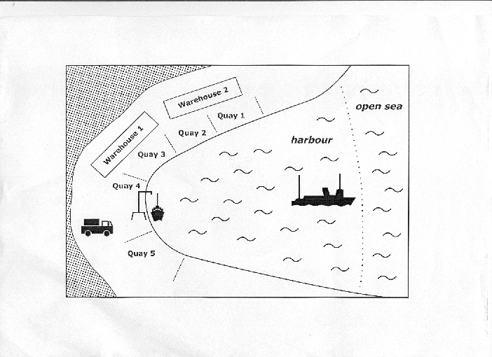

ACTION PROGRAMME OF THE EUROPEAN UNION

LEONARDO DA VINCI – PROJECT
PROJECT NO.: 2002 LA 112 628 BILVOC

LANGUAGE COMPETENCE THROUGH
BILINGUAL TEACHING AT VOCATIONAL COLLEGES

Teaching Modules

Date of Production: January 2005

Subject: International Trade

Topic: The Contents of a Sales Contract

Title: Incoterms 2000

Target Group: Trainees and employees working in international trade
students involved in international trade
Prior Knowledge: Means of transport
basics of insurance

Language Skills: Threshold/Vantage

Follow-Ups: Terms of payment

Objectives: Students should know how to use Incoterms.

Benefits: Students should be able to answer the following questions:
- What are Incoterms?
- What do certain Incoterms stipulate?
- Which Incoterms do you have to choose under given circumstances or to reach a given aim?

At the end of the lessons the students should know what Incoterms are and what they are for.
The should also know what each Incoterm stipulates and which Incoterms have to be chosen under given circumstances.

Teaching Time  (expe-rience) | Contents | Activities | Media | Teaching  Method | Skills
5 minutes | Warming up  - What may  have caused  the accident?  - What may  have happened  to ship and  cargo? | Discussion among students | Illustration 1 (trans-  parency or handout) | Discussion in small groups | Discussion skills –  listening,  speaking,  expressing and accepting objective criticism
5 minutes | - What may  have caused  the accident?  - What may  have happened  to ship and  cargo? | Collecting the ideas, discussing them in class and writing them on the blackboard | Illustration 1 (trans-  parency or handout);  blackboard | Discussion in class | Discussion skills –  listening,  speaking,  expressing and accepting objective criticism,  writing
5 minutes | What may importer and exporter have thought? => illustration 2  - who is right?  - what does the  answer depend  on if nothing is  agreed on in the  contract?  result: law is flexible ➔ contractual agreement | Reading and interpreting the excerpt form the Civil Code BGB  with the teacher’s help | Illustration 2 (trans-  parency) | Discussion in class | Reading legal texts,  accepting help,  speaking
10 minutes | Where could something have happened? | Students mark the places of risk on the transparency and defining the risk on the blackboard | Illustration 3 (trans-parency),  blackboard | Discussion in class | Speaking,  writing

10 minutes | The most favourable spot for the transfer of risks from the importer’s / exporter’s point of view | Students find the most favourable place for the transfer of risks from the importer’s /exporter’s point of view | Illustration 3
5 minutes | Transfer of risks | Students draw conclusion: Port of Shipment open to interpretation | Illustration 3 | Class work | Speaking,  drawing conclusions
5 minutes | Introduction of the Incoterms | Presentation by teacher: ICC has made rather interpretation proof regulations | Blackboard | Presentation by teacher | Listening
20 minutes | Introduction of the Incoterms | Students read texts and find  1.general  information  about  Incoterms  2. information  about specific  Incoterms;  They take notes | Texts 1 and 2 | Group work | Working in a group,  reading,  making notes
10 minutes | Introduction of Incoterms | Students tell the others about their results and transfer notes to the blackboard | Texts 1 and 2;  blackboard | Class work | Speaking, writing
20 minutes | All the Incoterms | Students and teacher explain  table 1 | Table 1 | Class work | Speaking,  asking questions, reading,  listening
10 minutes | All the Incoterms | Practising:  Students do exercise 1 | Work-sheet: exercise 1,  table 1 | Working with a partner | Working with a partner,  expressing and accepting objective criticism
5 minutes | All the Incoterms | Students compare results with the rest of the class and the teacher | Key to exercise 1,  table 1 | Class Work | Speaking, expressing and accepting objective criticism

10 minutes | All the Incoterms | Students do exercise 2 | Worksheet:  exercise 2,  table 1 | Individual work | Working all by oneself,  drawing conclusions, motivating oneself
5 minutes | All the Incoterms | Students compare and discuss their results with their neighbours | Worksheet: exercise 2,  table 1 | Working with a partner | Working with a partner;  speaking, arguing, expressing and accepting objective criticism
5 minutes | All the Incoterms | Students compare results with the rest of the class and the teacher | Key to exercise 2,  table 1 | Class work | Speaking, arguing,  listening,  expressing and accepting objective criticism
15 minutes | All the Incoterms | Students do exercise 3 | Worksheet: exercise 3,  table 1 | Individual work | Working all by oneself,  drawing conclusions, motivating oneself
10 minutes | All the Incoterms | Students compare results with the rest of the class and the teacher | Key to exercise 3,  table 1 | Class work | Speaking, arguing,  listening,  expressing and accepting objective criticism
any length of time | All the Incoterms | Students do exercises 4 and 5 on the computer | Computer | Individual work | Working all by oneself with the help of a computer,  drawing conclusions, motivating oneself

ILLUSTRATION I

Orion

“ ORION“ sunk

Illustration 2

I am sure I will get paid. I have sent off the goods in good order and condition and on time.

I am sure I need
not pay. I have t
not received the
goods.

Excerpt from the German Civil Code (Bürgerliches Gesetzbuch BGB)

§ 269
- Ist ein Ort für die Leistung weder bestimmt noch aus den Umständen ... zu entnehmen, so hat die Leistung an dem Ort zu erfolgen, an welchem der Schuldner zur Zeit der Entstehung des Schuldverhältnisses seinen Wohnsitz hatte.
- Ist die Verbindlichkeit im Gewerbebetriebe des Schuldners entstanden, so tritt ... die gewerbliche Niederlassung an die Stelle des Wohnsitzes.

§ 447
(1) Versendet der Käufer auf Verlangen des Käufers die verkaufte Sache nach einem anderen Ort als dem Erfüllungsort, so geht die Gefahr auf den Käufer über, sobald der Verkäufer die Sache dem Spediteur, dem Frachtführer oder der sonst zur Ausführung der Versendung bestimmten Person ausgeliefert hat.

Illustration 3

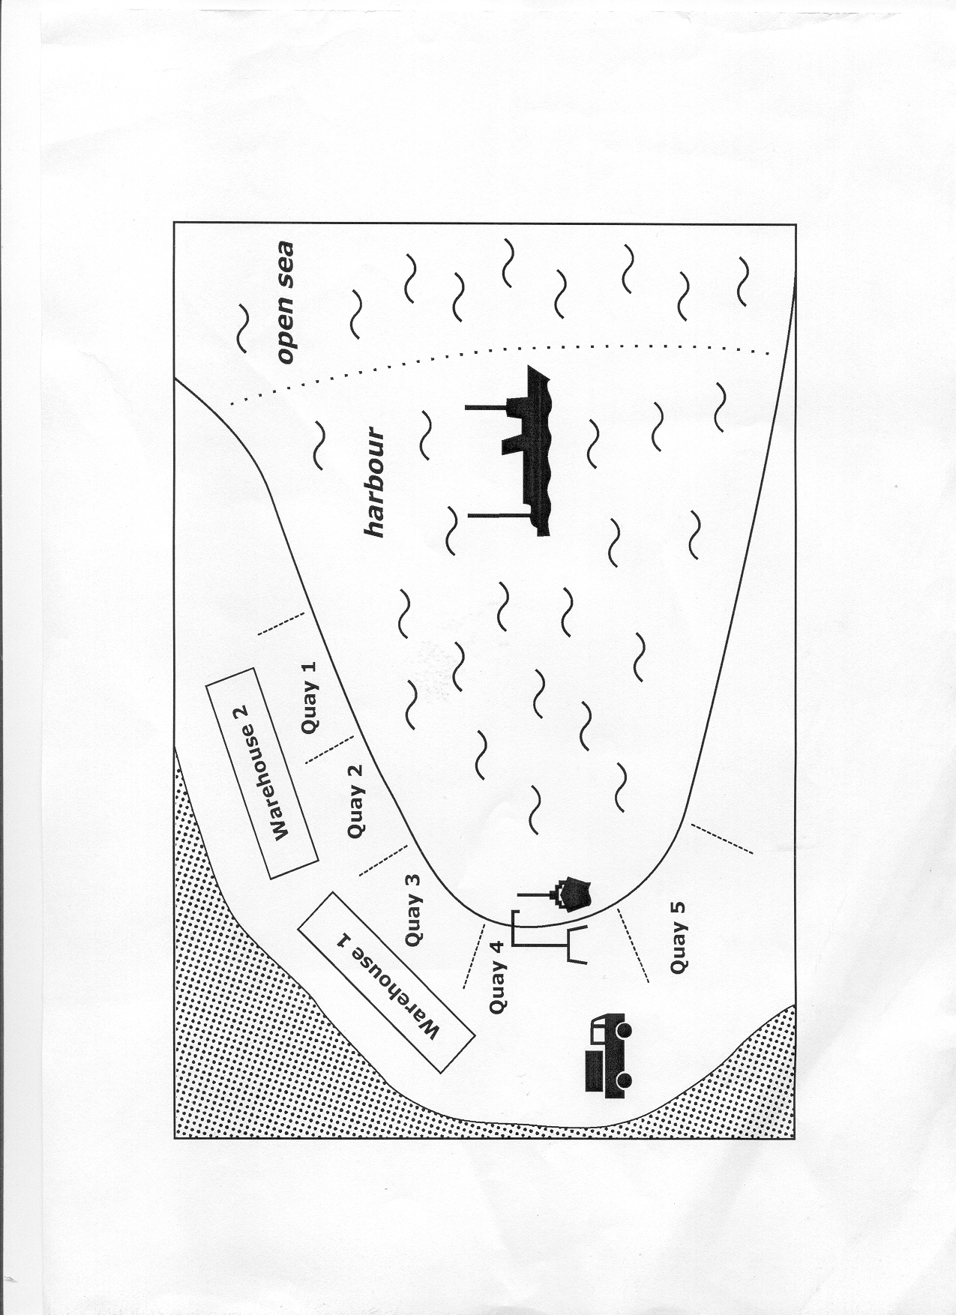
INCOTERMS 2000 - TEXT I

The trainee talks to his boss:

A: Look at this letter. It has just arrived. Our customer does not want to accept the machine we despatched four weeks ago. He therefore refuses to pay the price. That is awful. We have to have the machine shipped back. It’s a high price!
B: Why does he not want to accept the machine?
5 A: He writes that he heard that the machine had been damaged in transit.
Can he really refuse to pay for the machine that he ordered and that we sent off in proper condition and in time?.
And how are we going to get the machine back here? Nobody will want to buy it after such a long sea journey.
10 And look: he also writes that he does not want to pay the shipping costs. It will cost us a lot of money.
B: Now wait. Let’s have a look at the sales contract and see what terms of delivery we agreed on.
A: Terms of delivery? What do they have to do with the matter? We want him to pay the
15 invoice amount.
B: And the shipping costs.
A: That’s true.
B: Let’s see. Here we are. It says in our offer - and he agreed to that -:
“Terms of delivery: FOB Aarhus Incoterms 2000.“
20 A: What does that mean?
B: Luckily we agreed on Incoterms.
A: What are Incoterms and why is that lucky?
B: The Incoterms provide a set of international rules for interpreting the most commonly used terms of delivery. The aim is to avoid confusion that could be caused by
25 different interpretations of the same terms in different countries.
A: So he will not be able to say that he understood something different by FOB than we do.
B: That’s right. That’s why the International Chamber of Commerce in Paris published these rules and has them updated from time to time. The number after the word
30 “Incoterms“ tells you the year in which the Incoterms you refer to were
implemented. So the latest update was made early in the year 2000.
A: Can You tell me more about these terms of delivery.
B: I certainly can. Their proper name is International Commercial Terms or Incoterms for short. All the Incoterms - no matter which one you agree on - say that the seller
35 has to deliver the goods properly at the place named in the contract, that he has to supply the necessary documents or at least help the buyer to get them at the buyer’s cost. He also has to pack the goods properly.
The buyer has - no matter which Incoterm the two partners agree on - to accept the goods at the time agreed on. He is entitled to have the goods checked at his own
40 expense before they are loaded.
A: So our customer cannot refuse the acceptance of the goods and the payment of the price.
B: Well, they were damaged in transit.
A: Do you mean to say that that might give him the right to refuse the acceptance of the
45 machine after all?
B: As I said: that depends on the Incoterms we agreed on and on where the goods were damaged.
That means each term tells you exactly at which point the risk is transferred from the seller to the buyer. And if our customer has to bear the risk at the place of the
50 accident he will have to pay the price and can claim damages from his insurance company. If we bear the risk we don’t get paid by our customer and we will have to claim damages from our insurance company.
A: Well, what does FOB mean then?
B: It means that the risk is transferred as soon as the machine passes the rail of the
55 ship in the port of shipment.
A: Since they write that it has been seawater that has damaged the machine the machine must have been on board the ship already. So they will have to pay the invoice amount, won’t they.
B: Yes, you are right.
60 A: And what about the shipping costs?
B: We will have to pay the shipping costs up to the time when the machine was loaded on board the ship.
A: So our customer will also have to pay part of the shipping costs.
B: Exactly ...

INCOTERMS 2000 - TEXT II

This is a conversation between a British trainee (A) and the German businessman (B) he serves his traineeship with.

A: Look, what I have just read in the paper. There is a law made by the X-Country parliament that says that the transport of all the goods that are exported from X-Country have to be insured by an X-Country insurance company. What do you think: how is that supposed to work? The German law says that we have got to bear the risk from their premises - and they insure it? That is impossible.
5 B: Yes, up to now they have delivered ex works. This is the same in our law. We bear the risk from their premises and also have to effect the insurance.
A: And now? We have got to break our own law.
B: No, it’s not as bad as that. Our law is flexible. It only takes over if nothing is agreed on in the sales contract.
10 A: And now their law takes over. Why did they ever impose that law? It worked well in the past, didn’t it?
B: It worked well from our point of view. They probably want to protect their insurance business. But we are as flexible as they are. As we do not have any other supplier for the goods we will have to agree on something else. On CIF, for example.
15 A: CIF? What does that mean?
B: It means that they bear the risk until the goods are loaded on board in the port of shipment and the shipping costs until the goods are unloaded in the port of destination. From then on we take over the risk.
A: OK, I understand that. But according to their new law they will have to pay the
20 insurance premium for the entire period, which means that they will also have to bear the risk from loading to destination.
B: No, they don’t. If we agree on CIF, which means “cost, insurance, freight“ they will effect the insurance although we bear the risk.
A: Yes, but what if they cheat? Will they not effect a very low insurance so as to keep
25 the premium down? That would mean that for that part of the journey for which we have to bear the risk the goods may be under-insured and we may not be refunded the whole value if the goods are damaged.
B: Yes, you are right. That is to say, you would be right if the International Chamber of Commerce in Paris had not thought about that, too. They have provided that if you
30 arrange CIF the seller must effect a minimum level of insurance. This level is known as Institute Cargo Clauses Level C.
A: And if we wanted a higher insurance? Or if their insurance company goes bankrupt? You never know with these foreign countries.
B: No, unfortunately you never know. In the first case you have mentioned we could
35 agree on a higher insurance and on their sending us the insurance policy as proof of adequate cover. We could also effect an additional insurance in our country which would be considerably cheaper than if we had to insure the goods. That would also protect us from the second scenario.
A: Could you tell me more about these international terms of delivery?
40 B: I certainly can. Their proper name is International Commercial Terms or Incoterms
for short. There are 13 Incoterms in total. Ex works, or EXW for short, means that the buyer has to pay for everything. He has to pay for the transport from the time the goods leave the factory until the time they arrive at his warehouse. He has got to
45 arrange all the formalities for customs clearance in the exporter’s as well as in his own country and he has to form the contract of transport.
A: Yes, that’s how we have done it up to now with our X-Country supplier.
B: That’s right. But now we will buy CIF, which means - as I said already - cost, insurance, freight. But I think I’d better give you a table that explains the main
50 points of the Incoterms. When you have had a look at the table you can go to the computer and practice what you have learned.
A: That’s fine. Thank you very much. Then I can have a look at them myself and
practise them whenever I want.
INCOTERMS 2000 - EXERCISE I

After you have finished school you work as a trainee in a London firm. Your boss tells you something about the terms of delivery of the firm. You want to show him that you know a lot about Incoterms, so after he has finished you say: Ah, so you quote your prices (e.g. DDU)

1. Your boss: Our buyers normally have to pay the costs for transport and insurance from
the time the goods leave our premises.

You: Ah, so you quote your prices ..........................................................................
- Your boss: Sometimes we pay the cost of transport up to the port of destination. Our
customer has to bear the risk from the time the goods have been loaded onto the ship at the port of shipment.
You: Ah, so you quote your prices ...........................................................................

- Your boss: Some customers ask us to include in the quotation all costs of transport up
to and including loading the goods onto the ship. We also bear the risk of loss and damage up to that point.
You: Ah, so you quote your prices ...........................................................................

4. Your boss: We normally pay the costs of transport up to the port of destination.
Sometimes our customers ask us to effect insurance for all the time during which the goods are in transit although they have to bear the risk from the time the goods have been loaded onto the ship.
You: Ah, I see. So at the request of your customer you sometimes quote your
prices ........................................................................................……………….

5. Your boss: When you write to Hancock & Partners make sure that you make quite clear
to the customer that he has to bear the risk from the time the goods are taken over by the carrier. We only pay the costs of transport up to the place of destination that is named in the contract.
You: Ah, so you quote your prices …......................................................................

6. Your boss: With some customers we pay the costs of transport and we also bear the
risk until the goods have arrived at the port of shipment This port must be named in the contract. We do, however, not have to pay for loading the goods onto the ship. Nor do we bear the risk for damages or loss that occur during the loading.
You: Ah, so you quote your prices ..................................……..................................
..
7. Your boss: Our quotations sometimes include the costs of getting the goods to the
nearest railway station or airport.
You: Ah, so you quote your prices ....................................................................

8. Your boss: Very rarely an importer who does not often import goods and does neither
have the facilities nor the experience asks us to get the import licence for him and to clear the goods at the customs by paying import duty and taxes. We of course include the expenses in the price we ask him to pay. To make matters even easier for him we then also pay the costs of transport and bear the risk up to a place named in the contract. This place may be the buyer’s premises.
You: Ah, so you quote your prices ....................................................................

INCOTERMS 2000 - EXERCISE I (KEY)

After you have finished school you work as a trainee in a London firm. Your boss tells you something about the terms of delivery of the firm. You want to show him that you know a lot about Incoterms, so after he has finished you say: Ah, so you quote your prices ......................................................................

- Your boss: Our buyers normally have to pay the costs for transport and insurance from
the time the goods leave our premises. He has to arrange for the collection of the goods. We don’t even pay for the loading of the collecting vehicle.
You: Ah, so you quote your prices ..........EXW . . . Incoterms 2000.....................

2. Your boss: Sometimes we pay the cost of transport but not the insurance up to the port
of destination. Our customer has to bear the risk from the time the goods have been loaded onto the ship at the port of shipment.
You: Ah, so you quote your prices ..........CFR . . . Incoterms 2000 ......................

3. Your boss: Some customers ask us to include in the quotation all costs of transport up
to and including loading the goods onto the ship. We also bear the risk of
loss and damage up to that point.
You: Ah, so you quote your prices ......... FOB . . . Incoterms 2000 ......................

4. Your boss: We normally pay the costs of transport up to the port of destination.
Sometimes our customers ask us to effect insurance for all the time during which the goods are in transit although they have to bear the risk from the time the goods have been loaded onto the ship.
You: Ah, I see. So at the request of your customer you sometimes quote your
prices .............................................. CIF . . . Incoterms 2000 ........................

5.1 Your boss: When you write to Hancock & Partners make sure that you make quite clear
to the customer that when we deliver by road he has to bear the risk from the time the goods are taken over by the carrier. We only pay the costs of transport up to the place of destination that is named in the contract.
You: Ah, so you quote your prices ..........CPT . . . Incoterms 2000 ...................….
if you send the goods by road and .... CFR . . . Incoterms 2000 if you send them by sea.

6. Your boss: With some customers we pay the costs of transport and we also bear the
risk until the goods have arrived at the port of shipment This port must be named in the contract. We do, however, not have to pay for loading the goods onto the ship. Nor do we bear the risk for damages or loss that occur during the loading.
You: Ah, so you quote your prices ..........FAS . . . Incoterms 2000 .......................

7. Your boss: Our quotations sometimes include the costs of getting the goods to the
nearest railway station or airport including the unloading of our lorry.
You: Ah, so you quote your prices ..........FCA . . . Incoterms 2000 .......................

8. Your boss: Very rarely an importer who does not often import goods and does neither
have the facilities nor the experience asks us to get the import licence for him and to clear the goods at the customs by paying import duty and taxes. We of course include the expenses in the price we ask him to pay. To make matters even easier for him we then we also pay the costs of transport and bear the risk up to a place named in the contract. This place may be the importer’s premises.
You: Ah, so you quote your prices ..........DDP . . . Incoterms 2000 ................

INCOTERMS 2000 - EXERCISE II

Which terms of delivery have been agreed on?

1. The seller pays all the costs up to the port of destination, he does not, however, pay the costs of unloading. He also bears the risk of damage or destruction in transit up to that point i.e. he has to effect insurance against these risks.

2.1 The quotation includes the costs of getting the goods to the nearest railway station. The seller bears the risk up to that point.
2.2 The quotation includes the costs of getting the goods to the airport that is named in the
contract. The seller bears the risk up to that point.

3. The seller has to pay the costs of transport and insurance up to a place near the frontier that is named in the contract.

4. The buyer has to pay all the costs of transport and insurance from the time the goods leave the seller’s premises.

5. The seller bears the costs of transport and insurance up to a place in the importer’s country that is named in the contract; the buyer has to meet the costs of import duty, taxes, he has to apply for the import licence etc.

6. The seller bears all the costs including transport, insurance, export and import duty, taxes etc.

7. The seller pays the costs of transport up to the port of destination. The buyer bears the cost of insurance and the risk from the time the goods have been loaded onto the ship in the port of shipment.

8. The quotation includes all costs of transport up to and including loading the goods onto the ship.
The seller also bears the risk of loss and damage up to that point.

9. The seller pays the costs of transport up to the port of destination. Although the buyer bears the risk from the time the goods have been loaded onto the ship the seller has to effect insurance for all the time during which the goods are in transit.

10. The seller pays the costs of transport up to the place of destination that is named in the
contract. The risk and the costs of insurance, however, are borne by him only until the goods have been taken over by the carrier that is named in the contract.

11. The quotation includes all costs of transport up to the port of destination. It also includes
the costs of unloading. The seller also pays the import duty and has to get the import licence for the importer.

12. The quotation includes the costs of transport up to the place of destination that is named
in the contract. The exporter bears the risk only until the goods have been taken over by the carrier but he has to effect insurance for the complete transport from his firm to the importer’s firm.

13. The seller bears the costs of transport and the risk up to the port of shipment that is
named in the contract. He does not have to meet the costs for loading the goods onto the ship.

INCOTERMS 2000 - EXERCISE II (KEY)

1. DES ... named port of destination Incoterms 2000
CPT ... named place of destination Incoterms 2000

2. FCA ... named place Incoterms 2000
DAF ... named place Incoterms 2000

3. DAF ... named place of destination Incoterms 2000

4. EXW... named place (seller’s premises) Incoterms 2000
FCA ... named place (seller’s premises) Incoterms 2000

5. DDU ... named place of destination Incoterms 2000
CFR ... named port of destination Incoterms 2000
CPT ... named port of destination Incoterms 2000

6. DDP ... named place of destination Incoterms 2000

7. CFR ... named port of destination Incoterms 2000

8. FOB ... named port of shipment Incoterms 2000

9. CIF ... named port of destination Incoterms 2000

10. CPT ... named place of destination Incoterms 2000
CFR ... named port of destination Incoterms 2000

11. DDP ... named place of destination Incoterms 2000

12. CIP ... named place of destination Incoterms 2000
CIF ... named port of destination Incoterms 2000

13. FAS ... named port of destination Incoterms 2000
DAF ... named place Incoterms 2000

INCOTERMS 2000 - EXERCISE III

The following statements are either parts of clauses of the INCOTERMS 2000 or are - in the form
given – not contained in any of the clauses mentioned.
Match the following statements with the clause in question by marking the box or mark the box
“n.c.“ (not contained in any of the clauses mentioned)

statement FCA FOB CFR CIF CPT CIP DEQ DDP n.c.
1. The clause can be used for transport by sea only.
- The seller has to apply for export
and import licences.
- The seller bears the costs and risk
until the goods are handed over to
the first carrier.
- The sea freight is included in the
price quoted.
5. The clause can be used for transport by air.
6. The buyer has to pay 10 days after delivery.
7. The goods have to arrive at the
time agreed on in the sales contract.
8. The risk is transferred from the
seller to the buyer when the goods
are handed over to the carrier at the
place named.
9. The place named in the clause is
always a harbour.
10. If nothing else is agreed on the
buyer has to bear the costs of
inspecting the goods before loading.
11. The seller has to pack the goods properly.
12. The seller has to have the goods
inspected immediately on arrival.
13. The seller has to inform the buyer
in time about the place and the time
period required for the delivery of
the goods.
14. The buyer has to effect insurance for
that part of the route for which he bears the risk.
15. At the buyer’s request the seller
forms the transport contract at the buyer’s expense.
This is subject to the agreement of
the carrier.
16. The seller has to send off the goods
at the time stated in the contract.

17. The seller has got to see to the
customs clearance in the importer’s
country.
18. The buyer pays the shipping costs
and also bears the risk from the time the goods are put at the buyer’s
disposal at the seller’s premises.
19. The place named in the contract
must always be near the border.
20. The costs of unloading the ship are
borne by the seller.
21. The clause can be used for
transport by rail.
22. The seller has to see to the loading
of the goods onto the buyer’s lorry at
the seller’s premises.

Incoterms 2000 - Exercise III (Key)

statement FCA FOB CFR CIF CPT CIP DEQ DDP n.c.
1. The clause can be used for transport by sea only. |  | x | x | x |  |  | x
- The seller has to apply for export  and import licences. |  |  |  |  |  |  |  | x
- The seller bears the costs and risk  until the goods are handed over to  the first carrier. | x
4. The sea freight is included in the  price quoted. |  |  | x | x | (x) | (x) | x | x
- The clause can be used for  transport by air. | x |  |  |  | x | x |  | x
6. The buyer has to pay 10 days after delivery. |  |  |  |  |  |  |  |  | x
7. The goods have to arrive at the  time agreed on in the sales  contract. | x | x | x | x | x | x | x | x
8. The risk is transferred from the  seller to the buyer when the goods  are handed over to the carrier at the  place named. | x
9. The place named in the clause is  always a harbour. |  | x | x | x |  |  |  | x
10. If nothing else is agreed on the  buyer has to bear the costs of  inspecting the goods before loading. | x | x | x | x | x | x | x | x
11. The seller has to pack the goods properly. | x | x | x | x | x | x | x | x
12. The seller has to have the goods  inspected immediately on arrival. |  |  |  |  |  |  |  |  | x
13. The seller has to inform the buyer  in time about the place and the time  period required for the delivery of  the goods. | x | x
14. The buyer has to effect insurance  for that part of the route for which he bears the risk. |  |  |  |  |  |  |  |  | x
15. At the buyer’s request the seller  forms the transport contract at the buyer’s expense.  This is subject to the agreement of  the carrier. | x | x
16. The seller has to send off the goods  at the time stated in the contract. |  |  |  |  |  |  |  |  | x
17. The seller has got to see to the  customs clearance in the importer’s  country. |  |  |  |  |  |  |  | x

18. The buyer pays the shipping costs  and also bears the risk from the time the goods are put at the buyer’s  disposal at the seller’s premises. | x
19. The place named in the contract  must always be near the border. |  |  |  |  |  |  |  |  | x
20. The costs of unloading the ship are  borne by the seller. |  |  | x | x | x | x | x | x
21. The clause can be used for  transport by rail. | x |  |  |  | x | x |  | x
22. The seller has to see to the loading  of the goods onto the buyer’s lorry at  the seller’s premises. | x

