Bilingualer Fachunterricht an berufsbildenden Schulen

Unterrichtsmodul

Berufsfeld: Wirtschaft und Verwaltung

Beruf: Kaufmann / Kauffrau im Außenhandel

Basic Forms of International Trade

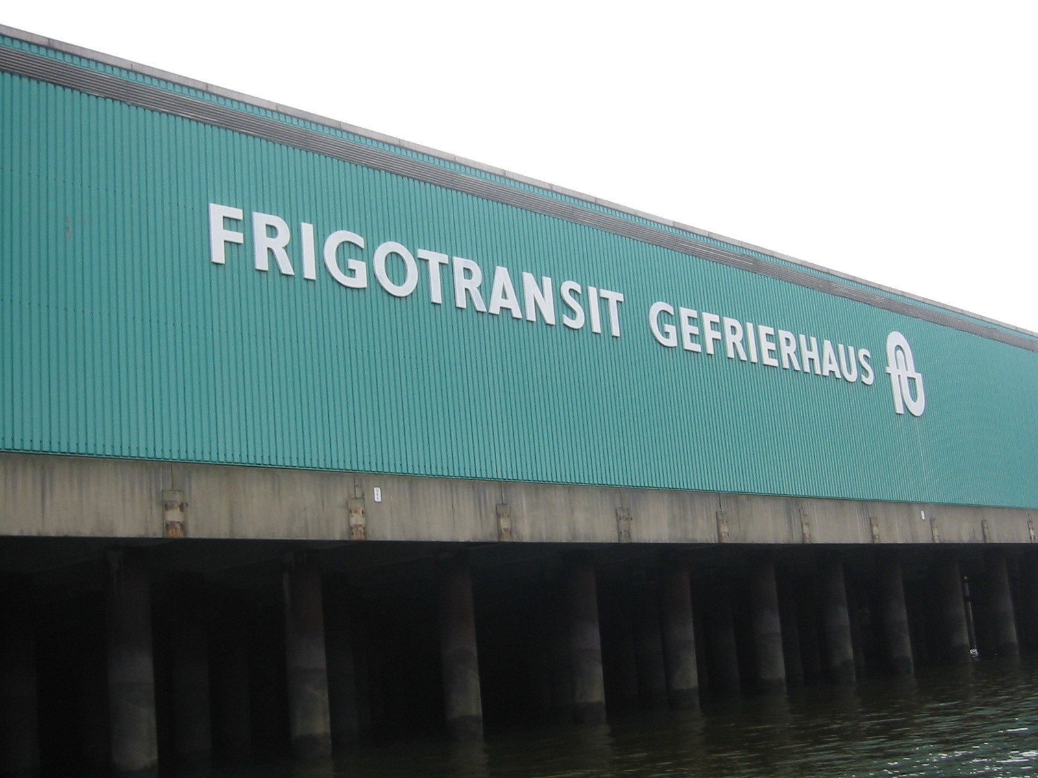

SELLER TRANSIT TRADER BUYER
in Tokio in Hamburg in New York

sales contract 1 sales contract 2

ACTION PROGRAMME OF THE EUROPEAN UNION

LEONARDO DA VINCI – PROJECT

PROJECT NO.: 2002 LA 112 628 BILVOC

LANGUAGE COMPETENCE THROUGH
BILINGUAL TEACHING AT VOCATIONAL COLLEGES

Teaching Module

Date of Production: January 2005

Subject: International Trade

Topic: Marketing

Title: Basic Forms of International Trade

Target Group: Students of international trade

Prior Knowledge: none

Level of Language Skills: Waystage/Threshold

Follow-Ups: Special types of international trade

Objectives: Students should know the ways that are open to international traders to distribute their goods abroad?

Benefits: Students should be able to explain:
- the differences between direct and indirect import and export
- transit trade

At the end of the lessons the students should be able to explain the significance of direct and indirect trade as well as transit trade. They should also be able to explain conditions under which a prospective international trader should choose either direct or indirect international trade or should engage in transit trade.

Teaching Time  (expe-rience) | Contents | Activities | Media | Teaching  Method | Skills
Alternative 1
5 minutes | Working on the basic scenario | Students find reasons for getting into contact with either the Indian or the German supplier | Advertise-ment for  T-shirts | Individual work | Self learning
10 minutes | working on the basic scenario | Students exchange their ideas in groups of three or four | Advertise-ment for  T-shirts | Group work | Listening to and understand-ing other students;  speaking skills;  team work
15 minutes | Working on the basic scenario | Students discuss their ideas with all the other students and with the teacher | Advertise-ment for  T-shirts | Class work | Listening to and under-standing other students,  expressing one’s own and accepting other people’s ideas and  criticism
Alternative 2
15 minutes | Working on the basic scenario | Introductory exercise:  students mark the reasons for getting into contact with the Indian or the German firm | Worksheet: intro-ductory exercise | Individual work | Self learning
10 minutes | Comparing results | Students compare results help each other or are helped by the teacher if necessary | Key to intro-ductory exercise | Class work | Speaking, arguing,  accepting help,  expressing and accepting objective criticism

Alternatives 1 and 2 continued
10 minutes | Defining  the expressions | With the teacher’s help students define the expressions  “direct import” and  “indirect import” | Black-board,  trans-  parency, beamer | Classroom discussion | Drawing conclusions  defining,  speaking,  listening,  accepting corrections
15 minutes | Finding  characteristics of direct and indirect import | Taking the reasons they have worked out before students work  on the characteristics of direct and indirect import | None | Group work | Speaking,  expressing criticism,  accepting corrections
10 minutes | Finding  characteristics of direct and indirect import | Students write their ideas on the blackboard after they have been agreed on by the class | Blackboard | Classroom discussion,  individual work | Speaking,  expressing and accepting objective criticism,  writing
10 minutes | Defining  (if need be with the help of graphs) | Based on what has been worked out before students define the expressions  “direct export” and “indirect export”  (and draw graphs on blackboard or transparency) | Blackboard  or trans-parency | Group work | Speaking,  listening,  defining,  expressing and accepting objective criticism
15 minutes | Finding characteristics  of direct and indirect export | The same groups that worked on the definitions of direct and indirect export now find out what is typical of direct and indirect export | Blackboard  or trans-parency | Group work | Defining,  speaking,  arguing,  expressing and accepting  objective criticism
15 minutes | Handing on ideas | Students explain their results to the other students | Blackboard or trans-parency | Classroom  discussion | Explaining,  arguing,  expressing and accepting objective criticism
45 minutes | Practising | Students mark which form of im- / export they would choose | Worksheet:  exercise 1 | Individual work | Self learning

25 minutes | Comparing  results | Students compare results, correct them if necessary; teacher explains if questions arise | Worksheet:  exercise 1 | Class work,  discussion | Expressing and accepting objective criticism; asking questions
5 minutes | Scenario for active transit trade | Teacher sets scenario | None | Presenta-tion by teacher | Listening, understanding their teacher
10 minutes | Definition of active transit trade | Students define the expression “active transit trade” and write the definition on the blackboard | Blackboard | Classroom discussion | Defining,  speaking,  writing,  expressing and accepting objective criticism
5 minutes | Scenario for passive transit trade | Teacher sets scenario |  | Presenta-tion by teacher | Listening, understanding their teacher
10 minutes | Definition of passive transit trade | Students define the expression “passive transit trade” correspondingly  and write the definition on the blackboard | Blackboard | Class work | Defining,  speaking,  writing,  expressing and accepting objective criticism
20 minutes | Practising | Students find out which form of im-/export is employed | Worksheet:  exercise 2 | Individual work | Self learning
10 minutes | Comparing results | Students compare results, correct them if necessary; teacher explains if questions arise | Worksheet:  exercise 2 | Class work | Expressing and accepting objective criticism;  asking questions
5 minutes | Scenario: active transit trade | Teacher sets scenario for active transit trade  and starts illustration on blackboard | Blackboard | Presenta-tion by teacher | Listening; understanding their teacher;
10 minutes | Active transit trade | Students find solutions:  illustration is added to | Blackboard | Class work | Defining;  expressing and accepting objective criticism;
5 minutes | Scenario: passive transit trade | Teacher sets scenario for passive transit trade and starts illustration on blackboard | Blackboard | Presenta-tion by teacher | Listening; understanding their teacher;

10 minutes | Active transit trade | Students find solutions:  illustration is added to | Blackboard | Class work | Defining;  expressing and accepting objective criticism;
20 minutes | Practising | Students work on exercise 2 | Worksheet:  exercise 2 | Individual work | Self learning;
20 minutes | Control | Students read their results and discuss them with the teacher | Key to exercise 2 | Class work | Expressing and accepting objective criticism;  asking questions;

Scenario I

You own a small enterprise that is involved in wholesaling textiles in Jena in Germany.
It is only you and a secretary that work in that firm.
You would like to start importing T-shirts from Asian producers.
One day you see the following advertisement in a trade magazine:

UNIQUE BARGAIN - UNIQUE BARGAIN

T-SHIRTS produced in India

sold at very low prices

for further information please contact:

Richa Textiles Export
134 Mahatma Ghandi Avenue

New Delhi
India

or:

Textil-Import Karl Werlich

60596 Kennedyallee 123

Frankfurt/Main

You do not know which of the two firms to contact and to establish business relations with. So you decide to think about it.

ALTERNATIVE 1

Assignment:
In order to help you to make a decision draw up a list of the conditions under which it would be advisable to establish business relations with
a) the German firm
b) the Indian firm
in order to get T-shirts from India.
Possible answers

The students may come up with the following ideas:

I will contact the German firm if:
- I have nobody in my firm who knows enough English to deal with the correspondence and with the sales negotiations;
- there is nobody in my firm that knows enough about international trade in general and trade with India in particular;
- I am afraid of the risks of trading with a firm in India - the risk of getting my goods in time, the risks of a different legal system etc.
- I have my account with a bank that is not familiar with international trade
- I do not have any possibility to transport the goods to Germany at a favourable price
- I am not very keen on a direct contact to the exporter of the T-shirts
- I do not like to start importing goods on a large scale
- I need a firm to store and service the goods before they arrive at my warehouse
- I need goods at a short notice rather unexpectedly
- I would like to make use of quantity discounts although the quantities I need are not high enough for discounts
- I would not like to bear the risk of punctual delivery
- the contact shall not necessarily be permanent
- I do not import permanently or only small quantities
- I import goods from many different countries and often change their suppliers
- prices may be favourable because the international trader gets discounts because he can order larger quantities (quantity discounts / more power to negotiate)
- the international trader may have more experience in importing than you have
- I do not want to deal with the problem of looking for new suppliers
- I do not want to bear the risk of the foreign firm not being ready to deliver the goods
- the international trader has a warehouse where he stores and services the goods (sorting, mixing, repacking, bottling,...)

I will contact the Indian firm if:
- I have somebody in my firm who knows enough English to deal with the correspondence and with the sales negotiations;
- there is somebody in my firm that knows enough about international trade in general and trade with India in particular;
- I am not afraid of the risks of trading with a firm in India e.g. with a different legal system etc.;
- I have my account with a bank that is familiar with international trade;
- my forwarder can transport the goods to Germany at a favourable price;
- direct contact to the exporter of the T-shirts is important for me;
- I would like to start to import goods on a large scale;
- goods can be stored and serviced at my own warehouse;
- the demand for the goods in my country enables me to import large amounts, make use of discounts and my negotiating strength;
- I can put up with delays in delivery;
- I would like the contact to become permanent
- I would like to choose my foreign suppliers myself;

ALTERNATIVE 2

Introductory Exercise

Mark the reasons for contacting

- the Indian firm with „I“
- the German firm with „G“.

  - I like direct and close contact with me foreign suppliers.
  - I do not know very much about international trade.
  - There is nobody in my firm who speaks English.
  - I have a good insurance company for the transport risks.
  - I need only small quantities but would like to make use of the quantity discounts the Indian trader grants.
  - I need goods from this Indian firm only once.
  - I would like to choose my foreign suppliers myself.
  - I need the money that my customers have to pay immediately after I have sent off the goods.
  - I often need goods very fast unexpectedly.
  - I have my account with a bank that knows a lot about international trade.

Key to the introductory exercise

I 1. I like direct and close contact with me foreign suppliers.
G 2. I do not know very much about international trade.
G 3. There is nobody in my firm who speaks English.
I 4. I have a good insurance company for the transport risks.
G 5. I need only small quantities but would like to make use of the quantity discounts
the Indian trader grants.
G 6. I need goods from this Indian firm only once.
I 7. I would like to choose my foreign suppliers myself.
G 8. I need the money that my customers have to pay immediately after I have sent
off the goods.
G 9. I often need goods very fast unexpectedly.
I 10. I have my account with a bank that knows a lot about international trade.

Blackboard or Transparency

If you make use of the German firm you will get involved in indirect import

border

IMPORTER enterprise involved in international trade EXPORTER/
PRODUCER
sales contract I sales contract II

The seller may be the producer or another firm in the foreign country.

Indirect import means:

You do not get your goods directly from the foreign firm but through an international
trader in your own country. You form the sales contract with the enterprise in your
country. There may be any enterprise in the foreign country.

Characteristics of Indirect Import

- temporary demand
- relatively small quantities → lower prices/higher discounts if imported by international trader
- suppliers all over the world
- no problem of finding the best sources of supply
- international trader usually more reliable as concerns dates of delivery
- international trader makes goods fit for the domestic market: e.g. sorting, mixing

If you contact the Indian firm directly you will get involved in direct import.

border

IMPORTER EXPORTER/
PRODUCER
sales contract

or

border

IMPORTER exporter supplier PRODUCER

sales contract 1 sales contract 2 sales contract 3

Direct import means:
The importer gets the goods directly from his foreign partner with whom he has also
formed the sales contract.

There may be an agent or a broker in his country assisting him. In the foreign country
there may also be agents or brokers or international traders involved.

Characteristics of Direct Import

- direct and close contact with suppliers
- demand for larger quantities
- permanent demand over a long period of time
- spontaneous purchases at auctions or trade fairs
- higher profit – lower costs
- higher risks (transport, delivery)
- higher demand for capital
- sometimes involvement of agents abroad

Indirect Export

border

EXPORTER/ enterprise involved in international trade IMPORTER
PRODUCER
I sales contract1 sales contract 2

The seller may be the producer or another firm in the foreign country.

Indirect export means:

You do not sell your goods directly to the foreign firm but through an international
trader in your own country. You form the sales contract with the enterprise in your
country. There may be any enterprise in the foreign country.

Characteristics of Indirect Export

- selling small quantities
- selling at irregular intervals
- no permanent, long-term business contacts
- no need for a distribution network of one’s own
- no need for capital for warehousing and distribution abroad
- no shipping costs
- no risks of transport and warehousing abroad
- no direct contact with customers → wrong ideas about development in foreign markets
- international traders
+ know most favourable routes of transport and distribution networks that are specific
to a foreign country
+ are specialized in certain ranges of products → more experience in the markets
abroad
+ may want to be sole representatives
+ bear part of the risks and the costs

Direct Export

border

EXPORTER/
PRODUCER IMPORTER

sales contract

Direct export means:

The exporter sells the goods directly to his foreign customer with whom he has also formed the sales contract.

There may be an agent or a broker in his country assisting him.
In the foreign country there may also be agents or brokers or international traders
involved.

Characteristics of Direct Export

- direct contact with customers → better knowledge of demand (e.g. fashion, traditions)
and development of the markets in foreign countries
- export of large quantities
- regular exports
- costs and risks of distribution (transport, changing demand, looking for new customers)
- risk of changing exchange rates
- risk of goods being confiscated abroad
- selling goods at trade fairs

Exercise I

Mark the forms of international trade for which the statements are appropriate.

 | direct import | indirect import | direct export | indirect export
1. You have your own distribution network in
foreign countries.
2. You have enough capital to build up and keep
your own stocks in foreign countries.
3. You are able to estimate the development of
foreign markets correctly.
4. The transport risks are too high for you to bear.
5. The quantities you can buy from your suppliers
often change. You do not have enough storage
capacity to supply your customers even in times
of short supply.
6. You have the facilities to process or refine the
goods that you have bought.
7. You are ready to give up buying spontaneously
at trade fairs and auctions in foreign countries.
8. You are not ready to bear the risk of changing
exchange rates.
9. Your foreign supplier is able to deliver the goods
in the exact quantities requested by your
customers and at the times you want them.
10. Your foreign customers are ready to accept the
quantities you offer them.
11. You would like to restrict your activities to
making your goods ready for export.
12. Your foreign suppliers are really reliable.

13. Your office is too small to keep your own import
department.
14. You staff are not able to speak foreign
languages.
15. You prefer direct contact with your customers.

16. You are in a position to build up your own
after sales services in foreign countries.
17. You need the money that your customers have
to pay in settlement of your invoices
immediately after you have sent the goods
away.
18. You only rarely sell your products in foreign
countries.

 | direct import | indirect import | direct export | indirect export
19. The demand for your products depends on
traditions, fashion, mentality etc. in the foreign
country; you are, however, not able to watch
the changes carefully enough.
20. You think your image will suffer if you do not
control the advertising for your products
yourself.
21. You can rely on your suppliers as concerns the
punctuality of deliveries.
22. You have the facilities to look for new
customers.
23. You have the facilities to choose the best
products at the best prices in the foreign
country.
24. You really have to make all the profit that you
can possibly make.
25. You are ready to give someone the sole
agency for selling your products.
26. Your products need special services and
consulting.
27. You have the facilities to see to the rules and
regulations concerning your product in all the
countries you want to sell them to.
28. The demand for the goods you want to buy is
not large enough for you to get the most
favourable prices.
29. You are regularly in need of goods that must
be bought in foreign markets.
30. The goods that you want to buy need checking
at the point of sale.
31. You would rather avoid the costs of storage
and distribution.

Key to Exercise I

 | direct import | indirect import | direct export | indirect export
1. You have your own distribution network in  foreign countries. |  |  | x
2. You have enough capital to build up and keep  your own stocks in foreign countries. | x |  | x
3. You are able to estimate the development of  foreign markets correctly. | x |  | x
4. The transport risks are too high for you to bear. |  | x |  | x
5. The quantities you can buy from your suppliers  often change. You do not have enough storage  capacity to supply your customers even in times  of short supply. |  | x
6. You have the facilities to process or refine the  goods that you have bought. | x
7. You are ready to give up buying spontaneously  at trade fairs and auctions in foreign countries. |  | x
8. You are not ready to bear the risk of changing  exchange rates. |  | x |  | x
9. Your foreign supplier is able to deliver the goods  in the exact quantities requested by your  customers and at the times you want them.. | x
10. Your foreign customers are ready to accept the  quantities you offer them. |  |  | x
11. You would like to restrict your activities to  making your goods ready for export. |  |  |  | x
12. Your foreign suppliers are really reliable. | x
13. Your office is too small to keep your own import  department. |  | x
14. Your staff are not able to speak foreign  languages. |  | x |  | x
15. You prefer direct contact with your customers. |  |  | x
16. You are in a position to build up your own  aftersales services in foreign countries. |  |  | x
17. You need the money that your customers have  to pay in settlement of your invoices  immediately after you have sent the goods  away. |  |  |  | x
18. You only rarely sell your products in foreign  countries. |  |  |  | x

 | direct import | indirect import | direct export | indirect export
19. The demand for your products depends on  traditions, fashion, mentality etc. in the foreign  country; you are, however, not in a position to  watch the changes carefully enough. |  |  |  | x
20. You think your image will suffer if you do not  control the advertising for your products  yourself. |  |  | x
21. You can rely on your suppliers as concerns the  punctuality of deliveries. | x
22. You have the facilities to look for new  customers. |  |  | x
23. You have the facilities to choose the best  products at the best prices in the foreign  country. | x
24. You really have to make all the profit that you  can possibly make. | x |  | x
25. You are ready to give someone the sole  agency for selling your products. |  |  |  | x
26. Your products need special services and  consulting. |  |  | x
27. You have the facilities to see to the rules and  regulations concerning your product in all the  countries you want to sell them to. |  |  | x
28. The demand for the goods you want to buy is  not large enough for you to get the most  favourable prices. |  | x
29. You are regularly in need of goods that must  be bought in foreign markets. | x
30. The goods that you want to buy need checking at the point of sale. |  | x
31. You would rather avoid the costs of storage  and distribution. |  |  |  | x

TRANSIT TRADE

Scenario II

For years already you have bought fine Japanese silk from a firm in Tokio at very favourable prices. One day you find an advertisement in the magazine “International Textile Trade” that says that a firm in New York would like to purchase Japanese silk. So you offer your services to the firm in New York. That means you import goods from Japan and export them again to New York.

Active Transit Trade (as seen from Germany)

SELLER TRANSIT TRADER BUYER
in Tokio in Jena New York

sales contract 1 sales contract 2

Active Transit Trade:

An international trader buys goods from one foreign country and does not sell them In his own country but exports them to another foreign country.

The goods may be delivered from one foreign country to the other foreign country direct.

Scenario III

You have good business connections with a firm in New York that imports German textiles.
One day they ask you whether you could send a consignment of curtain material made in Germany to a firm in Mexico City under the condition that you form the sales contract with them.

Passive Transit Trade (as seen from Germany)

SELLER TRANSIT TRADER BUYER
in Jena in New York in Mexico City

sales contract 1 sales contract 2

Exercise II

Scenario IV

You are asked by a customer for Mexican hats. As you have no business relations to a Mexican firm you ask your business partner in New York to help you. As they do not want to give away the address of their Mexican seller they offer to act as transit trader.

SELLER TRANSIT TRADER BUYER
Mexico City in New York in Jena

sales contract 2 sales contract 1

Passive Transit Trade means:

Goods are sold to a foreign trader from there and to third country. They may be delivered direct.

Exercise II

Which forms of international trade are represented by the following examples?

- A firm in Jena buys various tools like hammers, tongues, nails, screwdrivers etc. from different producers in China. The Jena firm also buys attractive boxes. They put together collections of different tools for household use, put the collections into the boxes and sell these boxes to do-it-yourself shops in Italy.

- You work in a firm in Germany in which coffee is roasted. You import coffee from Guatemala. After roasting, grinding and packing the coffee you
  - sell it to a chain of coffee shops in Hamburg.
  - sell it to a chain of cafés in Rome.

- The German chain of coffee shops buys coffee from an establishment of a Columbian coffee-roasting firm in Bremen and sells the coffee in its own shops.

- A firm in Berlin uses a business partner
4.1in Montreal
4.2 in Hamburg
to sell its goods to its customers in Canada because this business partner knows the Canadian market well. Contracts are only formed according to the conditions of the Berlin firm.

- A firm in Leipzig buys timber from Helsinki. They have asked a forwarding agent to transport the goods from Helsinki to his customer in Budapest direct.

6. A firm in Dresden has formed a sales contract with a firm in Tallinn to get goods that are produced in Moscow. The goods are delivered direct from the producer to the Dresden firm.

Key to Exercise II

- active transit trade
  - direct import
  - active transit trade
- indirect import (the establishment of the Columbian firm acts as an independent distributor)
4.1 direct export
4.2 direct export (the business partner does not act as an independent trader)
5. active transit trade
6. passive transit trade

