Bilingualer Fachunterricht an berufsbildenden Schulen

Unterrichtsmodul

Berufsfeld: Ernährung/Hauswirtschaft

Beruf: Restaurantfachleute
Hotelfachleute

Beer

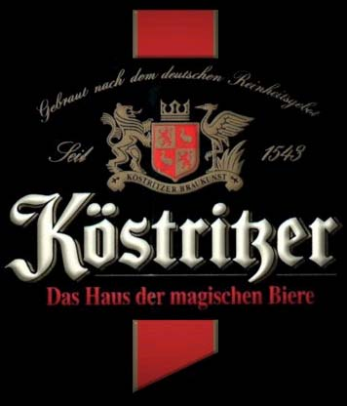

ACTION PROGRAMME OF THE EUROPEAN UNION
LEONARDO DA VINCI
PROJEKT NO.: 2002 LA 112 628 BILVOC
Language Competence Through
Bilingual Teaching at Vocational Colleges

Teaching Modules

Date of production 09/2005

Subject: catering

Topic: beverage technology

Title: beer

Target Group: any group of catering students (first year)

Prior Knowledge: the fermentation process

Level of Language Skills: waystage (A2)

Follow - Ups: wine

Objectives: beer at a glance

Benefits: definition beer, ingredients for brewing beer, styles of beer, serving and storing beer

Teaching Module: beer

Teaching Time  (experience) | Contents | Activities | Media | Skills
10 minutes  15 minutes  20 minutes  15 minutes  25 minutes  40 minutes  20 minutes  20 minutes  20 minutes  variation:  120 minutes | the fermentation process  definition beer and basic ingredients for brewing beer  how to produce cheaper beers or beers with various flavours  The German beer purity law  styles of beer  styles of beer  serving and storing beer  serving beer  evaluation  Fuller’s Brewery  (after the fermentation process until practical training serving beer) | brainstorming/ revision  check unknown words  Individual work (group work)  discussion  Individual work  lecture  discussion and tasting session  individual work  practicing in groups and presenting  evaluation of the content, way of learning  individual or group work for students with language skills above A2, presenting the information to the class | board  transparency/ worksheets  board  worksheet  board, transparency and  worksheets  worksheets, transparency  books in different languages, worksheets, dictionaries, internet  assessment sheets  dictionaries, glossaries, internet | classroom discussion  using dictionaries  giving exact explanations and reasons;  expressing and accepting objective criticism  translating skills, using dictionaries and glossaries  listening comprehension and note taking  note taking and tasting skills  finding information, using searching machines like www. google.com  practical skills (serving skills)  filling in the missing information  reading comprehension; presentation skills, summarising skills
185 minutes

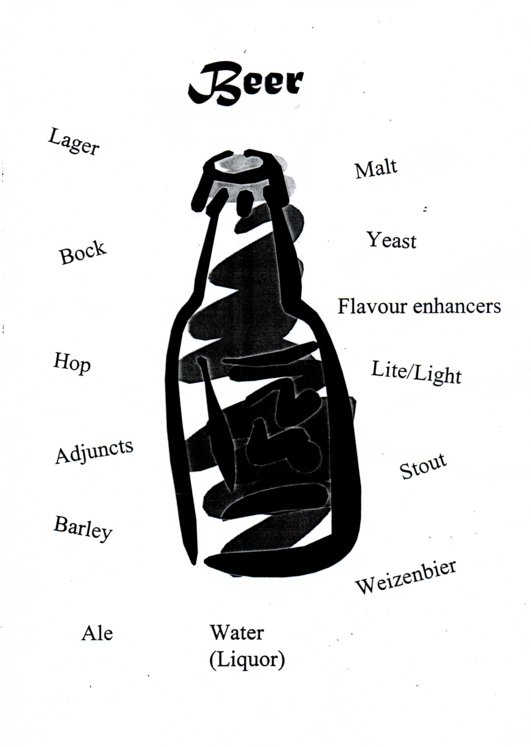

BEER

Beer is an alcoholic beverage produced by extracting raw materials with water, boiling (usuallywith hops), and fermenting. In some countries, beer is defined by law - as in Germany, where the standard ingredients, besides water, are germinated barley, hops and yeast.

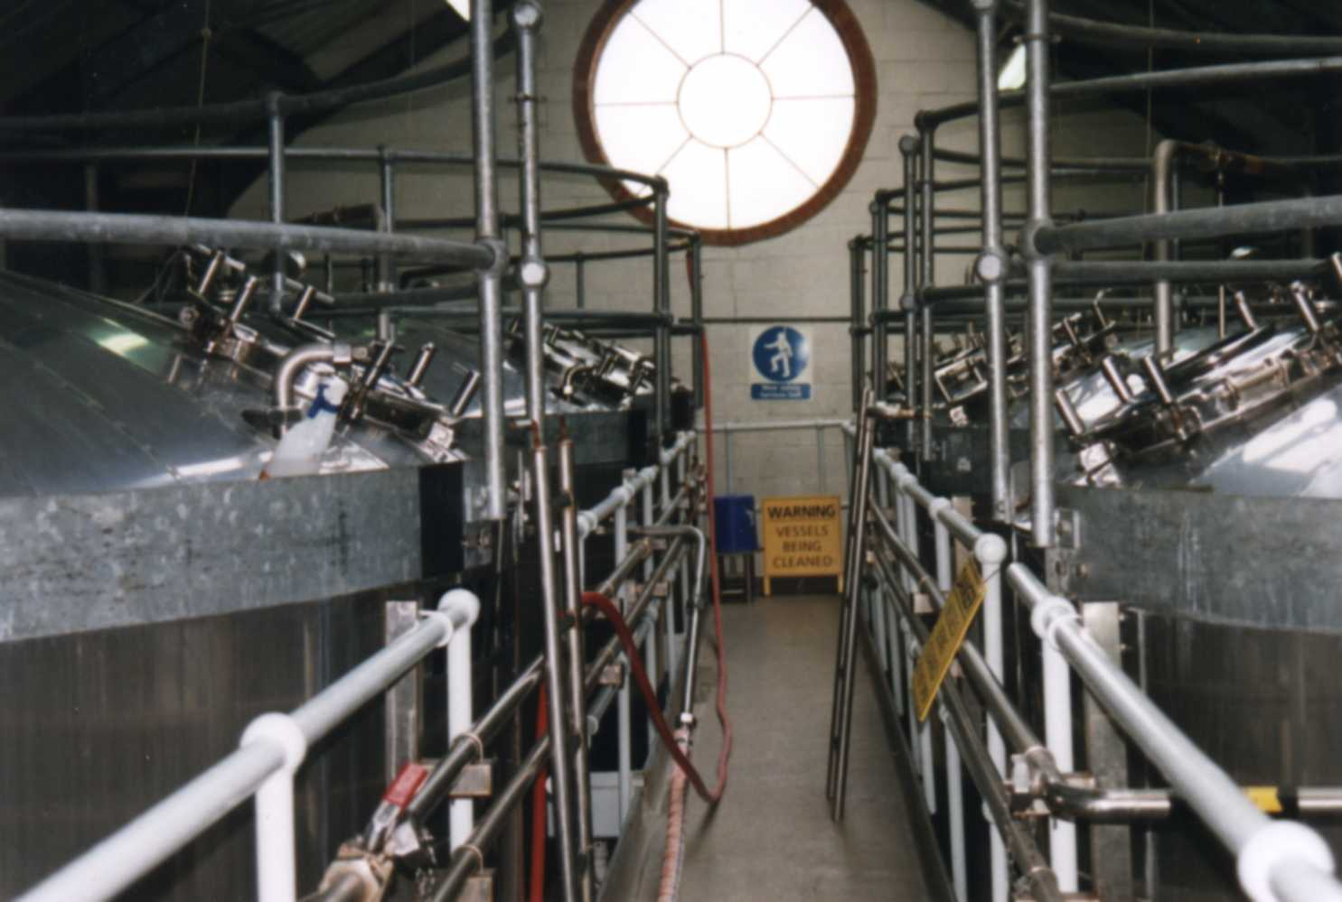

Basic ingredients for brewing beer

Water ( Liquor ): Its quality and mineral content directly affect the character of
the brew.
Malt: It is partially germinated , roasted grain that provides not only
the alcohol , but also much of the flavour and nearly all of the colour in a glass of beer .
Hop: It was originally added to the beer as a preservative .
It prevents the brew from going sour but also brings
a characteristic bitter flavour and aroma to the drink .
Yeast: Yeasts are living organisms . They are catalysts that
transform the hopped cereal solution
into a potent drink by consuming the sugar .
Alcohol and carbon dioxide are waste products of
the reproduction cycle of the yeast .
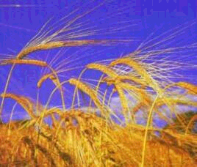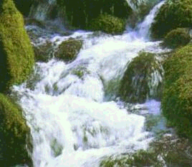

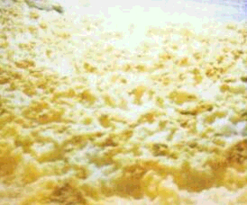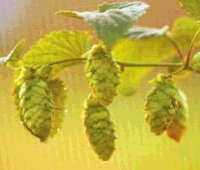

Other ingredients

Although the basic four ingredients - water , malt , hops , yeast - are all that you need to brew beer , many brewers add other substances to their recipes .

Adjuncts can be used to provide a cheaper substitute for part of the malt , or when malt is in short supply . The most common adjuncts are sugar , flaked maize , rice , torrefied wheat , malt extracts and roasted barley.

Flavour enhances are used to produce a distinctive flavour and aroma , for example honey , chilli , spices , herbs and fruit.

Using adjuncts or flavour enhances is not allowed for beers brewed in Germany because of the German beer purity law.

The German Purity law
The German beer purity law, the Reinheitsgebot, was first introduced in Bavaria in 1516 by Duke William JB and was only gradually spreading to the rest of the country this century.
The ruling – one of the world’s first consumer protection laws – insisted that beer should only be made from malt, hops and water (yeast was not at first mentioned, as its working was not understood).
It ensured that cheap adjuncts and sugars were not used, and that no beer was as wholesome as German beer. In 1987, the European Court ruled that the law was a trade barrier, preventing foreign beers from being imported. Although the German government could not stop beers which did not conform to the purity law crossing the border.
German brewers resolved to stick to the ruling. It was a wise decision, as drinkers voted with their glasses to stay loyal to their pure beer. The Reinheitsgebot is now seen as giving German beer a vital marketing edge in a competitive world.

Types of Beer

style | short definition | country | famous trademarks
Ale | top - fermented beer | England
Alt | bitter tasting beer ; produced in an ancient style of brewing  top - fermented | Germany  (near Düsseldorf) | Diebels
Berliner Weisse | a light sharply acidic wheat beer , low in alcohol , often served with a dash of green woodruff or raspberry juice | Germany  (Berlin) | Berliner Weisse
Bitter | draught ale , dry and hoppy | England
Black Beer | Strong - tasting , bitter chocolate lager | Germany | Köstritzer Schwarzbier
Bock | a strong malty beer of about 6,5 % alcohol , stronger versions are called Doppelbock (7,0 % alcohol) or Eisbock (10 % alcohol) | Germany | Paulaner Salvator  EKU 28
Brown Ale | a sweetish , bottled mild ale , dark in colour , low in alcohol | England | Newcastle Brown Ale
Export | former term for better quality beers - for selling abroad | Germany
Hefe | unfiltered top - fermented beer , yeast sediment in bottle | Germany | Schneider Weisse  Schöfferhofer Hefeweizen
Ice Beer | innovation of the 1990s , the beer is frozen during maturation to produce a purified beer and to increase the strengthen by removing the ice crystals | Canada  USA  Scotland | Bud Ice  Super Ice Tennent’s
Kölsch | looks like a lager , but fruity taste  top - fermented | Germany  ( Cologne )
Lager | golden , bottom - fermented beer  word derived from the German word “to store“
Lambic | a unique sour beer , produced by spontaneous fermentation  ( wild yeasts )  sometimes fruit is added to create  Framboise ( raspberry ) or Kriek ( cherry ) beers | Belgium | Bellevue Geuze  Chapeau Tropical Lambic  Timmermans framboise Lambic
Lite/Light | low - calorie beer  low - alcohol beer  ( 2,5 % alcohol ); alcohol - free beers ( 0,5 % alcohol ) | USA  Australia | Miller Lite
Pilsner | golden , hoppy aromatic lager first brewed in Plzen  ( Czech town ; German name : Pilsen ) | predominant lager  in Germany | Pilsner Urquell  Jever Pilsener , ...
Porter/Stout | a strong brown top-fermented ale | Ireland  England | Guinness
Real Ale | a traditional cask-conditioned  beer; continues to mature in  the pub cellar; is not filtered  or pasteurized | England
Roggen | rye beer | Austria  Germany
Weisse or Weizen | a pale, often cloudy wheat beer; have become popular  summer refreshers;  top-fermented; other brews are Kristall, Weizenbock, Dunkelweizen; in Berlin / Germany a lighter and sourer style of wheat beer is produced | Germany | Erdinger  Schneider Weisse  Berliner Weisse

Additional material

Fuller’s Brewery
London, GB
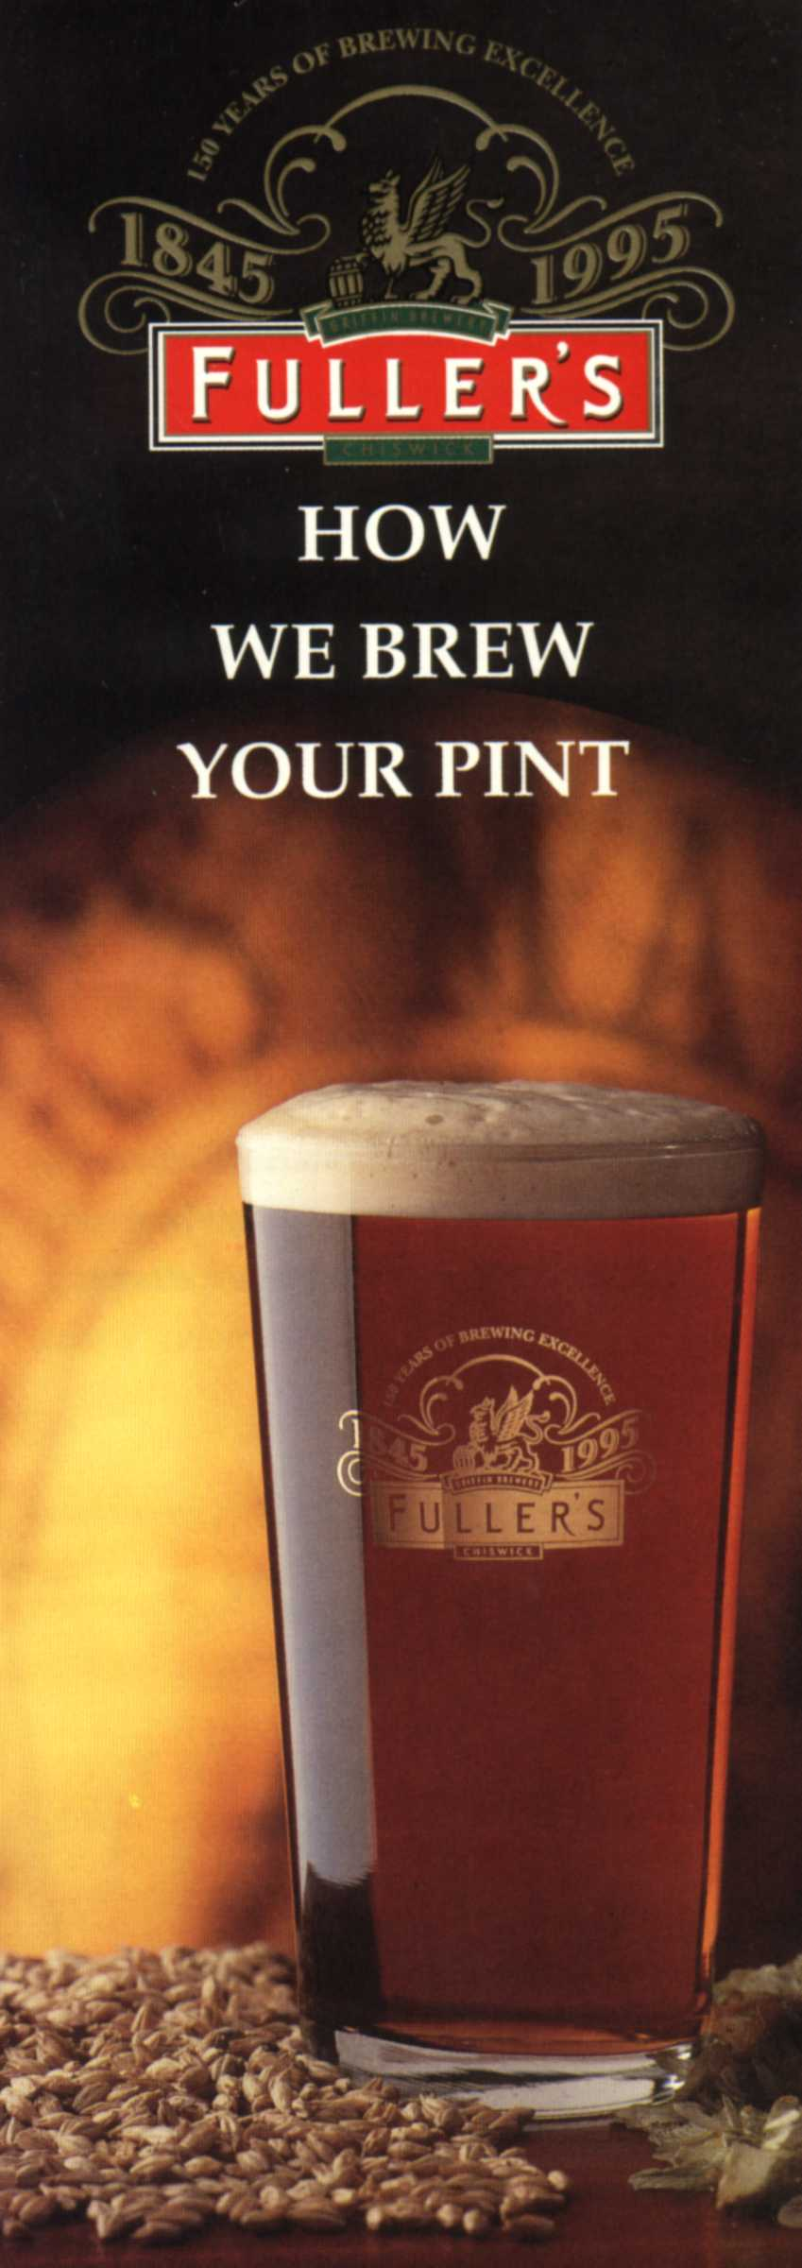
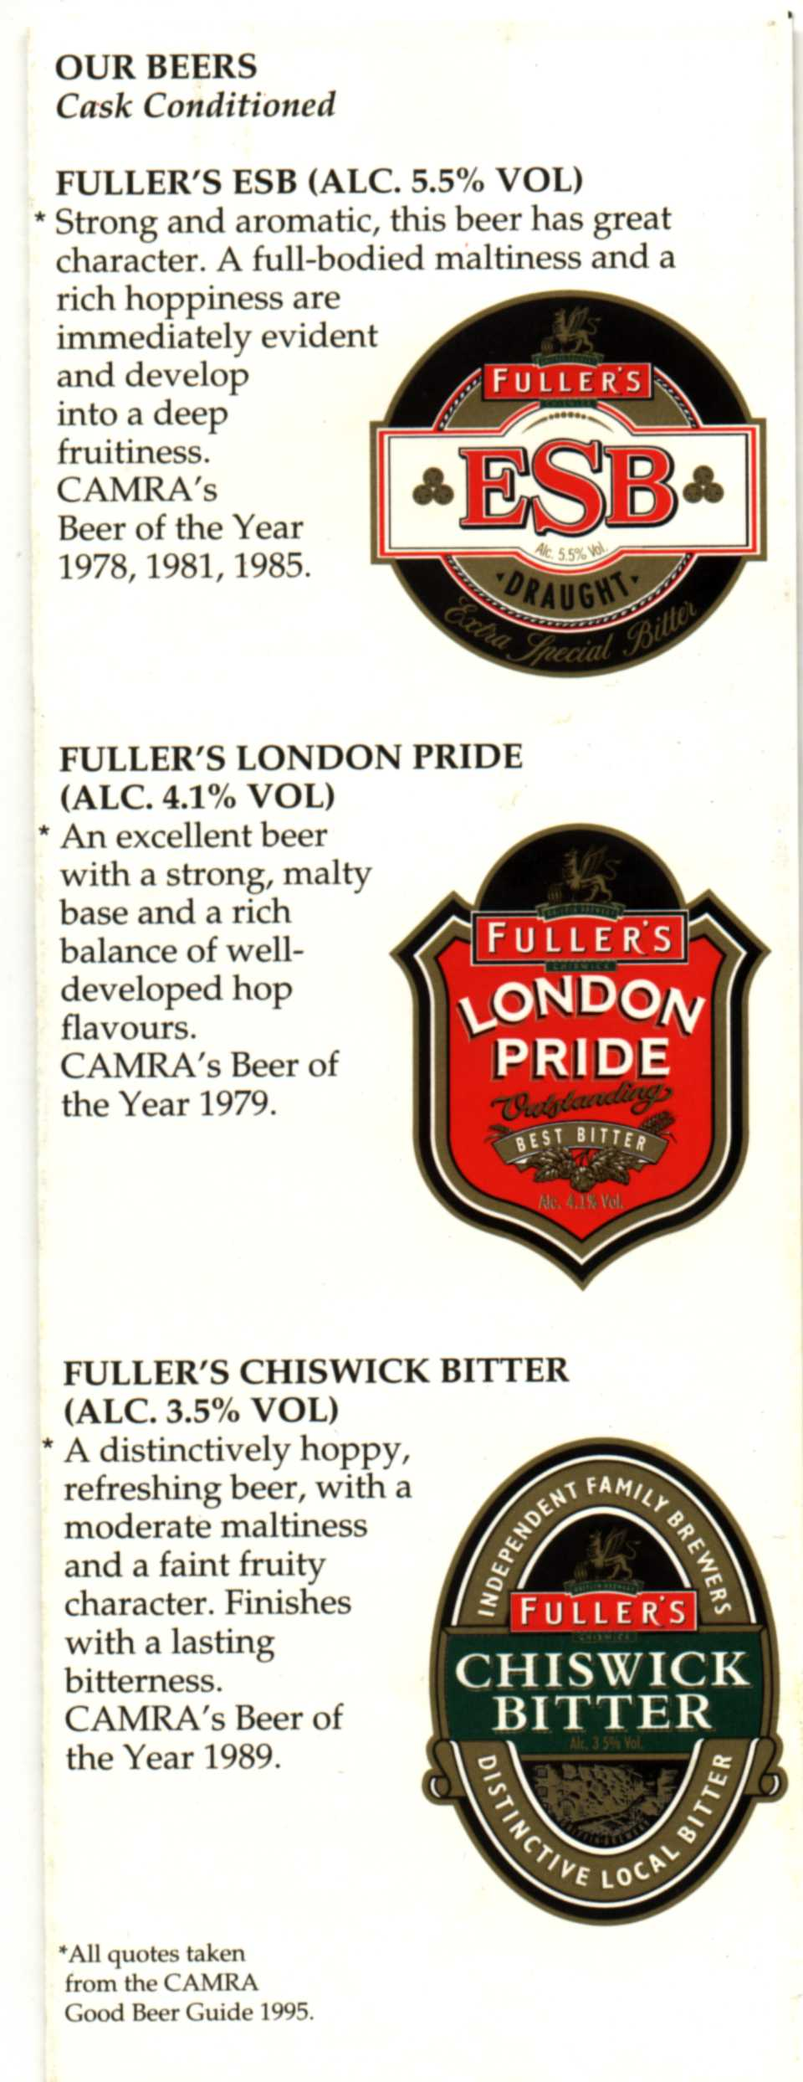

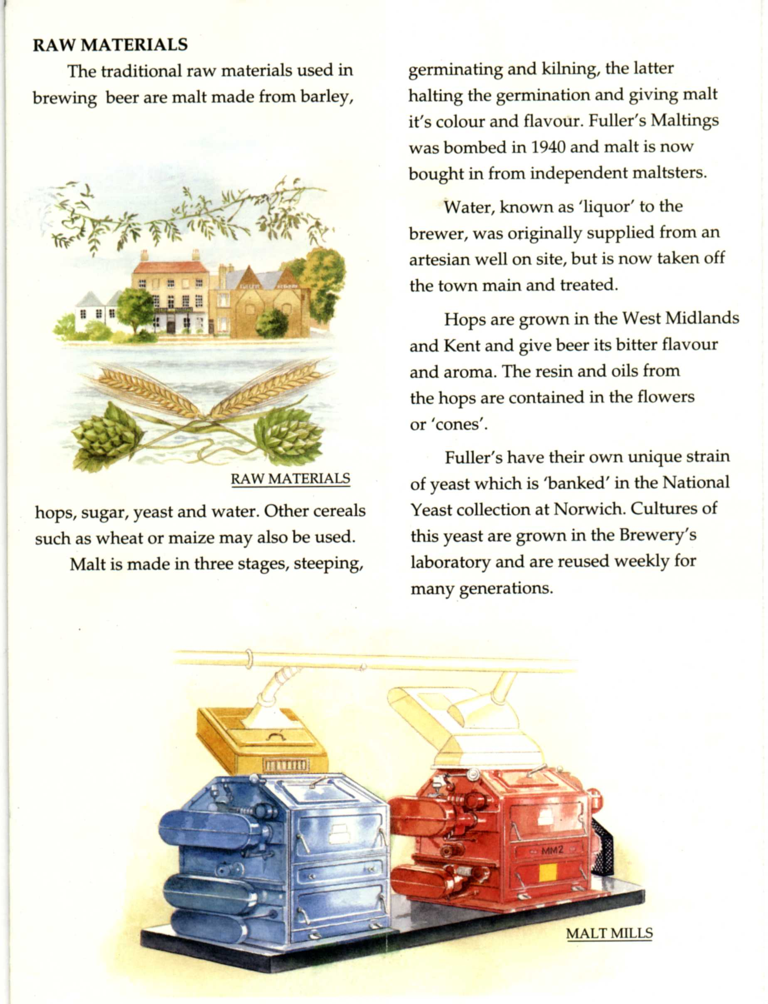

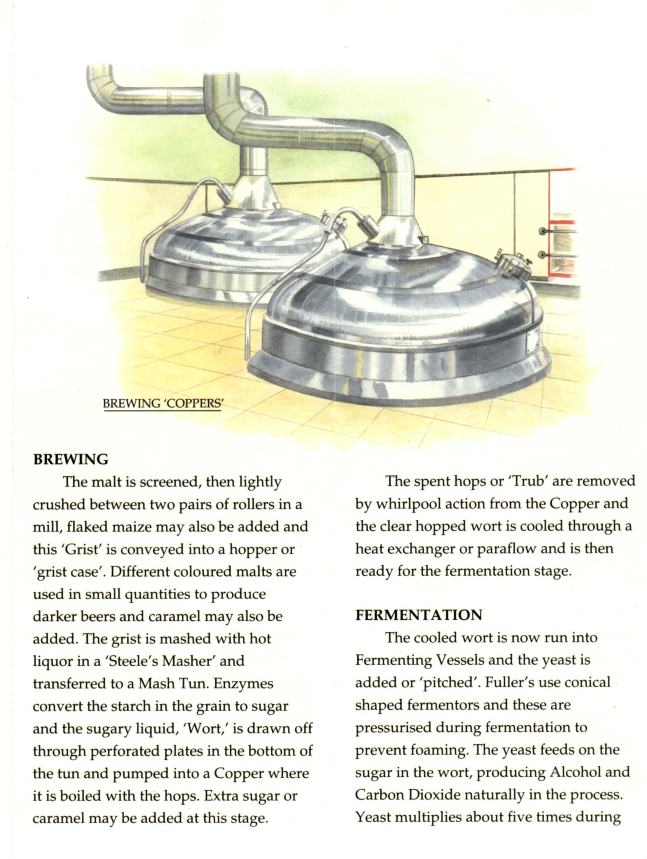

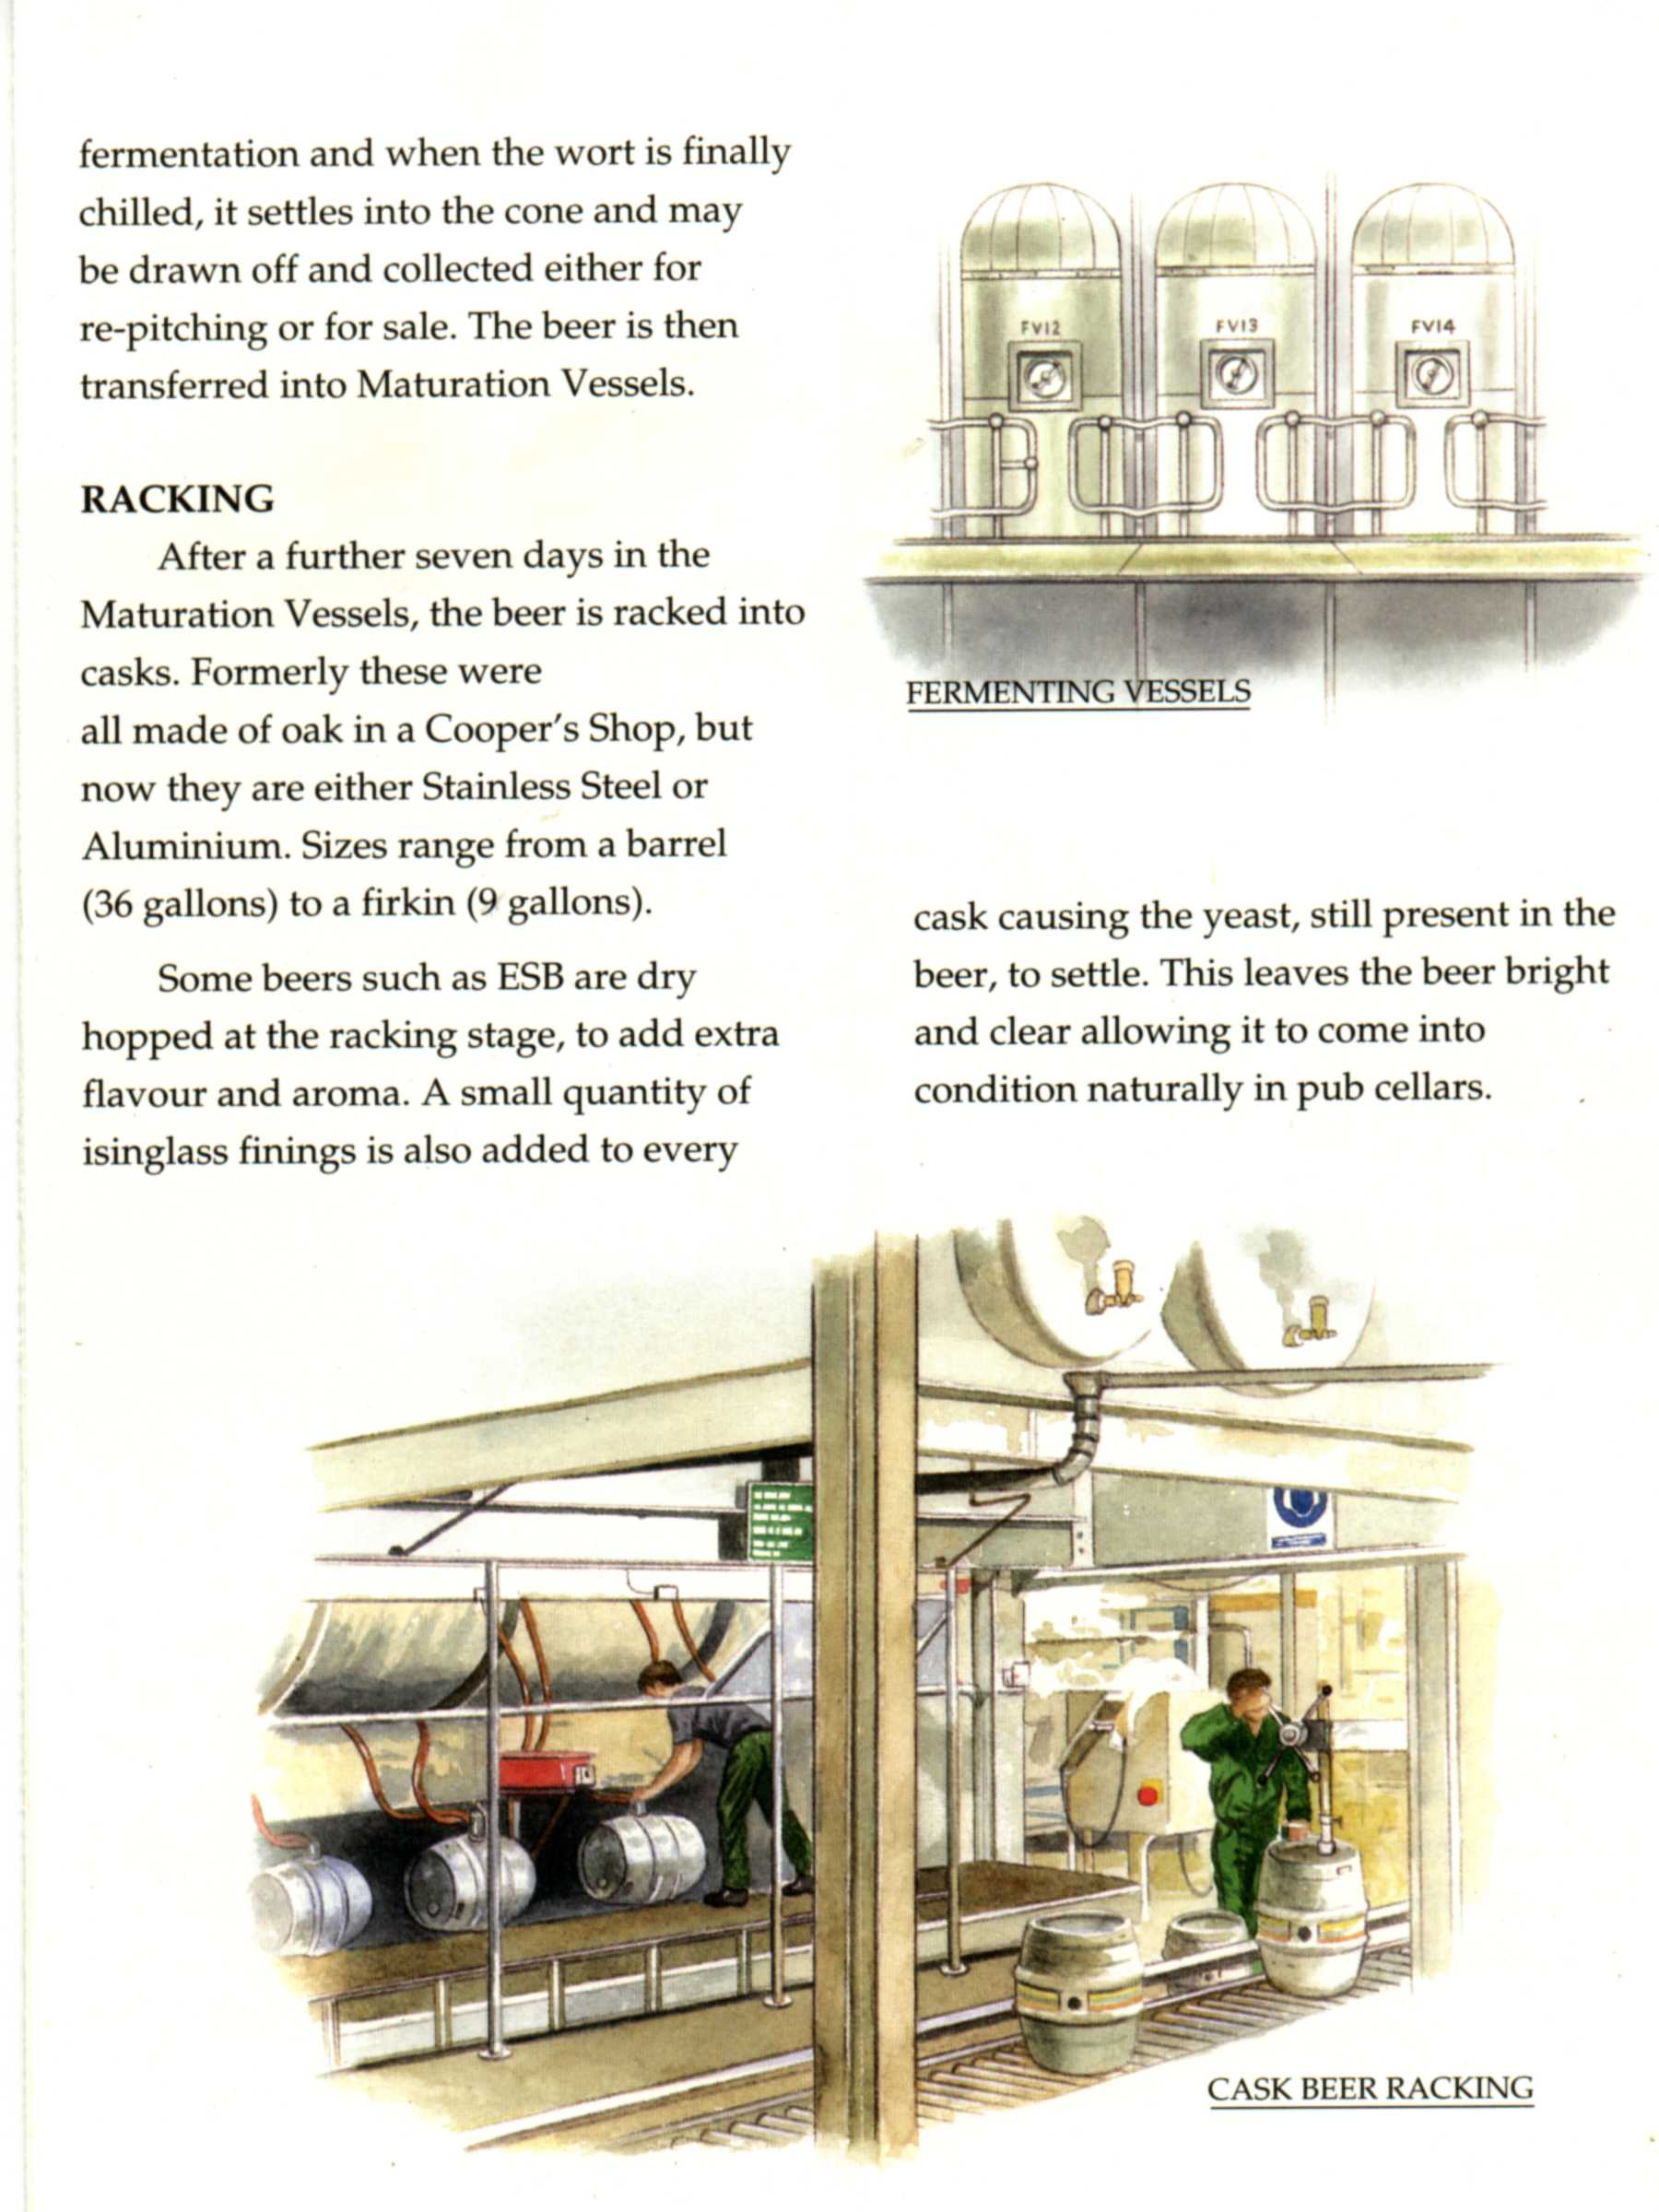

Exercises

A Have a look at the front page. Are you able to translate all terms in your
mother tongue as well as to give short definitions of them in English?

B Match the parts of sentences together.

Malt influence on the colour of the beer.
has the Pilsner the blonde colour.
Yeast makes minerals to the beer.
gives the beer bitter.
Hop is needed for the fermentation.
are the beer the strength.
Water important for the alcohol content.

C Explain the function of adjuncts and flavour enhancers.
Give at least 3 examples for each.

D What is the main information of the German Purity Law?

Test

A What is beer? 2pts.

B What are the basic ingredients for brewing beer? 2pts.

C What kinds of other ingredients are also usable for brewing? 2pts.

D What is the main information of the German purity law? 2pts.

E Name 4 styles of beer. 2pts.

Useful links for more information

www.amstel.nl
www.bassale.com
www.realbeer.com
www.blackstarbeer.com
www.labatt.com
www.budweiser.com
www.hopnotes.com
www.creamcitysuds.com
www.fostersbeer.com
www.grolsch.com
www.paulaner.com
www.heineken.com
www.leinie.com
www.millerbeer.com
www.molson.com
www.icehouse.com
www.shiner.com
www.köstrizer.com
www.Sternquell.de
www.goesser.com
www.becks.com
www.watzdorfer.de
www.apoldaer.de

Wordlist | Beer
English | German
A
adjuncts | Zusätze
affect | beeinflussen
ale | Ale
aroma | Aroma, Geschmack
B
barley | Gerste
basic | grundlegend
be in short supply | knapp sein
boil | kochen
bottom fermentation | untergärig
brew | brauen, Bräu
C
can | Blechdose
carbon dioxid | Kohlenstoffdioxid
casks | Fässer
catalyst | Katalysator
cereal | Getreide
cloudy | trüb
common | gewöhnlich
consume | aufnehmen/verzehren
content | Inhalt
craft | Handwerk
crushed | ge-/zermahlen
D
defined | definiert
devise | planen
distictive | unterscheidend
dominant | vorherrschend
dry | trocknen
E
ensure | sichern
equipment | Ausrüstung/Ausstattung
extracting | herauslösen
F
fermenting | Gären
filtered | gefiltert
flavour | Aroma
flavour enhancers | Aromazusätze
G
gefroren | frozen
German Purity Law | Deutsches Reinheitsgebot
germinate | keimen
grain | Getreide/ Korn
H
herbs | Kräuter
hops | Hopfen
I
ingredients | Zutaten
L
lager | Lager
liquor | Wasser
Lite\Light | leicht
M
maize | Mais
malty | malzig
maturation | reifen
matured | ausgereift
mechanization | Mechanisierung
mention | erwähnen
microorganisms | Mikroorganismen
O
occupation | Tätigkeit\Beschäftigung
overflow | überlaufen
P
package | Verpackung
pasteurized | haltbargemacht
potent | alkoholhaltig
preservative | Konservierungsmittel
preserve | konservieren
prevent | abhalten
provide | versorgen
pure-culture | Reinkultur
purify | reinigen\läutern
R
raw | roh
recipe | Rezept,
refresh | erfrischen
remove | entfernen
reproduction cycle | Reproduktionskreislauf
resolve | beschließen
rise | aufsteigen
rye | Roggen
S
sediment | Bodensatz
sharply | scharf/spitz
skimmed | abgeschöpft
solution | Lösung
spices | Gewürze
spontaneous | spontan
stainless steel | Edelstahl
stick to | beibehalten
stout | Stout
strength | Stärke
substitute | Ersatz
surface | Oberfläche
T
top | Oberfläche
top fermantation | obergärig
transfer | Übertragung
transform | verändern
V
vessel | Kessel
W
waste | Abfall
woodruff | Waldmeister
Y
yeast | Hefe

