Bilingualer Fachunterricht an berufsbildenden Schulen

Unterrichtsmodul

Berufsfeld: Elektrotechnik

Beruf: Elektroniker

Introduce, tools and practice for electrical engineers

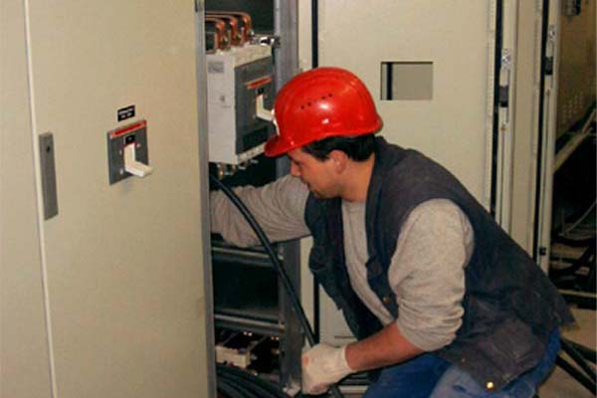

ACTION PROGRAMME OF THE EUROPEAN UNION
LEONARDO DA VINCI
PROJEKT NO.: 2002 LA 112 628 BILVOC
Language Competence Through
Bilingual Teaching at Vocational Colleges

Teaching Modules

Date of production 09/2005

Subject: Electrical technology

Topic: basic for bilingual teaching

Title: Introduce, tools and practice for electrical engineers

Target Group: Any group of electrical engineering students

Prior Knowledge: Basic of electrical engineering

Level of Language Skills: Waystage (A2)

Follow - Ups: Experiments on safety precautions

Objectives: Importance of precautions

Benefits: The danger of electricity and protection from
electric shock

Teaching Module: electrical installation

Teaching Time  (experience) | Contents | Activities | Media | Skills
45 minutes  90 minutes  45 minutes  180 minutes  45 minutes  45 minutes | 1. Welcome and Introduction  2. Education and Curriculum Vitae  3. Introducing people  4. Tools and practice for electrical engineers  5. Saying Numbers  evaluation | Discussion with the student  about the worksheet  Work out the contents in 3 groups,  Group presents the  summarised contents  Individual work  Information given by the teacher  Discussion with the student  about the worksheet  Discussion with the student  about the worksheet  evaluation of the material  Write definitions | Board, worksheet  dictionary  transparency  worksheet  Board, transparency and  worksheet  transparency  transparency  paper | Questions and answers and  classroom discussion  working independently  giving exact explanation expressing and accepting objective criticism  Questions and answers;  classroom discussion  Questions and answers;  classroom discussion
450 minutes

1. Welcome and Introduction

Crossword - Welcome –

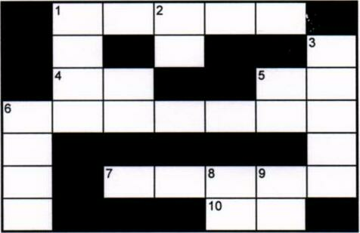

ACROSS:
1 Is this the English ............?
4 Excuse........
5.......... Mark. I'm Sandra.
6.......... to this English class.
7 .......... your name on a piece of paper
10 Welcome………….. this class.

Down:
1 "Is this the English class?" • "Yes, it is........... in."
2 You can get the book............ most bookshops.
3 Write your name on a...................... of paper.
6 See you next...............
8 Fold the piece of paper and place....... in front of you.
9 Welcome.......... Jena.

Can you say it in English

- Begrüßen Sie Ihren Kollegen (Nick Parker) aus Leeds.

....................................................................................................................................................
.................................................................................................................................................
...................................................................................................................................................
- Stellen Sie Ihre Kollegen Klaus Müller und Peter Huber vor.

................................................................................................................................................
..............................................................................................................................................
..................................................................................................................................................
3. Fragen Sie Ihren Gast: "Hattest du eine gute Reise?"

..........................................................................................................................................
............................................................................................................................................
...................................................................................................................................................

- Ich möchte mich vorstellen ......................................................................................................................................
....................................................................................................................................
......................................................................................................................................

Crossword - Introduction –

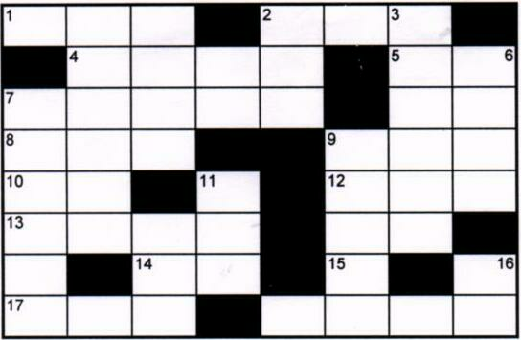

Across:
1 Where are...... from?
2 Oh, are you .......? Welcome to the class.
4 There's a seat………….. there.
5 Fold the piece of paper and place it..... front of you.
7 Sandra is over..........
8....... are you?
10 You can get the book............ most bookshops.
12 Have you ..... a ring binder
13 It's................. to see you again.
14 Come ......in.
15..... am from Dublin.
17...... you next week
18 What's your name ? My name is..................

Down:
3 Shall we shut the..................................?
6 See you ...............Tuesday.
7 "How are you?" I'm fine,.................."
9 Nice to see you ..............
11 I've got a notebook and a ........
16 Shall....... shut the window ?
18 I've got... notebook.

2. Education and Curriculum Vitae
How do the British schools compare to German Schools

Hochschule University
Fachschule Technical school or Commercial school
Fachoberschule College of Further Education
Berufsschule Vocational school
Gymnasium Secondary school "A" Level or Grammar
Gesamtschule Secondary school
Realschule Secondary school
Hauptschule Secondary school
Grundschule Primary school

A new job
You will be looking for a new job.
You will work in England.
You must write a curriculum vitae.

Curriculum vitae

Paul Christopher Welch

Photo
10 Rugby Road
Brighton, Sussex
0273-551977

born 16 September 1973. London
Parents Thomas and Patricia (Parker)
Education St Paul's Primary school 1985 - 1993
Cromwell Secondary school Brighton 1993 - 1997
Hove College of Further Education 1997 - 2000
Qualifications National Certificate in electronics June 2000

Special Training Evening and weekend courses in computing and information technology
References

Brighton, August 2000

Talking about family and profession

Introduction: My name is………………………........................
I come from……………………………................
I live in....………………………………................
(zip-code, city; street)

May I introduce (myself) Mr./Mrs.………………………………….. to you.
This is Mr./Mrs. from ............................................

Greetings: Hello,....................... Nice to meet you. Hi....................................
Good morning / afternoon / evening
Nice to see you (again).
Goodbye ! bye; bye-bye See you later! (See you) See you next………………….!

Questions: Where are you from ? What's your address ?
What's your job (profession) ? What do you do for a living ?
Where do you live ? Where do you work?
How are you (feeling) ?

3. Introducing people

Here are the people who work in a small company in Bristol:
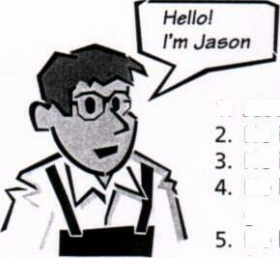
- Jason is an electrician.
- He is 1.80 m tall.
- He is 40 years old and single.
- He likes hamburgers, discos, going out, flirting, and rugby. He hates rap music but loves funky stuff.

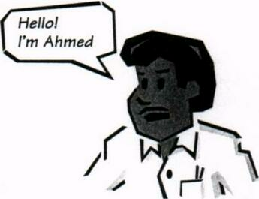
- Ahmed is a mechanic.
- He is 1.87 meters tall.
- He is 25 years old and married.
- He has a son and two daughters.
- He likes kebabs, big cars, karate and soccer.
- He loves pop songs and hates
heavy metal.

- Rick is a trainee.
- He is 1.75 meters tall.
- He is 17 years old and has a nice girl-friend.
- He likes coke, hamburgers, motorbikes, American football, wrestling, and beer.
- He dislikes pop but enjoys punk and house music.
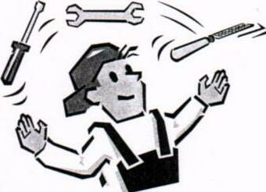

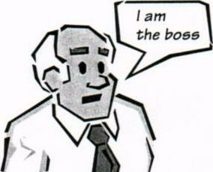
- Duncan is the boss.
- He is very tall.
- He is 58 years old, married and has three children.
- He likes hard work and has no time for sports. His job is his life.
- He sometimes listens to classical music.

What’s your job? How tall are you? How old are you? What do you like?
………………………………………………………………………………………………………………………………………………………………………………………………………………………………………………………………………………………………………………………………………………………………………………………………………………………………………………………………………………………………………………………………………………………………………………………………………………………………………………………………………………………………………………………………………………………………………………………………………………………………………………………………………………………………………………………………………………………………………………………………………………………………………………………………………………………………………………………..................
……………………………………………………………………………………………………………………….....................................................................................................................................
……………………………………………………………………………………………………………

4. Tools and practice for electrical engineers
Tools A tool kit
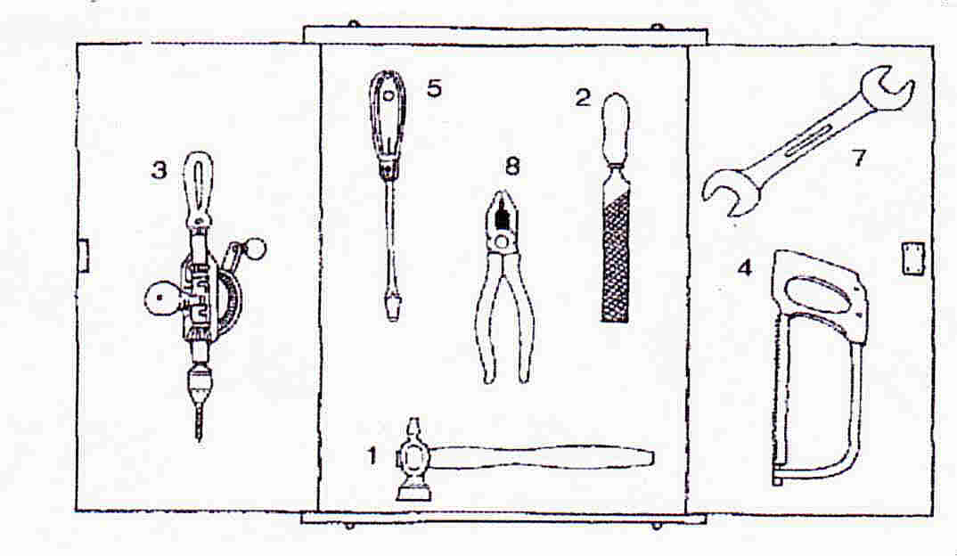
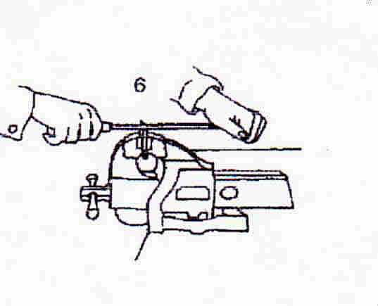

1a hammer 2 a file
3 a drill 4 a saw
5 a screwdriver 6 a vice
7 a spanner/wrench 8 a pair of pliers

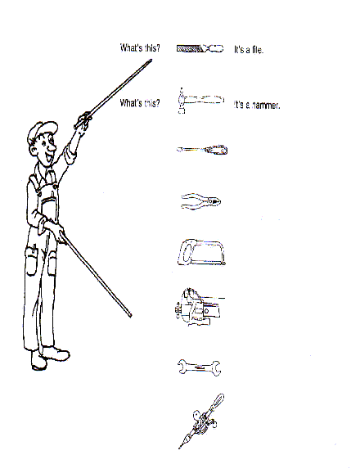

TOOLS – and how to work with them

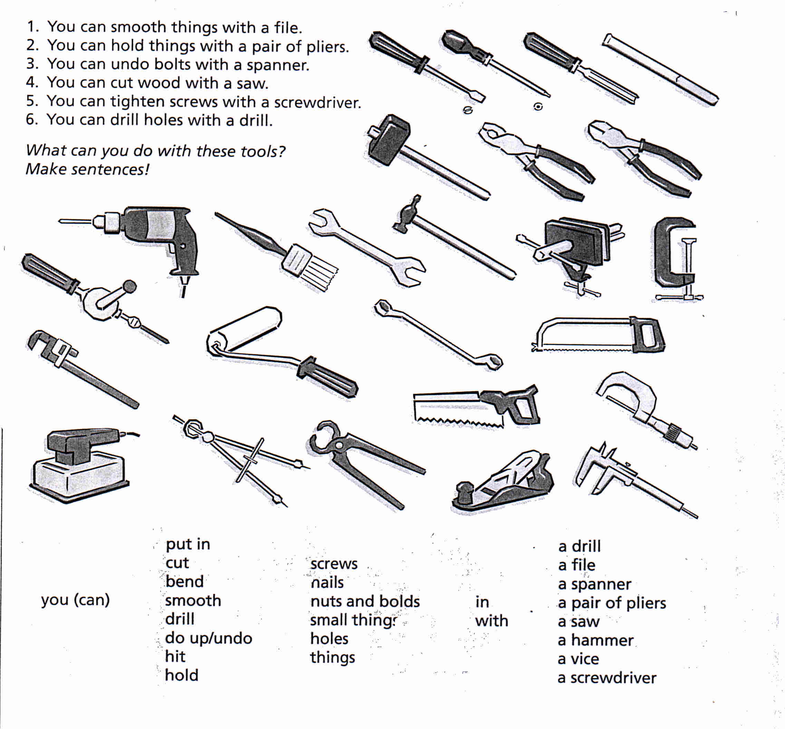

………………………………………………………………………………………………………………………………………………………………………………………………………………………………………………………………………………………………………………………………………………………………………………………………………………………………………………………………………………………………………………………………………………………………………………………………………………………………………………………………………………………………………………………………………………………………………………………………………………………………………………………………………………………………………………………………………………………………………………………………………………………………………………………………………………………………………………………………………………………………………………………………………………………………

TOOLS - and how to work with them
Complete this list.
Tools Job Verbs
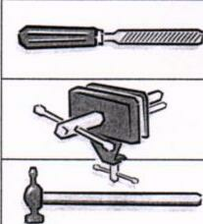
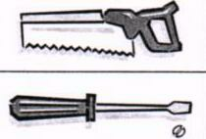
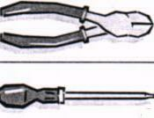

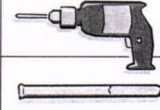

Use the information given to produce questions and small sentences like these:
1. Who uses a file? A mechanic uses a file to smooth rough objects.
2. What can you do with a hammer? With a hammer you can drive nails in.
3. Which tools does a joiner use? A joiner uses a mallet for woodwork.
4. What is a clamp used for? A clamp is used for holding things.

………………………………………………………………………………………………………………………………………………………………………………………………………………………………………………………………………………………………………………………………………………………………………………………………………………………………………………………………………………………………………………………………………………………………………………………………………………………………………………………………………………………………………………………………………………

Tools and jobs

Form the sentences this way!
A joiner cuts wood with a saw.
A plumber drills a hole in the pipe.
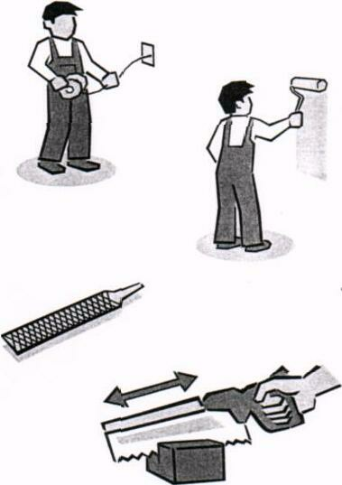
A painter paints ...................................................…….....
A tailor cuts ......................................................……….....
An electrician bends .........................................……….....
A car mechanic repairs ......................................………....
A technical draughtsman ...................................………...
A carpenter ..........................................................………..
With a file you can ..............................................………...
With a pair of pliers you can ..............................………....
With a hammer you can .....................................….......…

to switch off

to press
to push
to pull
to hold
to tighten
to loosen
to plane
to fill
to empty
to switch on
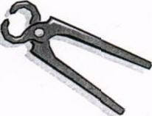
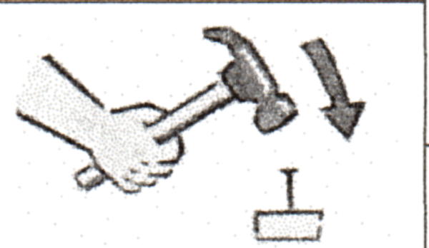

01. The drivers.........................the brake.
02. When I come home l.......................the television.
03. If you want to open the door of the car,
you must................... the handle.
04. If you like your girl-friend you ..................... her tight,
05. If the wood is too rough you.............................it.
06. When leaving the room you must...............the light.
07. At the end of the party you must............. the ashtray
08. Before working with an electric drill
you must............................................. the chuck.
09. Before changing the wheel, you must...........the nuts.
10. To open a can of coke, you .......... ring

Here are some more tools.
Write under each drawing the name of the tool and the job in which it is used.
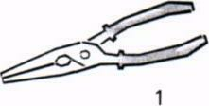
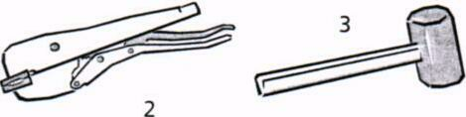
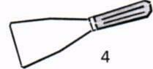

Form sentences like this:
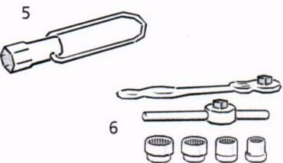

1. A mechanic uses pincers for twisting wires.
2...........................................................................
3..........................................................................
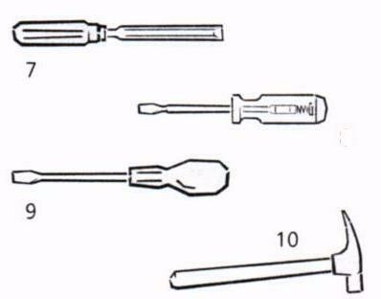
4...........................................................................
5...........................................................................
6...........................................................................
7...........................................................................
8...........................................................................
9............................................................................
10...........................................................................

Write down the correct English term. | Put in the job in which in tool.
01. Steinmeißel ..........................................................

02. Stechbeitel............................................................

03. Holzhammer........................................................

04. Zange....................................................................

05. Gripzange............................................................

06. Spannungsprüfer ................................................

07. Schraubendreher..................................................

08. Steckschlüssel ......................................................

09. Vierkantschlüssel.....................................'.............

10. Maurerhammer..................................................

11. Universalschlüssel ..............................................

TOOLS and JOBS -working with an electric drill
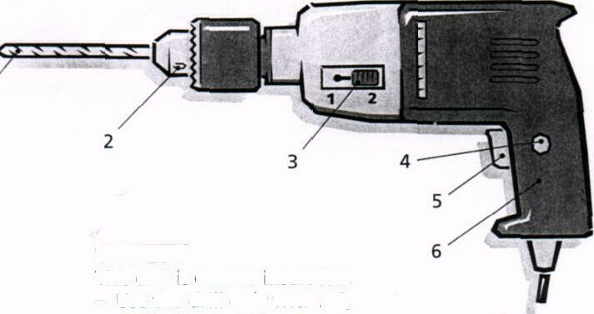

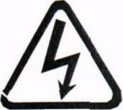
SAFETY
This drill is insulated twice.
Use the drill only with AC, correct voltage is 240. AC
Don't use the drill in wet places. DC
The cable must be in perfect condition.

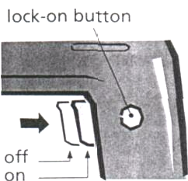
TRIGGER SWITCH
To work with the drill, you pull the trigger to pull
switch in the drill handle. For continuous to release
operation you pull the trigger switch and to operate
press the 'lock-on-button' at the side of
the switch. To stop continuous operation you only pull the trigger switch and release it afterwards.

.

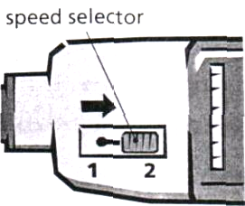
TWO SPEED SELECTOR
The drill has two speeds (1200 r.p.m. to select
and 3000 r.p.m.).
These are called high speed and low speed. To select the correct speed you push the switch in to position 1 or at the side of the drill.

LOOSENING in to THE CHUCK
Only use the correct chuck key. Put to tap
the chuck key in the chuck. Turn the to tighten
key anti-clockwise. If the key is tight, to loosen
tap the key with a small hammer.
To tighten the chuck again, turn the key clockwise.
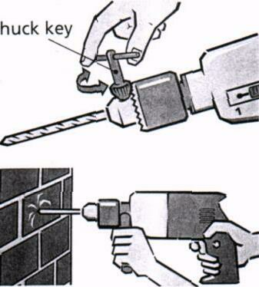

DRILLING
metal - use lubricant
wood - mark point of hole first, low speed
stone - use firm pressure, remove dust

Finish the sentences.

1. To operate the drill, pull........................................................................................
2. To select high speed,................................................................................. .........
3. To loosen the chuck...............................................................................................
4. For continuous operation .....................................................................................

Answer the questions.
- What does the trigger switch do?
………………………………………………………………………………………………
- How many speeds does it have?
……………………………………………………………………………………………
- What is the correct voltage for this drill?
……………………………………………………………………………………………
- Can it drill iron and steel?
……………………………………………………………………………………………
- When do you use high speed and when low speed?.
………………………………………………………………………………………………
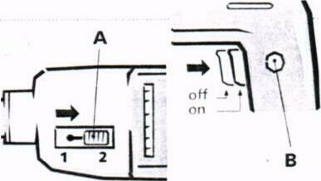
- What switches are A and B and what are they used for?
……………………………………………………………………………………………..

Right or wrong? | YES | NO
1. You can use the drill with AC and DC current.

2. To stop continuous operation you tap the trigger with a hammer.

3. It is possible to use the drill when it is wet.

4. You turn the key clockwise to loosen the chuck.

5. The correct voltage is 110 volts.

6. To tighten the chuck you use a chuck key.

7. To operate the drill you press the trigger switch.

8. You must use high speed for small holes.

9. When drilling stone press very hard.

5. Saying Numbers

1. NUMBERS
1 one 11eleven
2 two 12 twelve
3 three 13 thirteen
4 four 14 fourteen
5 five 15 fifteen
6 six 16 sixteen
7 seven 17 seventeen
8 eight 18 eighteen
9 nine 19 nineteen
10 ten 20 twenty
21 twenty-one 200 two hundred
22 twenty-two 220 two hundred and twenty
23 twenty-three 1,000 a / one thousand
30 thirty 1 ,000,000 a/one million
40 forty 3 ,520,000 three million five
50 fifty hundred and twenty thousand

2. OH, Zero, Love, Nought, Nil !

The above are all ways of saying 0 in English.

We say oh after a decimal point 5.03 five point oh three
in telephone numbers 670138 six seven oh one three eight
in bus numbers No. 701 get the seven oh one
in hotel room numbers Room 206 I` m in room two oh one
in years 1905 nineteen oh five

We say nought before the decimal point 0.02 naught point oh five

We say zero for the number 0 the number zero
For temperature - 5º C five degrees below zero

We say nil in football scores 5 – 0 Spain won five nil

We say love in tennis 15 – 0 The score is fifteen love

Now say the following:

- The exact figure is 0.002.
- Can you get back to me on 01244 249071 ? I’ll be here all morning.
- Can you put that on my bill ? I’m in room 804.
- Do we have to hold the conference in Reykjavik ? It’s 30 degrees below 0 !
- What’s the score ? 2 – 0 to Juventus.

- THE DECIMAL POINT

In English, we use a point ( . ) and not a comma ( , ) for decimals. We use commas in figures only when writing thousands.

10, 001 is ten thousand and one

10.001 is ten point oh oh one

When accounts are prepared on computer, commas
Are not used. The number appears as 82103

In English all the numbers after a decimal point are read separately:

10.66 ten point six six Not ten point sixty six

  - naught point three two five

0.001 naught point oh oh one or 10⁻³ , ten to the power minus three

You will also hear people say:

0.05 zero point oh five or oh point oh five

But if the number after the decimal point is a unit of money, it is read like a normal number:

£ 12.50 twelve pounds fifty DM 2.95 two marks ninety five

- PER CENT

The stress is on the cent of per cent ten percent.

Notice the following when talking about interest rates:

0.5 % a half of one per cent

0.25% a quarter of a percentage point

- HUNDREDS, THOUSANDS, AND MILLIONS

In British English you hear: a hundred and twenty three

In American English you usually hear: a hundred twenty three

The number 1,999 is said: one thousand nine hundred and ninety nine

The year 1999 is said: nineteen ninety nine

The year 2000 is said: the year two thousand

The year 2001 is said: two thousand and one

The year 2015 is said: two thousand and fifteen or twenty fifteen

- SQUARES, CUBES, AND ROOTS

10² is ten squared.

10³ is ten cubed.
$$\sqrt{6}$$
is thee square root of 6.

- TELEPHONE AND FAX NUMBERS

We usually give telephone and fax numbers as individual digits:

01273 736344 oh one two seven three, seven three six, three four four

  - can also be said as three double four

44 26 77 double four, two six, double seven

- can be said as seven double seven, or seven seven seven
- FRACTIONS

Fractions are mostly like ordinal numbers (Fifth, sixth, twenty third etc ):

a third a fifth a sixth

Notice, however, the following:

a half a quarter three quarters

three and a half two and three quarters

- CALCULATING

Remember to pronounce the s in equals as /z/. It is singular; the part on the left equals the part on the right.

10 + 4 = 14 ten plus four is fourteen
ten and four equals fourteen

10 – 4 = 6 ten minus four is six
ten take away four equals six

10 x 4 = 40 ten times four is ( or equals) forty
ten multiplied by four is forty

10 : 4 = 2 ½ ten divided by four is two and a half

+ = add - = subtract (or deduct) x = multiply : = divide

For most purposes these units are too large for use in low-power electronic circuits. The following symbols and prefixes are used:

Symbol Prefix Multiplier

M mega one million 10⁶

k kilo one thousand 10³

m milli one thousandth 10⁻³

μ micro one millionth 10⁻⁶

n nano one thousand millionth 10⁻⁹

p pico one million millionth 10⁻¹²

Review
How many of the following can you say aloud in under 1 minute ?

  - 234,567
  - 1,234,567,890
  - 1.234
  - 0.00234 %
  - 3.14159
  - $19.50
  - £7.95
  - 19,999
  - 1,999 years
  - In 1999
  - I think the phone number is 01227-764000
  - Have you got a pen ? Their fax number is: 00 33 567 32 49
  - Please pay it into my account-number G4.744.440
  - He was born in 1905 and died in 1987
  - It’s a white Lamborghini Diablo, registration number MI 234662, and it look as if it’s doing 225 kilometers an hour !
  - 30 x 25 = 750
  - 30 + 25 = 55
  - x² + y³ = z

