Bilingual Teaching at Vocational Colleges

Sample Module

Vocational Qualification: Business and Administration

Degree: Business College Graduate

Bothnia.net
Web Magazine


Produced at: Raahe Business College, Merikatu 2, FIN-92 100 Raahe, Finland
For: LEONARDO PILOT PROJECT (supported by the European Union)
“Bilingual Teaching at Vocational Colleges” BILVOC

ACTION PROGRAMME OF THE EUROPEAN UNION
LEONARDO DA VINCI - PILOT PROJECT
PROJECT NO.: 2002 LA 112 628 BILVOC
BILINGUAL TEACHING AT VOCATIONAL COLLEGES

Teaching Module

Date of production October 2005

Subject: Bothnia.net, autumn 2005

Title: Web magazine

Topic: Designing, writing and editing a web magazine

Target Group: Students in Vocational Business Studies

Prior Knowledge: Basic skills in using Windows, basics of photo editing,
writing in Finnish and English

Level of Language Skills Intermediate (B1, B2)

Follow-Ups: Producing and updating web sites in companies

Objectives: The students will be able to take advantage of IT technology and produce material to be published in the Internet.

Benefits: The students know how to find information and produce
their own articles and photos and also follow the regulations concerning the copyright law. They improve their team work skills and learn to keep to the given schedule. The magazine makes it possible for the students to co-operate with other students in the Bilvoc Leonardo project.

Authors: Aho, Satu
Koivu-Junnila, Marjatta
Putro, Eira
Viitanen, Roy

Produced at: Raahe Business College, Merikatu 2, FIN-92 100 Raahe, Finland
For: LEONARDO PILOT PROJECT (supported by the European Union)
“Bilingual Teaching at Vocational Colleges” BILVOC

INTRODUCTION

Target group Students who have the following knowledge and skills:
- word processing
- photo editing
- writing in English
- editing web pages
- regulations concerning copyright

Teachers who teach IT programs, media skills and communication.

Benefits for the school Students can test how well they are able to use, combine and apply the features of various programs. They will also learn the skills needed in team and project work.

This process helps students to prepare themselves to face the fact that companies more and more use the Internet to communicate, to promote sales and to sell their products or services.

Students may refer to the work they have done for example when applying for a job.

Teachers will be able to see how well the students have achieved the aims set for the different courses. Co-operation between teachers increases and offers a good way to integrate different subjects.

Benefits for the schools in the project

The number of real time contacts between students and teachers increases.
Writing a web magazine together is an easy way of co-operation inside a school and between schools in the project. The results are available for everybody to see. The publicity motivates the students to aim at a hig standard in their work.

Produced at: Raahe Business College, Merikatu 2, FIN-92 100 Raahe, Finland
For: LEONARDO PILOT PROJECT (supported by the European Union)
“Bilingual Teaching at Vocational Colleges” BILVOC
RAAHE BUSINESS COLLEGE COURSE OUTLINE

Course: Designing and editing a web magazine

Extent: 2 cu

Teachers: Roy Viitanen using FrontPage 1,0 cu
Satu Aho producing content and editing pictures 0,5 cu
articles in Finnish
Marjatta Koivu-Junnila producing content 0,5 cu
articles in English

Description The class is divided into teams of 2 – 3 persons. Each team will produce at least two articles for the web magazine and one of the articles is written in English.

The production of the articles involves not only writing the text but also taking and editing pictures.
The language in each article should be readable and correct. Texts must not be copied from other articles in the net. The regulations concerning the copyright law must be followed.
Each team will make a proposal concerning the layout of www.bothnia.net , in other words the appearance of the magazine (colours, fonts, links etc.). The whole group will decide together what the final magazine will look like.

Assessment Scale 1 – 5
The assessment focuses on:
- skills in using FrontPage
- processing text and editing pictures
- the articles (how interesting they are, how readable and correct the language is)
- skills in team work
- the initiative, activeness and carefulness of the students
- keeping to the given schedule
- attendance in classes

A student will be given a grade if the articles are finished by the given deadline.
At the end of the course each student will evaluate his/her work (commitment), skills in team work and the articles produced.

Schedule The topic of the first article must be decided not later than week 2 and the topic for the second article on week 4 at the latest.
The magazine is published on week 6 by which time all the articles should be completed. The whole group chooses the chief editors (2 – 3 persons) who, together with the teachers, are in charge of finalising the magazine and its general style.

Produced at: Raahe Business College, Merikatu 2, FIN-92 100 Raahe, Finland
For: LEONARDO PILOT PROJECT (supported by the European Union)
“Bilingual Teaching at Vocational Colleges” BILVOC

RAAHE BUSINESS COLLEGE
Teaching module: Designing, writing and editing a web magazine

Lessons | Contents | Activities | Media | Teaching methods | Skills
45 minutes | Introduction to the course | Discussing the aim and content of the course. Comparing various web magazines. | a data projector, email, hand-outs with tasks | Orientation to the subject and studying and evaluating other web magazines. | Understanding the aim of the course. Comparing and assessing the idea  Ii various web magazines
10 x 45 minutes | Learning how to use a program for making a web magazine (FrontPage) | Learning how to edit www pages | a data projector,  a program for making a web magazine | The teacher explains and shows the different functions of the program; individual work | Learning the functions of the program. Designing the appearance of the web magazine .
12 x 45 minutes | Writing articles in Finnish. | Choosing the topic, finding information and writing the article. Taking pictures. | Word program, a photo editing program, the Internet, a digital camera | Individual work, working in teams | Team work, producing interesting and correct text, arousing the reader’s interest with pictures
12 x 45 minutes | Writing articles in English | Choosing the topic, finding information and writing the article. Taking pictures. | Word program, a photo editing program,  the Internet, a digital camera | Individual work, working in teams | Team work, organising ideas in English, producing attractive and correct text, arousing the reader’s interest with pictures
12 x 45 minutes | Editing the web pages | Putting the texts and pictures in the web pages | a program for making a web magazine (FrontPage) | Individual and team work | Editing a web magazine and designing its appearance.
1 x 45  minutes | Assessing the magazine, self evaluation | The students evaluate the work process, how well they managed in the different tasks and what they learned.  In addition, they assess the magazine as a whole. | A hand-out with questions, the completed issue of Bothnia magazine | Individual task, discussion | Evaluating skills, stating opinions and giving feedback

Produced at: Raahe Business College, Merikatu 2, FIN-92 100 Raahe, Finland
For: LEONARDO PILOT PROJECT (supported by the European Union)
“Bilingual Teaching at Vocational Colleges” BILVOC
SELF EVALUATION: Designing and editing a web magazine

Name and class: _________________________________________

Evaluate your work and the articles you have produced and return this form to your teacher.

Evaluating you work:
attendance in classes (%)/activeness/
carefulness
The articles produces and  other tasks | How many articles in Finnish? ____  How many articles in English? ____  Additional tasks? ___________________________________________
Knowing the properties of the site (frames, links etc.)

Sills in using the programs:
FrontPage
Paint Shop Pro

Using a digital camera

English skills

Your team skills and your share of the work (%) in the team

How would you evaluate the course as a whole and how would you develop it?

Evaluate the tutoring you received (sufficiency, any wishes?)

Select the best article in the web magazine.

Which grade would you give yourself? ______

THE LATEST ISSUE OF BOTHNIA:

- the front page (Finnish and English) and some examples of articles including the articles from our German correspondents (Jena – Göswitch)


Home  Travelling in Finland  Christmas tourism  Au pair  Language course abroad  London  Stockholm  Raahe  Travelling and the environment  Steinberger Esplanade  The first day at work  Work in the kitchen  Students’ union  Staff   | Front Page  Welcome to see Bothnia which is a Web magazine designed and edited by the students of the Office Services and Information Management, L2B class, of Raahe Business College. In this Bothnia issue the topic is travelling.  You can read our interesting articles using the links on the left. You will find the group picture  of the editors in the “editors“ link. You should also see the earlier net papers, if you haven’t seen them yet.  We are very glad that we have received material from our foreign correspondents at our partner school in Germany: Staatliches Berufsbildendes Schulzentrum Jena – Göschwitz. http://www.sbsz-jena.de/  We hope that you will enjoy our interesting web magazine. With kind regards the whole L2B class and our German correspondents.

Home  Travelling in Finland  Christmas tourism  Au pair  Language course abroad  London  Stockholm  Raahe  Travelling and the environment  Steigenberger Esplanade  The first day at work  Work in the kitchen  Students’ union  Staff | TRAVELLING IN FINLAND BY SUMMER  Finland is a very beautiful and many-sided country by summer. There are festivals for everyone, all different kinds of activities, amusement parks and the beautiful nature give great experiences for a traveller.  Finland is famous for the clean water and the thousands of lakes. That gives opportunity to fishing and sailing almost everywhere you want. There are nothing as refreshing as Finnish sauna and swimming in clean, clear water.  There are more islands than people! The sea, wind and waves give a special sense of freedom. But the islands are not completely without signs of life and bustle. Some people live in islands, while others come to work here.  Others spend their holidays in islands. Some just pass through and others return time after time. No one can remain untouched by the magnificent surroundings. This is the boundary between land and sea.....  The archipelago offers unique experiences in nature, an interesting history and culture.  Finland has many forests of which a few are natural forests that no-one has touched. Forests enable hunting, hiking, making excursions and picking berries. You only have to remember to follow Everyman's right.  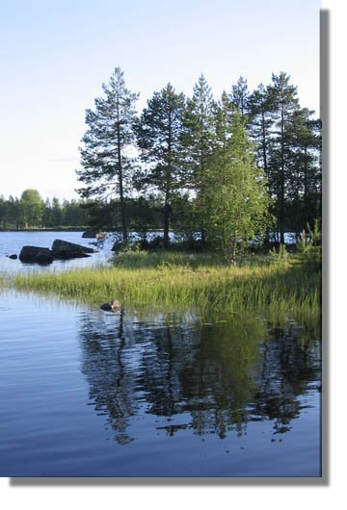  Maybe one of the most popular summer festival of the countryside in Finland is Midsummer, when the sun remains above the horizon all night. At Midsummer people usually go to a summer cottage or some kind of festival. At the moment we have 450 000 summer cottages in Finland, most of which are located on the about 314 000 kilometres long coast-line.  Welcome to Finland to feel the power of summery nature!  Takalo Irene and Kirmanen Kirsi  Photos: Kirmanen Katja

Home  Travelling in Finland  Christmas tourism  Au pair  Language course abroad  London  Stockholm  Raahe  Travelling and the environment  Steinberger Esplanade  The first day at work  Work in the kitchen  Students’ union  Staff | Travelling in Lapland from autumn to winter  If you like to ski downhill you might want to go to these places in Finland:  Levi is a perfect place for the young and fast. Levi has everything what you want for vacation: good restaraunts, hotels, a spa, slopes and pipes for all skill-levels and a wide system of trails for cross-country skiing.  Pyhä is designed for the experts. At Pyhä they have a smart-card system. It serves you at the lifts, at the bars and restaurants. At Pyhä you also have good communications to the Luosto slopes.  Ruka opens as early as in October, which makes Ruka the first among the skandinavian skiing centers which open that early. Ruka is located in Kuusamo.  Saariselkä is located in Inari. Saariselkä is meant for people longing for peace and silence. Snowmobiles are forbidden there! It's a great place for beginners.  Ylläs has great activities for everyone: downhill slopes, a multitude of program services and a vast system of cross-country trails.  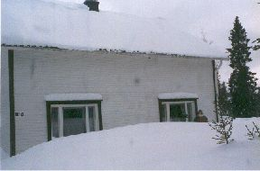  Lapland Holiday  Deep in the pine trees sits Santa's North Pole home, covered with snow - it's the stuff that dreams are made of and you can see it on the faces of everyone, not just the children, as they set off in search of their fantasy.  It's not just Father Christmas though that makes Lapland so exciting. You can ride a snow cat or skidoo (a motorised snow vehicle) sedately along prepared tracks.  The challenge is very exciting but most of all it's fun. Then there's the Santa's reindeer and husky dogs safaris to provide exhilarating rides which will long remain memorable.  Lapland really is the winter experience of a lifetime, where dreams often do become reality.  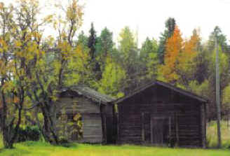  Autumn colours - Ruska in Lapland  The first freezing temperatures at the end of the summer suggest the approach of autumn. Just a few more crisp nights until the surroundings explode into a vivid array of colours. Autumn colours the land, even down to the smallest of plants. The array of colours is radiant, quite striking yet natural.  The leaf green colours fade and after a few nights of freezing temperatures, the colourful ballet of varying shades of yellow and red conquer the land. The drier the autumn, the more vibrant the colours  Autumn is often thought of as a time of abandon and sadness, but in Lapland this is not the case. The beautiful autumn foliage is a joyous event, with the invigorating and fresh air. Hiking, walking in the fells and other outdoor activities are on the autumn programme.  Accompanying activities in Lapland's nature opens your mind and gives you energy to learn new things. Why not pick berries and utilise this natural exercise. The tasty berries and mushrooms you have picked in the clean nature of Lapland will give you wonderful memories.  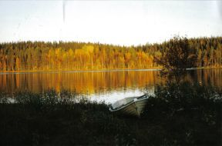  Made by: Milla Kantola and Susan Hänninen

Home  Travelling in Finland  Christmas tourism  Au pair  Language course abroad  London  Stockholm  Raahe  Travelling and the environment  Steinberger Esplanade  The first day at work  Work in the kitchen  Students’ union  Staff | Au pair  Who is an Au pair?  An au pair lives and works in a foreign family babysitting and doing household chores.  The family gives room, food and pay in exchange for work.  The payment varies between 200-400 euros a month depending on the country.  Au pair is not only a worker but she also takes an active part in the family as a family member.  What is most important as an au pair is that you can study a foreign language.  As an au pair you have a possibility to a get study place where you can improve your  language skills.  When leaving for an au pair you have an excellent opportunity to improve language skills, get work experience and get to know better a new culture and family. It is a very reasonable way to spend a year between studies.  Being an au pair demands social skills, flexibility and adjustment ability.  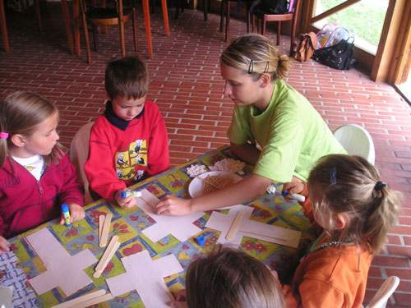  Work  Au pair’s tasks are mainly composed of babysitting and household chores. However the tasks will change by family. Au pair should have one day off a week.  If the host family needs help in babysitting, the au pair should be there a couple of evenings a week. Also doing easy house works, like for example cleaning up children’s room, washing the dishes and clothes and making breakfast for children are part of the program.  Age  18- year- old and unmarried are able to go as an au pair.  The maximum age varies between 25 to 30 years.  Almost all placements are for girls but boys can also apply for placements in some countries.  The applicant should have experience in babysitting and household.  If you are non-smoking and if you have a driving licence it is a benefit to you when you apply to become an au pair.  Working hours  The working hours are normally week- days and –nights. Weekends are free in accordance with the rules. The families have the right to ask the au pair to do babysitting in the evening from  1 to 2 times a week as well.  You can spend your free time as you wish. If you are willing to work as au pair, they presuppose conscientiousness, tolerance, helpfulness and honesty from you not forgetting the main thing - desire to take care of the children!  How to apply to become an au pair?  You can acquire the au pair place in many different ways:  through offices or organizations that arrange placements you can , insert an advertisement in a paper and follow employment agency’s announcements.  Going to abroad through the au pair agency is much safer because you have your agency’s support behind you. For instance if everything doesn’t progress agreed time.  Getting to au pair you can go mainly to the European countries and to the United States of America by the agency’s.  More information:  http://www.au-pair-box.com/  http://www.au-pair.com/  http://www.aupairinamerica.com/  http://www.greataupair.com/  http://www.aupairsearch.com/  http://www.aupairs.co.uk/  http://www.iapa.org/  http://www.europa-pages.com/au_pair/  Experiences from Au pairs and host families:  http://www.au-pair-box.com/aupairforum/for_me_ER/1102363497.html  Makers: Elsi Luomanmäki ja Katri Tuomivaara

Home  Travelling in Finland  Christmas tourism  Au pair  Language course abroad  London  Stockholm  Raahe  Travelling and the environment  Steigenberger Esplanade  The first day at work  Work in the kitchen  Students’ union  Staff | Language trip  Language trip  What is a language trip? is an easy choice to study a language and have new experiences. Trips are arranged for all ages. This kind of experience is exciting, nice and inspiring also for the future. In a language course your language skills can be improved noticeably. Your own attitude also influences your development. Teachers are well-qualified and lessons are very interesting. On language trips you will have a lot of new friends. You will get to know them quickly when you will go on tours and discos.  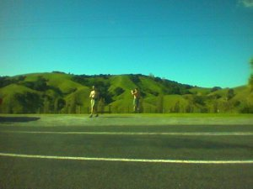  Host family  Students often have accommodation in local families. Being in a foreign country for a longer time, you will learn the culture of this country. In a host family you will see the life of local people and you will get to taste their foods, which you haven’t tasted in your country. Language trip agents have very high requirements for host families. The leaders of language trips visit the host family before they make their choice. Often the communication between the family and the student continues for many years. Students who will go on a language trip again often want to stay with the same host family.  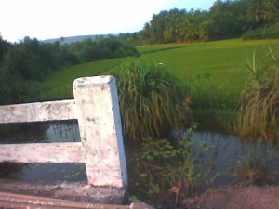  Teaching  Teachers take care of teaching, but they are also your supervisors and trip guides. You’ll meet your teacher also in your free time. Study croups are small, about 10-15 students. At the beginning of the course you have to do a test and the teacher divides you to groups on the basis of the language skills. Studying is different than at school; you must use your language skills in everyday situations, for example you must interview your host family and also read newspapers etc. At the end of your course you will have a diploma for your future.  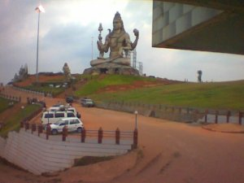  Freetime  Tours and various kinds of events fill your freetime. Leaders take care that there is always something to do; tours, being on the beach, competitions etc. In addition to the tours and events that are included in the price you can book more tours and various activities.  Organizers  Well-known language trips organizers are for example EF and STS.  http://www.sts-education.com/  http://www.ef.com/default.asp?newCountry=true  Prices
   | 14 days | 21 days | 29 days
  United Kingdom | 1345 € | 1640 € | ---
  Malta | 1385 € | 1500 € | ---
  Germany | 1495 € | 1625 € | ---
  Spain | --- | 1885 € | ---
  France | 1580 € | 1755 € | ---
  USA | --- | --- | 2665 €

Home  Travelling in Finland  Christmas tourism  Au pair  Language course abroad  London  Stockholm  Raahe  Travelling and the environment  Steigenberger Esplanade  The first day at work  Work in the kitchen  Students’ union  Staff | LONDON  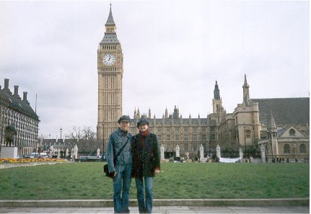  London as a destination is a city of all opportunities.  There is a lot to see even if you come for a longer visit. Most of us have probably heard about Big Ben, London eye, Buckingham Palace and not forgetting Madame Tussaud`s wax museum. It`s also worth going to Camden town`s busy market, a paradise for shoppers.  The several parks of London that have giant trees and white bridges make every walker dream about romantic picnics under the trees. Peaceful walks in the parks make even the citypeople enjoy the nature.  For outgoing people London`s nightlife offers a lot of possibilities. There is a place for everyone. There are traditional English pubs, nightclubs, elegant restaurants and even Finnish bars. Who wouldn`t like the English way of visiting the local pub at lunchtime for a quick beer.  It is easier to get to know the centre of London on foot. The small shops and cafés in Soho give wings for your imagination, while you are sitting on the terrace drinking hot chocolate and eatintg a baguette.  London`s only problems are the high prices and the crowded red buses, but if you choose to travel away from the center you can see everyday English life and enjoy cheaper prices.  London is waiting for you and will take your heart!  Sanna Vasankari

Home  Travelling in Finland  Au pair  Christmas tourism  London  Language course abroad  Stockholm  Raahe  Travelling and the environment  Steigenberger Esplanade  The first day at work  Work in the kithchen  Students` union Staff | Stockholm  Stockholm is over 750 years old. Stockholm is regarded as one of the most beautiful cities in the world. It has been the capital of Sweden since 1634.  Stockholm is built on several islands, that all of them have their own atmosphere.  Each part of Stockholm has its own special characteristics. In the Söder there are lots of little shops and bars. In City there are many supermarkets, galleries and places where you can spend your evening. Östermalm is a more quiet and refined part of the city.  There are for example a historic museum and the Kaknäs-view tower. In Norrmalm there are houses, offices and ethnic restaurants. Some of which have been there since the turn of the century.  Sights of Stockholm  The city hall  The city hall is one of the most interesting buildings in Stockholm. It has a 106 meters high tower and in the tower there is the old symbol of Sweden, "The three crowns".  The city hall is the political centre of Stockholm.  http://www.personal.psu.edu/users/d/r/drj122/images/My%20Trips/stockholm%20city%20hall.jpg  The great church  The great church is the cathedral of Stockholm. The oldest church in Stockholm offers 700 years of Sweden`s history. It is full of valuable cultural treasures.  http://www.stockholmtown.com/upload/storkyrkan200.jpg  The old city  The old city is the oldest part of Stockholm. On the old city`s biggest island "Stadsholmen" there are still relics from 1200s. The old city itself is a historic monument.  There are interesting shops, charming coffee houses and restaurants. The Royal Palace is also located in there.  http://www.viaggimagazine.it/VM/foto/2003/11/stoccolma/0-gamla-stan.jpg  The Royal Palace  The Royal Palace is one of the biggest palaces in Europe. It represents Italian baroque and it was finished in 1754. The Royal families of Sweden have lived in Stockholm since 1600.  The Stockholm culture  If you are interested in culture, Stockholm offers old and new. Museums, theatres and galleries represent the traditional culture. In Stockholm there are about 100 museums, where you can look more closely into the city`s history, culture and art. For example in Vasa-museum there is the repaired royal Vasa-ship, which sank in 1682. Stockholm is the stage of northern design and universal trends, where you can always find something new.  The nature  In the beautiful surroundings of Stockholm there are plenty of historic sights and places you can visit. Large green areas and clean river systems exist in the middle of the city.  http://www.blackfrog.org/travel/europe2002/sweden_files/03_church_%20stockholm.jpg  Restaurants  You can find lots of different restaurants in Stockholm. Both food and design are special things. In Stockholm there are also lots of cafés, which tourists love.  Shopping centres  In Stockholm there are big shopping centres. Shopping is easy because most of the shops are near the centre. The oldest department store is the stylish NE, which is located in Hamngatan. Åhlens City is the biggest department store in Sweden. In the middle of Stureplan there is Sturegallery a fine shopping mall.  Hotels  In Stockholm there are many high quality hotels and in most of them prices are reasonable. Many hotels offer a great view over the sea.  Travelling  Flying to Stockholm from Finland is not very expensive. Arlanda is one of the liveliest airports. Cruising is a nice way to travel to Stockholm, where you can see many cruisers.  Railway and motorway nets are advanced. Stockholm is a destination worth visiting around the year and it`s appearance changes by the seasons.  Sources: www.tukholma.net  www.stockholmtown.com

Home  Travelling in Finland  Christmas tourism  Au pair  Language course abroad  London  Stockholm  Raahe  Travelling and the environment  Steigenberger Esplanade  The first day at work  Work in the kitchen  Students’ union  Staff | Travelling in Raahe  The History  The Swedish count Pehr Brahe established Raahe in 1649. Old Raahe is one of the best-preserved wooden house districts in Finland and dates back to the 19th century. Today the 23,000 people living in Raahe are proud of their traditions as a school, harbour and industrial town.  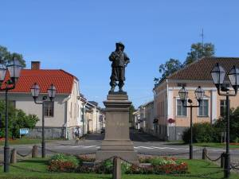  Pekka-statue  A town of culture and conferences  The Kauppaporvari conference centre located in the town centre of Raahe is the town’s heart of culture and conference services. Raahe offers education in a polytechnic and an opportunity for further tertiary education at the university level up to the doctorate.  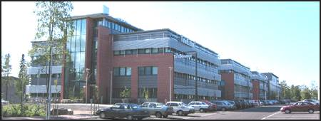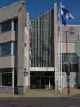  Places to visit:  - Old Raahe  - Museums in Raahe: Merimuseo with marine exhibitions, Soveliuksen talo museum  - Tornitalo scenery platform  - Matti Lepistö sculpture park  - City tours and guided trips  - Cruises to the archipelago  - There are five official churchs in Raahe, four are open for travellers in the summer as well.  THE RAAHE MUSEUM  Includes...  World's oldest diving suit! Fashion from 1800's.  Ships from 1800's.Paintings and ornaments from the old church of Raahe  And much more...  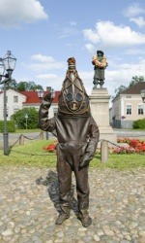 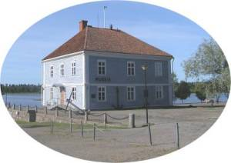  Accommodation:  - Hotel Raahen Hovi  - Hotel Tiiranlinna  - Raahe Camping  - Gasthaus Brahe  - Lohenpyrstö  The oldest museum in Finland  The items tell a story of Raahe as a town of seamen and shipbuilders. The treasure of the museum is the Old Gentleman –the oldest diving suit in the world.  The home of an important ship-owner has been decorated in the 1890’s style on the first floor of the Soveliuksen talo museum.  Main events of the year:  - Raahe Music Festival in February  - Raahe spring market in April  - Rauhanpirtti running event in April  - Premier league Finnish baseball from May to August  - Pekanpäivät on the weekend following the Midsummer  - Rantajatsit jazz festival in July  - Raahe autumn market in October  - Cultural festival for children in October  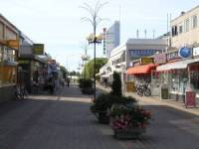  A charming footpath by the channel from the town centre takes you to Pikkulahti beach, which is buzzing with swimmers, sunbathers and beach volleyball players.  There is also a picturesque view from Pikkulahti to the historical area of Rantakatu.  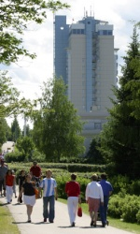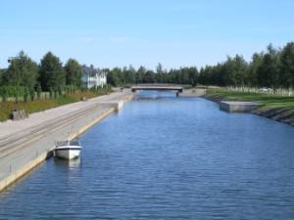  The archipelago  The old, yellow-beaming beacon of Tasku has welcomed visitors and said goodbye to those leaving their homes for 150 years.  Mighty heaps of ice form every spring a couple of kilometres west of Tasku Island. The heaps pile up in shoals and reach the height of a couple of metres from the bottom of the sea.  The Raahe harbour is the sixth largest harbour in Finland as measured by the amount of freight traffic. Approximately 800 vessels pass through the harbour every year. All kinds of raw materials, steel, sawn timber, bulk cargo and containers are transported through the harbour.  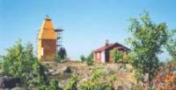  Sources:  www.raahe.fi  www.fennica.net  www.raahe24.net  Brochure: Kauppaporvari, Raahe 2005, Old Gentleman’s Raahe  Elisa and Johanna

Home  Travelling in Finland  Christmas tourism  Au pair  Language course abroad  London  Stockholm  Raahe  Travelling and the environment  Steinberger Esplanade  The first day at work  Work in the kitchen  Students’ union  Staff | Environmentally friendly travelling  Environmentally friendly travelling is travelling which consumes the environment as little as possible. Environment means living (people, animals, plants) and lifeless (for example water and air) nature round us.  Why should we do everything environmentally friendly?  Among other things the pollution from factories and exhaust fumes from cars cause the greenhouse effect, smogs and sour rains. The raw materials, for example oil and uranium, have been used nearly over.  If we do not protect environment water will be spoiled, climate will get warmer and polluted useless for us and the non-renewable raw materials will decrease up faster.  How have they observed environmentally friendliness in companies?  Companies have had to admit their responsibility for the environment and so they have made huge agreements on it, for example the Kyoto Agreement. They make raw materials with less pollution than earlier. They improve manufacturing techniques of products so that the products would be environmentally friendlier to use.  Companies look after exceedingly well that consumers are able to travel environmentally friendly.  How should people observe the environmentally friendly travelling?  People don’t observe the environmentally friendliness well enough in their everyday life. It’s a problem nowadays. The best choose would be point of view of environment certainly we wouldn’t travel at all. It’s unpracticable in practice, however and from another point of view would it supposed to be environmentally friendly travelling you don’t travel? – of course not. Even authorities cannot interfere in purchases and the moving of people. People themselves have to take resbonsibility of what they do.  People can observe the environment by moving short trips on foot, by bike, with roller skates or with some other way of muscular strength. People may contemplate: “Will I need a car surely or could I travel by public transport?”. The aggressive and hurried driving is a bad way: the life span of the vehicle will decrease and petrol will be used up faster. It’s good if the owner brings her/his vehicle to be recycled in the end: The environment is not consumed or polluted so badly because we do not have to collect so much raw materials, the vehicles are out of sight and the owners will be saved from possible problems with authorities.  Even a small action for the environment is a step forward.  Fuel cell cars will be the big environment action of the future (Toyota)  Joni Kurtti, L2B  Sources of the photos:  http://www.kouvolansanomat.fi/arkisto/vanhat/2001/02/03/uutiset/juttu2/sivu.html  http://www.msc-smc.ec.gc.ca/media/annual_report/2002-03/ourproducts_e.html
  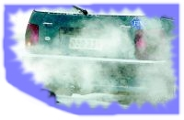 | 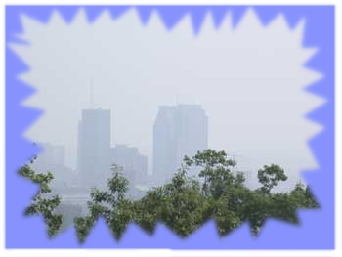 | 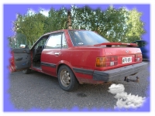
  Exhaust fumes that have got in- side the car may kill everybody.  !Reproduced with the permission of Irma Jäppinen, 2005! | Smog in Montreal  !Reproduced with the permission of Environment Canada, 2005! | Even a little amount of pollution adds illnesses and deaths.  !This photo is free to reproduce!

Home  Travelling in Finland  Christmas tourism  Au pair  Language course abroad  London  Stockholm  Raahe  Travelling and the environment  Steigenberger Esplanade  The first day at work  Work in the kitchen  Students’ union  Staff | Steigenberger Esplanade  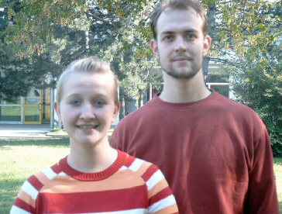  We work at the Steigenberger Esplanade, a 4* City Hotel at the heart of Jena. At our hotel you can choose between 267 rooms, 4 suites and 1 appartment. 65 colleagues work in 5 departments. Besides this we have 2 restaurants, 5 conference rooms and 1 library. We have 20 colleagues in the restaurant. We also cater for the "Volkshaus" and the "Planetarium". Sometimes we cater for castles. Recently we were at the "Wasserburg", a castle surrounded by water.  A working day at such a catering establishment is a long day. It begins with the loading of, for example, chairs, desks, carpets, napkins, barrels and dishes. When we arrive we must unload these things. We build, supply napkins and make the decorations. Often there are no lifts to carry difficult and unwieldy things. We dress up in traditional clothes such as a farmhand and his wife. In the rest of the time before the guests arrive we enjoy a plain meal. Then we're ready for our guests. First we welcome our guests and ask them what they want to drink, escort them to their tables and pick up the dishes from the buffet that stands in front of the guests. We almost always present a dessert arrangement consisting of a plate of ice cream with fresh fruit, burning sparklers and a fire fountain, which is the highlight of the evening.  When the evening is over for all the guests, a huge amount of work is still waiting for us. After loading the stuff we drive home but if you think it's over, you're a fool! Not only polishing the cutlery, but cleaning the dishes and many other tasks are still to be done. After 12-16 hours of work we fall into our beds, sleep a short while before starting the next day. Nevertheless it's a rewarding job!  The authors are Ronny Scheller and Nicole Buschmann, trainee hotel specialists, 2nd year, working at Steigenberger Esplanade Hotel and Best Western Hotel, Jena.

Home  Travelling in Finland  Christmas tourism  Au pair  Language course abroad  London  Stockholm  Raahe  Travelling and the environment  Steigenberger Esplanade  The first day at work  Work in the kitchen  Students’ union  Staff | The first day at work  My name is Julia Sander. I´m 17 years old and work as a trainee in the hotel business.The job is really stressful but also fun because of my friendly and humorous workmates.  One year ago I started work as a trainee in the hotel business.  The day before the first working day I was really excited and also very nervous. I thought about which clothes I should wear and tried to imagine the atmosphere, how my workmates would be like. Can it be that they are friendly and humorous, or are they unfriendly, so that I won´t like working there? Therefore I think I was a bit scared.  Before I went to bed I looked three times for the time I had to get the bus.The next point was I couldn´t sleep.The night was so terrible. Every hour I woke up and thought about the next day.  I got up early in the morning and ate nothing for breakfast. I waited for the bus for 20 minutes but then I was too early for work.  My boss received me and told me everything about my working place. Then I got to know my workmates. They were all very friendly so that I felt very welcome.  Now I know what is important to do on the first day:  You have to be openminded and you have to present yourself in a very good way. Your appearance and your behaviour are very important. You have to do your best every time, and it can be useful for yourself if you´re not so nervous! Take it easy!!!

Home  Travelling in Finland  Christmas tourism  Au pair  Language course abroad  London  Stockholm  Raahe  Travelling and the environment  Steigenberger Esplanade  The first day at work  Work in the kitchen  Students’ union  Staff | A day in the kitchen  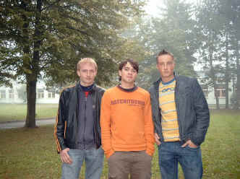  Working in a restaurant kitchen is very hard - it means long working hours, working part-shifts, on holidays or at weekends and the heat in the kitchen - that means a lot of emotions arise…  The first thing when you start work is making the mis en place that means, e.g. slicing or dicing onions or tomatoes.  The work in the kitchen is divided into various posts, e.g. gardemanger, saucier, entremetier, patisier or poissonier. Everyone has special things to do, e.g. the patissier makes only desserts or sweets. However, all the staff have to work in a team to create enjoyable meals for the guests, that means everything must be ready in time and the chefs have to arrange the food on the plates.  At the end of a long working day you have to clean the kitchen - one of the most unpleasant jobs in the kitchen; but once you have finished you really enjoy a small beer…  The authors are 3 trainee chefs of the 3rd year who work in different hotels in Jena;  Tim Nawrath, Hotel und Braugasthof "Papiermühle"  Markus Koch, Fair Ressort Hotel  Robert Glaser, F- Haus Restaurant "Zum Löwen"

Home  Travelling in Finland  Christmas tourism  Au pair  Language course abroad  London  Stockholm  Raahe  Travelling and the environment  Steinberger Esplanade  The first day at work  Work in the kitchen  Students’ union  Staff | STUDENT'S UNION OF RAAHE BUSINESS COLLEGE  I want to introduce the best students' union government at first which we may hope only. These people are them: Tanja "Taikku" Niinimaa (puheenjohtaja), Anniina "Nanna" Kastelli, Harri "Hartsa" Kylmänen, Paavo "Pate" Järvelä, Anna "Apa" Turpeenoja, Janika "Jannu" Itäpalo ja allekirjoittanut Tuire "Tuippa" Lampinen.  We do also a lot of other thing as walking round the school. We have got committees: executive committee, financial committee, apprentice committee, athletics committee, pleasure committee, international committee and tutor operation.  Anniina (kastelan@rpkk.fi) and "Tuippa" (lampintu@rpkk.fi) are answering for pleasure and athletics committees'. If you have got guestions or comments in these things you may e-mail to them. Anniina is answering for tutor operation, too. Tanja Niinimaa (niinimta@rpkk.fi) and the executive director, Tiina Moilanen (moilanti@rpkk.fi) are the leader of financial and executive committees.  Cafeteria Merkantiini of our school serves very good coffee and delicious meal. It is kept up of students' union. There is also a bookshop, Mercur, kept up of students' union. You may buy there text-books, copying cards, pens, pencils, paper, notebooks, student's card, swimming tickets etc.  You get a lot of good and important advantages if you join to students' union.  Students' union employs four people: the employees of cafeteria and the executive director.  Students' union has already worked over a hundred years.

Home  Travelling in Finland  Christmas tourism  Au pair  Language course abroad  London  Stockholm  Raahe  Travelling and the environment  Steinberger Esplanade  The first day at work  Work in the kitchen  Students’ union  Staff | Staff  It was a peaceful schoolmorning until Roy Viitanen gave us a paper. There read in the paper we should make web sité "Bothnia". We were in panic. Which subject would each other write the web article. We invented subjects little by little and here are they all now. We hope everybody will get some pleasure and information of our web sité. L2B class want to thank for our teachers especially: Marjatta Koivu-Junnila, Roy Viitanen, Satu Aho.  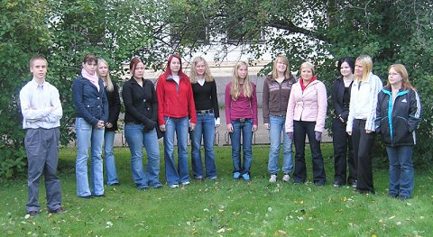

Etusivu  Vinkkejä matkailijoille  Lapin matkailu  Interrail  Au Pair  Kielimatkat  Lontoo  Tukholma  Matka USA:han  Iso-Syöte  Ympäristöystävällisyys  Oppilasyhdistyksen toiminta  Tekijät  Vanhemmat Bothniat   | Etusivu  Sydämellisesti tervetuloa Raahen Porvari- ja Kauppakoulun oppilaiden ylläpitämään verkkolehteen.  Tämän Bothnian numeron aiheena on matkailu ja matkustaminen.  Pääset lukemaan mielenkiintoisia juttujamme vasemman puolen linkkipalkista. Ryhmäkuvaa tekstin tuottajista voit käydä katsomassa Tekijä-linkistä. Vanhemmat verkkolehdet kannattaa myös käydä katsomassa, ellet ole vielä niihin tutustunut.  Artikkelinkirjoitusvuorossa tänä syksynä (2005) ahkeroivat toimistopalvelun ja tietohallinnon koulutusohjelman L2B-luokkalaiset merkonomiopiskelijat.  Saimme lisämateriaalia verkkolehteemme ulkomaankirjeenvaihtajiltamme saksalaisesta partnerikoulusta, Staatliches Berufsbildendes Schulzentrum Jena - Göschwitz (Valtion ammatillinen koulukeskus Jena - Göschwitz) http://www.sbsz-jena.de/ Artikkelit ovat englanninkielisessä Bothiassa  Toivottavasti viihdyt mielenkiintoisten artikkeleidemme ääressä.  Ystävällisin terveisin koko L2B luokka ja saksalaiset kirjeenvaihtajamme

Etusivu  Vinkkejä matkailijoille  Lapin matkailu  Interrail  Au Pair  Kielimatkat  Lontoo  Tukholma  Matka USA:han  Iso-Syöte  Ympäristöystävällisyys  Oppilasyhdistyksen toiminta  Tekijät  Vanhemmat Bothniat | VINKKEJÄ MATKAILIJALLE  Muista ainakin seuraavat asiat niin matkasi onnistuu!  - matkaliput  - passi (tarvittaessa viisumi)  - matkavakuutus, matkatavaravakuutus  - rokotukset  - valuutta (joskus valuutta kannattaa vaihtaa vasta matkakohteessa, esim. Ivy-maat  Apteekkituotteet  - laastaria  - lääkkeet; ainakin päänsärkylääkettä, lääkettä mahataudin varalle, tarvittaessa matkapahoinvointilääkkeitä, omat reseptilääkkeesi, esim. allergialääkkeet jne.  Henkilökohtainen hygienia  - shampoo, hammasharja, pesuaineet yms.  - kosteusvoide, aurinkovoide  - kosteuspyyhkeitä on hyvä olla laukussa, matkakohteesta riippuen tarvitset niitä ehkä käsien puhdistukseen ja muuhunkin…  Vaatteet  - älä pakkaa mukaan liikaa vaatteita! Jätä matkalaukkuun tilaa myös tuliaisia varten  - esim. T-paidat menevät pieneen tilaan, kun pakkaat ne rullaamalla  - viileitä iltoja varten villatakki tms.  - kertakäyttöinen sadetakki tai kokoontaittuva sateenvarjo (riippuen tietenkin matkakohteesi ilmastosta)  - hyvät kengät joilla jaksaa kävellä ilman, että jalat ovat rakkuloilla…  Muuta tarpeellista ainakin pidempikestoisella matkalla  - sanakirja, matkalukemista, kohdealueen kartta, herätyskello  - hakaneuloja, matkapakkaus ompelulankaa ja neuloja  Ota mukaan myös hyvät aurinkolasit ja tietenkin kamera !  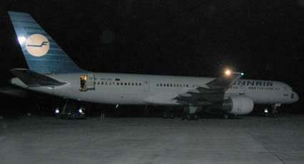  YLEINEN TURVALLISUUS  Matkusteltaessa kannattaa pitää mielessä ettei ulkomailla ole välttämättä yhtä rauhallista kuin Suomessa. Selvitä kohdemaan olosuhteet jo etukäteen. Älä matkusta ollenkaan levottomaan tai sotaa käyvään maahan. Käytä tervettä järkeä eli rahaa ei kannata esitellä julkisilla paikoilla tai liikkua yksin öiseen aikaan epäilyttävillä alueilla. Liiku mieluummin seurassa kuin yksin. Toisaalta liika varovaisuuskin voi pilata koko matkan.  EMBASSY WORLD  - lähetystöt ja konsulaatit maailmalla. Myös hakupalvelu. (englanninkielinen) http://www.embassyworld.com/  THE WORLD’S MOST DANGEROUS PLACES  - opas matkailijoille, vaaralliset paikat maittain, myös kielletyt alueet. (englanninkielinen) http://www.fieldingtravel.com/df/index.htm  SUOMEN ULKOMINISTERIÖ  - tietoa matkustajille ”palvelut” osiossa. http://formin.finland.fi/suomi/  ROKOTUKSET  Jos matkustat Eurooppaa kauemmaksi on hyvä tarkastaa ajoissa ennen lähtöpäivää rokotusten voimassaolot sekä maakohtaiset määräykset rokotuksista. Kaukomaille matkustava joutuu ehkä ottamaan useammankin uuden rokotuksen tai vahvistamaan entisiä. Kannattaa ottaa yhteys omaan terveyskeskukseen ja kysellä sieltä ohjeita.  MATKAILIJAN ROKOTUKSET  - Kansanterveyslaitoksen sivut http://www.ktl.fi/oppaita/matkailijan/l4/index.html  PASSI JA VIISUMIT  Matka alkaa mukavasti jos jo etukäteen olet selvillä määräyksistä passien ja viisumien suhteen. Länsi-Euroopan 15 maassa voit matkustaa pelkällä henkilökortilla, sen sijaan joihinkin kohteisiin tarvitset ison nipun erilaisia papereita ja lupia. Matkatoimistoissa osataan neuvoa, mutta tietoa löytyy myös:  POLIISI  - määräykset passista ja EU-passista http://www.poliisi.fi  Kirmanen Kirsi, Takalo Irene L2B  Kuvat: Kirmanen Katja | 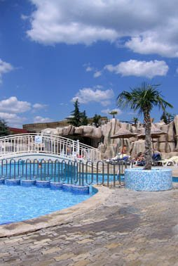

Etusivu  Vinkkejä matkailijoille  Lapin matkailu  Interrail  Au Pair  Kielimatkat  Lontoo  Tukholma  Matka USA:han  Iso-Syöte  Ympäristöystävällisyys  Oppilasyhdistyksen toiminta  Tekijät  Vanhemmat Bothniat | Lapin matkailu Syksystä - Talveen  Lapin elämyksiä ovat: Lapin mystiikan ja eksotiikan yötön yö, ruska, revontulet, aidot lappilaiset ihmiset, Suomen suurimmat kansallispuistot, käsivarren suurtunturit, maan parhaat hiihtokeskukset, upeat vaellus- ja hiihtomaastot sekä Ivalojen, Lemmenjoen ja Tanskavaaran kultamaat.  Lapin kiehtovat nähtävyydet  - Euroopan ainoa toimiva ametistikaivos Luostolla, aito kultakylä ja kansainvälinen Kultamuseo Tankavaaralla ainoa maailmassa  - Reidar Särestöniemen erämaa-ateljee Kittilässä ja Saamelaismuseo Siida Inarissa.  - Alariesto-Galleriassa Sodankylässä esittäytyy Lapin eksotiikka Andreas Alarieston värikylläisissä maalauksissa.  - Inarin porofarmi ja Kamisakin huskykoiratila Inarissa ovat koko perheen käyntikohteita.  Syysmatkailu  Suomen syksy on Lapissa värikästä aikaa. Syksyllä kannattaa suunnata kulkunsa Lapin metsämaisemiin. Erityisesti Lapissa kannattaa käydä katsomassa ruskaa. Ruska syntyy valon hiipumisesta ja ilman kylmenemisestä. Mitä kovemmat yöpakkaset ja mitä kuivemmat ilmat, sitä kirkkaammat värit. Ruska on parhaimmillaan syyskuun puolessa välissä. Parhaat ruskan katselupaikat ovat Inari, Utsjoki ja Enontekiö.  Syksy on myös erinomaista aikaa metsästäjille ja marjastajille. Lappi on oiva paikka harrastaa metsästystä. Suomen luonnon rauhassa viihtyy hyvin niin metsästäjät kuin marjastajatkin.  Jokamiehenoikeuksiin kuuluva marjastus ja sienestys ovat monen suomalaisen syksyisiä harrastuksia. Marja- ja sieniretkelle lähdetään virkistymään, rentoutumaan luonnon helmaan ja keräämään vitamiineja talven varalle. Lapin luonto on puhdasta ja raikasta, joten siellä marjat ovat maukkaita ja niissä on kaikki vitamiinit tallella. Lapissa kasvaa seuraavia marjoja: mustikka, puolukka, kaarnikat ja hillat. Syksyn runsaimpiin sienilajeihin kuluu: haperot, rouskut ja tatit, myös löytyy muitakin lajeja. Lapin luonnosta on helppo löytää niin riistaa kuin marjojakin.  Metsästyksestä kiinnostuneille lisää tietoa: http://www.villipohjola.com/  Metsästysajat: http://www.pulkkila.fi/era/metsajat.htm  Talvimatkailu  Pohjois-Suomessa on luonto aivan erilaista kuin muualla Suomessa. Lapin kesä on lyhyt ja talvi pitkä. Talvi on hyvin pimeä, koska aurinko on poissa kaksi kuukautta ja silloin Lapissa on kaamos.  Eksoottinen kaamosajan Lappi vetää turisteja puoleensa. Joulun tunnelmaa löytyy Lapin hangilta ja odottaahan siellä joulupukkikin. Lapissa käy joulukautena noin 380 charter-lentoa, joista suurin osa tulee Britanniasta. Kittilään tulee noin 140 charteria. Lisäksi Rovaniemelle tulee noin 180 konetta, Ivaloon 40 ja Enontekiölle 30. Kuusamoon tulee viisi koneellista ulkomaisia matkailijoita.  Joulumatkailun kärkimaita ovat Iso-Britannia ja Venäjä  Suomessa voi talvella harrastaa monia eri aktiviteetteja, kuten hiihtoa, laskettelua, luistelua ja lumikenkäkävelyä. Jos olet kiinnostunut lumikenkäkävelystä, voit mennä harrastamaan tätä lajia Anttolan Neitvuorelle, Kurivaaraan tai Ounasvaaralle. Ylipäätänsä voit harrastaa lumikenkäkävelyä missä vain metsässä. Jos haluat opastetulle kävelylle hintahaitari on 25 - 65 €. Yleensä hintaan sisältyy lumikengät lainaksi, lämmin juoma ja välipala matkan aikana. Joskus tarjoukseen saattaa jopa kuulua sauna reissun jälkeen. Retket yleensä kestävät 3 - 4 tuntia. Opastetulla retkellä on 5 - 15 henkilöä ja opas on mukana.  Jos olet kiinnostunut laskettelusta hyviä paikkoja ovat: Levi, Pyhä, Ruka, Saariselkä ja Ylläs.  Leville kannattaa suunnata matkansa, jos olet nuori tai vauhdikas, mieluiten kumpaakin. Siellä on laskettelun lisäksi Hullu Poro, jossa soi rokki ja Areena, jossa esiintyy kotimaisia tähtiä. Rinteitä on monen eri tasoisille laskettelijoille.  Pyhä on enemmän tarkoitettu taitohiihtäjille ja laskettelijoille. Smart-cardilla maksaminen onnistuu Pyhällä vaivattomasti.  Kuusamon Rukalla on monipuolinen palveluvalikoima. Ruka avaa laskettelukeskuksensa jo lokakuun puolella.  Saariselkä on tarkoitettu rauhasta ja hiljaisuudesta nauttiville hiihtäjille. Perhelaskettelijoille Saariselkä on erinomainen paikka. Saariselällä pääsee ensilumille jo lokakuussa. Kilpisjärvellä Saanan alatuntureilla voi hiihtää vielä juhannuksen tienoilla. Saariselällä avautuu maastohiihtäjän paratiisi. Alueella on merkittyjä vaellus- ja maastopyöräilyreittejä ja halukkaat pääsevät opastetulle kultaretkelle. Saariselän matkailukeskuksen kongressi- ja kylpylähotellit tarjoavat korkeatasoiset kokouspalvelut, virkistystä ja rentoutusta.  Ylläksellä on Suomen ehkä monipuolisimmat hiihtokeskukset. Ylläksellä on seitsemän tunturia, jotka tekevät maisemastakin mahtavan. Ylläkseltä löytyy jotain jokaisen makuun.  Rekiajelut porolla ovat ikimuistoinen kokemus. Poroja voi käydä ihastelemassa esim. joulupukin pajakylän Santaparkissa. Sieltä saa myös tietoa Lapin historiasta. Joulupukin kylässä voit käydä poroajelulla talvisin.  Joulupukin luona vierailusta saat lisätietoa: http://www.santapark.com/  Tehnyt: Milla Kantola ja Susan Hänninen  Kuvat: Sirkka Mankinen | 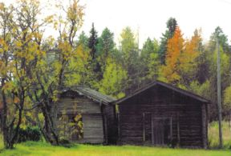

Etusivu  Vinkkejä matkailijoille  Lapin matkailu  Interrail  Au Pair  Kielimatkat  Lontoo  Tukholma  Matka USA:han  Iso-Syöte  Ympäristöystävällisyys  Oppilasyhdistyksen toiminta  Tekijät  Vanhemmat Bothniat | Interrail  Mitä on interrail?  Interrail on vapaa-muotoista matkustamista junalla Euroopassa. Interrail matkustaminen eroaa täysin ”normaaleista” lomamatkoista. Se on erittäin halpa tapa tutustua moniin eri maihin. Interrail matkustaminen sopii erinomaisesti seikkailunhaluisille nuorille. Ei muuta kuin reppu selkään ja junaan.  Interrail kortti  Interrail junalipulla voit matkustaa junissa niin paljonkuin haluat ja niillä vyöhykkeillä joilla lippu on voimassa. Näitä vyöhykkeitä ovat 28 Euroopan maata (+Marokko) ne on jaettu kahdeksaan vyöhykkeeseen A - H . Valittavissa on 1tai 2 vyöhykettä tai vaihtoehtona on global-kortti. Global- korttilla voit liikkua rajoituksetta kaikilla vyöhykkeillä.  Nuoria kiinnostaa interrail matkustamisessa sen vapaus. Kuinka saa vapaasti valita minne menee, missä nukkuu, missä syö. Interrail matkalla on mukava lähteä suuren kaveriporukan kanssa tai ihan kaksistaan. On syytä miettiä tarkkaan kenen kanssa lähtee matkalla. Yleensä interrail matkustaminen tekee ikuisiksi ystäviksi tai erottaa.  Interrailaajan muistilista:  - Hyvät kävelykengät tai sandaalit, älä osta uusia  - Kevyitä käyttövaatteita, kuten T-paitoja ja shortsit  - Pyyhe  - Henkilökohtaisia hygieniatarvikkeita tarpeen mukaan  - Yksi parempi vaatekerta  - Kertakäyttösadetakki  - Pesupulveria  - WC-paperia  - Vesipullo  - Makuupussi  - Lakana  - Kopiot interrailkortista, passista ja vakuutustodistuksesta  - Rahat matkashekkeinä  - Kamera  - Päänsärkylääkkeitä, hiilitablettaja ja desinfiointipyyhkeitä  Linkit: http://www.pallontallaajat.net/interrail/  http://www.vr.fi/heo/lansi/finterail.htm  http://www.nicehouse.fi/matkailu/info/interail.htm  Elsi Luomanmäki ja Katri Tuomivaara | 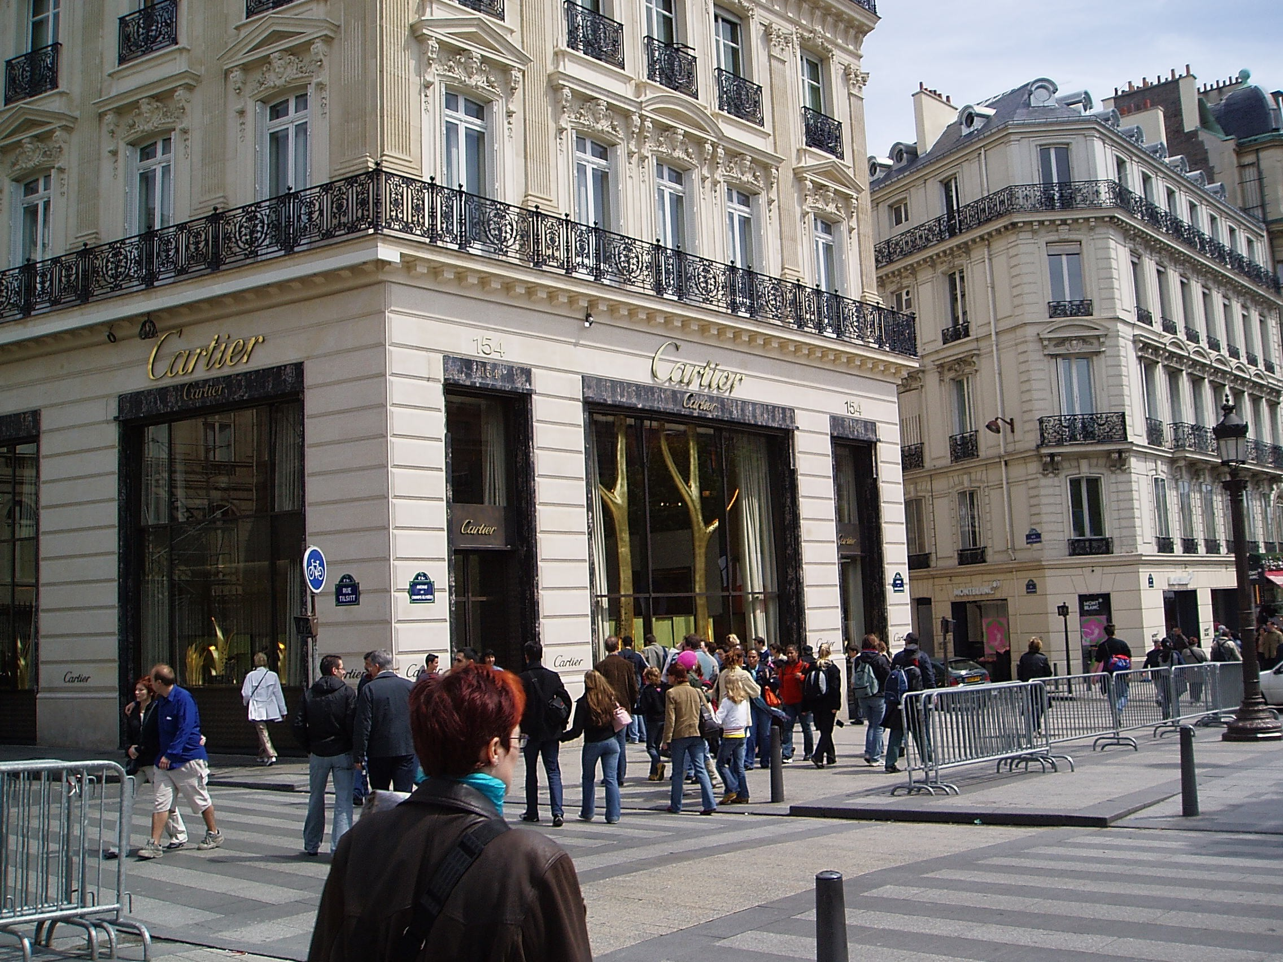  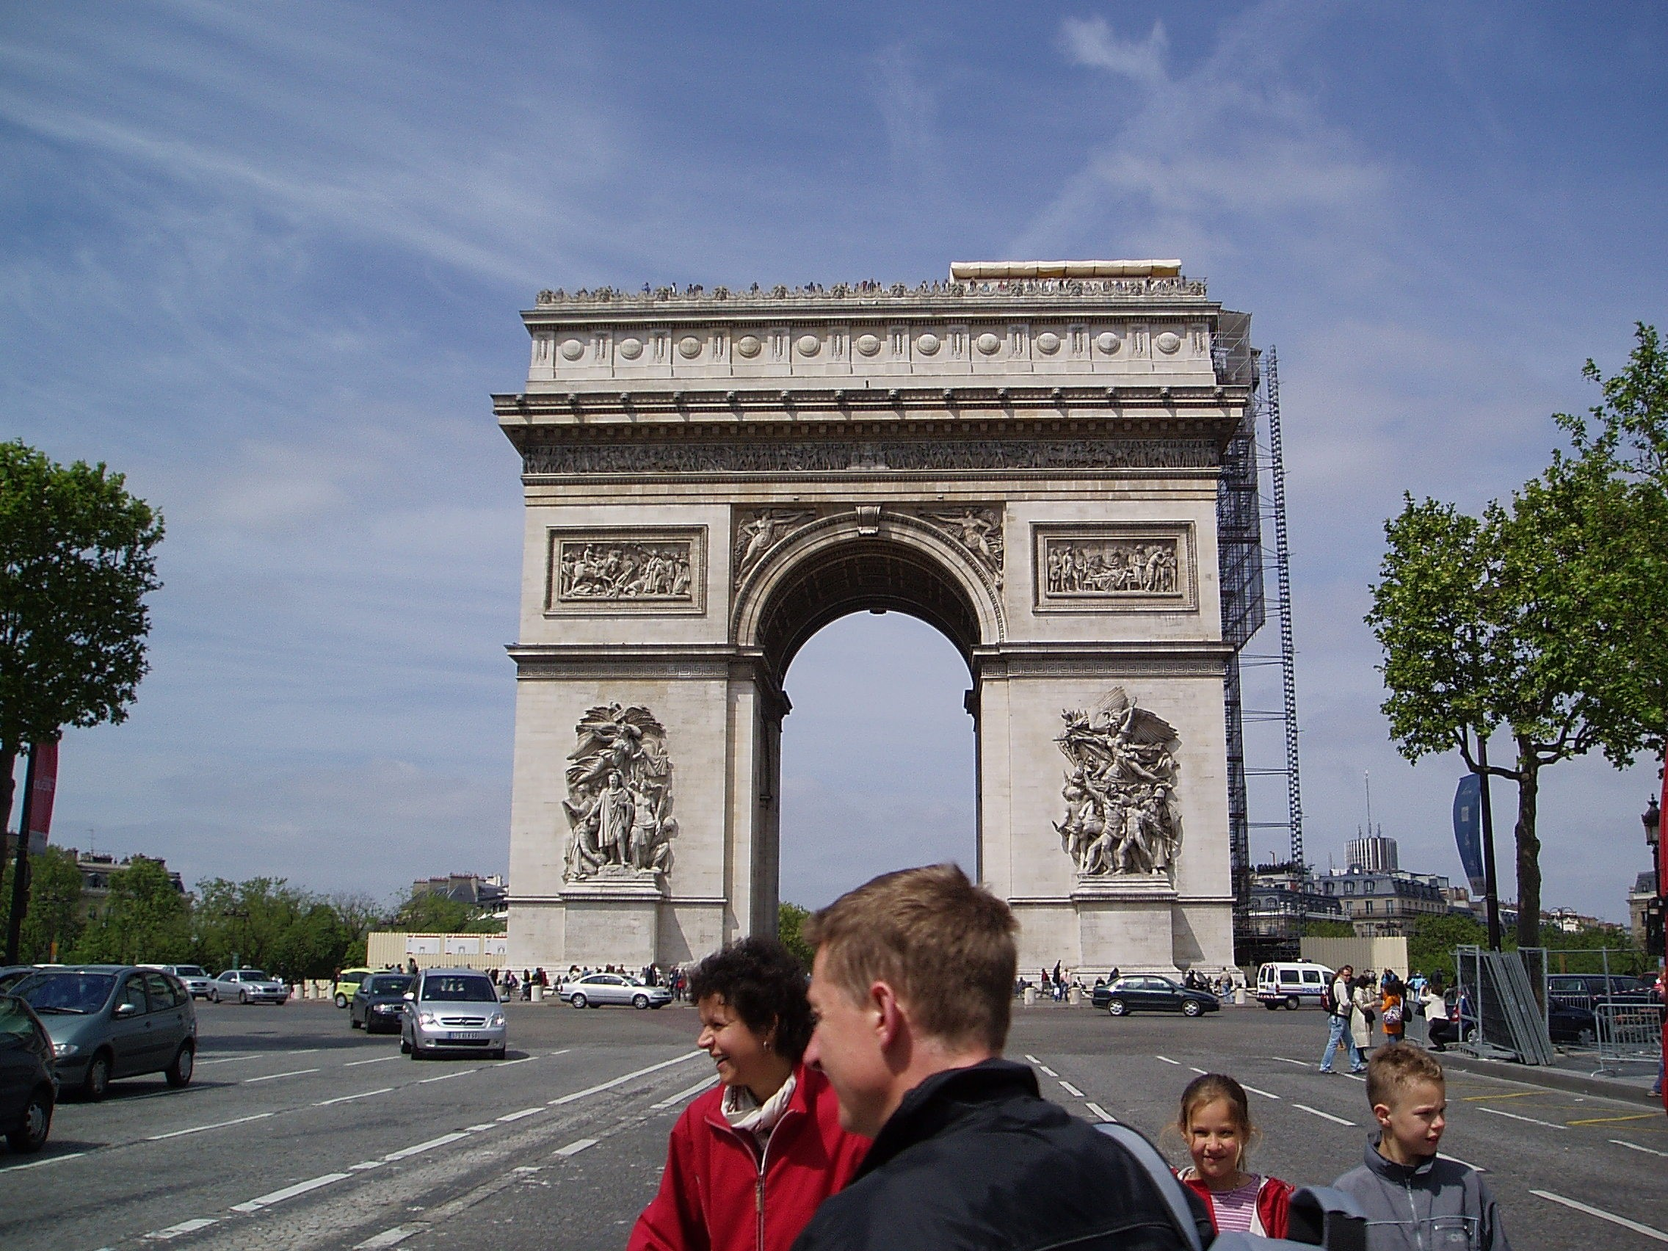  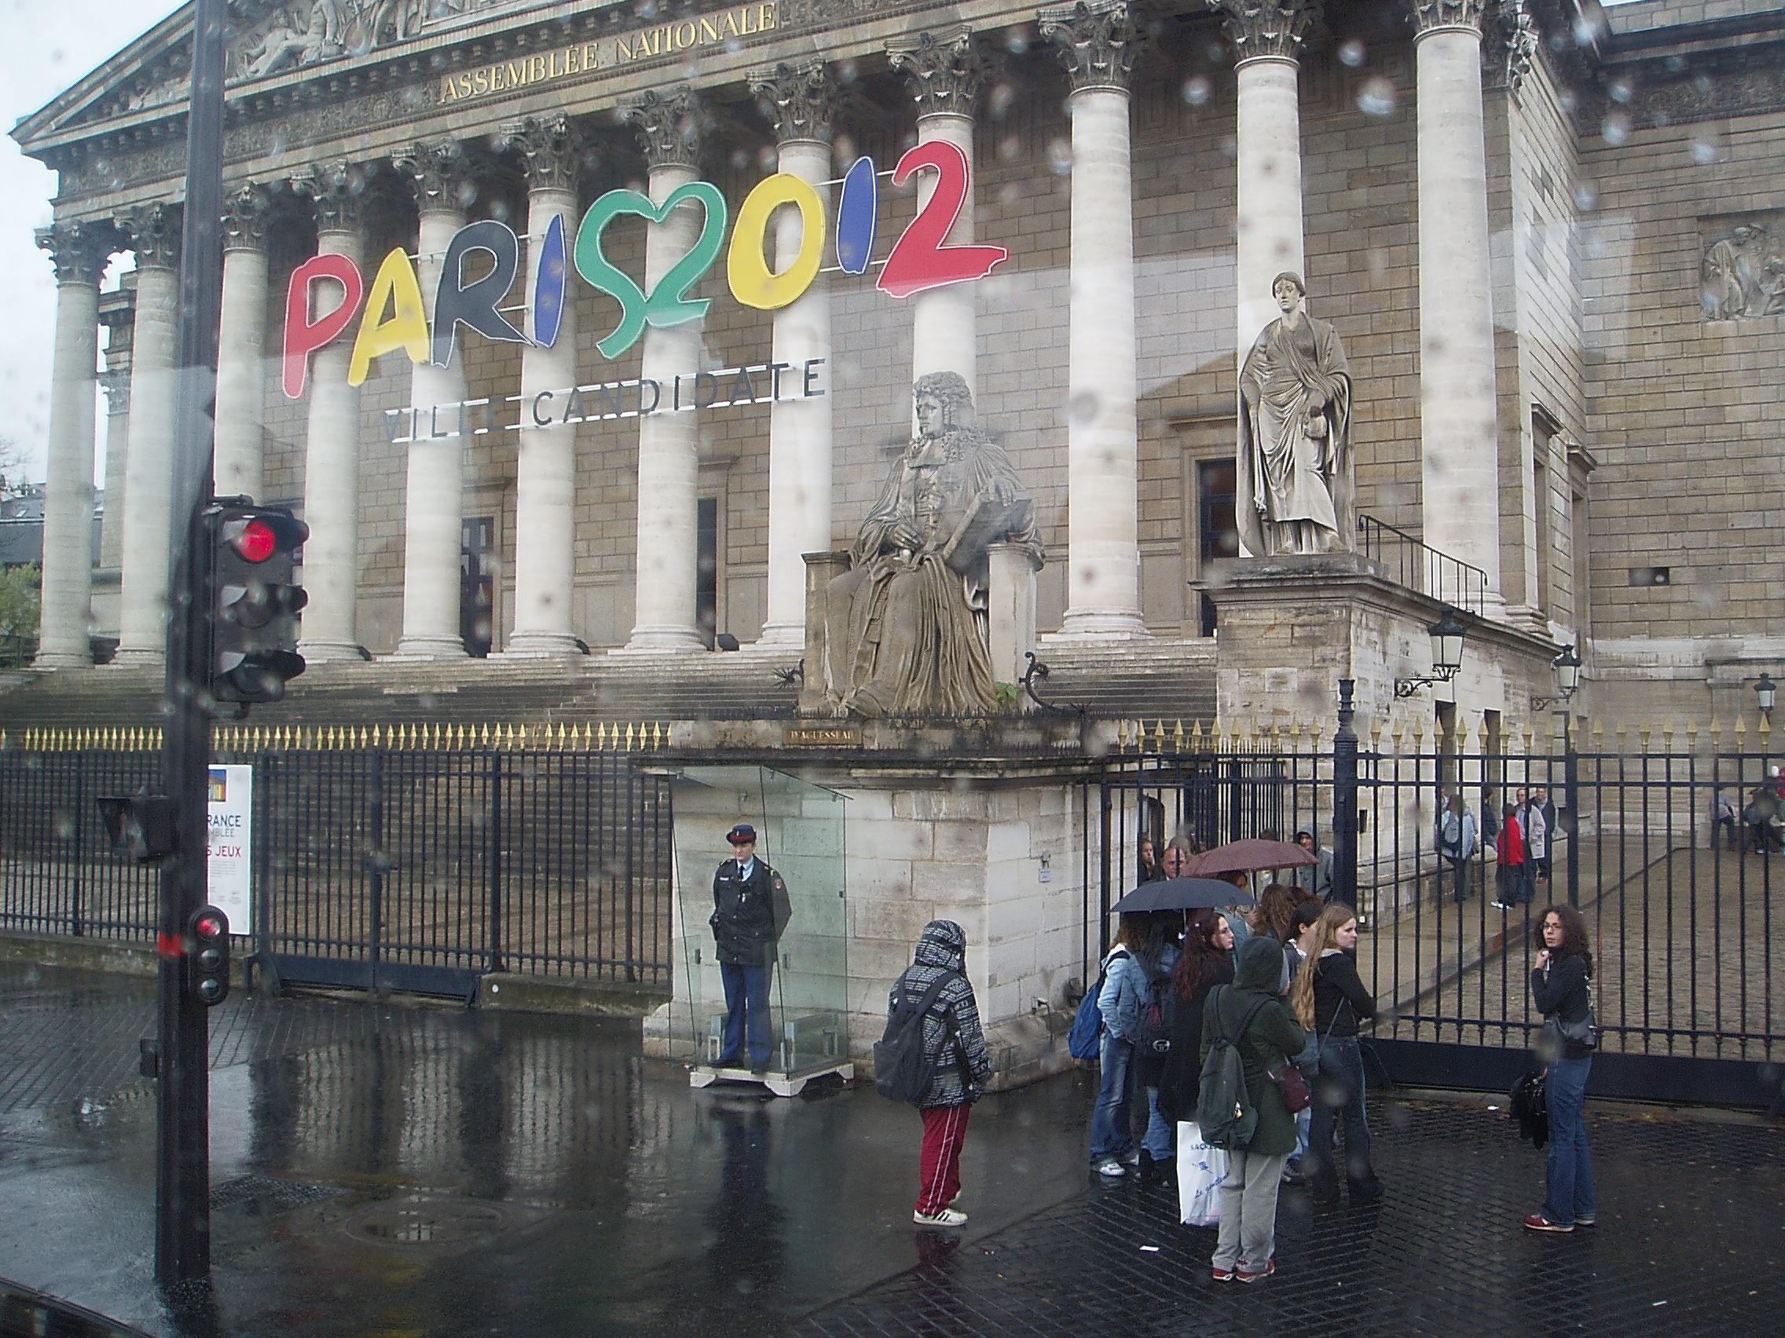
   | Nuoret 12 - 25v. | aikuiset + 26v.
  1 vyöhyke 16 päivää | 195 € | 286 €
  2 vyöhykettä 22 päivää | 275 € | 396 €
  Global 1 kuukausi | 385 € | 546 €

Etusivu  Vinkkejä matkailijoille  Lapin matkailu  Interrail  Au Pair  Kielimatkat  Lontoo  Tukholma  Matka USA:han  Iso-Syöte  Ympäristöystävällisyys  Oppilasyhdistyksen toiminta  Tekijät  Vanhemmat Bothniat | Au pair  Mikä on au pair?  Au pair asuu ja työskentelee ulkomaalaisessa perheessä lapsia hoitaen ja kotitöitä tehden.  Työn vastikkeeksi perhe antaa au pairille ruuan, huoneen sekä palkkaa. Palkka vaihtelee maittain 200-400 euroa kuukaudessa. Au pair ei ole pelkkä työntekijä vaan hän toimii perheessä perheenjäsenen asemassa. Kielen opiskelu on tärkein osa au pairina oleskelua. On mahdollista hankkia opiskelupaikka jossa voit parantaa kielitaitoja.  Au pairiksi lähteminen antaa erinomaisen tilaisuuden parantaa kielitaitoa ja tutustua uuteen kulttuuriin ja perheeseen. Se on myös järkevä tapa pitää välivuotta. Au pairina oleminen parantaa kielitaitoasi ja saat työkokemusta. Au pairina oleminen vaatii sosiaalisia kykyjä sekä joustavuutta ja sopeutumiskykyä.  Työtehtävät  Au pairin työtehtävät muodostuvat pääosin lastenhoidosta ja kotitöistä. Työtehtävät vaihtelevat kuitenkin perheittäin. Au pairilla kuuluu olla yksipäivä viikosta vapaata. Parina Iltana viikossa au pairin on oltava lapsenvahtina mikäli isäntäperhe tarvitsee apua.  Myös kevyiden kotitöiden tekeminen, kuten esimerkiksi lasten huoneen siivoaminen, pyykkien ja astioiden konepesu sekä aamupalan tekeminen lapsille, kuuluu osana ohjemaa  Ikä  Au pairiksi voivat lähteä 18 vuotta täyttäneet naimattomat henkilöt, yläikäraja vaihtelee 25-30 vuoteen. Lähes kaikki paikat ovat tytöille mutta muutamiin maihin voivat hakea myös pojat. Hakijalla täytyy olla kokemusta kotitöistä ja lastenhoidosta. Lastenhoitokokemukseksi lasketaan lapsen vahtina toiminen ja lasten kerhojen vetäminen. Kun haet au pairiksi sinulle on etua jos omistat ajokortin ja olet tupakoimaton.  Työaika  Työaika on normaalisti arkipäivät - illat ja viikonloput ovat säännönmukaisesti vapaita. Perheillä on oikeus pyytää au pairia 1- 2 kertaa viikossa myös iltaisin huolehtimaan lapsista. Vapaa-aikaa voit käyttää oman mielen mukaan.  Jos olet halukas lähtemään au pairiksi, Sinulta edellytetään tunnollisuutta, suvaitsevuutta, avuliaisuutta ja rehellisyyttä unohtamatta pääasiaa - halua huolehtia lapsista!  Miten hakea au pairiksi  Au pair- paikan voi hankkia monella eri tavalla: au paireja välittävin toimistojen tai organisaation kautta, laittamalla ilmoituksen lehteen ja seuraamalla työvoimatoimistojen ilmoituksia. Au pair- toimistojen kautta ulkomaille lähtö on turvallisempaa, koska sinulla on toimiston tuki takanasi. Esim. jos kaikki ei sujukaan sovitussa ajassa. Toimistojen kautta pääsee au pairiksi lähinnä Euroopan maihin ja Yhdysvaltoihin.  Elsi Luomanmäki ja Katri Tuomivaara | 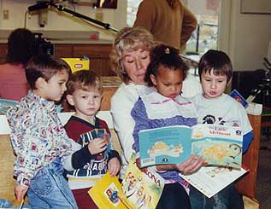  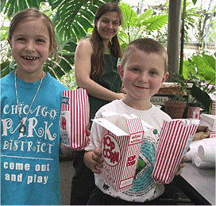

Etusivu  Vinkkejä matkailijoille  Lapin matkailu  Interrail  Au Pair  Kielimatkat  Lontoo  Tukholma  Matka USA:han  Iso-Syöte  Ympäristöystävällisyys  Oppilasyhdistyksen toiminta  Tekijät  Vanhemmat Bothniat | Kielimatka  Kielimatka on helppo vaihtoehto parantaa kielitaitoa ja saada uusia kokemuksia. Matkoja järjestetään kaikenikäisille. Tällainen kokemus on jännittävä, hauska ja kehittävä myös tulevaisuutta varten. Kielikurssin aikana kielitaitosi kehittyy huomattavasti. Oma panoksesi myös vaikuttaa asiaan. Opettajat ovat päteviä ja tunnit ovat erittäin mielenkiintoisia. Kielimatkoilla tapaat paljon uusia ystäviä. Opit tuntemaan nopeasti kurssikavereitasi kun yhdessä tutustutte kurssikohteeseen, käytte diskossa ja retkillä.  Isäntäperhe  Kurssilaiset majoitetaan usein paikallisiin perheisiin. Oleskelemalla toisessa maassa pidemmän ajan opit myös tuntemaan maan kulttuuria. Isäntäperheessä näet paikallisten ihmisten elämää ja pääset maistamaan ruokia, joita et ole Suomessa maistanut. Kielimatkoilla on korkeat vaatimukset isäntäperheiden suhteen. Kielimatkojen ohjaajat vierailevat isäntäperheissä ennen valintaa ja katsovat, että perhe täyttää tietyt vaatimukset. Usein yhteydenpito perheen ja oppilaan välillä jatkuu useita vuosia. Oppilaat, jotka lähtevät samaan kohteeseen uudelleen kielikurssille, haluavat useimmiten takaisin samaan isäntäperheeseen.  Opetus  Opettaja hoitaa opetuksen, mutta sen lisäksi hän on myös tukihenkilösi ja matkanjohtaja. Opettajaasi tapaat usein myös vapaa-ajalla. Opetusryhmät ovat pieniä, n. 10-15 oppilaan ryhmiä. Kurssin alussa tehdään testi, jossa ryhmitellään oppilaat kielitaidon mukaan. Opiskelussa on se etu , että kieltä kuulee jatkuvasti käytettävän arkipäivän tilanteissa. Tehtävät voivat liittyä arkipäivän tilanteisiin, esim. isäntäperheen haastatteluun, nuorisolehtien lukemiseen jne. Kurssien loputtua jokainen saa diplomin tulevaisuutta varten.  Vapaa-aika  Retket ja erilaiset tapahtumat täyttävät vapaa-ajan. Ohjaajat pitävät huolen siitä, että aina tapahtuu jotain mukavaa; retkiä, rannalla oleilua, kilpailuja yms. Kielimatkan hintaan sisältyvien retkien ja tapahtumien lisäksi voit varata lisää retkiä ja tekemistä.  Järjestäjät  Yleisimpiä kielimatkojen järjestäjiä ovat EF ja STS.  www.sts.fi  www.ef.fi  Hinnat  14 vrk 21 vrk 29 vrk  Tekijä: Susanna Vanhatalo
  Iso- Britannia | 1345€ | 1640€ | --
  Malta | 1385€ | 1500€ | --
  Saksa | 1495€ | 1625€ | --
  Espanja | -- | 1885€ | --
  Ranska | 1580€ | 1755€ | --
  USA | -- | -- | 2665€

Etusivu  Vinkkejä matkailijoille  Lapin matkailu  Interrail  Au Pair  Kielimatkat  Lontoo  Tukholma  Matka USA:han  Iso-Syöte  Ympäristöystävällisyys  Oppilasyhdistyksen toiminta  Tekijät  Vanhemmat Bothniat | Lontoo  Ensimmäistä kertaa suunnitellessani ulkomaille lähtöä oli määränpää ollut kuin asetettuna aivoihini jo aikojen alusta, mielessäni ei edes vilahtanut muita vaihtoehtoja. Matkakohteeni oli Lontoo.  Ensi kohtaaminen kaupungin kanssa oli järisyttävä. Kadulle noustessa hengen salpasi taivaisiin kohoavat rakennukset ja ihmisten loputon vilinä. Suu ammollaan ilon kiljahduksia päästellen tallustelin vihdoinkin Lontoon katuja. Kaikkialla välkkyi jättimäisiä mainoksia ja kaupungin kiivaan sykkeen pystyi lähes tuntemaan kävelyn rytmissä.  Pari ensimmäistä päivää meni kierrellen Lontoon keskustan tuntumassa, tutustuen pieniin kauppoihin, syöden tuoretta patonkia ja ihmetellen kaupungin suuruutta. Vaikka olen vieraillut Lontoossa kolme kertaa, en ole koskaan kierrellyt nähtävyyksiä.  Muutamana iltana lähdimme katselemaan kaupungin yöelämää, jossa kyllä oli valinnanvaraa nirsommallekin bailaajalle. Hippodrom oli kokemuksena omaa luokkaansa. Kolmikerroksisen yökerhon massiiviset peilipallot, valot, erikoistehosteet, esitanssijat ja suunnaton tanssilattia saivat tuntemaan itsensä kovin pieneksi. Tottumattomana ”maalaisena” ihmetyksen aihetta antoi myös erittäin tarkat turvajärjestelyt. Sisälle mennessä kaikki metalliketjut, suuremmat sormukset yms. esineet joilla voisi vahingoittaa toista takavarikoitiin pusseihin, jotka sitten lähtiessä palautettiin.  Tutustumisen arvoinen paikka on myös Camden town alue. Pieniä markkinakojuja on sullottu kymmeniä vieri viereen teiden varsilla oleville aukeille. Myytävänä on koruja, kankaita, seinävaatteita, ruokaa, takkeja ja asusteita jokaiselle tyylisuunnalle. Kierrellessä katettujen kojujen lomassa, tuntuu kuin siirtyisi toiseen aikakauteen ja paikkaan.  Parhaimmat muistot minulle kuitenkin jäivät, Notting Hill:n karnevaaleista, puistoissa vietetyistä piknikeistä ja ennen kaikkea ihmisten suunnattomasta ystävällisyydestä, kohteliaisuudesta ja ennakkoluulottomasta kiinnostuksesta Suomea ja suomalaisia kohtaan.  Sanna Vasankari | 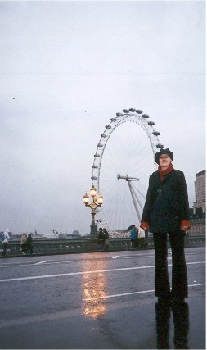

Etusivu  Vinkkejä matkailijoille  Lapin matkailu  Interrail  Au Pair  Kielimatkat  Lontoo  Tukholma  Matka USA:han  Iso-Syöte  Ympäristöystävällisyys  Oppilasyhdistyksen toiminta  Tekijät  Vanhemmat Bothniat | Tukholma  Tukholman kaupunki on yli 750 vuotta vanha. Tukholmaa pidetään yhtenä maailman kauneimmista kaupungeista. Ruotsin pääkaupunkina Tukholma on ollut vuodesta 1634. Ensimmäistä kertaa Tukholma nimetään historiassa vuonna 1252.  Tukholma on rakennettu usealle saarelle, joilla on kaikilla oma tunnelmansa. Tukholman eri kaupunginosilla on kullakin omat erityispiirteensä. Söder on pikkuputiikkien ja korttelikapakoiden kaupunginosa. Cityssä korostuvat shoppailu ja baarit, sieltä löytyvät tavaratalot, galleriat, putiikit ja illanviettopaikat. Östermalm on hiljaisempi ja hienostuneempi kaupunginosa, siellä sijaitsee esimerkiksi historiallinen museo ja Kaknäs-näköalatorni. Norrmalmille ovat ominaisia vuosisadan vaihteesta peräisin olevat asuintalot, konttorit ja etniset ravintolat.  Tukholman nähtävyyksiä  Kaupungintalo  Kaupungintalo on yksi Tukholman mielenkiintoisimpia rakennuksia. Sen 106 metriä korkean tornin huipulla on Ruotsin vanha symboli kolme kruunua. Kaupungintalo on Tukholman poliittinen keskus. http://www.personal.psu.edu/users/d/r/drj122/images/My%20Trips/stockholm%20city%20hall.jpg  Suurkirkko  Suurkirkko on Tukholman tuomiokirkko. Tukholman vanhin kirkko tarjoaa 700 vuotta ruotsin historiaa. Suurkirkko on täynnä arvokkaita kulttuuriaarteita.  http://www.stockholmtown.com/upload/storkyrkan200.jpg  Vanhakaupunki  Vanhakaupunki on Tukholman vanhin kaupunginosa. Vanhankaupungin suurimmalla saarella Stadsholmenilla on vielä jäänteitä 1200-luvun asutuksesta. Vanhakaupunki on kokonaisuudessaan historiallinen muistomerkki. Sieltä löytyy mielenkiintoisia putiikkeja, viehättäviä kahviloita ja ravintoloita. Kuninkaanlinna sijaitsee vanhassa kaupungissa.  http://www.viaggimagazine.it/VM/foto/2003/11/stoccolma/0-gamla-stan.jpg  Kuninkaanlinna  Kuninkaanlinna on yksi Euroopan suurimpia linnoja. Italialaista barokkia edustava linna valmistui vuonna 1754. Ruotsin kuningasperheet ovat asuneet Tukholmassa 1600-luvulta lähtien. Kuninkaanlinnassa suoritetaan vahdinvaihto, kesäisin puolenpäivän aikaan.  Tukholman kulttuuri  Kulttuurista kiinnostuneelle Tukholma tarjoaa vanhaa ja uutta. Perinteistä kulttuuria löytyy esimerkiksi museoiden, teatterien ja gallerioiden muodossa. Kaupungissa on noin 100 museota, joissa voi perehtyä kaupungin historiaan, kulttuuriin ja taiteeseen. Esimerkiksi Vasa-museossa on esillä vuonna 1628 Tukholman edustalla uponnut ja alkuperäisen veroiseksi kunnostettu kuninkaallinen Vasa-laiva. Tukholma on pohjoismaisen muotoilun ja kansainvälisten trendien näyttämö, josta löytää aina jotain uutta.  Luonto  Tukholman luonnonkauniissa ympäristössä on runsaasti kulttuurihistoriallisia nähtävyyksiä ja käyntikohteita. Tukholmassa on isoja viheralueita ja puhtaita vesistöjä suurkaupungin keskellä.  http://www.blackfrog.org/travel/europe2002/sweden_files/03_church_%20stockholm.jpg  Ravintolat  Tukholmassa on paljon ravintoloita laidasta laitaan. Ravintolat kiinnittävät huomiota ruuan lisäksi myös sisustukseen ja muotoiluun. Tukholmasta löytyy myös paljon kahviloita jokaiseen makuun. Tukholmalaiset ja turistit rakastavat kaupungin kahviloita.  Kauppakeskukset  Tukholmassa on useita suuria tavarataloja ja kauppakeskuksia. Ostoksien tekeminen on helppoa, koska useimmat kaupat ja putiikit ovat aivan keskustan tuntumassa. Vanhin on Hamngatanilla sijaitseva tyylikäs tavaratalo NK. Åhléns City on pinta-alaltaan suurin tavaratalo Ruotsissa. Keskellä Stureplania sijaitsee Sturegallerian hieno kauppakeskus.  Hotellit  Tukholmassa on paljon tasokkaita hotelleja. Useat hotellit ovat edullisia. Monissa kaupungin hotelleissa on myös mahtava merinäköala.  Matkustus  Tukholmaan voi lentää edullisesti, Arlanda on Euroopan vilkkaimpia lentokenttiä. Risteileminen on mukava tapa matkustaa Tukholmaan, jossa risteilyaluksia liikkuu paljon. Rautatie- ja moottoritieverkostot ovat kehittyneitä. Tukholma on tutustumisen arvoinen kohde ympäri vuoden, se muuttaa ilmettään ja muotoaan vuodenaikojen mukaan.  Linkit: www.tukholma.net  www.stockholmtown.com

Etusivu  Vinkkejä matkailijoille  Lapin matkailu  Interrail  Au Pair  Kielimatkat  Lontoo  Tukholma  Matka USA:han  Iso-Syöte  Ympäristöystävällisyys  Oppilasyhdistyksen toiminta  Tekijät  Vanhemmat Bothniat | Matka Amerikkaan  Meitä oli ryhmä suomalaisia, jotka halusivat oppia puhumaan englantia ja nähdä maailmaa. Aluksi vietimme kaksi viikkoa leirillä Stony Laken leirikeskuksessa. Tämän kahden viikon aikana vierailimme viikonlopun Kanadan puolella. Leirin jälkeen aloitamme kahden viikon mittaisen upean ja kokemuksia täynnä olevan matkamme Minneapoliksesta.  Minnesota  Ajaessamme aamuruuhkassa kohti Pohjois-Amerikan suurinta kauppakeskusta, Mall of Americaa, ajamme suoraan Minneapoliksen ydinkeskustan ohi. Minneapolis on Minnesotan osavaltion suurin kaupunki ja sen kyllä huomaa korkeista pilvenpiirtäjistä.  Saapuessamme Mall of Americaan saamme käsiimme kauppakeskuksen kartan. Lähdemme kiertelemään siellä olevia yli viisisataa kauppaa. Kauppakeskuksen keskellä on huvipuisto jossa on laitteita vuoristoradoista maailmanpyörään.  Seuraavana päivänä kiertelemme muualla Minneapoliksessa. Käymme Suomen muistomerkillä, johon on kirjoitettu kiitos suomalaisille siirtolaisille jotka ovat auttaneet rakentamaan ja kehittämään Minnesotaa.  Vierailemme myös Minnesotan "valkoisessa talossa", jossa säädetään Minnesotan osavaltion lait. Tämä Minnesotan eduskuntatalo on hieno. Sen parvekkeella olevat kultaiset hevoset upeine kultaisine vaunuineen loistavat rakennuksen kirkkaan valkoista seinää vasten.  Päivämme Minneapoliksessa ovat ohi ja lennämme Denveriin, Coloradoon.  Colorado  Ajamme bussilla kauniin vuoriston keskellä. Oppaamme kertoo välillä kiinnostavista tapahtumista ja paikoista joita ohitamme. Illalla saavumme pieneen vuoristokylään, Carbon Daleen. Kylä on mahtavien vuorten ympäröimä. Olemme korkeammalla merenpinnasta kuin jos olisimme Suomen korkeimman tunturin laella.  Aamulla menemme näköalahissillä ylös vuorelle. Vuorella voimme laskea ratakelkalla, kiivetä vuorelle, liitää suurella keinulla kallionkielekkeen yli syvän rotkon yllä ja paljon muuta. Kierrämme myös suurissa tippukiviluolissa opastetulla kierroksella. Opas kertoo mielenkiintoisesti tippukivien synnystä ja kehittymisestä.  Carbon Dalessa meillä on mahdollisuus käydä uimassa kuumissa lähteissä, mutta kenelläkään ei tee mieli kuuman päivän jälkeen uimaan kuumaan veteen.  Carbon Dalesta lähdemme parin päivän kuluttua bussilla kohti Utahia ja Grand Canyonia.  Utah  Utahissa yövymme motelleissa. Toinen motelleista sijaitsee navajo-reservaatissa. Siellä tarjotaan navajojen käyttämiä ruokia ja matkamuistomyymälöissä myydään intiaaneihin liittyviä tavaroita. Intiaanimusiikkia kuuluu joka paikassa. Maisemat ovat kuin aidosta Tex Willeristä.  Oppaamme kertoo paljon intiaaneista ennen ja nykyään. Vaellamme eräänä aamuna vuoren rinteellä olevaan valtavaan luolaan. Luolan takaseinämällä on intiaanien rakentamia asumuksia. Luola oli helposti puolustettavissa ja turvassa suuriltakin ryöstöjoukoilta.  Pysähdymme matkamme varrella kivipuistoon. Käymme kiertämässä siellä kierroksen oppaamme johdolla. Kävellessämme näemme maailman pisimmän kivikaaren, "surevan morsiamen" ja monia muita kivimuodostumia.  Seuraavana päivänä lähdemme jo heti aamulla Grand Canyonille. Se on 445 km pitkä, 29 km leveä ja lähes 2 km syvä. Ilma ei vielä näin aamusta ole liian tukala. Lähdemme oppaan johdolla vaeltamaan kanjonia alaspäin kanjonin seinämää pitkin kiertelevää polkua pitkin. Kahden ja puolen kilometrin matka taittuu nopeasti alamäkeen. Kun saavumme matkamme päähän, meitä odottaa vesipiste. Ihana juoda raikasta vettä! Kun alamme matkata ylöspäin, huomaamme kiipeämisen olevan paljon rankempaa. Hiki valuu, sillä lämpötila nousee koko ajan. Aurinkorasvaa kuluu, sillä aurinko paistaa jo polttavasti. Tuntuu kuin olisimme kävelleet pitkänkin matkan, mutta todellisuudessa kävelimme vain pienen matkan kanjonin sivuhaarassa, emmekä edes nähneet kanjonin pohjaa.  Matkamme Utahissa on oikeastaan vain läpikulku matka Arizonaan.  Arizona  Arizonaan saavuttuamme hämmästelemme suuria kaktuksia, jotka ovat korkeampia kuin bussimme. Täällä maisemat ovat aivan erilaisia monihaaraisine kaktuksineen ja palmuineen kuin Suomessa. Arizonassa on hyvin kuivaa. Vain muutaman kerran vuodessa siellä sataa.  Suurimman osan Arizonassa olostamme vietämme Phoenixissa. Se on USA:n viidenneksi suurin kaupunki. Phoenixissa lämpötila kohoaa yli 100 Farenhaitin eli todella lämmintä on. Celsius asteita kertyy jopa 40 - 50. Ilma on tukala. Suomessa oleva niin vilvoittava tuuli on täällä kuumaa. Ulkona ei voi olla, vain uima-altaalla. Sisällä taloissa ja autoissa tuulettimet ja ilman viilentimet hurisevat.  Illalla menemme Cactus Parkiin, kaktuspuistoon. Siellä kaktukset ovat suuria ja kauniita. Pelikenttiä on niin koripallonpelaajille kuin lentopalloa harrastavillekin. Uima-altaita on myös ja pehmeää nurmikkoa auringonottajia varten. Täällä pelailemme lentopallolla amerikkalaisten ystävien meille opettamaa peliä, spaikkia, juttelemme ja vain oleskelemme.  Pian lomapäivämme myös Arizonassa ovat ohi. On aika aloittaa kotimatka.  Tämä matka on ylittänyt kaikki suurimmatkin odotuksemme. Olemme tutustuneet ihmisiin ympäri maailman. Jäämme kaipaamaan Amerikan lämpöä, iloisia ihmisiä ja monia pienempiä ja huomaamattomiakin asioita.  Palaamme vielä…  Tehnyt: Ulla |     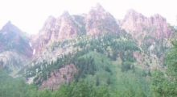  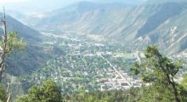  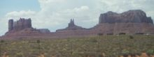  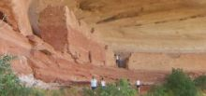  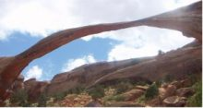  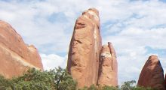  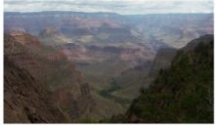  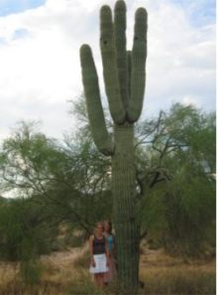

Etusivu  Vinkkejä matkailijoille  Lapin matkailu  Interrail  Au Pair  Kielimatkat  Lontoo  Tukholma  Matka USA:han  Iso-Syöte  Ympäristöystävällisyys  Oppilasyhdistyksen toiminta  Tekijät  Vanhemmat Bothniat | ISO-SYÖTE  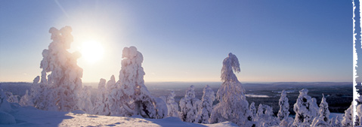  Iso-syöte sijaitsee Suomen eteläisimmällä tunturialueella.  Siellä voi harrastaa talvella laskettelua, lautailua, SnowTubing pulkkailua ja hiihtoa. Syötteeltä voi myös vuokrata moottorikelkkoja.  Rinteet avataan marraskuussa ja suljetaan huhtikuun lopulla. Rinteitä on yhteensä 14.Hissejä on yhteensä 2 + SnowTubingin hissi.  Iso- Syötteen asiakkaita palvelee monipuolinen varustevuokraamo, josta voi vuokrata suksia, lumilautoja, SnowTubing – renkaita. Siellä on myös pieni varustemyymälä, josta voi ostaa lasketteluun ja hiihtoon liittyviä välineitä.  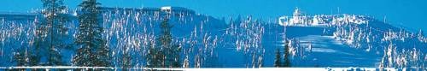  Hiihtokoulussa saa opetusta hiihtoon, lasketteluun, lumilautailuun ja telemarkiin. Hiihtokoulu on avoinna joka päivä klo: 10.00-15.00.  Majoitus  Hotelli Iso- Syöte sijaitsee tunturi huipulla, mistä avautuvat erämaisemat. Retkeilyreiteille, rinteisiin ja valoladuille pääsee suoraa hotellin pihasta. Hotellissa on suuri saunaosasto ja uima-allas.  Iso- Syötteen alueella on monia mökkikyläkeskittymiä. Kelosyötteellä on 28 hyvin varusteltua kelomökkiä ja Kotakahvilassa A-oikeudet.  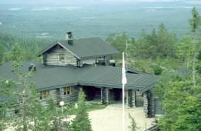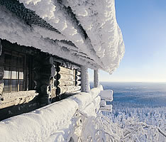  Vaunupaikat  Vaunupaikkoja on yli 350, jotka sijaitsevat tunturin juurella. Retkeilyreiteille, laduille ja rinteeseen sekä moottorikelkkailureiteille pääsee lähes suoraan vaunulta.  Ravintolat  Hotelli Iso- Syötteen maisemaravintola Panoraama on tunnettu korkeatasoisesta ruuastaan. Rinneravintola Romekievari sijaitsee Iso- Syötteen juurella, eturinteessä. Romekievari on tapaamispaikka ja hiihtosesongin tapahtumien keskipiste. Aurinkoterassilta voi katsella lumilautailukansaa ja laskettelijoita.  Uusi Rolls Express -hampurilaisravintola Romekievarin tiloissa.  Takarinteiden ravintola Pärjänkievari on karavaanareiden uusi tapaamispaikka. Ruokalistalta löytyvät pizzat, hampurilaiset ja pihvit.  Luontokeskuksen kahvilassa voi poiketa ennen ja jälkeen talvisen laturetken. Kahvila tarjoaa leivonnaisia kahvin kanssa.  Rinneliput  Snowtube  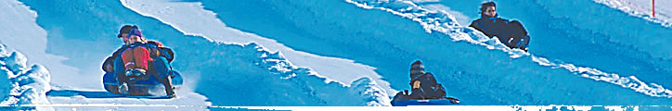  Johanna ja Elisa | 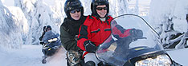  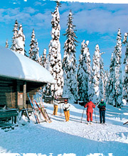  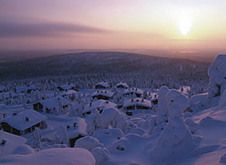  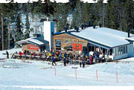  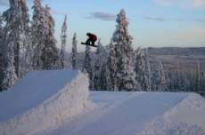
  Hinnasto | 3t | päivä | lisäpäivä
  paketti  (ei sis. kypärää) | 18€ | 25€ | 16€
  Pro sukset | 18€ | 24€ | 13€
  lumilauta +monot | 23€ | 28€ | 17€
  murtomaahiihto paketti | 12€ | 15€ | 11€
  Lipuntyyppi: | Normaalikausi
  päivälippu(10-17/20) | 24€
  iltalippu(17-20) | 18€
   | Normaalikausi
  1 tunti | 5€
  2 tuntia | 7€

Etusivu  Vinkkejä matkailijoille  Lapin matkailu  Interrail  Au Pair  Kielimatkat  Lontoo  Tukholma  Matka USA:han  Iso-Syöte  Ympäristöystävällisyys  Oppilasyhdistyksen toiminta  Tekijät  Vanhemmat Bothniat | Ympäristöystävällinen matkustaminen  Ympäristöystävällinen matkustaminen on matkustamista, jossa kulutetaan ympäristöä mahdollisimman vähän. Ympäristöllä tarkoitetaan ympärillämme olevaa elollista (ihmiset, eläimet, kasvit) ja elotonta (mm. vesi, ilma) luontoa, siis kaikkea, mitä ympärillämme on.  Miksi pitäisi toimia ympäristöystävällisesti?  Tehtaiden aiheuttamat saasteet ja autojen pakokaasut aiheuttavat SMOG- ja kasvihuoneilmiöiden sekä happamien sateiden lisääntymistä. Energian raaka-aineet, öljy ja uraani ovat vähissä.  Jos ei ryhdytä aktiivisesti säästämään ja suojelemaan ympäristöä, uusiutumattomat raaka-aineet hupenevat nopeammin loppuun, ilmasto lämpenee ja saastuu sekä vesi pilaantuu elolliselle luonnolle kelvottomaksi. Nämä ovat erittäin painavia syitä kiinnittää huomiota ympäristön tilaan jokapäiväisessä elämässä oman terveytensä ja henkensä vuoksi.  Miten ympäristöystävällisyys on huomioitu yritysmaailmassa?  Maailmalla sovittujen sopimusten, esimerkiksi Kioton sopimuksen takia yritysten on ollut pakko ottaa vastuuta ympäristöstään. Raaka-aineet valmistetaan päästörajoitusten vuoksi saasteettomammin kuin ennen. Päästörajoitukset ovat tiukat. Raahen terästeollisuusyritys Ruukkikin on joutunut tekemään muiden teollisuusyritysten kanssa päästökauppoja.  Tekniikkaa kehitetään myös runsaasti, jotta tuotteet olisivat ympäristöystävällisempiä käyttää. Tästä esimerkkinä kohtalaisen uusi suomalainen keksintö on Z-moottori. Se on Diesel-moottorin tapainen puristustyyppinen moottori. Sen on arvioitu olevan 20 % taloudellisempi ja 25 % halvempi valmistaa kuin nykyiset moottorit.  Tuotteiden valmistus ympäristöystävällisesti ja ympäristöystävällisiksi sekä kierrätys sujuu yrityksiltä jo mallikkaasti. Yritykset huolehtivat erittäin hyvin siitä, että kuluttajat voivat matkustaa ympäristöystävällisesti.  Miten ihmisten tulisi huomioida ympäristöystävällistä matkustamista?  Ihmiset eivät huomioi ympäristöystävällisyyttä tarpeeksi hyvin arjessaan. Se on nykyisin suuri huolen aihe. Paras vaihtoehto ympäristön kannalta olisi tietenkin, ettei matkustettaisi ollenkaan. Se on kuitenkin käytännössä mahdotonta toteuttaa ja toisaalta olisiko matkustamattomuus muka ympäristöystävällistä matkustamista: ei tietenkään. Virkavaltakaan ei voi lakipykälillä puuttua ihmisten ostopäätöksiin ja liikkumiseen. Ihmisten on itse osattava nähdä oma etunsa ja ottaa vastuu tarkemmin teoistaan.  Ihmiset voivat huomioida ympäristöänsä kulkemalla lyhyet matkat jalkaisin, pyörällä, rullaluistellen tai jollain muulla lihastyöllä tapahtuvalla matkustamismuodolla. He voivat miettiä tarvitsevatko varmasti oman auton vai voisivatko kulkea julkisilla kulkuneuvoilla. Myös agressiivinen ja kiireinen autoilu on nykyihmisten huono elämäntapa. Kaasu pohjassa kiihdyttäen ajokin käyttöikä vähenee ja bensaa kuluu huomattavasti enemmän kuin, jos ajettaisiin rauhallisemmin. Samalla auton omistaja säästää silkkaa rahaa. Omistajan on hyvä viedä täysin palvellut kulkuneuvonsa lopuksi kierrätykseen, varsinkin, kun kierrätys on Suomessa ilmaista. Kierrätyksestä on hänelle itselleen hyötyä monellakin tavalla. Ympäristö ei kulu eikä saastu niin pahasti, koska raaka-aineita ei tarvitse louhia niin paljon maaperästä, ajokit ovat pois rumentamasta näköpiiriä ja omistaja säästyy kaiken lisäksi mahdollisilta kahnauksilta viranomaisten kanssa.  Pienikin teko ympäristön hyväksi on askel eteenpäin.  Polttokennoautot ovat tulevaisuuden ympäristöteko  Joni Kurtti, L2B  Kuvien lähteet:  http://www.kouvolansanomat.fi/arkisto/vanhat/2001/02/03/uutiset/juttu2/sivu.html  http://www.msc-smc.ec.gc.ca/media/annual_report/2002-03/ourproducts_e.html |   Älä pyöri!  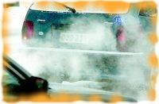  Huonolla tuurilla auton sisälle päässyt pakokaasu tappaa koko seurueen.  !Kopioitu Kouvolan Sanomien Irma Jäppisen luvalla!  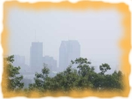  SMOG eli savusumu Montrealissa.  !Kopioitu Environment Canadan luvalla, 2005!  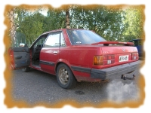  Pienetkin saastemäärät lisäävät sairastuneisuut- ta ja kuolleisuutta.  !Täysin vapaasti käytettävissä!

Etusivu  Vinkkejä matkailijoille  Lapin matkailu  Interrail  Au Pair  Kielimatkat  Lontoo  Tukholma  Matka USA:han  Iso-Syöte  Ympäristöystävällisyys  Oppilasyhdistyksen toiminta  Tekijät  Vanhemmat Bothniat | RAAHEN PORVARI- JA KAUPPAKOULUN OPPILASYHDISTYS  Ensimmäisenä haluan esitellä hienon, upean, mahtavan, loistavan ja parhaimman hallituksen mitä voi vain toivoa. Hallitukseen kuuluu Tanja "Taikku" Niinimaa (puheenjohtaja), Anniina "Nanna" Kastelli, Harri "Hartsa" Kylmänen, Paavo "Pate" Järvelä, Anna "Apa" Turpeenoja, Janika "Jannu" Itäpalo ja allekirjoittanut Tuire "Tuippa" Lampinen.  Me teemme paljon muutakin kuin kävelemme ympäri koulua (vaikkei sitä heti uskoisi). Toimintaamme kuuluu toimikunnat, joita ovat työvaliotoimikunta, liiketaloustoimikunta, oppilastoimikunta, urheilutoimikunta, huvitoimikunta, kansainvälisyystoimikunta ja tutortoiminta.  Huvi- ja Urheilutoimikunnan vastaavat ovat Anniina (kastelan@rpkk.fi) ja Tuippa (lampintu@rpkk.fi), eli jos ko. asioihin liittyen on kysyttävää tai ehdotuksia, mitä vain niin laittakaa mailia, yritämme parhaamme mukaan toteuttaa ideoitanne. Tutorvastaava on Anniina. Liiketaloustoimikuntaa ja Työvaliotoimikuntaa johtaa Tanja Niinimaa (niinimta@rpkk.fi) sekä toiminnanjohtaja Tiina Moilanen (moilanti@rpkk.fi).  Ruokala- Kahvio Merkantiini tarjoilee hyvää kahvia ja maistuvaa ruokaa (muistakaa kouluruokailun tärkeys!!) ja on oppilasyhdistyksen ylläpitämä.Oppilasyhdistyksen alaisuudessa toimii myös kirjakauppa Mercur, joka palvelee opiskelijabudjetilla eläviä. Kauttamme voit hankkia oppikirjat, kopiokortit, kynät, vihkot, paperit, opiskelijakortit, uimaliput, kuntosaliliput jne..  Oppilasyhdistyksen jäsenenä saat tuntuvia etuja paikallisista liikkeistä ja uusimpana etuna kauppakoulun bileisiin halvemmat liput. Oppyn jäsenenä voit myös hakea hallitukseen ja päästä kanssamme kahvittelemaan ja suunnittelemaan tempauksia oppilaiden pään menoksi. Jos haluat päästä vaikuttamaan kanssamme asioihin, liity jäseneksi ja pyri hallitukseen.  Oppilasyhdistys on liiketoimintaa, Ruokala- kahvio Merkantiini on oppilasyhdistyksen pyörittämä ja työllistää neljä ihmistä: ruokalan henkilökunnan sekä toiminnanjohtajan.  TUPSULAKIN TARINA  Merkonomilakin syntyyn liittyvät tapahtumat ovat läheisesti yhteydessä koulutusjärjestelmämme syntyyn.  Mistä nämä tupsulakit ovat lähtöisin ?  Jo toimintansa alkuvuosina Raahen Porvari- ja Kauppakoulussa (perustettu 1883) aloitti toimintansa myös oppilaskunta, jolla oli tapana kokoontua omiin neuvonpitoihinsa joka lauantai. Näitä kokouksia kutsuttiin nimellä konventsmöte, ja oppilaskunta puolestaan nimellä konvent. Säännöt konventin toimintaa varten hyväksyttiin 10.12.1892.  Eli idea merkonomilakista syntyi Raahen Porvari- ja Kauppakoulussa ja sen alkulähde on oppilaskunnan kokous.  Seuraavan kerran asiaa käsiteltiin oppilaskunnan kokouksessa 25.11.1893, jossa oppilaskunnan hallitus suositti lakkikomitean ehdotuksen hyväksymistä ja koko oppilaskunta päätettiin kutsua koolle lakkiehdotuksen esittämistä varten. 27.11.1893 ehdotus hyväksyttiin ja merkonomien valkolakkitupsu oli syntynyt. Ensimmäiset merkonomit lakitettiin lukukauden päättäjäistilaisuudessa 15.6.1894.  Oppilasyhdistystoiminnassamme on pitkät perinteet, jotka kantavat hedelmää yhä edelleen. | 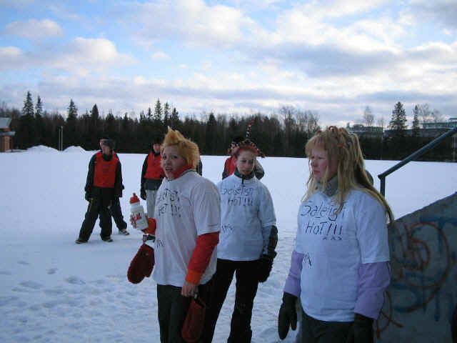

Etusivu  Vinkkejä matkailijoille  Lapin matkailu  Interrail  Au Pair  Kielimatkat  Lontoo  Tukholma  Matka USA:han  Iso-Syöte  Ympäristöystävällisyys  Oppilasyhdistyksen toiminta  Tekijät  Vanhemmat Bothniat | Tekijät  Oli rauhallinen kouluaamu kunnes Roy Viitanen lätkäisi nokan eteen paperin, jossa ilmoitettiin että nyt olisi meidän vuoro jatkaa perinnettä ja tehdä Bothnia verkkolehti. Luokkaan iski pieni paniikki. Mistä kukin kirjoittaisi verkkoartikkelin. Alku säpsähdyksen jälkeen alkoi jutunaiheita syntyä ja tässä ne kaikki on sitten yhteen koottuna. Toivon, että jokainen teistä saa jotain irti näiltä sivuilta. Erityisesti luokkamme L2B haluaa kiittää seuraavia opettajiamme Marjatta Koivu-Junnilaa, Roy Viitasta ja Satu Ahoa.

Etusivu  Vinkkejä matkailijoille  Lapin matkailu  Interrail  Au Pair  Kielimatkat  Lontoo  Tukholma  Matka USA:han  Iso-Syöte  Ympäristöystävällisyys  Oppilasyhdistyksen toiminta  Tekijät  Vanhemmat Bothniat | Vanhat Bothniat  Syksy 2003  Joulu 2003  Kevät 2004  Syksy 2004 D2C  Syksy 2004 L2B  Syksy 2004 L2A  Nordplusjunior

