Bilingualer Fachunterricht an Berufsbildenden Schulen

Unterrichtsmodul

Berufsfeld: Metalltechnik

COMPUTER
NUMERICALLY CONTROLLED
BORING- and MILLING WORK
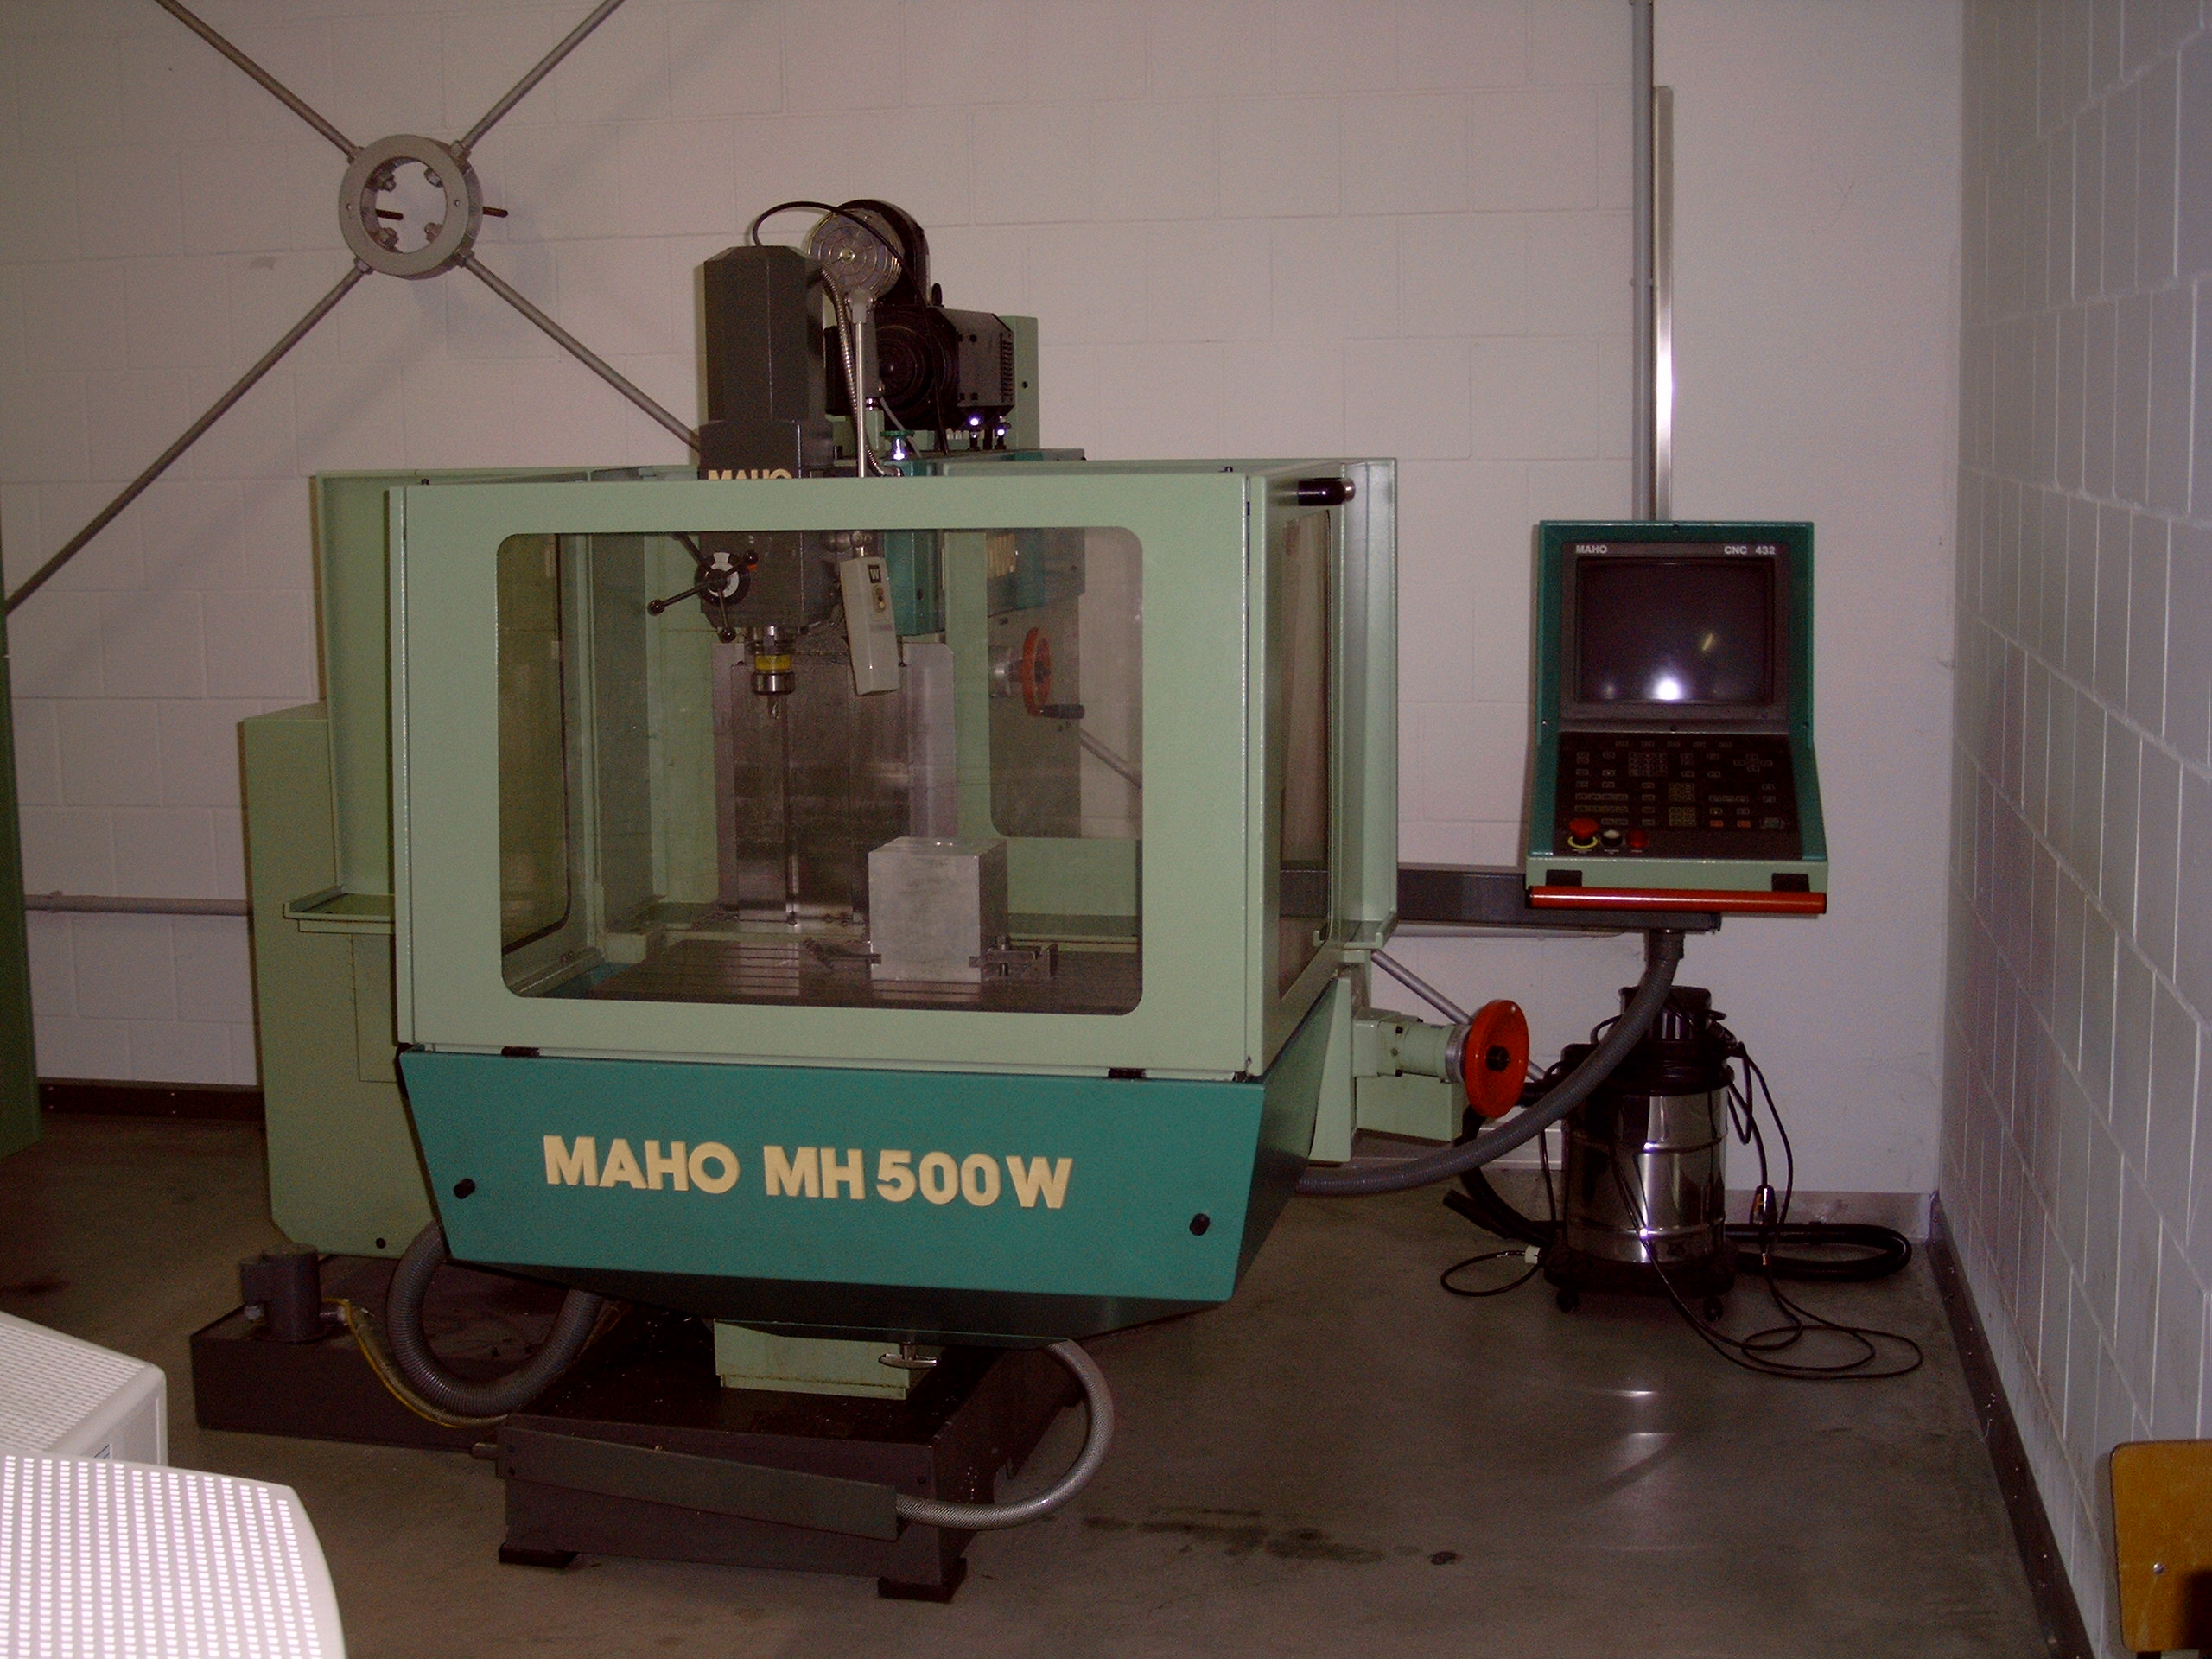

ACTION PROGRAMME OF THE EUROPEAN UNION
LEONARDO DA VINCI
PROJEKT NO.: 2002 LA 112 628 BILVOC
Language Competence Through
Bilingual Teaching at Vocational Colleges

Teaching Modules

Date of production 09/2005

Subject: Metal technology

Topic: Programming of CNC milling machines

Title: Boring - and milling work

Target Group: Any group of metal technology students

Prior Knowledge: Basic knowledge of computer numerical control

Level of Language Skills: Way stage (A2)

Follow - Ups: Programming exercises for machining of work piece
Drilling- and milling work

Objectives: To understand the importance of precautions

Benefits: Avoiding errors
Avoiding machine defects caused by faulty programmes
Teaching - module: Programming of computer controlled milling machines (CNC) and creation of a workshop drawing with the Computer (CAD)
12 lessons of 90 mins with the structure:

Teaching Time | Contents | Activities | Media | Activities
10 minutes  35 minutes  20 minutes  10 minutes  5 minutes  5 minutes  5 minutes | Introduction into conceptual formulation  Workshop drawing  CNC program  Discussion of results  Input of program  Simulation of machining  evaluation | Teacher – students discussion  Discussion about work sheet  Work with dictionary  Students work on pc  4 groups working with the work sheet  1 group present their results  Enter the program on Pc  Operation of software  Teacher – students discussion  Discussion of errors | worksheet  dictionary  worksheet  Computer with CAD - software  worksheet  solutions sheet  transparency, projector  Computer with CNC - software  Computer with CNC - software  Computer with CNC - software  solutions sheet | Lecture by teacher  Group discussion  Individual work on pc with teacher  Creation of CNC programme on the solution sheet  Students discussion of results  Input of programme into Pc  Operation of Pc  Individual work  Students presentation  Correction of errors
90 minutes




Zespo Szkó Mechanicznych
w Biaystoku

>>>Computer Numerically Controlled<<<
Tasks:
- Program machining of work piece with G90!
- Use commands G0 and G1!
- Enter program %1 into your computer and simulate machining!
- Consult your teacher for removing of any errors!

Input:
Tool – change - point (WWP): X=150; Y=100; Z=50  Rotation speed (S): 1800 1/min; 800 1/ min  Feed rate(F): 80 mm/min  Tools: T1 pre drill Ø 3  T2 drill Ø 10 | M03 spindle ON, clockwise rotation  M08 cooling medium ON  M09 cooling medium OFF  M30 main program STOP  G00 fast movement (rapid feed)  G01 straight line with given feed

Zespo Szkó Mechanicznych
w Biaystoku

>>>Computer Numerically Controlled<<<
Tasks:
- Please program machining of work piece with G90.
- Use commands G0 and G1, L83 and L92.
- Enter program %9 into your computer and simulate machining.
- Consult your teacher for removing of any failures.

Input:
Tool – change - point (WWP): X=150; Y=100; Z=50  Rotation speed (S): 1800 1/min; 800 1/ min  Feed rate(F): 80 mm/min  Tools: T1 pre drill Ø 3  T2 drill Ø 10 | M03 spindle ON, clockwise rotation  M08 cooling medium ON  M09 cooling medium OFF  M30 main program STOP  G00 fast movement (rapid feed)  G01 straight line with given feed

Zespo Szkó Mechanicznych
w Biaystoku

>>>Computer Numerically Controlled<<<
Tasks:
- Program machining of work piece with G90 and for centre point path of the tool!
- Use commands G0 and G1!
- Enter program %2 into your computer and simulate machining!
- Consult your teacher for removing of any errors!

Input:
Tool – change - point (WWP):  X=150; Y=100; Z=50  Rotation speed (S): 1200 1/ min  Feed rate (F): 60 mm/min  Milling depth: 6 mm  Tool: T1 cutter Ø10 | M03 spindle ON, clockwise rotation  M30 main program STOP  G00 fast movement (rapid feed)  G01 straight line with given feed  G90 absolute position

Zespo Szkó Mechanicznych
w Biaystoku

>>>Computer Numerically Controlled<<<
Tasks:
- Program machining of work piece with G90 and for centre point path of the tool.
- Use commands G0, G01, G02 and G03.
- Enter program %3 into your computer and simulate machining.
- Consult your teacher for removing of any errors.

Input:
Tool – change - point (WWP):  X=150; Y=100; Z=50  Rotation speed (S): 1200 1/ min  Feed rate (F): 60 mm/min  Milling depth: 6 mm  Tool: T1 cutter Ø8 | M03 spindle ON, clockwise rotation  M30 main program STOP  G00 fast movement (rapid feed)  G01 straight line with given feed  G90 absolute position  G02 circular are clockwise  G03 circular are anticlockwise

Zespo Szkó Mechanicznych
w Biaystoku

>>>Computer Numerically Controlled<<<
Tasks:
- Program machining of work piece with G90 and for centre point path of the tool.
- Use commands G00, G01, G02 and G03.
- Enter program %4 into your computer and simulate machining.
- Consult your teacher for removing of any errors.

Input:
Tool – change - point (WWP):  X=150; Y=100; Z=50  Rotation speed (S): 2500 1/ min  Feed rate(F): 60 mm/min  Milling depth: 6 mm  Tool: T1 cutter Ø6 | M03 spindle ON, clockwise rotation  M30 main program STOP  G00 fast movement (rapid feed)  G01 straight line with given feed  G90 absolute position  G02 circular are clockwise  G03 circular are anticlockwise

Zespo Szkó Mechanicznych
w Biaystoku

>>>Computer Numericlly Controlled<<<
Tasks:
- Program machining of work piece with G90 and for centre point path of the tool.
- Use commands G00, G01, G02 and G03.
- Enter program %5 into your computer and simulate machining.
- Consult your teacher for removing of any errors.

Input:
Tool – change - point (WWP):  X=150; Y=100; Z=50  Rotation Speed (S): 2500 1/ min  Feed rate(F): 60 mm/min  Milling depth: 3 mm  Tool: T1 cutter Ø6 | M03 spindle ON, clockwise rotation  M30 main program STOP  G00 fast movement (rapid feed)  G01 straight line with given feed  G90 absolute position  G02 circular are clockwise  G03 circular are anticlockwise

Zespo Szkó Mechanicznych
w Biaystoku

>>>Computer Numerically Controlled<<<
Tasks:
- Program machining of work piece with G90 and with tool path correction.
- Use commands G00, G01, G02, G03, G40, G41 and G42.
- Enter program %6 into your computer and simulate machining.
- Consult your teacher for removing of any errors.

Input:
Tool – change - point (WWP):  X=150; Y=100; Z=50  Rotation speed (S): 1200 1/ min  Feed rate(F): 60 mm/min  Milling depth: 10 mm  Tools: T1 cutter Ø 30  G40 Tool path correction OFF  G41 Tool path correction ON and left  G42 Tool path correction ON and right | M03 spindle ON, clock wise rotation  M30 main program STOP  G00 fast movement (rapid feed)  G01 straight line with given feed  G90 absolute position  G02 circular are clockwise  G03 circular are anticlockwise

Zespo Szkó Mechanicznych
w Biaystoku

>>>Computer Numerically Controlled<<<
Tasks:
- Program machining of work piece with G90 and with tool path correction.
- Use commands G00, G01, G02, G03, G40, G41 and G42.
- Enter program % 7 into your computer and simulate machining.
- Consult your teacher for removing of any errors.

Input:
Tool – change - point (WWP):  X=150; Y=100; Z=50  Rotation speed (S): 1200 1/ min  Feed rate(F): 60 mm/min  Milling depth: 10 mm  Tools: T1 cutter Ø20  Tool path correction OFF  Tool path correction ON and left  Tool path correction ON and right | M03 spindle ON, clockwise rotation  M30 main program STOP  G00 fast movement (rapid feed)  G01 straight line with given feed  G90 absolute position  G02 circular are clockwise  G03 circulare are anticlockweise

Zespo Szkó Mechanicznych
w Biaystoku

>>>Computer Numericlly Controlled<<<
Tasks:
- Program machining of work piece with G90 and for centre point path of the tool.
- Use commands G00, G01, G02 and G03.
- Enter the main program %8 and both subroutines L110 / L111 into your computer and simulate machining.
- Consult your teacher for removing of any failures.

Input:
Tool – change - point (WWP):  X=150; Y=100; Z=50  Rotation speed(S): 2500 1/ min  Feed rate(F): 60 mm/min  Milling depth: 3 mm  Tool: T1 cutter Ø6 | M03 spindle ON, clockwise rotation  M30 main program STOP  M17 subroutine END  G01 straight line with given feed  G02 circular are clockwise  G03 circular are anticlockwise

Zespo Szkó Mechanicznych
w Biaystoku

>>>Computer Numerically Controlled<<<
Tasks:
- Please program machining of work piece with G90, with tool path correction and the circle – like depression as well as rectangle depression with corresponding cycles!
- Use commands G00, G01, G02, G03, G40, G41, G42 and variables for the depressions!
- Enter program %10 into your computer and simulate machining!
- Consult your teacher for removing of any failures!

Input:
Tool – change - point (WWP):  X=150; Y=100; Z=50  Rotation Speed(S): 1500 1/min  2500 1/ min  Feed rate(F): 60 mm/min  Milling depth: 6 mm  Tools: T1 cutter Ø30,  T2 cutter Ø12 | M03 spindle ON, clockwise rotation  M30 main program STOP  G00 fast movement (rapit feed)  G01 straight line with given feed  G90 absolute position  G02 circular are clockwise  G03 circular are anticlockwise  R01, R02, …. Parameters of cycles

Zespo Szkó Mechanicznych
w Biaystoku

>>>Computer Numerically Controlled<<<
Tasks:
- Please program machining of work piece with G90 and for centre point path of the tool.
- Use commands G0 and G1 as well as cycle polar multiple copying.
- Enter program %11 into your computer and simulate machining.
- Consult your teacher for removing of any errors.

Input:
Tool – change - point (WWP):  X=150; Y=100; Z=50  Rotation Speed(S): 1800 1/ min  Feed rate(F): 60 mm/min  Milling depth: 6 mm  Tool: T1 Cutter Ø10 | M03 spindle ON, clockwise rotation  M30 main program STOP  G00 fast movement (rapid feed)  G01 straight line with given feed  G90 absolute position  A 60°

Zespo Szkó Mechanicznych
w Biaystoku

>>>Computer Numerically Controlled<<<
Taskse:
- Please program machining of work piece with G90, with tool path correction and the circle – like depression as well as rectangle depression with corresponding cycles.
- Use commands G00, G01, G02, G03, G40, G41, G42 and variables for the depressions.
- Enter program %12 into your computer and simulate machining.

Input:
Tool – change - point (WWP):  X=150; Y=100; Z=50 | Select commands and parameters free (as you like)

Answer sheet EN
 | X= |  |  |  | Y= |  |  |  | Z= |  |  |  |  |  | Row part dimension

Tool store
T 1 |  |  |  |  |  |  |  |  |  |  |  |  | T 4
T 2 |  |  |  |  |  |  |  |  |  |  |  |  | T 5
T 3 |  |  |  |  |  |  |  |  |  |  |  |  | T 6

Program
N | G | X | Y | Z | I | J | T | S | F | M |  | N |  | G |  | X | Y | Z | I | J | T | S | F | M

