Bilingualer Fachunterricht an berufsbildenden Schulen

Unterrichtsmodul

Berufsfeld: Elektrotechnik

Beruf: Elektroniker

Capacitor

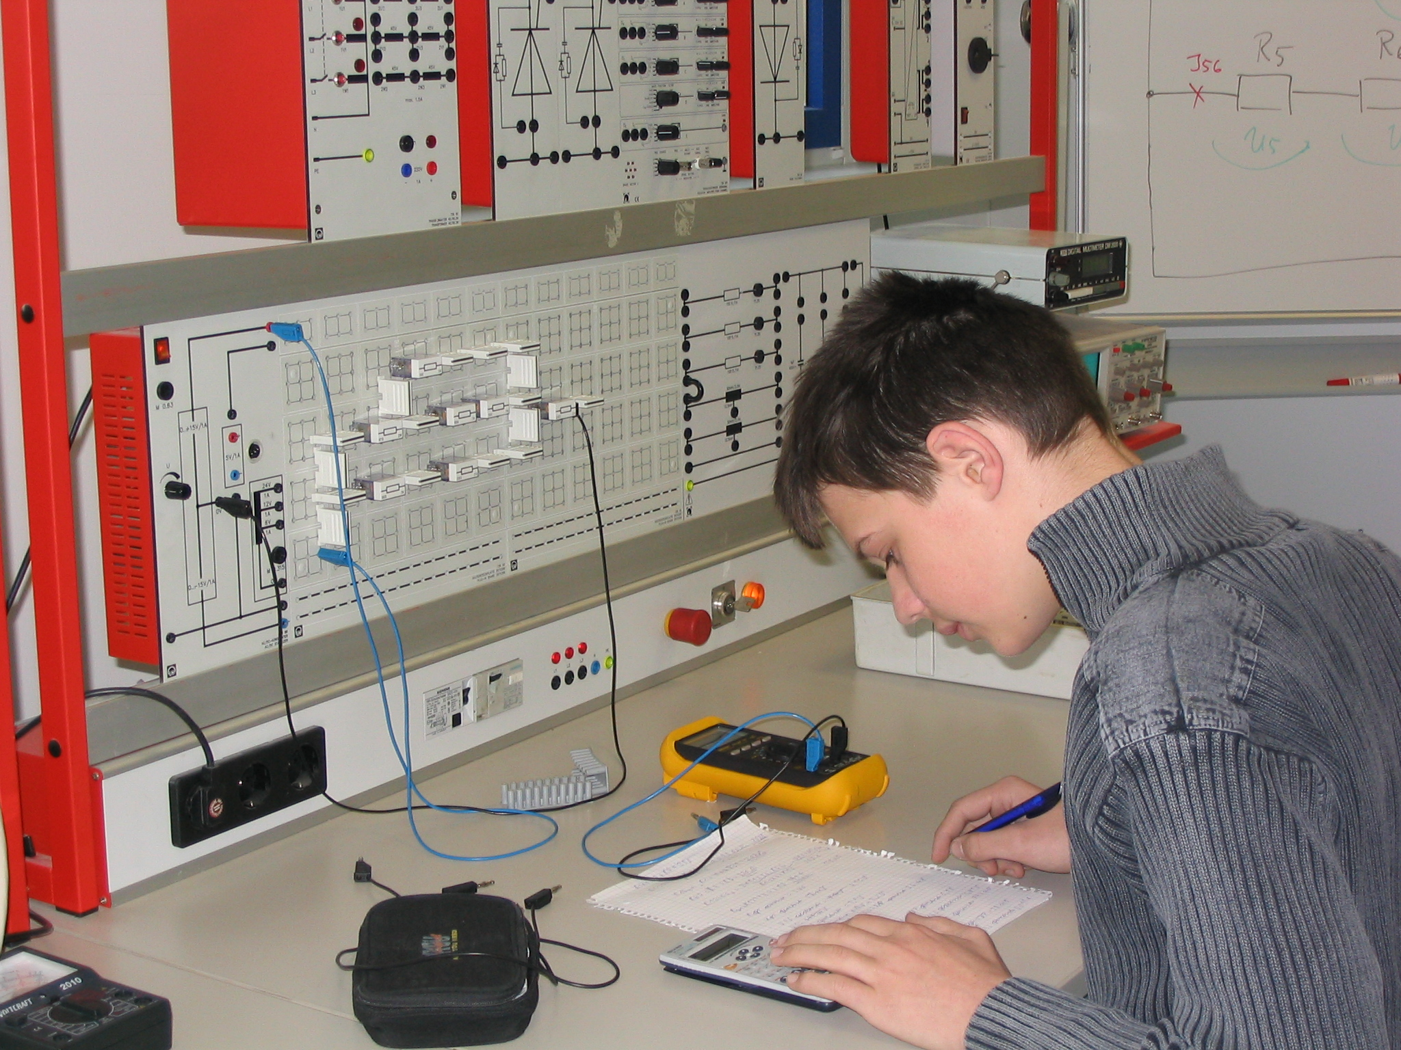

ACTION PROGRAMME OF THE EUROPEAN UNION
LEONARDO DA VINCI
PROJEKT NO.: 2002 LA 112 628 BILVOC
Language Competence Through
Bilingual Teaching at Vocational Colleges

Teaching Modules

Date of production 09/2005

Subject: Electrical technology

Topic: Capacitor

Title: Charge and discharge of the capacitor

Target Group: Any group of electrical engineering students

Prior Knowledge: Basic of electrical engineering

Level of Language Skills: Waystage (A2)

Follow - Ups: Excercise with other electronic components

Objectives: Capacitor in the technic

Benefits: Rrelationhip between the voltage, curent and capacity

Teaching Module: capacitor

Teaching Time  (experience) | Contents | Activities | Media | Skills
45 minutes  15 minutes  60 minutes  30 minutes  20 minutes | Introduction and repetition to the topic  Capacitor  Formulation for the excercise  Construction of the wiring and execution of this one  Test according to formulation  Preparing the diagrams  evaluation | Pupil conversation  Disskusion  Work with the dictionary  Teacher lecture  Groups work with the formulation  Construction of the wiring  Noting down the results  Groups draw the diagrams with your measurement results  Evaluation and conclusion from the results | Board, worksheet  dictionary  transparency  Excercise board  paper  transparency | Lessons conversation under use of the entry knowledge of the pupils  Individual work  Circuit arrangement with this  Excercise board  Individual work of the students  Discussion of the results in the stdents conversation
170 minutes

Excercise Capacitors

1. Theory

Capacitors

Capacitors are the constructive elements, which are able to store electrical charges for example electrical energy.

In it’s simplest form a capacitor consists of two metal plates lying opposite each other.

Between these metal plates lies a ‘dilektric materia’, which prevents any electrical connection between the two plates. (Isolator)

When the capacitor is connected to a voltage an electrical field develops between the two plates.

‘Charging-time’ of a Capacitor.

To calculate the charging-time the value of the resistance on the capacitor and of the capacitor itself will be needed.

The level of voltage has no influence on the time it takes to charge.

Charging occurs quicker;

- The smaller the capacitor is.
- The smaller the circuit resistance is.

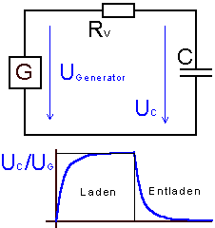

Calculation of the charging-time
R * C is only a fraction of the charging time.
Time constant τ
τ=R*C

After 5 Time constants the capacitor is charged
t_{E} = 5 * τ

Capacitors in a direct current circuit.

- When switched on the capacitor operates as a short circuit.
- The capacitor can store electrical energy.
- Obstructs the direct current
- charges and discharges itself in an E-function.

When switched on the electricity heavily increases.

After which the capacitor becomes high ressistance so that the electricity decreases and the voltage increases.

t

Voltage: $\text{Uc}=U∗(1−e−\frac{t}{RL∗C})$

Current: $\text{Ic}=\frac{U}{RL}∗e−\frac{t}{RL∗C}$

When switched on t= 0s $\text{Ico}=\frac{U}{RL}$

Discharge capacitor
When discharge the voltage diminishes and the current rises. The current runs in the other direction.

Voltage: $\text{Uc}=U∗e−\frac{t}{RE∗C}$

current:

When switched on t= 0s $\text{Ico}=\frac{U}{RE}$

Exercises

1. Measure the voltage charge and discharge in 10 s measurements until the capacitor is charged.

Caution: Amps reverse the charge.

2. Measure the voltage charge and discharge. in 10s until the capacitor is charged.

3. Calculate the starting current.

4. Show the diagrams for the voltage charge and discharge, current charge and discharge on a piece of millimeter squared paper in oblong format.

MEASURING DIAGRAM
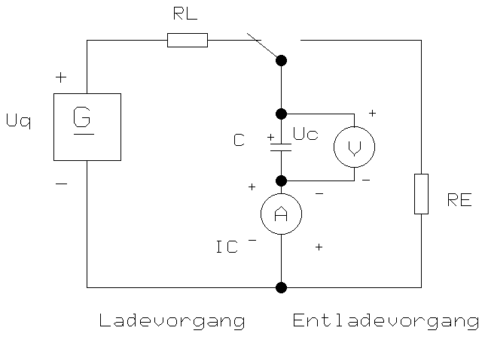

C= 470 µF

RL= 47 kΏ

RE= 47 kΏ

Uq= 15 V

CHARGE
DISCHARGE

Result - Diagram
 | L A D E V O R G A N G |  |  | E N T L A D E V O R G A N G
Zeit in Sek. | Ic in Ampere | Uc in Volt |  | Ic in Ampere | Uc in Volt
0 | 0,000319149 | 0 |  | 0,000319149 | 15
10 | 0,000202951 | 5,46130509 |  | 0,000202951 | 9,53869491
20 | 0,000129059 | 8,93421996 |  | 0,000129059 | 6,06578004
30 | 8,20704E-05 | 11,1426916 |  | 8,20704E-05 | 3,85730835
40 | 5,21896E-05 | 12,5470875 |  | 5,21896E-05 | 2,4529125
50 | 3,31881E-05 | 13,4401611 |  | 3,31881E-05 | 1,55983893
60 | 2,11047E-05 | 14,0080782 |  | 2,11047E-05 | 0,99192185
80 | 8,53444E-06 | 14,5988814 |  | 8,53444E-06 | 0,40111865
100 | 3,4512E-06 | 14,8377935 |  | 3,4512E-06 | 0,1622065
120 | 1,39562E-06 | 14,9344061 |  | 1,39562E-06 | 0,06559393
140 | 5,64366E-07 | 14,9734748 |  | 5,64366E-07 | 0,02652522
160 | 2,28222E-07 | 14,9892736 |  | 2,28222E-07 | 0,01072641
180 | 9,22894E-08 | 14,9956624 |  | 9,22894E-08 | 0,0043376
200 | 3,73205E-08 | 14,9982459 |  | 3,73205E-08 | 0,00175406
240 | 6,10293E-09 | 14,9997132 |  | 6,10293E-09 | 0,00028684
300 | 4,03575E-10 | 14,999981 |  | 4,03575E-10 | 1,8968E-05

DIAGRAM

Evaluation

1. Use the time constant τfrom the measured functions and calculate it from C.
2. Calculate the from U_{rl}=f(t) and add it to the diagram.
3. How do the charge and discharge times change when C; R_{e} and R_{l} change.
4. Name possible uses of capacitors.

Words

Capacitor Kondensator
capacity Kapazität
dielectric material Dielektrikum
charge Ladung
discharge Entladung

