Bilingualer Fachunterricht an berufsbildenden Schulen

Unterrichtsmodul

Berufsfeld: Ernährung/Hauswirtschaft

Beruf: Restaurantfachleute
Hotelfachleute

Coffee
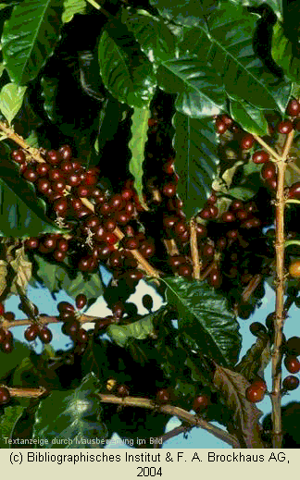

ACTION PROGRAMME OF THE EUROPEAN UNION
LEONARDO DA VINCI
PROJEKT NO.: 2002 LA 112 628 BILVOC
Language Competence Through Bilingual Teaching

Teaching Module

Date of production 09/2005

Subject: catering

Topic: beverage technology

Title: coffee

Target Group: any group of catering students (first year)

Prior Knowledge: tea

Level of Language Skills: waystage (A2)

Follow - Ups: summary hot beverages

Objectives: students get an overview on the regions where coffee is grown, on processing the coffee beans and on different kinds of coffee, tasting terminology

Benefits: history of coffee, regions where coffee is grown, processing the coffee beans, tasting session, brewing and serving coffee
Teaching Module: coffee

Teaching Time  (experience) | Contents | Activities | Media | Skills
15 minutes  30 minutes  15 minutes  30 minutes  30 minutes  20 minutes  40 minutes  30 minutes  60 minutes  variation:  60 minutes | general knowledge about coffee, find out the information and words needed to work on the topic  structure the gathered knowledge  make a mind-map on coffee (English and/or German  regions where coffee is grown (coffee belt)  processing the coffee beans  tasting terminology/  brewing and serving coffee  tasting terminology/  brewing and serving coffee  tasting session  exercises  1. How should you prepare coffee in western Europe?  2. How is coffee prepared in Arabia?  summary coffee  coffee from Costa Rica  instead of lsummary | brainstorming/ revision  )  Individual work (group work)  group work, discussion  Individual work – translating and structuring (making a flow-chart)  work in 2 groups according to the 2 themes  presenting the information,  discussion  individual work, discussion  individual work, check answers  reading exercise and/or making an own summary – 1 sheet only, presenting the summaries  individual or group work for students with language skills above A2, presenting the information to the class | board, worksheets  worksheets, dictionaries  maps, worksheets  worksheet, dictionary, wordlist  worksheets, wordlist/ dictionary  worksheets, transparency, board  worksheets,  wordlist/ dictionary, worksheets  worksheets, wordlist/ dictionary, board, transparency  worksheets, wordlist/ dictionary, board, transparency | classroom discussion,  using dictionaries, note taking, mind-mapping skills  marking information in a map  translating skills, using dictionaries and glossaries  note taking  presentation skills  tasting and note taking  language skills  reading and presentation skills, summarising skills  reading and presentation skills, summarising skills
270 minutes

Exploring the world of coffee

Encircling the world, within the tropical latitudes, is a narrow belt- the coffee belt. This tropical region supports the coffee tree, which requires abundant sunshine, moderate rainfall, year-round warm temperatures averaging 70° F and no frost.

Two species of coffee trees produce coffees of commercial importance. The robusta is, as the name implies, a robust species, resistant to disease, with a high yield per plant. Flourishing at low elevations, it produces harsh coffees that are also high in caffeine. The arabica, which accounts for about 75% of the world production, thrives in volcanic soil at high altitudes of 3,000 to 6,500 feet. Arabica yields the world’s best coffees, more refined than robusta coffees, with a caffeine level less than half that of robusta beans. The slower growing cycle of arabica coffee trees at higher elevations concentrates still more flavour in the beans, producing some of the finest of all coffees - so-called high-grown beans.

Many nations within the coffee belt produce fine arabica coffees. While coffees will differ from one country or area to the next, depending on growing conditions and preparation methods, those in each general coffee-growing region in the world exhibit common characteristics that you can learn to recognize, linking them in a geographic coffee “family“.

EAST AFRICA and ARABIA
Beans from the region that gave birth to coffee generally have rich flavour, sparkling acidity, unique floral or winy qualities and medium to full body. Included in this family are coffees from Burundi, Ethiopia, Kenya, Malawi, Tanzania, Uganda, Yemen, Zambia and Zimbabwe.

INDONESIA and the PACIFIC
Dutch traders spread coffee cultivation to Indonesia by the late 17th century. These coffees are usually smooth, earthy and exotic-tasting, with low acidity and full body. The family includes coffees from Java, Sulawesi and Sumatra. Coffee from Papua New Guinea, while geographically related, has a spicier, more pointed flavour with brighter acidity - an exception to the family rule

AMERICAS
The French, Dutch and Portuguese began cultivating coffee here in the 1720s.Today`s best coffees from this family are clean-tasting and lively, with light to medium body. Included in this group are Colombia, Costa Rica, Guatemala, Honduras, Jamaica, Mexico, Nicaragua and Panama as well as coffee from Kona, the south-western coast of the island of Hawaii.

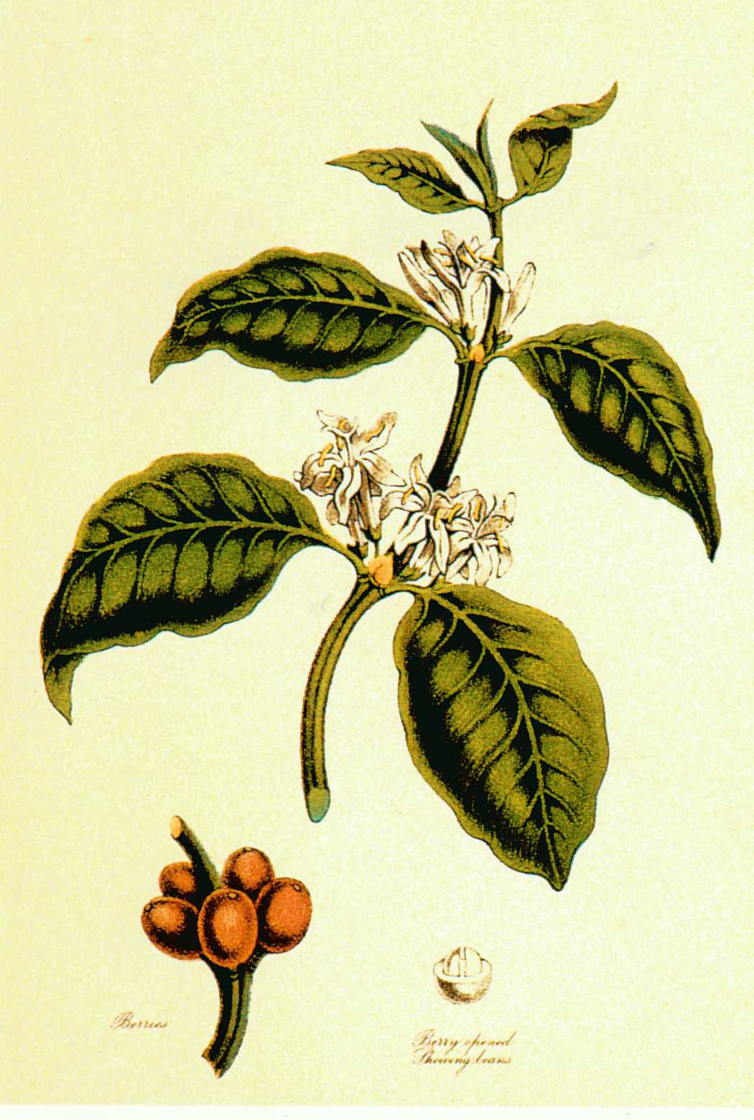

Coffee beans - the way from the tree to the roaster

Wherever in the world high-quality coffee is grown, it follows a similar journey to reach a coffee roaster’s warehouse.
Most often called a tree, the plant that gives us coffee is actually a tropical evergreen shrub with delicate white blossoms whose intense fragrance resembles that of jasmine. The “beans“ are in fact the seeds or pits of the fruit - known as coffee cherries for their plumpness and ripe red colour. Each cherry normally contains two beans, which grow with their flat sides facing each other.

It usually takes about five years for a coffee tree to bear the first full crop, at which stage it will have grown and been pruned to maintain a height of about 6 feet. The tree can continue to be productive for 15 years or more, annually producing enough cherries to yield about one pound of roasted coffee.
Not all coffee cherries ripen at the same time, and any branch of a tree might simultaneously bear blossoms, green fruit and ripe cherries. So quality coffees must be picked entirely by hand, a process that requires three or four visits per tree each year. In one day, an experienced coffee plantation worker can pick up to 200 pounds of ripe cherries, equivalent to 50 pounds of green coffee beans.

Once the cherries have been picked, the beans must be extracted from them. The task may be accomplished by one of two different methods, determined by the availability of water in the region where the coffee is grown.
The wet method, used in major Latin American coffee countries (except Brazil) and in other regions, requires abundant fresh water. Firstly, a machine stripes away the outer two layers of skin and fruity pulp. The beans, still tightly enclosed in a sticky inner pulp and a tight parchment wrapper, are soaked for 24 to 72 hours in large fermentation tanks. This process loosens the fruity pulp, which is washed away. The beans are then dried in the sun or in mechanical driers. The resulting beans, sometimes known as “washed“ coffees, generally will have higher acidity and cleaner, more consistent flavours than beans processed by the dry method.
In the dry, or “natural“, method, coffee cherries are spread out to dry in the sun for two or three weeks. When the fruit has dried, a hulling machine stripes away the outer skin and pulp. Though the results are not always consistent in quality. the acidity of the beans is reduced and the body increased. Many of the world’s greatest coffees - including Arabian Mocha and many Indonesian varieties - are processed by this method.

After wet or dry processing, a mill removes any remnants of the parchment along with the silver skin, a tissue-thin covering that clings to the beans. The beans are then carefully sorted by hand and machine to remove defects and to separate them by size before they are bagged, graded for quality and readied for sale.

The quality and consistency of a sample of coffee beans is judged through “cup testing“, a ritualised and scientific process as simple but as exact as wine tasting.
Tasters keep notes on general and specific impressions of each coffee’s flavour, acidity and body, and of the consistency of these characteristics from one cup to the next.

The world’s best coffee beans realize their full potential only through careful batch roasting - a process monitored and adjusted constantly by a skilled roasting expert. Over the course of 11 to15 minutes, depending on the individual batch, the temperature of the beans rises to as high as 450°F.Their colour progresses from straw-green, to yellow-orange, to light cinnamon to an optimal rich chestnut brown. The colour is allowed to to turn darker still for espresso and Italian and French roasts. Along the way, the beans pop open, doubling in size while losing about 18% of their weight (up to 25% weight in a French roast).
The most important transformation occurs in the volatile flavour oils of the coffee beans. The oil gradually develops to the critical point at which their variable character is fully realized, with every flavour element in perfect balance. At that precise moment the beans are released into a rotating cooling tray. In just 4 minutes, powerful fans draw off their heat, and the beans darken one final shade as they swirl around.

Flavour development during roasting

green / raw beans
In their raw state, coffee beans look like inert green pebbles, their flavour potential locked deep within.

yellow / moisture loss
After 5 to 7 minutes, the beans begin to lose moisture and turn yellow-orange. Yellow beans exude a distinctive aroma, often compared to buttery vegetables.

cinnamon roast / beans pop open
The beans increase in size and turn a light tan. Sour “green“ flavours predominate, and body and complexity remain undeveloped. This stage is sometimes called an “institutional“ roast.

city roast / acidity dominates body
At 10 to 11 minutes, the beans reach an even, light brown, developing a full flavour dominated by markedly high acidity.

fully ripe roast
After 11 to 15 minutes, the beans turn a rich chestnut brown. At this stage, their acids and sugars are uniquely balanced, and their full variable character has been realized.

dark roasts/ caramelly and spicy to pungent and smoky
The flavour becomes focused, rich and sweet; natural sugars caramelise, making this roast ideal for espresso. A bit darker and oils come to the surface, producing a sweet but lighter bodied cup. Finally, pushed to the limit, beans turn dark and shiny, taking on an intense, smoky flavour.

Tasting terminology

So many adjectives apply to the taste of coffee that descriptions of specific variable and blends can begin to resemble poetry. Such words are subjective, and whatever descriptions work best for you are fine.

In describing your own response to coffee-tasting experiences, it might help to bear in mind the three fundamental aspects of any coffee’s taste.

1. Flavour
The most important tasting term describes the total impression of aroma, acidity and body. It can be used generally ("this coffee is flavourful“) or with specific attributes in mind (“this coffee has a flavour of reminiscent of chocolate).

2. Acidity
This easily misunderstood term refers to the lively, palate-cleansing property characteristic of all high-grown coffees, which is experienced primarily on the sides of the tongue. Acidity is not the same as bitterness.

3. Body
The tactile impression of brewed coffee in your mouth can be described as light, medium or full. Some coffees naturally have more body than others. The brewing method also affects the perception of body. Coffees made in a French press or an espresso machine seem to be fuller in body than those brewed by other methods.

other tasting terms
-aroma: fragrance of brewed coffee
-earthy: spicy taste “of the earth“ is often used to describe Indonesian coffees
-exotic: applied to coffees with an unusual aroma or flavour suggestive of flowers, berries or sweet spices, for example.
-mellow: well-balanced coffee of low to medium acidity
-mild: denotes coffee with harmonious flavour, such as high-grown Latin American coffees
-soft: low-acid coffees such as Indonesians, which may also be called mellow or sweet
-spicy: describes an aroma or flavour reminiscent of a particular spice
-sweet: smooth and palatable
-tangy: denotes a darting, pleasing brightness
-wild: racy nuances of flavour, as found in Ethiopia Harrar
-winy: fruitlike acidity and smooth body reminiscent of fine red wine

A little guide to different coffees

Bright, mild and welcoming

-Kona: smooth, gentle and mild
-Mexico Altura: light and lively, with a delicate nutty flavour
-Costa Rica Tres Rios: lively, fragrant and tangy, with a morning brightness
-Ethiopia Sidamo: sweet flavour and floral aroma
-Ethiopia Yergacheffe: medium-bodied, with sweet flavour and aroma
-Tanzania: clean and direct flavour, with a brisk liveliness

Deep, complex and satisfying

-Guatemala Antigua: complex and refined, with hints of cocoa and spice
-Colombia Narino Supremo: unusually full-bodied, with a walnut flavour
-Papua New Guinea: rich, harmoniously pungent and tangy, with medium body
-Kenya: bright, rich and sweet, with a hint of black currant
-Zimbabwe: sparkling, piquant and well-balanced, with a spicy aftertaste

Diverse, distinctive and intriguing

-Ethiopia Harrar: earthy and exotic, with an intense berrylike flavour
-Arabian Mocha Sanani: wild, pungent and winy, exotically spicy and sweet
-Estate Java: full-bodied, syrupy, powerful and peppery
-Sumatra: full-bodied, syrupy, deep and earthy
-Sulawesi: smooth and buttery, with well-rounded flavour and rich aroma

Coffee blends

Just as an artist can combine two or more colours on a palette to produce a vibrant, distinctive hue, so high-quality coffee roasters can combine different variable beans in varying proportions to make blends that offer a more complex, complete coffee drinking experience than the mere sums of their parts.
A successful blend might contrast the acidity of a Central American coffee with the smoothness of Indonesian beans, for example, or might include dark Italian-roasted beans for extra depth and sweetness. Or coffees from several different countries might be carefully blended for the definitive experience of a particular region.
The world’s best-known blend is Arabian Mocha Java. Full-bodied, spicy Estate Java beans combine with aromatic Arabian Mocha beans to produce a powerful, yet well-balanced brew.

Coffee brewing - the four fundamentals

Think of coffee making as a form of cooking.
Naturally you want to start with the best ingredients: the better the beans, the better the cup. Following a tested, proven recipe, you then need to prepare them in the right way and in the correct proportions.

Proportion - use the right proportion of coffee to water
This is the most important step in making perfect coffee. You need 2 tablespoons of ground coffee for every 6 ounces of water.
Time and experience have borne out these proportions as ideal for a full-flavoured cup of coffee.

Grind - use the right grind of coffee for your coffeemaker
How finely or coarsely your coffee is ground determines how quickly water will pass through it. Different brewing methods require different grinds, depending on how long they allow the water to remain in contact with the ground coffee. A grind that is too coarse for the method you use lets the water pass through too quickly, yielding under extracted, watery coffee. A grind that is too fine for your method allows the water too much contact with the ground beans, extracting flavour compounds that produce a bitter cup of coffee.

Water - use fresh, cold water, just off a boil
The water you use will affect the flavour of the coffee you make with it. After all, coffee is 98 percent water. Avoid water from a water softener, city water that tastes like chlorine, water that tastes like iron or sulfur - or any water with a strong flavour. If your local tap water has no unpleasant flavours, feel free to use it. Otherwise, make your coffee with filtered or bottled water.
Water just off the boil - 195° -205°F - extracts just the right amount of flavour from ground coffee. Any cooler and it cannot adequately extract the coffee’s complete range of flavours.
An automatic coffeemaker heats the water for you; make sure the one you buy gets the water hot enough. When using a pot or kettle to heat the water, bring the water to a boil. Then remove it from the heat and wait a few seconds before you pour it over the ground coffee.

Freshness - start with freshly roasted coffee beans, freshly ground, then drink the coffee freshly brewed
Fresh coffee beans should be used within two weeks of purchase from a reputable roaster or retailer if you can buy weekly your coffee. If you must store it for more than two weeks, keep the beans in the freezer in the smallest practical airtight container.
Coffee’s main enemies are oxygen and moisture. To maintain freshness, store it in an airtight container at cool room temperature, away from light. Make the small investment in a grinder so you can grind the beans every time you make coffee. Ground coffee will stay fresh only for a few days.
For the best coffee, brew it fresh every time you serve it. Keep it on a warmer or, better yet, put it in a thermos. Never reheat coffee or let it sit on a warmer for more than 20 minutes. At best, it will taste dull and stale; at worst, it will develop a bitter, acrid flavour.

Exercise

Coffee preparation
Tent-dwelling Bedouins in Arabia invariably welcome guests with coffee. This is prepared by the men of the family over an open fire.

Write a description of the process of coffee preparation which is illustrated below.
Use the present simple passive.

Begin: Coffee beans are taken from a skin bag and ...

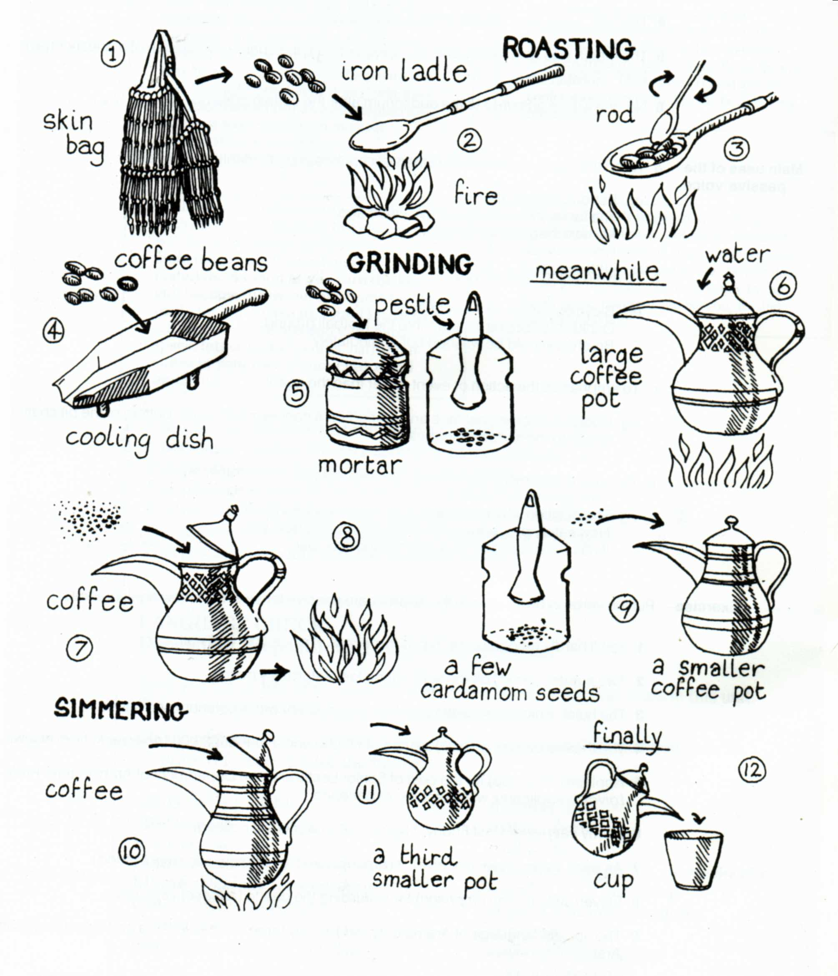

Summary Coffee

Coffee, a beverage brewed from the roasted and ground seeds of the tropical evergreen coffee plant of African origin, is consumed either hot or cold by about one-third of the people in the world, in amounts larger than those of any other drink. Its popularity can be attributed to it invigorating effect, which is produced by caffeine, an alkaloid present in green coffee in amounts between 0.8 and 1.5 percent for the Arabica varieties and 1.6 to 2.5 percent for Robusta.

Two species of the coffee plant, Coffea arabica and Coffea canephora, supply almost of the world’s consumption. Arabica coffee, which is divided between Brazilians and milds, is considered to brew a more flavourful and aromatic beverage than Robusta, the main variety of coffea canephora. Arabicas are grown in Central and South America, the Caribbean, and Indonesia, while Robustas are grown mainly in Africa.

History

Wild coffee plants, probably from Kefa (Kaffa), Ethiopia, were taken to southern Arabia and placed under cultivation in the 15th century. One of the many legends about the discovery of coffee is that of Kaldi, an Arab goatherd, who was puzzled by the queer antics of his flock. About AD 850, Kaldi supposedly sampled the berries of the evergreen bush on which the goats were feeding and, on experiencing a sense of exhilaration, proclaimed his discovery to the world.

Whatever the historical origin, the stimulating effect of coffee undoubtedly made it popular, especially in connection with the long religious service of the Muslims. The orthodox priesthood pronounced it intoxicating and therefore prohibited by the Qur`an, but despite the threat of severe penalties, coffee drinking spread rapidly among Arabs and their neighbours.

During the 16th and 17th centuries, coffee was introduced into one European country after another; many accounts are recorded of the prohibition or approval as a religious, political and medical potion. Coffee gained popularity as a beverage in the London coffee houses, which became centres of political, social, literary, and eventually business influence. The first coffee house in London was established about 1652.In Europe, too, the coffeehouse flourished later in the 17th century. In such American city as Boston, New York City, and Philadelphia, coffeehouses became popular beginning in the late 1600s.

Until the close of the 17th century, the world’s limited supply of coffee was obtained almost entirely from the province of Yemen in southern Arabia. But, with the increasing popularity of the beverage, the propagation of the plant spread rapidly to Java and other islands of the Indonesian archipelago in the 17th century and to the Americas in the 18th century. Coffee cultivation was started in the Hawaiian Islands in 1825.
By the 20th century the greatest concentration of production was centred in the Western Hemisphere - particularly Brazil. In the late 19th and early 20th centuries, industrial roasting and grinding machines came into use, vacuum-sealed containers were invented for ground roasts, and decaffeinating methods for green coffee beans were developed. After 1950 the production of instant coffee was perfected. The popularity of instant coffee led to increased production of the cheaper Robusta beans in Africa.

Processing green coffee

Hulling
The ripened fruits of the coffee shrubs, known as coffee cherries, are processed by disengaging the coffee seeds from their coverings and from the pulp and by drying the seeds from an original moisture content of 65 -70 percent water by weight to 12 -13 percent. Two different techniques are used: a wet process (used mainly for the mild Arabica coffees) and a dry process (used mainly for Brazilians and Robustas).

The wet process:
First the skin and pulp of the fresh fruit is removed by a pulping machine, which consists of a rotating drum or disk that presses the fruit against a sharp-edged plate, disengaging the pulp from the seed. Pulp still clings to the coffee, however, as a thin mucilaginous layer. This is eliminated by fermentation in which naturally occurring pectin enzymes decompose the pulp while the wetted seeds are held in tanks for one to three days. Washing clears all remaining traces of pulp from the coffee seeds, which are then dried either by exposure to sunlight on concrete terraces or by passing through hot-air driers. The dry skin around the seed, called the parchment, is then mechanically removed, sometimes with polishing.

The dry process:
In this process, the fruits are immediately placed to dry either in sunlight or in hot-air driers. Although mechanical drying is replacing the labour- and time-consuming sun drying, more time and equipment are required than in drying pulped seeds in the wet process. When the fruits have been dried to a water content of 12 percent, they are mechanically hulled to free the seeds from their coverings.

Grading and storage
The practise of grading coffee gives sellers and buyers a guarantee concerning the origin, nature, and quality of the product to aid their negotiations. Each country has a certain number of defined types and grades, but there are no international standards outside the contract market.

The prolonged storage of coffee in the producing countries presents problems, especially in the warm and humid coastal regions, where moulds and parasites may developed and cause damage; for this reason coffee from these areas is exported as quickly as possible. In moderate climates, the conservation of dry lots does not pose a problem as long as they are stocked in well-ventilated places.

Processing the bean

Decaffeinating
Caffeine can be removed from the green coffee by a variety of methods. In the most common, solvent extraction, the beans are steamed to raise the moisture content and bring the dissolved caffeine to the surface of the beans. They are then washed by an organic solvent such as methylene chloride, the solution is removed by steam, and the beans are dried.

Roasting
The aromatic and gustatory qualities of coffee are developed by the high temperatures to which they are subjected during roasting or broiling.

Temperatures are raised progressively to about 220°-230° C (430°-440° F).This releases steam, carbon dioxide, carbon monoxide, and other volatiles from the beans, resulting in a loss of weight between14 and 23 percent. Internal pressure of gas expands the coffee beans by 30 to 100 percent. The beans become a deep, rich brown, and their texture becomes porous and crumbly under pressure. But the most important phenomenon of roasting is the appearance of the characteristic aroma of coffee, which arises from very complex chemical transformations within the bean. Roasting too long can destroy volatile flavour and aroma compounds. For this reason, Robusta beans are often over-roasted (as in the dark French and Italian roasts) to get the natural harshness of the coffee.

In the oldest method of roasting, a metal cylinder, or sphere, containing the coffee is rotated above a source of heat such as charcoal, gas, or electricity. In modern roasters, hot air is propelled by a blower into a rotating metal cylinder containing coffee. The tumbling action of rotation ensures that all beans are roasted evenly.

Regardless of the method used, the coffee, after leaving the industrial roasters, is rapidly cooled in a vat, where it is stirred and subjected to cold air propelled by a blower. Good-quality coffees are then often sorted by electronic sorters to eliminate those seeds, either too light or too dark, that roasted badly whose presence depreciates the quality.

Grinding
Some coffees are left as whole beans to be ground at the time of purchase or by the consumer at home. But a large part of the coffee is ground, or milled, by the manufacturer immediately after roasting. In most modern roasting plants, grinding is accomplished by feeding the coffee through a series of serrated or scored rollers, set at progressively smaller gaps that first crack the beans and then cut them to the desired particle size.
The degree of fineness is important. If a coffee is too coarse, the water filters through too fast to pick up flavour; if it is too fine, water filters through too slowly and retains particles that deposit at the bottom of the cup.

Packaging and brewing

Packaging
Effective packaging prevents air and moisture from reaching the coffee. Ground coffee alters rapidly and loses the aromatic qualities within a few days if it is not put into hermetically sealed containers immediately.

The air, especially in humid atmospheres, causes rancidity through the oxidation of fatty components. Modern packaging materials, plastic films like polyethylene and complexes of aluminium and cellulose, are capable of conserving the quality of coffee for a time. The most satisfactory solution to the problem, however, is packing under vacuum or in an inert gas, in rigorously impervious containers.

Brewing
There are several methods of extracting flavour and aroma from ground coffees.
In steeping or boiling, pulverized coffee is measured into hot water, which is set or boiled before being poured off the grounds.
In percolation, water is brought to the boil in an urn and fed up a tube to a basket holding the coffee. After filtering through the coffee, the water drips up to the urn, where it is forced back up the tube and recirculated until the brew reaches the desired strength. In the filter, or drip, method, hot water is slowly filtered through the coffee and dripped into a receptacle; it is not recirculated.
The espresso machine forces boiled water under pressure through finely ground coffee; because the water has only brief contact with the grounds, it extracts a highly flavoured brew with little bitterness.

Caffeine content varies with the variety of bean and method of brewing. One serving (five fluid ounces) of Arabica instant coffee contains about 70 milligrams of caffeine, while a serving of brewed Robusta may contain 200 milligrams.

Instant coffee
In the manufacture of instant coffee (called soluble coffee in the industry), a liquid concentration of coffee prepared with hot water is dehydrated. This can be done by spray drying in hot air, by drying under vacuum, or by freeze drying. The operations are complex, and methods vary among manufactures. The resulting soluble powder, on the addition of hot water, forms reconstituted coffee. The average yield is 25 to 30 percent by weight of the ground coffee. Because it picks up moisture readily, instant coffee needs special vacuum packages.

Additional material:

Cafè de Costa Rica, The authentic taste of coffee
(based on a brochure by ICAFE, Instituto del cafe de Costa Rica)

Coffee came to Costa Rica in the last decade of the 18th century. Its arrival on the national scene was discrete, but definitive and coffee growing expanded slowly over the high lands of the Central Valley. The brotherhood of coffee farmers formed the basis that allowed Costa Rica to become the first Central American country to establish coffee as an industry.

The first export was to Colombia. Those lonely sacs that crossed the border in 1820, became the ground breaking activity which changed the lives of the Costa Ricans. By 1823, quality coffee was exported to Chile. There, it was repackaged for sale to England under the name of “Cafè Chileno de Valparaiso“.

It was in1854, when a visionary group of local exporters undertook the complex task of exporting coffee directly to London. In this they were helped by the cooperation of William Le Lacheur Lyon, captain of the English ship “Monarch“, who transported several one hundred sacs to Europe. That enterprise was the success that converted our coffee into the “grain of gold“ we know today.

The growing and commercialisation changed the face of the country. The economic bounty that coffee brought allowed building the first access to the Atlantic in 1850.Since then, Costa Ricans know that coffee and the activities forged around it, set the foundations what Costa Rica is proud of.

If you were to think in terms of a love affair, you could say that Costa Rica and coffee were made for each other. The soils have that slight degree of acidity typical of a land enriched by volcanic ashes. Rich in organic matter, these soils promote a good distribution of the coffee plant’s roots, retain humidity and facilitate oxygenation. This combination of characteristics injects vigour into the plant and is one of the many factors contributing to the quality of Costa Rican coffee.

More than 70 percent of the production comes from the high mountains whose altitudes range from 1,000 to1,700 meters above sea level .At these altitudes, the temperature fluctuates between 17° and 23°C.Sun light is stable and rain fall optimal, the sum total of which ensures an environment as regulated and favourable as that of a green house.
Costa Rican producers have done their part to take advantage of nature’s gifts. Their efforts along with scientific advances have allowed them to develop agricultural practices which are sound and environmentally committed. The same is true of the harvesting procedures and of the milling and the use of the highest quality genetic material. For example, Costa Rica is the only country where, by edict only the Arabica varieties may be planted. Costa Rican coffee is a medium in which wisdom, experience and the finest gifts of nature all converge.

The large sheds... the pulping machines... the driers... the lighted yards and, above all, hat smell of ripened fruit is the canvas upon which the Costa Rican coffee mills are drawn. Sometimes they seem to appear more like alchemical laboratories converting the red berries that the earth has yielded into that “grains of gold“. With the initiation of the harvest the mill comes to life with the humming of the machines and the voices of the workers.

Approximately 95 coffee mills, distributed throughout the country, process the crop every year. The work of the mill begins with the reception of the fruit and the separation of the pulp from the bean. Next, the coffee bean is transferred to fermentation tanks where it remains until the mucilaginous covering has been broken down and removed. Then it is washed and dried, partially or entirely, under the tropical sun while strict control of the temperature and humidity are maintained during the drying process. Finally it is classified and stored. Afterwards it will be shipped in 69 kilogram sacs that will bear with pride the label of their Costa Rica origin. Coffee milling is the art of the exact: it demands an experienced eye and technological support to guarantee the quality of the final product for the export market.

Costa Rica produces fine high altitude coffees. Their quality is unsurpassed and, for this reason, it is recommended that they be drunk pure and unmixed in order to savour the uniqueness of their flavour. The varieties grown in the country belong to the “Arabica“ species which yield a beverage which is tasty, aromatic and delicate. The history of the country’s coffee production is rich in the development of species which are strong in their constitution and resistance and delicate in the quality of their fruit.

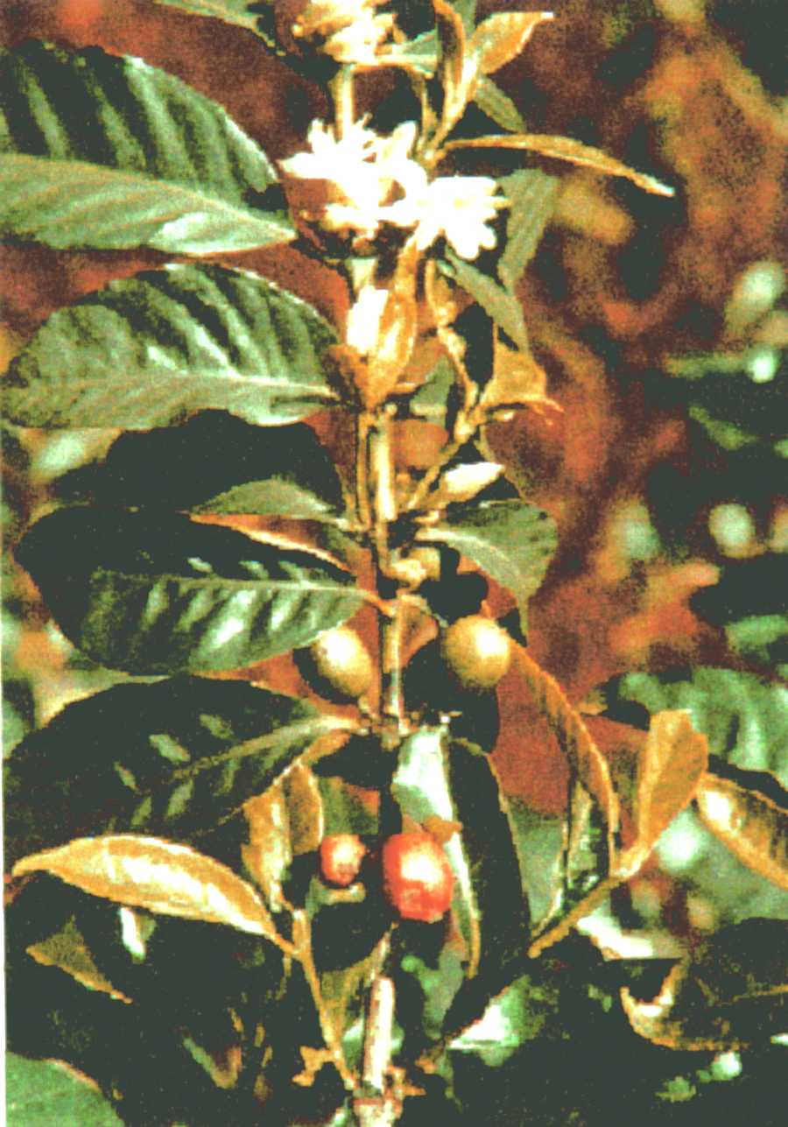

Tarrazú

This coffee grows on terrain located between 1,200 and 1,700 meters above sea level. Coffee producing villages like the prosperous Tarrazú tend this coffee with loving care. The unique microclimate associated with this area gives this coffee an intense flavour of marked acidity. This type grows in a splendid environment which produces a hard bean, and good body and an exceptional aroma.

Tres Rios

Central America’s oldest mills, and those with the greatest experience are located in this area. With the small plantations and a high quality this area has a coffee growing tradition of long standing. The coffee of Tres Rios is well-balanced and boasts of a complex aroma. Those who know coffees enjoy this coffee and often ask for it by the name of the plantation that produces it.

Orosi

The coffee from the area of this ancient and proud city is characterized by the perfect balance which exists between the body and the acidity, characteristics which become clearly apparent in the cup. The production of this area is processed in small mills that leave in the “grain of gold“ unmistakable stamp of quality.

Central Valley Strictly Hard Bean

This type grows in plantations at an altitude of 1,200 to 1,600 meters above sea level and it is characteristic of the villages located in the slopes of the imposing Poás, Barva and Irazú volcanoes. Communities like Barva, Carrizal, Grezia, Santo Domingo and Sarchi tend the growth and development of this coffee known for the fine quality.

West Valley Strictly Hard Bean

This is grown in rich soils that are located between 1,000 and 1,200 meters above sea level. Naranjo, Palmares and San Ramón are communities located at these altitudes and which are noted for their warmth of their climate and their people. This very favourable environment is perceptible in the good liquor and aroma of this coffee.

Turrialba Hard Bean

This coffee is special thanks to the excellent size of the bean, the well-balanced body and the exquisite aroma. It grows in beautiful valleys under the Caribbean influence of Costa Rica’s Atlantic region and ripens between the months of August and December. The people of this area, happy and full of life, contribute to the production of a fruit worthy of the most exacting palate.

Talamanca Hard Bean

This type reigns in the farms found between 800 and 1,200 meters above sea level. The canton of Coto Brus, and Pérez Zeledón located between these altitudes, has fertile and beautiful lands which are apt for a coffee which possesses good liquor, body and aroma, characteristics maintained through the hard work of the farmers of this area.

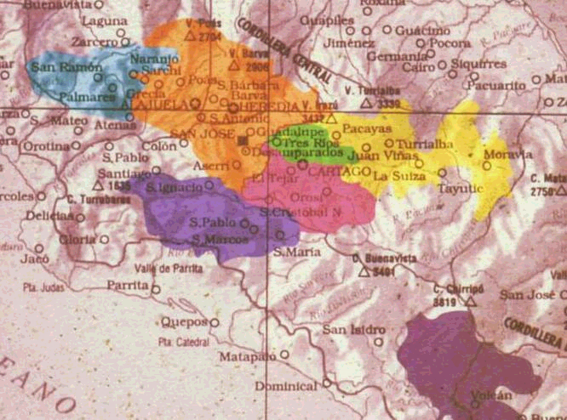

Costa Rica’s coffee production has evolved into a prosperous activity which is closely linked to the purity of the water and the transparency of the air. Costa Rica’s ecological coffee bears the trade mark of the pride that Costa Ricans feel in their natural resources and the way in which they watch over them.

Important data

The country has an equitable distribution of the land in which there are about 50,000 coffee producers. The coffee production extends through out the national territory, mainly in the highlands where more than 70 percent of the coffee production is cultivated from 1,000 to 1,700 meters above sea level, 100% percent of it is from the Arabica species.

The Costa Rican average production is 2,6 million of 60 kilogram bags, from which 2,3 millions are exported and 300,000 are for internal consumption.

Wortsammlung | Kaffee
Deutsch | Englisch
A
abkühlen, kühlen | cool
Alkaloid | alkaloid
Aroma/ Geschmack | flavour
auslösen | release
B
blühen | flourish
Blüte | blossom
brauchen | require
D
Duft | fragrance
E
Eigenschaft | property
einweichen | soak
Enthülsmaschine | hulling machine
Erde/ Boden | soil
erdig | earthy
Ernte | yield
Ernte(ertrag) | crop
exotischer Geschmack | exotic tasting
F
Feind | enemy
Feuchtigkeit | moisture, humidity
flüchtig | volatile
Fruchtfleisch | pulp
G
Gaumen-neutralisierende | palate-cleansing
gedeihen | thrive
georaphischeBreite | latitude
Geschmacks- | gustatory
Gewürz | spice
glatt | smooth
grob | coarse
Gürtel | belt
H
hart | harsh
Hochland | high-grown
Höhe | altitude
I
im Zelt lebend | tent-dwelling
K
Kaffee filtern | percolation
karamelisieren | caramelize
Kern | pit
Kieselstein | pebbles
Koffein | coffeine
Kohlendioxid | carbon dioxide
Kohlenmonoxid | carbon monoxide
kraftvoll/ energisch | vigourous
Krankheit | disease
L
Lage | elevation
Lage/ Schicht | layer
lockern | loosen
löslich | soluble
Lösungsmittel | solvent
luftdicht | airtight
M
Methylenclorid | methylene chloride
O
Oberfläche | surface
organisch | organic
P
Pergamenthaut | tight parchment wrapper
Personen/ Werkzeuge | batch
R
reich, ausgiebig | abundant
rotierend | rotating
S
Samen | seed
Sauerstoff | oxygen
Säure | acidity
Schale | skin
Strauch | shrub
T
Tablett, Ablage | tray
U
umkreisen | encircle
Ungeziefer | parasites
V
Vakuum verpackt | vacuum-sealed
Ventilator | fans
verfeinern | refine
Verhandlungen | negotiations
vor Licht schützen | shade
W
widerstandsfähig | resistant
wirbeln/ Wirbel | swirl
wohlriechend /angenehm | fragrant
Z
Zellulose | cellulose
Wordlist | Coffee
English | German
A
acidity | Säure
abundant | reich, ausgiebig
airtight | luftdicht
alkaloid | Alkaloid
altitude | Höhe
B
batch | Schicht
belt | Gürtel
blossom | Blüte
C
caramelize | karamelisieren
carbon dioxide | Kohlendioxid
carbon monoxide | Kohlenmonoxid
cellulose | Zellulose
coarse | grob
coffeine | Koffein
cool | abkühlen, kühlen
crop | Ernte(ertrag)
D
disease | Krankheit
E
earthy | erdig
elevation | Lage
encircle | umkreisen
enemy | Feind
exotic-tasting | exotischer Geschmack
F
fans | Ventilator
flavour | Aroma/ Geschmack
flourish | blühen
fragrance | Duft
fragrant | wohlriechend/ angenehm
G
gustatory | geschmacklich wahrnehmbar
H
harsh | hart/ rauh
high-grown | Hochland
hullingmachine | Enthülsmaschine
humid | feucht
L
latitude | geographische Breite
layer | Lage/ Schicht
loosen | lockern
M
methylene chloride | Methylen chlorid
moisture | Feuchtigkeit
N
negotiations | Verhandlungen
O
organic | organisch
oxygen | Sauerstoff
P
palate-cleansing | Gaumen-neutralisierende
parasites | Ungeziefer
pebbles | Kieselstein
percolation | Kaffeefiltern
pit | Kern
plant | Pflanze
property | Eigenschaft
pulp | Fruchtfleisch
R
refine | verfeinern
release | auslösen
require | brauchen
resistant | widerstandsfähig
rotating | rotierend
S
seed | Samen
shade | vor Licht schützen
shrub | Strauch
skin | Schale
smooth | glatt
soak | einweichen
soil | Erde/Boden
soluble | löslich
solvent | Lösungsmittel
spice | Gewürz
surface | Oberfläche
swirl | wirbeln/Wirbel
T
tent-dwelling | im Zelt lebend
thrive | gedeihen
tight parchment wrapper | Pergamenthaut
tray | Tablett, Ablage
V
vacuum-sealed | Vakuum verpackt
vigourous | kraftvoll/ energisch
volatile | flüchtig
Y
yield | Ernte

