Bilingualer Fachunterricht an berufsbildenden Schulen

Unterrichtsmodul

Berufsfeld: Wirtschaft und Verwaltung

Beruf: Bürokräfte

Describing my office

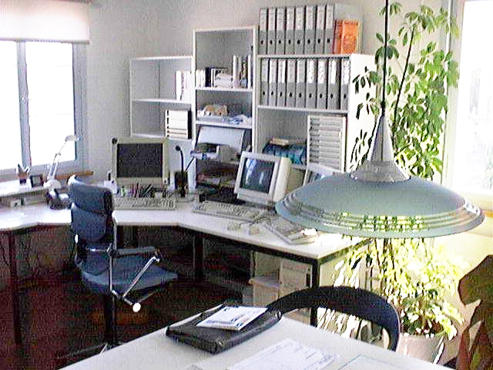

ACTION PROGRAMME OF THE EUROPEAN UNION

LEONARDO DA VINCI- PROJECT
PROJECT No.: 2002 LA 112 628 BILVOC
LANGUAGE COMPETENCE THROUGH BILINGUAL TEACHING AT VOCATIONAL COLLEGES

Teaching Module

Date of Production: May 2004

Subject: English for disadvantaged students

Topic: The office

Title: Describing my office

Target Group: disadvantaged students

Prior Knowledge: none

Level of Language Skills: waystage ( A2)

Follow – Ups: Jobs in the Office

Objectives : Students learn to talk about the office environment they
work in

Benefits: Students should be able to answer the following questions:
- What words and prepositions do I need to describe an office?
- How does my office look like ?

Unit Structure
Teaching Time | Contents | Teacher’s activity | Students´  activities | Media | teaching method
10 minutes | reading comprehension  Mary’s place of work | read the text slowly , at least twice | listen to the text Mary´s place of work (given below)  take notes on the main ideas | text | teacher’s presentation, individual work
15 minutes | comparison | gather the information in English | using their notes the students collect the main facts ( e.g. items that were mentioned) | blackboard | questions and answers
20 minutes | outline of Mary’s office | explain the task: “Use the ground plan of Mary´s office and outline how the equipment in Mary´s office is arranged  The draft will be needed at some stage later | work in pairs | worksheet (ground plan) | pair work
45 minutes | typical phrases | hand out texts,  correct pronunciation and focus on typical phrases | each student read the text on his/her own; afterwards the text is read aloud sentence by sentence | worksheets | Individual work, student’s presentation,  questions and answers,  teacher’s presentation
30 minutes | questions on the text | explain the task,  offer help | answer questions (given below) on details of the text | worksheets, dictionary | individual work, questions and answer
15 minutes | description of Mary’s office | explain the task, offer help  ask students to label the items in their sketch | work in pairs,  discuss and check in detail if Mary´s description matches the sketch they made,  if necessary, the students add things that are missing or make a new and better sketch | worksheets | pair work
30 minutes | Describe the office you work in. | explain the task, offer help | make up 10 short sentences about his or her place of work | copybooks | individual work
15 minutes | Describe the office you work in. | offer help | pass their work on to somebody else  students try to make a sketch based on the facts they were given by the classmates´ texts  students discuss if and why the sketch differs from what the author really wanted to describe | copybooks | individual work, discussion

Verlaufsplanung
Unterrichtszeit | Inhalte | Lehreraktivitäten | Schüleraktivitäten | Medien | Methoden
10 Minuten | Leseverstehen  Mary’s Arbeitsplatz | liest Text langsam, wenigstens 2 mal | hören den Text Mary´s place of work (given below)  machen Notizen zu Hauptinhalten | Text | Lehrervortrag, Einzelarbeit
15 Minuten | Vergleich der Ergebnisse | sammelt Informationen | Schüler sammeln mit Hilfe ihrer Notizen die Hauptfakten ( z.B. Dinge, die genannt worden) | Tafel | Unterrichtsgespräch
20 Minuten | Entwurf von Mary’s Büro | erklärt Aufgabe:  „Benutzt den Grundriss von Mary’s Büro und zeichnet ein, wie die Dinge in ihren Büro angeordnet sind.“  Der Entwurf wird später noch einmal gebraucht. | arbeiten zusammen in Partnerarbeit | Arbeitsblatt (Grundriss) | Partnerarbeit
45 Minuten | Typische Redewendungen | gibt Texte aus, korrigiert Aussprache und macht auf typische Redewendungen aufmerksam | Jeder Schüler liest den text selbstständig, danach wird der Text Satz für Satz laut gelesen | Arbeitsblätter | Einzelarbeit, Schülervortrag, Unterrichtsgespräch, Lehrervortrag
30 Minuten | Fragen zum Text | erklärt Aufgabenstellung, bietet Hilfestellung an | beantworten Fragen | Arbeitsblätter, Wörterbücher | Einzelarbeit, Unterrichtsgespräch
15 Minuten | Beschreibung von Mary’s Büro | erklärt Aufgabenstellung, bietet Hilfestellung an  bittet die Schüler , die Gegenstände in ihrer Zeichnung zu beschriften | Arbeiten zu zweit, diskutieren und überprüfen, ob Mary’s Beschreibung mit ihrer Zeichnung übereinstimmt,  wenn notwendig fügen die Schüler Dinge hinzu oder fertigen eine neuen Zeichnung an | Arbeitsblätter | Partnerarbeit
30 Minuten | Beschreibe das Büro, in dem Du arbeitest. | erklärt Aufgabenstellung, bietet Hilfestellung an | Schreiben 10 kurze Sätze über ihren Arbeitsplatz | Hefte | Einzelarbeit
15 Minuten | Beschreibe das Büro, in dem Du arbeitest. | bietet Hilfestellung an | Geben ihre Ausarbeitung an einen anderen Schüler weiter,  Schüler versuchen eine Zeichnung anzufertigen , die auf den Fakten basiert, die in den Texten ihres Klassenkameraden vorkommen  Schüler diskutieren, ob und warum die Zeichnung sich von dem unterscheidet , was der Autor eigentlich beschreiben wollte | Hefte | Einzelarbeit , Diskussion

Vocabulary

Part One: Giving Positions
near
next to
in front of
behind
on the left
on the right
in the middle
on the wall
in the corner
above
under
between

Part Two: Office equipment
a modern office building
my desk ; on someone´s desk.
several shelves
be packed with files.
hundreds of business letters and documents are stored
to have all the necessary office equipment
a telephone
computer, monitor, keyboard and printer
to print out business letters or other documents
flowers
a lamp above my desk
a photocopier
a modern fax machine
to be installed on someone´s desk
calendar
to have comfortable office chairs
a wastepaper basket in the corner
to feel comfortable

Mary´s place of work
Mary works in a modern office building in Hayes, which is near London Heathrow Airport. Here she tells us something about her place of work:

“When you enter my office you can see my desk on your left hand side. A second desk stands in front of it. That´s where Susan works. Susan is my colleague and she is a close friend of mine. There are shelves alongside the wall on the right hand side. They are packed with files. In each file hundreds of business letters and documents are stored so that the weight of each file is enormous.
Of course, me and Susan have all the necessary equipment on our desks.
I have a telephone on the right hand side of my desk.
My computer is hidden under my desk with the monitor and keyboard right in front of me in the centre of my desk. There is a low table next to the window on my left-hand side. A printer is placed there, so neither me nor Susan have to go far if we print out business letters or other documents. On Susan´s side of the window we have placed some flowers. They make us feel very comfortable. In order to help me read, I also have a lamp above my desk which I use in the evening if I work late. We used to have a photocopier here, but because of the noise it made it was put in a separate room. Instead, we now have a modern fax machine installed on Susan´s desk. There is a calendar on the wall behind me, but only Susan can see it from her desk. We simply had no other place for it.
Of course, we both have comfortable office chairs to sit on and I have some pictures of my family between the computer and the telephone. Last but not least there is a wastepaper basket in the corner.
All in all, my office is a place where I do my work and feel comfortable at the same time.”

Questions about ”Mary´s place of work”

Are the following statements true or false? Discuss with your partner and find in the text the relevant information, if any.

Example: There are no flowers in the office.
The statement is false. There are flowers on Susan´s side of the window.

- Only Mary can see the calendar.
- The files are stored on the shelves alongside the wall.
- Susan and Mary have no fax machine.
- The heating is hidden under Susan´s desk.
- Susan and Mary have to sit on wooden chairs.
- The photocopier was put in a separate room because Mary and Susan were too often disturbed by colleagues from other offices.
- Mary doesn´t work in the City of London.

Mary´s office
Window

Door

Take a close look at the photograph. How many computers are there? What kind of work do you think is done in this office?

Vocabulary:

English German

near in der Nähe von
next to neben
in front of vor
behind hinter
on the left links/ auf der linken Seite
on the right rechts / auf der rechten seite
in the middle in der Mitte
on the wall an der Wand
in the corner in der Ecke
above über
under unter
between zwischen
desk Schreibtisch
shelf Regal
file Akte
to store lagern
printer Drucker
photocopier Kopiergerät
fax machine Faxgerät
calendar Kalender
comfortable bequem
office chair Bürostuhl
wastepaper basket Papierkorb

