ACTION PROGRAMME OF THE EUROPEAN UNION
LEONARDO DA VINCI
PROJEKT NO.: 2002 LA 112 628 BILVOC
Language Competence Through
Bilingual Teaching at Vocational Colleges

Teaching Module 5

Date of production: | October 2004
Subject: | Compressed air networks
Topic: | Dimensioning and necessary care in compressed air networks installation
Title: | Compressed air distribution
Target Group: | Youths and workers whose professional profile is somewhat related to the use of pneumatics
Prior Knowledge: | Knowledge of teaching units 1, 2, 3 and 4
Level of Language Skills: | Intermediate English
Follow - Ups: | Determine and install a compressed air network
Objectives: | Dimension a compressed air network taking into account the load losses caused by the additional network elements (valves, curves, etc.)
Benefits: | At the end of the module, trainees should know:  The factors that influence the dimensioning of compressed air networks  Analyse the graphs and diagrams inherent in the dimensioning process

Module 5
Foreseen time | Contents | Activities / Tasks | Pedagogic means | Pedagogic method
 | 5- Distribution of compressed air
45 minutes | 5.1- To calculate nets of compressed air | To present general concepts of calculation of nets. To present means and methods of calculation of nets of compressed air. | Transparencies; notes; PowerPoit presentation; whiteboard. | To expose the matter using the demonstrative whenever possible method supported in practical situations.
120 minutes | 5.2 - Practical exercises of calculation | To do several exercises of application of the matter | Transparencies; notes; PowerPoit presentation; whiteboard. | Practical resolution of proposed theoretical exercises

INDEX

5 DISTRIBUTION of COMPRESSED AIR 5
5.1 To calculate nets of compressed air 5
5.2 Materials used in the nets of compressed air 5
5.3 SUMMARY 8

DISTRIBUTION
of
COMPRESSED AIR

DISTRIBUTION of COMPRESSED AIR

To calculate nets of compressed air

The Diameter of the tubes should be chosen in a way that if the consumption increases, the pressure fall should not surpass 10 Kpa (0,1 bar), otherwise the profitability of the system is harmed, decreasing its capacity considerably.

The diameter of the tubes is not determined starting from any empiric formulas or for use of existent materials, but yes considering aspects as:

The average volume (flow)
The length of the net of compressed air
The pressure fall (acceptable)
The work pressure
The number of throttling points in the net

The distribution nets can assume varied types:

To open Circuit
To shut Circuit
The combined Net

In the assembly of nets of compressed air, it should be had in attention the following aspects:

They should not be set up inside of walls or narrow cavities, because it hinders the detection of escapes.
The In open circuit, they should be set up with a decline from 1 to 2%, in the direction of the flow.
The sockets should be installed in the superior part of the net, because it works as barrier to the humidity passage for the work elements. The drains should be placed in the inferior part of the net
 Whenever possible the nets should be set up in shut circuit, because a uniform feeding is gotten, because the air flows in both directions.

Materials used in the nets of compressed air

Main net:
Copper, brass, steel calls, tube black steel, steel galvanized, synthetic material

Secondary net:
Rubber, Polyethylene, Polyimide

Let us see an example of determination of the diameter of a net:

Consumption of air = 240 m3/h
Increase in 3 years 300% = 3 x 240 = 720 m3/h
Total consumption = 720 + 240 = 960 m3/h
Length of the net = 280 m
Pressure fall (acceptable) = 0,1 bar
Pressure in the net = 8 bar

Nomogram (diameter of the piping)

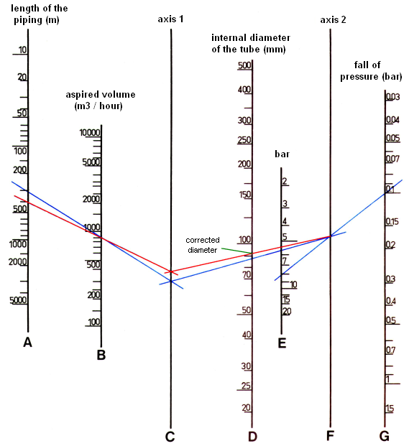

Equivalent length

6 pieces “T” 6 x 10,5m = 63m
1 straight-through valve 1 x 32m = 32m
5 normal elbows 5 x 1m = 5m
Equivalent length = 100m
Length of the net = 280m
Total length = 380m

With this total length, we are going again to the nomogram of the previous page and we make the new plan just altering the length and removing of there the new value for the diameter that will necessarily be larger.

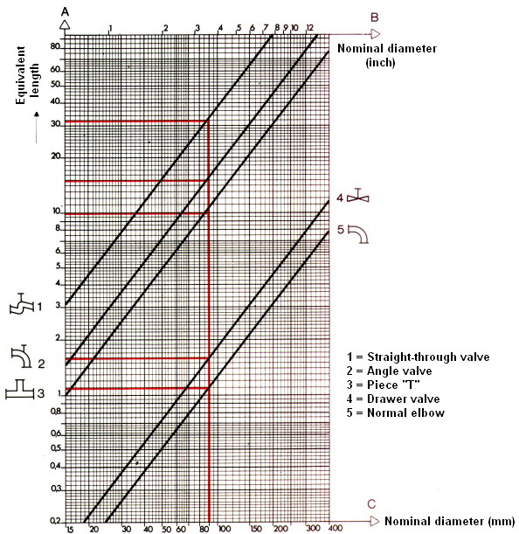

SUMMARY

AOf the theoretical point of view, it is not possible to summarize more this chapter than it is already, because the trainee should drive his attention to the subject described in page 39.

AOf the theoretical-practical point of view it is advisable to do a careful analysis of the presented exercise, and for own initiative (arbitrating values) creating new study situations.

