ACTION PROGRAMME OF THE EUROPEAN UNION
LEONARDO DA VINCI
PROJEKT NO.: 2002 LA 112 628 BILVOC
Language Competence Through
Bilingual Teaching at Vocational Colleges

Teaching Module 7

Date of production: | October 2004
Subject: | Pneumatic control
Topic: | Pneumatic valves
Title: | Pneumatic control elements
Target Group: | Youths and workers whose professional profile is somewhat related to the use of pneumatics
Prior Knowledge: | Knowledge of teaching units 1, 2, 3, 4, 5 and 6
Level of Language Skills: | Intermediate English
Follow - Ups: | Understand the phenomena associated to the pneumatic control and identify the main elements used in circuit control
Objectives: | Analyse and identify the main pneumatic control elements (valves)  Distinguish the elements by their symbology  Analyse, read, interpret and perform simple pneumatic plans  Solve simple situations using pneumatics
Benefits: | At the end of the unit, trainees should know:  The types of pneumatic control elements and their applications  Choose the control elements (valves) according to the intended applications and their specifications  Interpret the symbology  Draw and interpret schematic plans of pneumatics  Solve simple problems of pneumatics

Module 7
Foreseen time | Contents | Activities / Tasks | Pedagogic means | Pedagogic method
 | 7- Pneumatic elements of command
10 minutes | 7.1- Introduction | To present general concepts. | Transparencies; notes; PowerPoint presentation; whiteboard. | Presentation to the whole group; to promote the discussion and exchange of ideas.
45 minutes | 7.2- Directional valves | To present the different valve types, its operation, characteristics, constructive aspect and performances. | Transparencies; notes; PowerPoint presentation; whiteboard; Films of the specialty; catalogs, to show the own equipment. | Presentation to the whole group; to promote the discussion and exchange of ideas.
20 minutes | 7.3- Non-return valves | To present the different valve types, its operation, characteristics, constructive aspect and performances. | Transparencies; notes; PowerPoint presentation; whiteboard; Films of the specialty; catalogs, to show the own equipment. | Presentation to the whole group; to promote the discussion and exchange of ideas.
20 minutes | 7.4- Shuttle valve (OR function) | To present the different valve types, its operation, characteristics, constructive aspect and performances. | Transparencies; notes; PowerPoint presentation; whiteboard; Films of the specialty; catalogs, to show the own equipment. | Presentation to the whole group; to promote the discussion and exchange of ideas.
20 minutes | 7.5- Dual-pressure valve (AND function) | To present the different valve types, its operation, characteristics, constructive aspect and performances. | Transparencies; notes; PowerPoint presentation; whiteboard; Films of the specialty; catalogs, to show the own equipment. | Presentation to the whole group; to promote the discussion and exchange of ideas.
30 minutes | 7.6- Pressure valves | To present the different valve types, its operation, characteristics, constructive aspect and performances. | Transparencies; notes; PowerPoint presentation; whiteboard; Films of the specialty; catalogs, to show the own equipment. | Presentation to the whole group; to promote the discussion and exchange of ideas.
25 minutes | 7.7- Flow valves | To present the different valve types, its operation, characteristics, constructive aspect and performances. | Transparencies; notes; PowerPoint presentation; whiteboard; Films of the specialty; catalogs, to show the own equipment. | Presentation to the whole group; to promote the discussion and exchange of ideas.
30 minutes | Summary | To do a summary of the main knowledge to acquire in this module. | Transparencies; notes; PowerPoint presentation; whiteboard. | To summarize the matter using the interrogative method.

INDEX
7 PNEUMATIC ELEMENTS OF COMMAND 5
7.1 Introduction 5
7.2 Directional valves 8
7.2.1 Symbols of the valves 8
7.2.2 Characteristics of construction of the directional valves 10
7.2.3 Seat valves 10
7.2.3.1 Ball bearing seat valves 10
7.2.3.2 Disk seat valves 11
7.2.4 Slide valves 11
7.2.4.1 Longitudinal slide principle valves 11
7.2.4.2 Mid-position closed valves 12
7.2.5 3/2 Way Valve 12
7.2.5.1 3/2 Way Valve, normally closed position 13
7.2.5.2 3/2 Way Valve, normally open position 13
7.2.5.3 3/2 Way Valve, with 2 position handle (normally closed) 15
7.2.5.4 3/2 Way Valve (roller actuated) 15
7.2.5.5 3/2 Way Valve (roller actuated only in one direction) 16
7.2.6 5/2 Way Valve 16
7.3 Non-return valves 17
7.3.1 Check valves non-return 17
7.3.2 Shuttle valve (OR function) 18
7.3.3 Dual-pressure valve (AND function) 19
7.4 Pressure control valves 20
7.4.1 Pressure regulating valve 21
7.4.2 Pressure relief valve 21
7.4.3 Pressure sequence valve 22
7.5 Flow control valves 23
7.5.1 Flow control valves 23
7.5.2 Quick exhaust valve 25
7.5.3 Stop valves 26
7.6 SUMMARY 27
8 DIRECT BASIC COMMANDS 28
8.1 Control of Single-acting cylinder 28
8.2 Control of Double-acting cylinder 28
8.3 Indirect control of Double-acting cylinder 29
8.4 Indirect control of Double-acting cylinder 30
8.5 Indirect control of Double-acting cylinder using a 5/2 Way Valve. With this valve the 31
8.6 Speed control of Single-acting cylinder (Advance Speed control) 31
8.6.1 Return Speed control 32
8.6.2 Advance and Return Speed control 32
8.6.3 Advance and Return Speed control in de Double-acting cylinder 33
8.7 Control of Single-acting cylinder, with Shuttle valve (OR function) 34
8.8 Control of Single-acting cylinder, with Dual-pressure valve (AND function) 35
8.9 Control of Double-acting cylinder, with Time delay valve 36

PNEUMATIC ELEMENTS
of
COMMAND

PNEUMATIC ELEMENTS OF COMMAND

Valves

Introduction

The valves are organs whose function is to command the greatness of a pneumatic variable or to alter the type of circuit (see Picture. 45). In the first case we have the regulating valves and in the second the directional control valves.

The adopted symbols will be according to the recommendation CETOP.

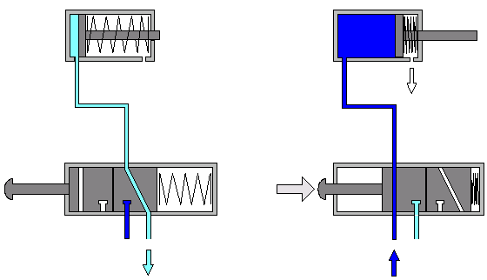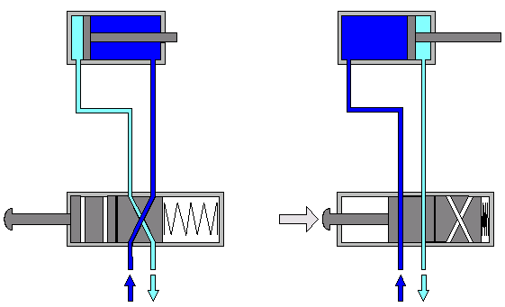

Picture- 45

According to its functions, the valves are subdivided in 5 groups:

1. Directional valves | 4. Flow valves
2. Non-return valves | 5. Stop valves
3. Pressure valves

Several other subdivisions for the valves are possible, as for example:

As for the number of states (operation positions or number of boxes), the valves are divided in:

2 states

3 states

As for the number of holes (connections, ports):

2 ports
3 ports
4 ports
5 ports

As for the command type (types of actuation):

manual

general | 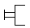
pushbutton operated | 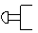
via lever with detent | 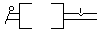
foot pedal operated | 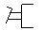

mechanical

spring actuated
spring centered
roller actuated
roller actuated only in one direction

electrical

single solenoid operation
double solenoid operation

pneumatic

direct pneumatic actuation
indirect pneumatic actuation piloted

combined

double solenoid valve, piloted, with manual overrid

Directional valves

The directional valves have as we already saw, the function of changing the type of the circuit. That is, when a valve of this type is used, it is possible to modify the sense of circulation of the flowed in the circuit, as for example it happens in the lineal actuators (cylinders) of double effect, through a directional valve the filling and emptying of its cameras are inverted, modifying the sense of movement of the rod piston (see Picture 46).

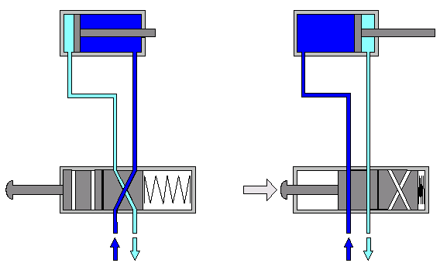
Picture- 46

Symbols of the valves

To represent the directional valves in the outlines, symbols are used; these symbols don't intend to represent the constructive aspect of the valve (its construction interns), but its function in the circuit.

The positions of the valves are represented by squares.

The number of united squares indicates the number of positions that a valve can assume.
The operation is represented inside in a symbolic way of the squares
The lines indicate the roads of passage. The arrows indicate the sense of the flow.
The blockades are suitable represented inside of the squares with traverse lines.
The union of ways inside of a valve it is symbolized by a point.
The connections (of entrance and exit) are represented by external lines, that indicate the rest position of the valve. The number of lines indicates the number of roads.
Other positions will be obtained moving the squares, until that coincide with the connections.
Valve with 3 command positions. The central position corresponds to the rest position.

It is defined as " rest " position, that condition in that, through springs, for example (see Picture 47), the mobile elements of the valve are positioned while the same is not being used (acted).
Picture- 47

The departure position (or initial) of the valve, it will the one that its mobile elements assume after assembly in the installation.

To guarantee identification and a correct connection of the valves, the roads are marked with lower cases, or numbers.

It was stipulated the following numerations (in brackets as below shown), for the identification of the connections of the valves (see Picture 48):

 | connections identification | or in alternative
Roads for use (outputs) | A, B, C, D,… | (2,4,6)
Feeder lines (inputs) | P | (1)
Escapes (exhaust) | R,S,T | (3,5,7)
Command lines (piloted) | Z,Y,Z | (12,14,16)

Picture- 48

The denomination of a valve depends on the number of ways (connections) and of the number of the operation positions. The first number indicates the amount of connections and the second the amount of positions of operation of the valve. The pilot connections are not considered as roads.

The denomination of a valve will be for example 3/2, that is to say that the 2 are the number of states or positions (in the symbols it corresponds to squares), and the 3 are the number of holes or roads.

Characteristics of construction of the directional valves

The characteristics of construction of the valves are one of its fundamental properties. These characteristics can determine the useful life of a valve for example or to determine the force of operation.
As its constructive aspect, in this type of valves we can be distinguished the following types:

seat valves
ball bearing seat
disk seat
slide valves
longitudinal slide principle
mid-position closed

Seat valves

The connections in the seat valves are open for sphere, plate or cone. The seal of the seat valve is made in a very simple way, generally with elastic element of seal. This type of valves possesses little waste pieces and it has a long useful life. They are also robust and insensitive to the dirtiness.

Ball bearing seat valves

The construction of the ball bearing seat valves is very simple and, therefore, of advantageous price. These valves are characterized by its reduced dimensions.

A spring forces the sphere, avoiding that the compressed air passes of the hole of pressure 1 to the hole of work 2 (see Picture 49). By operating the stem of the valve, it stands back the sphere. For that, it is necessary to expire by force of the spring and by force of the compressed air. The hole 3 is the escape hole. The operation can be manual or mechanic.

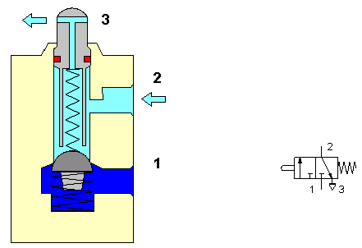

Picture- 49

Disk seat valves

This type of valves (see Picture 50), they are built and based in a disk seat. These valves have a simple and good seal. The time of commutation is short. A small movement of the disk frees a quite big area for the flow of the air. Also this constructive type of valves, as the one of ball seat is insensitive to the dirtiness and they have a long useful life.

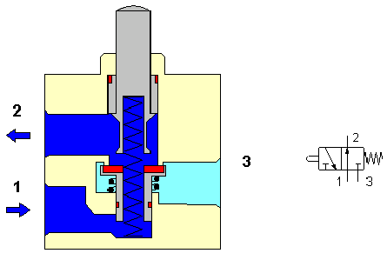
Picture- 50

Slide valves

The several types of connection of the slide valves will be interlinked and closed by pistons (sliding, switches or rotative).

Longitudinal slide principle valves

This type of valves (see Picture 51) has as command element, a piston that selects the connections by means of its longitudinal movement.
The force of operation is small, because it is not necessary to win the pressure of the air or of the spring, both nonexistent ones (as in the beginnings of the Ball bearing seat valves). In this type of valves they are possible all the operation types: manual, mechanic, electric and pneumatic, the same is valid for the return to the initial position. The course is considerably longer than the seat valves, as well as also the times of commutation.
The seal in this type of slide valves is plenty problematic. A seal of the type "metal on metal " as it is used in the hydraulics, it requests a perfect adjustment of the slide in the body of the valve. The gap between the slide and the interior cylinder of the valve, in pneumatic, it should not be larger than 0.002 to 0.004 mm. A larger gap it would provoke great internal escapes. To overcome this problem, they are usually used rings " O " (The-Ring), set up in the body of the valve (static) or in the piston (dynamic).

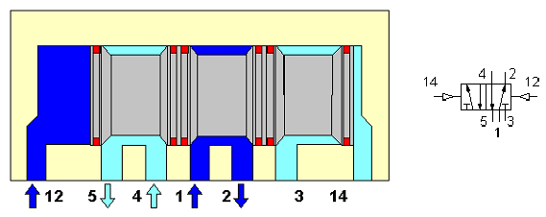
Picture- 51

Mid-position closed valves

These valves are generally of manual operation or by pedal. It is difficult to adapt other operation type to these valves.
They are generally manufactured as directional valves of 3/3 roads or 4/3 roads. Considering the rotative displacement of two drawers it can be made the communication of the channels to each other (see Picture 52).

With the configuration of the valve (Picture 52), all the channels are blocked in the central position. Due to that, the piston of the cylinder can stop in any position of its course; even so those intermediate positions cannot be fastened with accuracy. Due to the compressibility of the compressed air, when varying the load the stem it also varies its position.
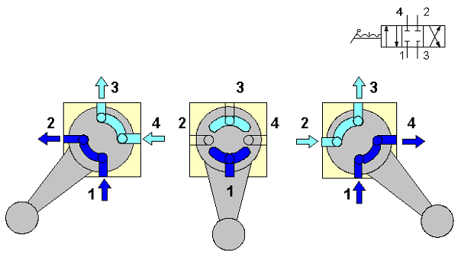

Picture- 52

3/2 Way Valve

The 3/2 way valve (see Picture 53), it has this name because it possesses 3 roads (holes) and 2 positions (boxes) of operation.
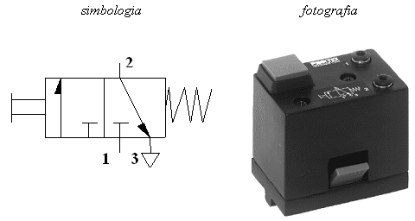

Picture- 53

3/2 Way Valve, normally closed position

These valves (see Picture 54), when operated, its axis will be moved against the return spring. In this situation the holes 1 and 2 will be interlinked (the escape 3 is cut). After the annulment of the command sign, the command piston will be put back in the initial position through the spring. The connection between 1 and 2 will be cut. The air of the work channel can escape through the channel of escape 3.
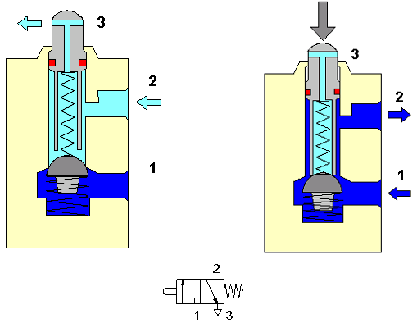

Picture- 54

3/2 Way Valve, normally open position

These valves (see Picture 55), they have the opened rest position. When being operated, it is closed the connection firstly between 1 and 2, being established later on the connection between 2 and 3. A spring goes back him, re-establishing the connection between 1 and 2 again (rest position).

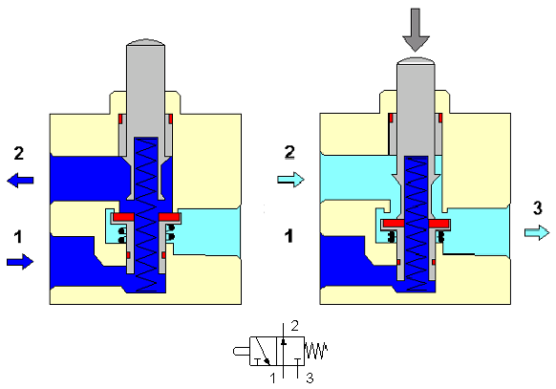

Picture- 55

Constructively, these valves can be: ball bearing seat or disk seat (see Picture 56).
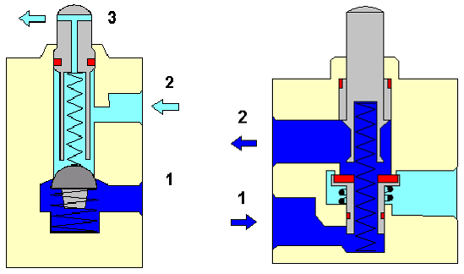

Picture- 56

The operation of these valves can be of several types as it indicates it the (Picture 57), (see following sections).

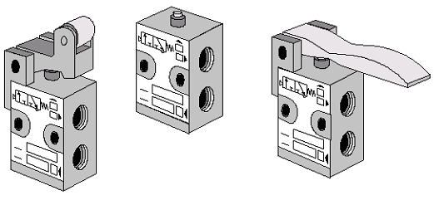

Picture- 57

3/2 Way Valve, with 2 position handle (normally closed)

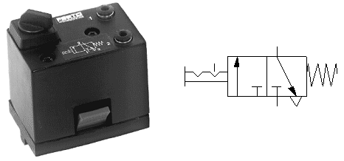

Picture- 58

3/2 Way Valve (roller actuated)

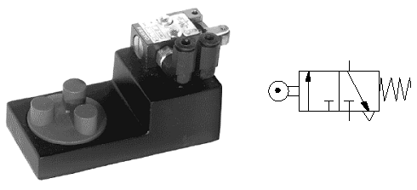

Picture- 59

3/2 Way Valve (roller actuated only in one direction)

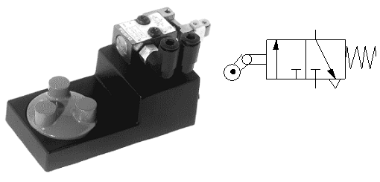
Picture- 60

The 3/2 directional valves are used to command single-action cylinders, or as sign originators to pilot command valves (see Picture 61, Picture 62, and Picture 63).

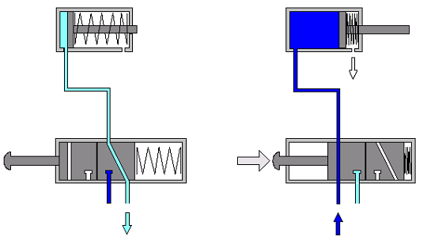

Picture- 61

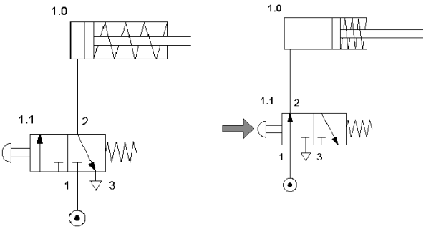
Picture- 62

5/2 Way Valve

The 5/2 valves (5 ways, 2 positions), they are directional valves, constructively of slide principle. This valve is commuted alternately by pulses, maintaining the command position to receive a new pulse. Observing the (Picture 64), it can be verified that if the valve is commuted by 12, the coming pressure of 1 is transmitted to the road 2. The road 4 will be connected to the escape through the hole 5. The hole 3 is cut (without connection to some road).

And, if the valve is commuted by 14, then the connection betwen the roads will be of 1 (pressure) to 4, being the road 2 to the escape. The road 5 in this situation will be cut.
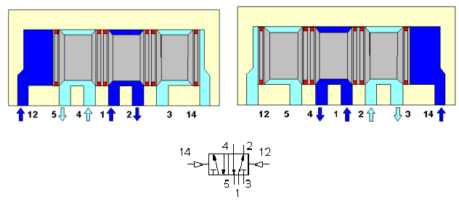
Picture- 64

As it can be verify in (Picture 65), these valves are the suitable ones to command single-action cylinders.
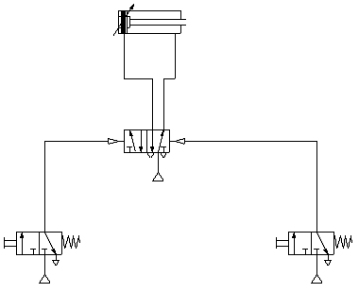
Picture- 65

Non-return valves

These valves are the elements that block the passage in an alone direction, allowing like this the free passage in the contrary direction. The pressure beside the entrance, acts on the seal element and it allows with that a perfect seal of the valve.

Check valves non-return

These valves stop the passage completely in a direction. In the contrary direction the air passes with a fall of minimum pressure (see Picture 66).

The close of the valve, in a constructive point of view, can be obtained through a cone (Picture 67), sphere, disk (Picture 68) or membrane.

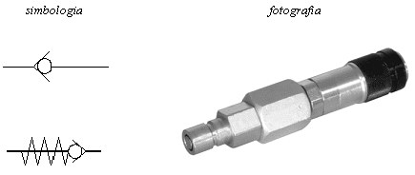
Picture- 66
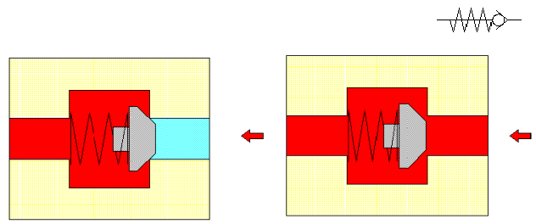

Picture- 67

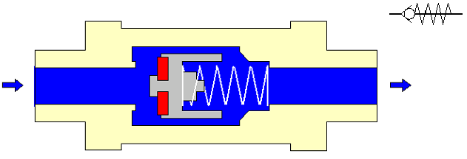

Picture- 68

Shuttle valve (OR function)

This valve has two entrances X and Y, and an exit A (see Picture 69 and Picture 70). When the compressed air enters in X, the sphere blocks the entrance Y and the air circulates from X to A. In a contrary way, when the air circulates from Y to A, the entrance X is blocked.

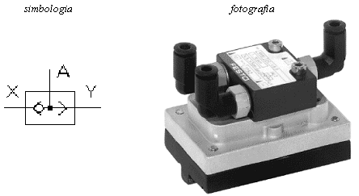

Picture- 69

This valve is also called (OR), because it has a behavior similar to a OR logical.

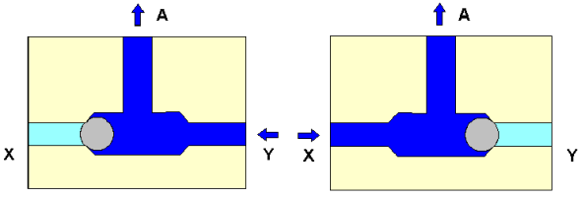

Picture- 70

These valves are used for example, when a cylinder or a command valve should be operated of two or more places (see Picture 71).

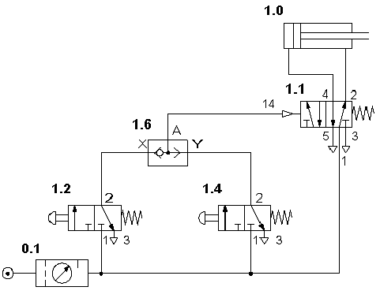
Picture- 71

Dual-pressure valve (AND function)

This valve has two entrances X and Y and an exit (see Picture 72 and Picture 73). The compressed air can only pass when there is pressure in both entrances. An entrance sign X or Y stops the flow to A because of the unbalance of the forces that act on the mobile piece. When there is a difference of time pressures, the last is the one that arrives in the exit A. If the entrance signs are from different pressures, the largest blocks a side of the valve and the smaller pressure arrives to the exit A.

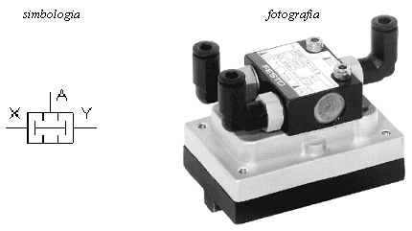

Picture- 72
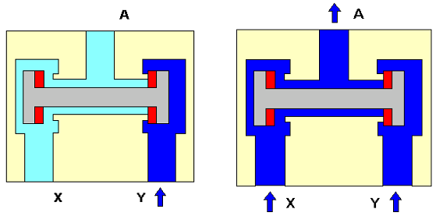

Picture- 73

This valve is also called (AND), it is used in blockade commands, control functions and logical operations (see Picture 74).

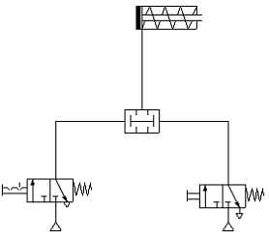

Picture- 74

Pressure control valves

They are valves that have influence mainly on the pressure, and through which it can be made the regulation, or valves that depend on the command pressure. They are distinguished in the following way:

Pressure regulating valve
Pressure relief valve
Pressure sequence valve

Pressure regulating valve

This valve (see Picture 75 and Picture 76), it has the task of maintaining constant the work pressure, that is, to transmit the pressure adjusted in the air gauge without variation, to the work elements or valves, even with the rocking pressure of the net.

The primary pressure has to be always larger than the secondary pressure. The pressure is regulated by means of a membrane 1. One of the faces of the membrane is submitted to the work pressure, while the other is pressed by a spring 2 whose pressure is adjustable by means of a screw regulating. With the increase of the work pressure, the membrane is moved against by force of the spring. With that, the nominal section of passage in the headquarters of the valve 4 decreases to its close is complete. That means that the pressure is regulated by the flow.

With the consumption of compressed air, the pressure decreases and the force of the spring reopen the valve. With that, maintaining the regulated pressure, it will imply a constant open and close of the valve. To avoid the occurrence of an undesirable vibration, on the plate of the valve 6 a shock is built by spring 5 or air. The work pressure is indicated in the air gauge.

If the pressure grows too much on the secondary side, the membrane is pressed against the spring. With that, it opens up the hole of the central part of the membrane and the air in excess leaves for the escape hole to the atmosphere.

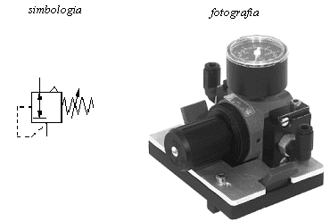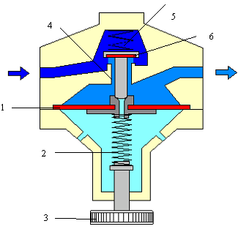

Picture- 75 Picture– 76

Pressure relief valve

These valves are used, above all as valve of safety. They don't allow an increase of the pressure in the system, above the adjusted maximum pressure. Reached in the entrance of the valve the maximum value of the pressure P, it opens up the exit and the air escapes for the atmosphere R. The valve it stays opened until the spring, after the pressure to have dropped below the adjusted value, and closes it again (see Picture 77).

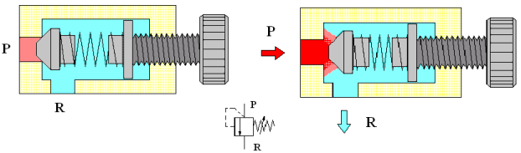

Picture– 77

Pressure sequence valve

The operation of this valve (see Picture 78), it is very similar to the pressure relief valve. It opens up the passage when a superior pressure is reached to the adjusted by the spring.
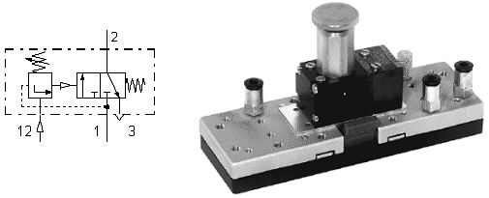

Picture– 78

The pressure sequence valve is operated, when in the command 1.2 the pressure, so that the valve gauged will be reached. In this situation, the compressed air passes from 1 to 2. If the pressure decreases to an inferior value there will be calibration pressure, then the valve turns to close (for action of the spring), cutting the connection between 1 and 2.

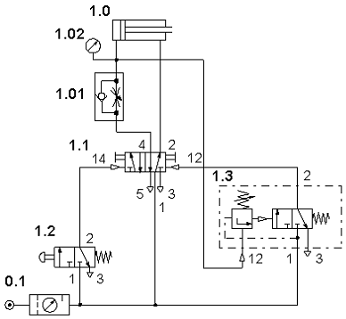

The cylinder 1.0 will only retreat when the pressure will be reached so that the valve of sequence 1.3 is regulated.
Picture– 79

These valves are used in pneumatic commands that act when there is need of a fixed pressure for the commutation process (commands in function of the pressure). The sign is only transmitted when the command pressure is reached (see Picture 79).

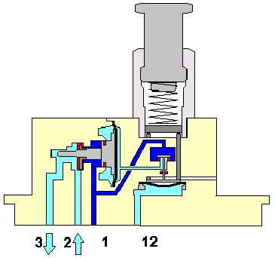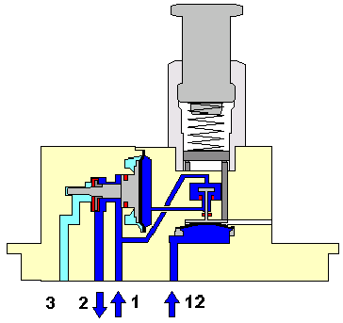

Picture– 80

Flow control valves

These valves have influence on the amount of compressed air that flows in a tubing.

Flow control valves

The flow control valves (see Picture 81, Picture 82 and Picture 83), they are pieces made to create a resistance to the flow passage giving place to a pressure fall in the sense of passage of the compressed air.

Its construction is simple, because the effect is only obtained by a throttling of the section of passage of the air. When there is regulation they can be fixed or adjusted.

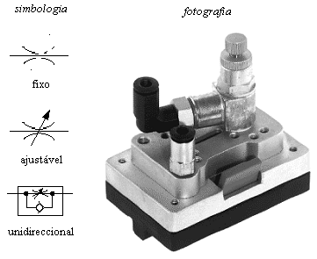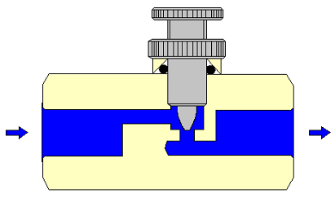

Picture– 81 Picture– 82 Flow control valve

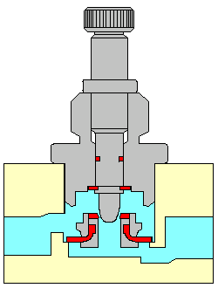

Picture– 83 One-way Flow control valve

As it can be seen in Picture - 84, with the use of these valves we can be control the progress speeds and of retreat of the cylinders.

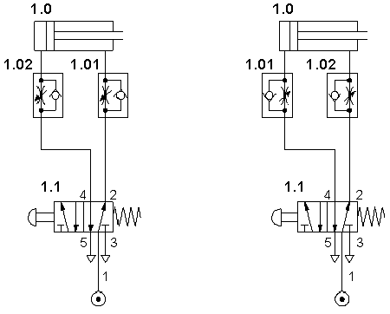
Picture– 84

Quick exhaust valve

These valves are used to increase the speed of the pistons of the cylinders (see Picture 85). High times of return, especially in single-action cylinders can be eliminated using this valve.

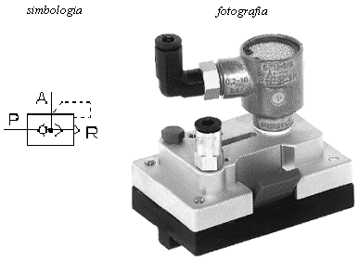

Picture– 85

This valve is endowed with a pressure connection P, an escape connection blocked R and an exit A (see Picture 86).

When pressure is applied in P, the seal moves against the seat and it hinders the escape R. The air it circulates to the exit A.

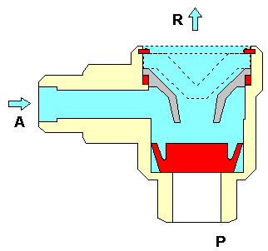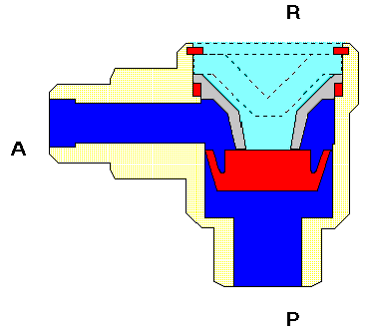
Picture– 86

When the pressure in P stops existing, the air, that now comes back for the connection A, it moves the seal against the connection P provoking its blockade. This way, the air can escape quickly from R to the atmosphere. With this, we avoid that the escape air is forced to pass for a long connection and of small diameter to the command valve. The most advisable is to place the fast escape directly in the cylinder or then the closest possible of the same (see Picture 87).

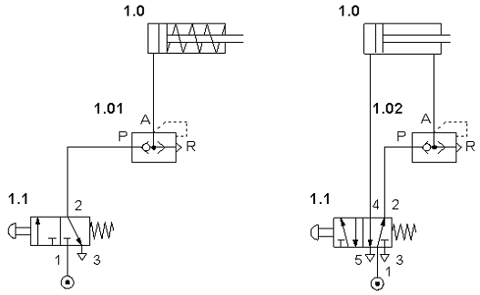
Picture– 87

Stop valves

These valves (see Picture 88), they allow the opening and close of the flow of compressed air, without scales (everything or anything).
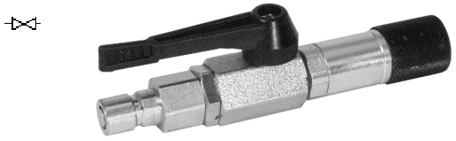

Picture– 88

SUMMARY

The valves are organs whose function is to command the greatness of a pneumatic variable or to alter the type of the circuit (see Picture 45). In the first case we have the regulating valves and in the second the directional control valves.

Segundo as suas funções, as válvulas subdividem-se em 5 grupos:
As its functions, the valves are subdivided in 5 groups:

1. Directional valves | 4. Flow valves
2. Non-return valves | 5. Stop valves
3. Pressure valves

Non-return valves These valves are the elements that block the passage in an alone direction, allowing with this the free passage in the contrary direction.

Non-return valves They are valves that have influence mainly on the pressure, and through which it can be made the regulation, or valves that depend on the command pressure.

They are distinguished in the following way:

Pressure regulating valve
Pressure relief valve
Pressure sequence valve

These valves are used, above all as valve of safety. They don't allow an increase of the pressure in the system, above the adjusted maximum pressure

The flow control valves, they are pieces made to create a resistance to the flow passage giving place to a pressure fall in the sense of passage of the compressed air.
They are used to control the progress speed and of retreat of the cylinders.

Quick exhaust valve are used to increase the speed of the pistons of the cylinders (see Picture 85). High times of return, especially in sinle-action cylinders they can be eliminated using this valve.

DIRECT BASIC COMMANDS

Control of Single-acting cylinder
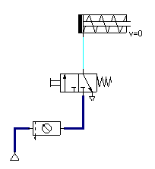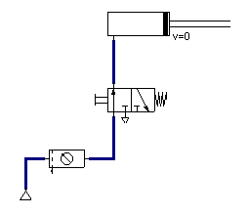

Control of Double-acting cylinder
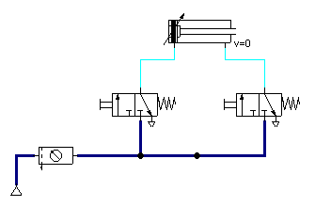

Pause

Advance
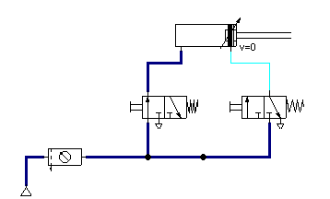
Return
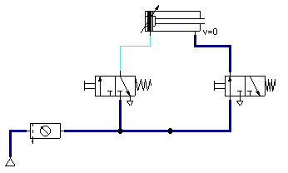

Indirect control of Double-acting cylinder
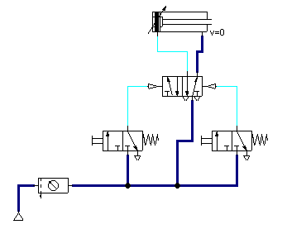

Pause

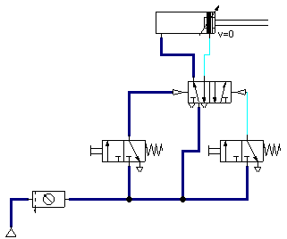

Advance

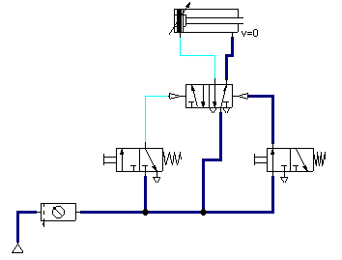

Return

Indirect control of Double-acting cylinder

In this example it is shown how to get an automatic cycle of Return from a 3/2 Way Valve with roller.

Pause
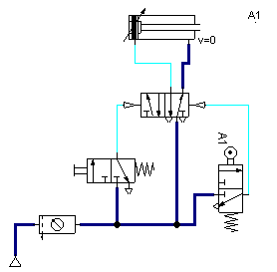

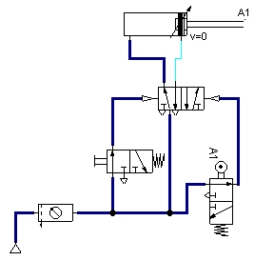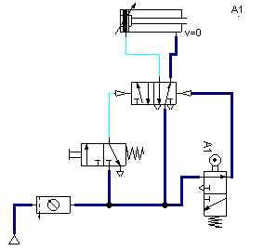Advance Return

Indirect control of Double-acting cylinder using a 5/2 Way Valve. With this valve the

Return is done automatically. When there is no sign on the left side the valve through the spring comes back to its initial position.
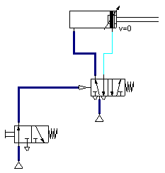
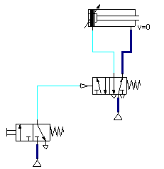Advance Return

Speed control of Single-acting cylinder (Advance Speed control)

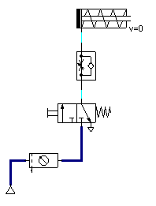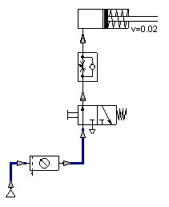

Return Speed control

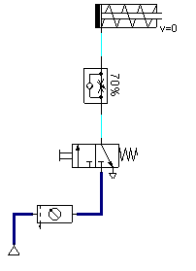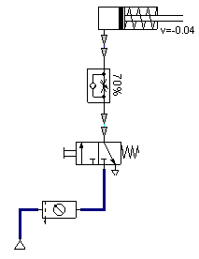

Advance and Return Speed control
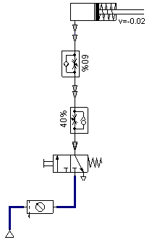
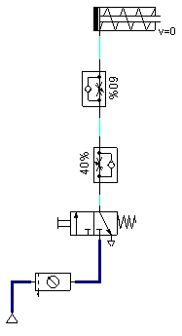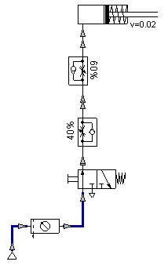

Advance and Return Speed control in de Double-acting cylinder
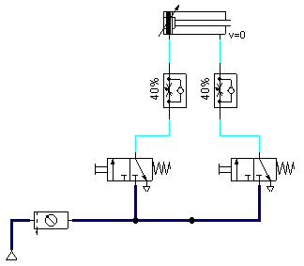

Pause

Advance
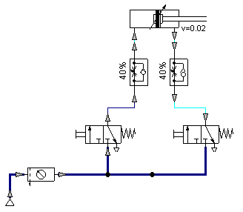

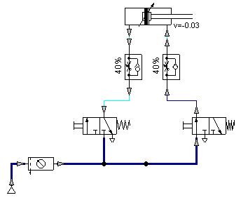 Return

Control of Single-acting cylinder, with Shuttle valve (OR function)

These valves are applied whenever we intend to command, from different places, any work element or of command. It can be said, that for the cylinder to advance is necessary to supply it a sign in the left valve OR in the right one.

Pause Left control

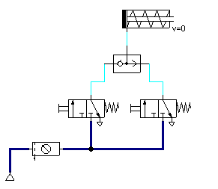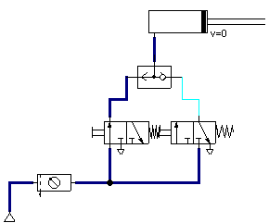

Right control

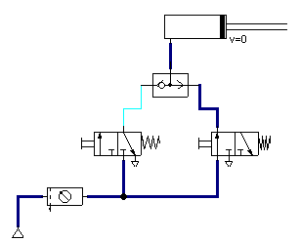

Control of Single-acting cylinder, with Dual-pressure valve (AND function)

These valves are applied whenever we intend to obtain a sign starting from two different signs acted in simultaneous. These valves or equivalent functions are used in machines or mechanisms as process of safety. The example of that are the Presses, so that they can be acted it is necessary that the operator presses the left button AND the right one.

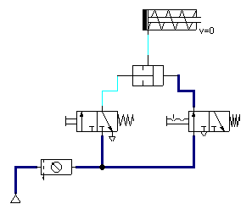

If we only act one of the valves we can’t operate the cylinder.

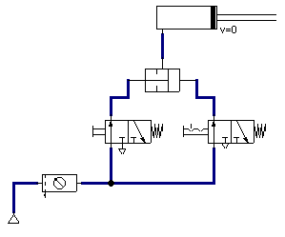

Control of Double-acting cylinder, with Time delay valve

Whenever we intended to control the time of actuation, of a certain work or control element we have to use the Time delay valve. For example if we intend that the cylinder of a press is acted after 10 seconds of having pressed the button, we have to apply a Time delay valve properly adjusted (10 seconds)

The button was already acted and the cylinder advance
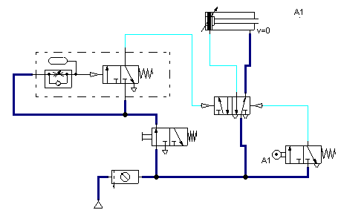

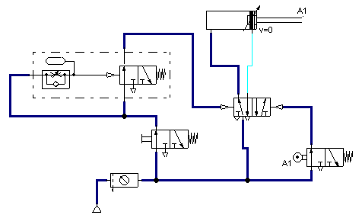
The cylinder advances only when the time is over

