ACTION PROGRAMME OF THE EUROPEAN UNION
LEONARDO DA VINCI
PROJEKT NO.: 2002 LA 112 628 BILVOC
Language Competence Through
Bilingual Teaching at Vocational Colleges

Teaching Module 6

Date of production: | October 2004
Subject: | Pneumatic movements and forces
Topic: | Pneumatic cylinders and motors
Title: | Pneumatic elements of work
Target Group: | Youths and workers whose professional profile is somewhat related to the use of pneumatics
Prior Knowledge: | Knowledge of teaching modules 1, 2, 3, 4 and 5
Level of Language Skills: | Intermediate English
Follow - Ups: | Understand the phenomena associated to the production of pneumatic forces and movements and identify the main elements used in those functions
Objectives: | Analyse and identify the main pneumatic work elements (cylinders and motors);  Distinguish the elements by their symbology;
Benefits: | At the end of the unit, trainees should know:  The types of pneumatic cylinders and motors and their applications;  Choose the elements according to the intended applications and their specifications;  Interpret the symbology;

Module 6
Foreseen time | Contents | Activities / Tasks | Pedagogic means | Pedagogic method
 | 6- Pneumatic elements of work
10 minutes | 6.1- Introduction | To present general concepts. | Transparencies; notes; PowerPoint presentation; whiteboard. | Presentation for the whole group; to promote the discussion and exchange of ideas.
20 minutes | 6.2 - Pneumatic elements of rectilinear movement | To present general concepts of rectilinear movement, and the elements that allow to accomplish this movement type. | Transparencies; notes; PowerPoint presentation; whiteboard; Films of the specialty. | To expose the matter using the demonstrative method, whenever possible method supported in practical situations. To promote the exchange of ideas
50 minutes | 6.3- Kinds of Single and double Action Cylinder | To present the different types of cylinders, its operation, characteristics and performances. | Transparencies; notes; PowerPoint presentation; whiteboard; Films of the specialty; catalogs, to show the own equipment. | Presentation for the whole group; to promote the discussion and exchange of ideas.
30 minutes | 6.4- Cylinders construction | To present the different aspects of the cylinder construction (materials; seals; types of mounting etc.) | Transparencies; notes; PowerPoint presentation; whiteboard; Films of the specialty. | Presentation for the whole group; to promote the discussion and exchange of ideas.
25 minutes | 6.5- Pneumatic elements with rotative movements | To present general concepts of rotative movement, and the elements that allow to accomplish this movement type, its characteristics and operation. | Transparencies; notes; PowerPoint presentation; whiteboard; Films of the specialty; catalogs, to show the own equipment. | To expose the matter using the demonstrative method, whenever possible method supported in practical situations. To promote the exchange of ideas
90 minutes | 6.6- Calculation of cylinders | To present general concepts, means and methods of cylinders calculation. | Transparencies; notes; PowerPoint presentation; whiteboard; catalogs, | To expose the matter using the demonstrative, whenever possible method supported in practical situations. Practical resolution of proposed theoretical exercises
60 minutes | 6.7- Calculation of the air consumption | To present general concepts, means and methods of calculation of the compressed air consumption. | Transparencies; notes; PowerPoint presentation; whiteboard; catalogs, | To expose the matter using the demonstrative, whenever possible method supported in practical situations. Practical resolution of proposed theoretical exercises
30 minutes | Summary | To do a summary of the main knowledge to acquire in this module. | Transparencies; notes; PowerPoint presentation; whiteboard. | To summarize the matter using the interrogative method.

INDEX

6 PNEUMATIC ELEMENTS of WORK 5
6.1 Introduction 5
6.1.1 Symbols 5
6.2 Pneumatic elements of movement rectilinear (cylinders) 6
6.3 Single Action Cylinder 6
6.4 Double Action Cylinder 7
6.4.1 Projection membrane cylinder 8
6.4.2 Cylinder with reduction in the course ends 8
6.4.3 Double piston rod cylinder 8
6.4.4 Tandem cylinder 9
6.4.5 Multiple position cylinder 9
6.4.6 Impact cylinder 9
6.4.7 Rodless cylinder 10
6.4.8 Rotary cylinder 10
6.5 Cylinders construction 10
6.5.1 Types of mounting 11
6.5.2 Types of Seal 11
6.6 Pneumatic elements with rotative movements (motors) 12
6.6.1 Axial and radial piston air motor 12
6.6.2 Vane Rotary Motors 13
6.6.3 Gear motors 13
6.6.4 Turbo – Motors 14
6.7 CALCULATION OF CYLINDERS 15
6.8 CALCULATION OF THE AIR CONSUMPTION 18
6.9 SUMMARY 22

PNEUMATIC
ELEMENTS
of
WORK

PNEUMATIC ELEMENTS of WORK

Pneumatic Cylinders and Motors

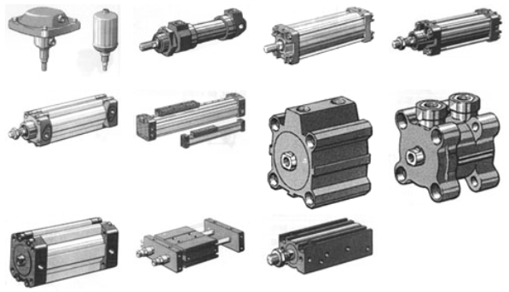

Introduction

The elements or pneumatic apparels are those that work using as potency source the energy of the compressed air.

The pneumatic energy (studied in the previous chapters), it will be transformed, by pneumatic cylinders in lineal movements and by the pneumatic motors in rotative movements.

Picture 39

In pneumatic, the limit of application of a cylinder is in the planner's imagination, because up to 30.000 Newton, a lot of operations can be executed by a pneumatic way force, directly applied.

Symbols

For the symbols of the elements of high pressure the annotation CETOP was adopted (European Commission of Transmissões Hydropneumatics) due to its general use. These logical symbols can also be used in pneumatic of low pressure, being also very disclosed in electronic. From the numerous existent elements the ones that will only be represented are considered more useful and for that, used, in a way that they allow the understanding of the circuits.

Pneumatic elements of movement rectilinear (cylinders)

The generation of a rectilinear movement with mechanical elements, can be obtained by using the pneumatic cylinders.

The cylinders can be classified in following way:

Types of cylinders:

1 – Single Action
2 – Double Action

Classes of cylinder:
1 – Light
2 – Medium
3 – Heavy
4 – Special
4.1 – Projection membrane
4.2 – With reduction in the way
4.3 – Tandem
4.4 – Double piston rod
4.5 – Multiple position
4.6 – Impact
4.7 – Rodless
4.8 – Rotary

Single Action Cylinder

The Single Action Cylinder, are worked by compressed air from one side, and therefore they only accomplish work in a sense. The return happens due to a spring or through external force (sees Pict. 40 and Pict. 41).

Symbol | Picture
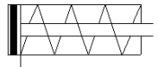 | 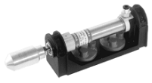

Picture 40

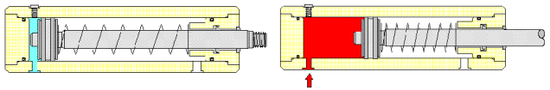

Picture 41

The spring force is calculated so that the piston of the cylinder can return to its initial position, with a speed sufficiently high, without absorbing, even so high energy.

These Single Action Cylinder, the course of the piston is limited by the length of the spring. For this reason, cylinders of simple effect are manufactured with course lengths to approximately 100 mm.

These elements are used mainly to fasten, to expel, to press, to elevate, to feed, etc…

Double Action Cylinder

The force exercised by the compressed air moves the piston of the cylinder of double effect, accomplishing movement in the two senses. A certain force will be produced in the progress, as well as in the piston return (see Pict.42 and Pict.43 and Pict.44).

Symbol | Picture
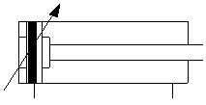 | 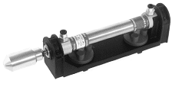

Picture 42

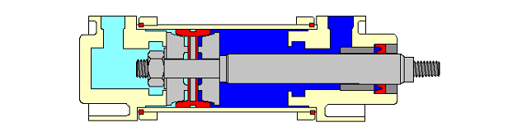

Picture 43

It is the most used type of cylinder.
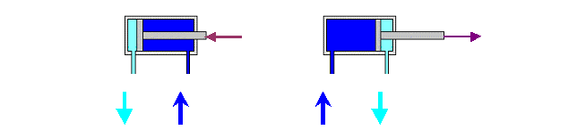
Picture 44

Projection membrane cylinder

The Picture illuminates the operation of this cylinder.
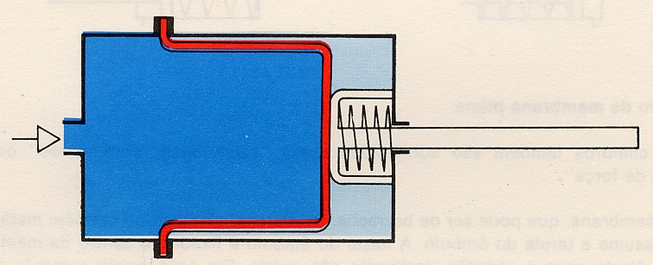

Cylinder with reduction in the course ends

When they are heavy volumes, cylinders are applied with system of reduction to avoid dry impacts that as everyone knows it contributes negatively to the duration of the useful life of the same ones.
Before reaching the final position, a piston of reduction interrupts the direct escape of the air, leaving only a small passage, usually a regulated one.
With the escape of restricted air a pressure increase is created that, in order be expired it absorbs great part of the energy and it results in the loss of speed in the way. Inverting the movement of the piston, the air enters without being stopped by the valves in the cylinder, and the piston cannot, with force and total speed, go back.

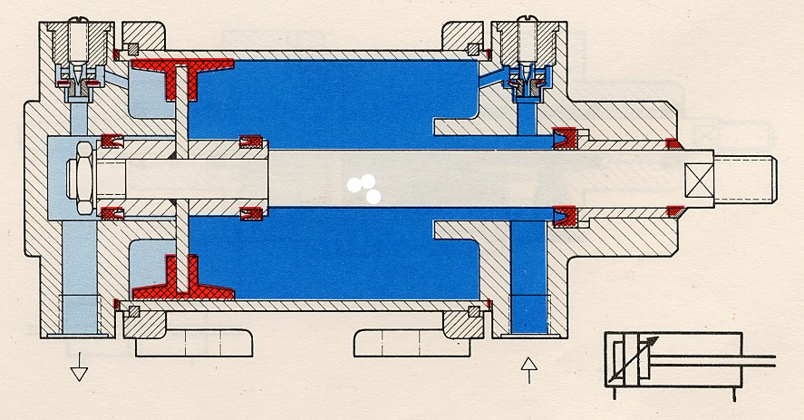

Double piston rod cylinder

This Double piston rod cylinder has some advantages.
The stem is guided better due to two limp of guide. This facilitates the admission of a slight lateral load. In this case, the obtained force is the same on both sides (same pressure area).

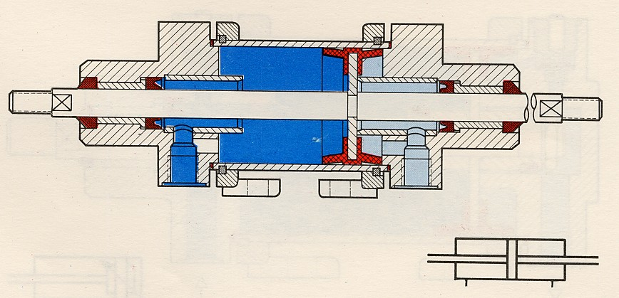

Tandem cylinder

In this construction there are two cylinders of double action that form only one unit. This way, with simultaneous load in the two pistons, the force is a sum of the forces of the two cylinders. The use of this construction it is necessary to obtain great force, when the diameter, of the cylinder is problematic (small space).
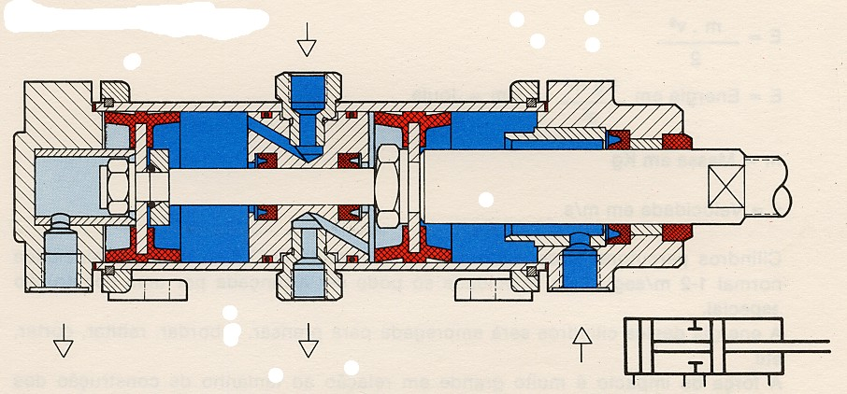

Multiple position cylinder

The cylinder of multiple position is formed by two or more cylinders of double action. These elements are, as showed, united each other.
The cylinders are moved, according to the pressure side, individually. With two cylinders of different shapes we obtained 4 positions.

It is used to carry shelves with wake carrier, to work levers, etc..

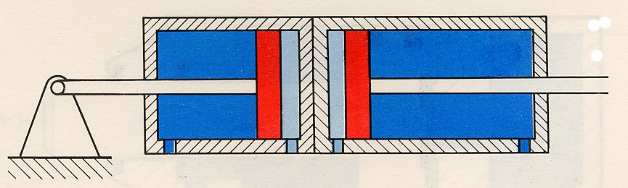

Impact cylinder

The use of the normal pneumatic cylinders in the deformation technique is limited.
To develop great kinetic energy, cylinders of Impact are used. These cylinders develop a speed of 7,5 to 10 m/s (speed normal 1a 2 m/s). This speed can only be reached by a special construction.
The energy of these cylinders is usually applied to press, to fettle, to rivet, to cut, etc.

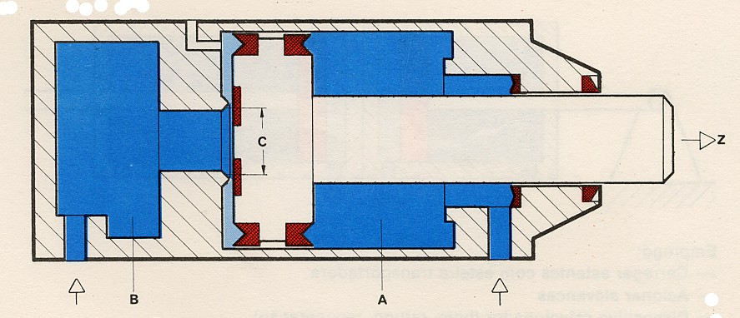

Rodless cylinder  It is a cylinder of double action, that has on each side of the piston a fastened cable and guided by rolls.  It is used in the opening and closing of doors and to situations of great courses with small construction dimensions. | 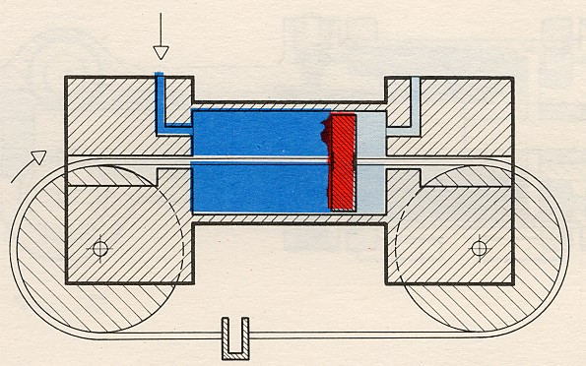

Rotary cylinder

In the execution with cylinders of double action, the stem of the piston has a jagged Profile (rack) . The stem of the piston works with this rack an engagement, transforming the lineal movement in a rotative movement to the left or right, always according to the direction of the course.
The usual rotation fields are several, that is, of 45th, 90th, 180th, 270th up to 720th. A regulation screw facilitates even so the determination of the field of partial rotation, inside of the total.
The moment of torsion depends on the pressure, of the area of the piston and of the transmission relationship. The rotative movement is used to turn pieces, to curve tubes, to regulate facilities of conditioned air, connection of valves of closing and butterfly valves, etc.

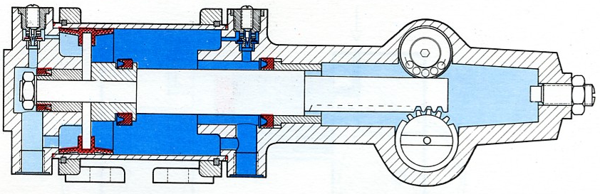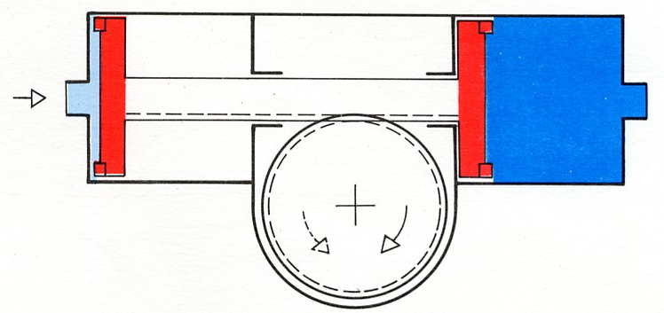

Cylinders construction

Os cilindros são construídos tendo em conta as seguintes peças constitutivas:

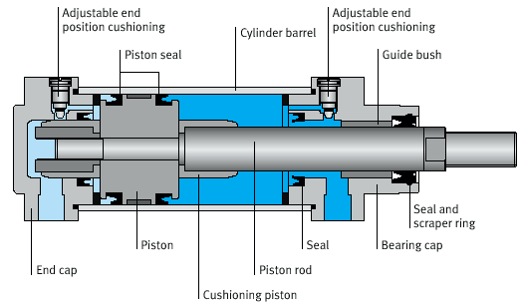

Types of mounting

The choice of the fixation type depends on the assembly of the cylinders in the devices

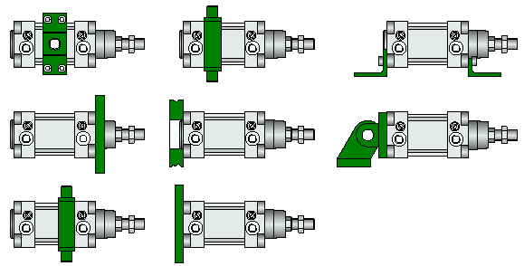

Types of Seal

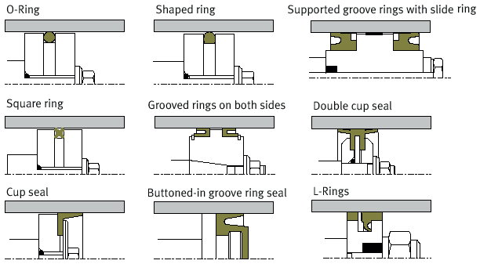

Pneumatic elements with rotative movements (motors)

These elements transform the pneumatic energy in rotation movement. They are the motors to compressed air.
The pneumatic motor is one of the work elements more used in the pneumatic. The pneumatic motors are classified, according to its constructive aspect, in the following way:

Piston air Motors
Vane Rotary Motors
Vane type motors
Gears motors

All these types of motors present the following particularities:

 regulation without rotation scale and of the moment torsion

 great rotation choice

 light and small construction

 safe against overloads

 insensitive to dusts, water and temperature

 safe against explosion

 conservation and insignificant maintenance

 rotation sense easy to invert

Axial and radial piston air motor

The way of operation of the axial and radial motors is similar. A rocking disk transforms by force of 5 cylinders, positioned in an axial way, in rotative movement. Two pistons are fed simultaneously with compressed air. With this we will obtain a moment of balanced inertia, guaranteeing a movement of the uniform motor and without vibrations.
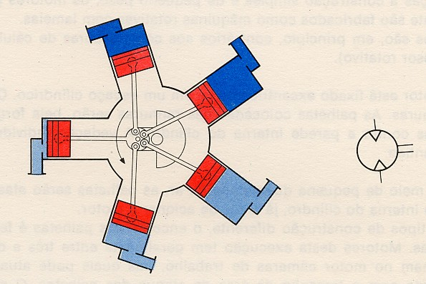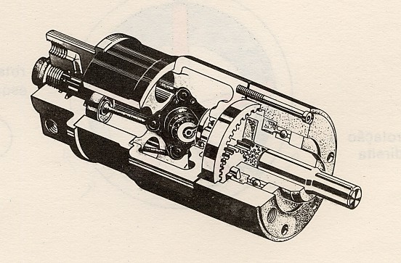

Radial Motor Axial Motor

Vane Rotary Motors

Due to its simple construction and small weight, the pneumatic motors are generally manufactured following this constructive type (see Pict.44). These are the ones of inverse operation to the rotative compressors (of vanes).

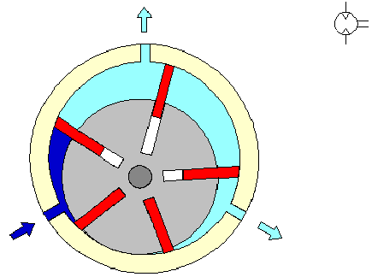

The rotor is fastened in an excentric way in a cylindrical space. The rotor is endowed with grooves. The vanes placed in the grooves will be, by force, moved away against the inverse wall of the cylinder. The individual seal of the cameras is guaranteed.
By means of a small amount of air, the vanes are distant against the internal wall of the cylinder, already before working the rotor. In types of different construction, the fixation of the vanes is made by pressure of springs. Motors of this execution generally have between 3 and 10 vanes. These form in the motor, working cameras, in which the air can act, always in agreement with the size of the area of attack of the vanes. The air enters in the smaller camera, and it expands the camera.
The rotation of the rotor varies in this type of pneumatic motors, between 3000 and 8500 r.p.m..

Gear motors

The generation of the torque is made in this construction by the projection of the pressure of air against the flanks of the teeth of two geared jagged wheels (mounted one in the vein motor and another liberates).
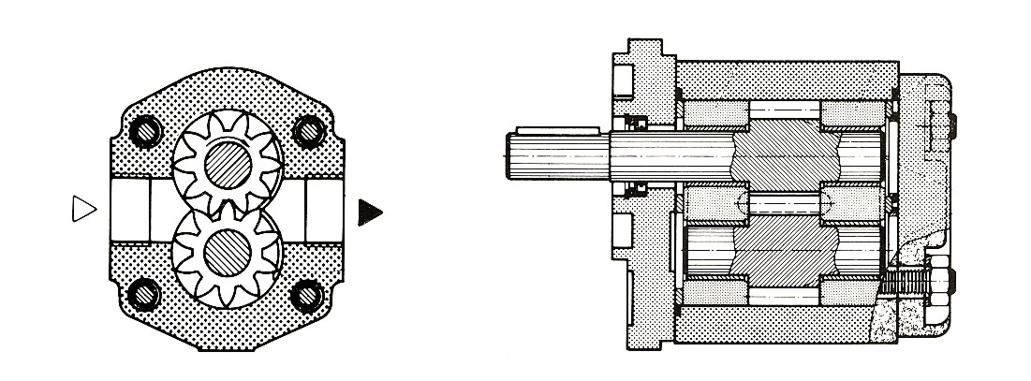

Turbo – Motors

This constructive type can only be applied in light works. Even so the rotation strip is very wide (in dental equipments up to 500000 rpm). Its operation corresponds unlike a darken - compressor.
The sense of the flow is from darkness to clear.

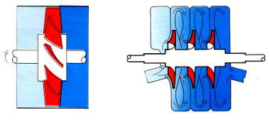

CALCULATION OF CYLINDERS

The force of the piston depends on the pressure of the air, on the diameter of the cylinder and on the resistance of friction of the seal elements.

In the cylinders there are two types of forces essentially:

Theoretical force (Fth)

Effective force, real or normal (Fn)

Theoretical force = Pressure x Area |  | F_{th} = P x A | ( Kg = bar x cm² )

For Single-action cylinder

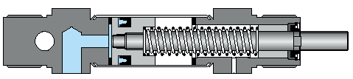

Effective force, or normal = Pressure x Area – (Friction resistance + Spring resistence)
F_{n} = P x A – ( F_{r} + F_{f} )

For Double-action cylinder

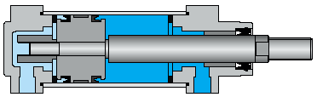

Advance |  | Retract
F_{n} = P x A₁ - F_{r} |  | F_{n} = P x A₂ - F_{r}

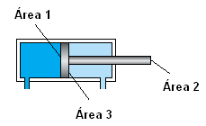

Calculation example

Fn = ?
D = 50 mm
d = 12 mm
A₁ = 19.625 cm²
A₃ = 18.5 cm²
F_{r} = valor médio 10%
P = 6 bar

Surface or area of the piston (Area 1)

A₁ | = | π x D² | ⇒ | 3,14 x 5² cm² | = | 19,625 cm²
A₁ | = | 4 | ⇒ | 4 | = | 19,625 cm²

Surface or Area of the piston ring (Area 3)

A₃ | = | π x D² | - | π x d² | ⇒ | 3,14 x (D² – d²) | = | 3,14 x (5² – 1,2²) | = | 18,5 cm²
A₃ | = | 4 | - | 4 | ⇒ | 4 | = | 4 | = | 18,5 cm²

Tends the value of the areas we can determine the theoretical Force of the piston

F_{th} = A x P ⇒ F_{th} = 19,625 cm² x 6 bar = 117,75 Kg.f

Then the effective or real Force of the piston will be

We know that Fr = 10% then, for the advance,

F_{n} = A₁ x P – F_{r} ⇒ F_{n} = 19,625 cm² x 6 bar – 0,1 x (19,625 x 6) = 106 Kg.f

For the return,

F_{n} = A₃ x P – F_{r} ⇒ F_{n} = 18,5 cm² x 6 bar – 0,1 x (18,5 x 6) = 100 Kg.f

The advance force can also be obtained with relative rigidity, through the graph of the following page, in the following way. With the larger diameter (50 mm) a perpendicular line is made to the abscissa axis to find the diagonal corresponding to the pressure in the net (6bar). Starting from the intersection of the lines described previously, a horizontal one is made parallel to the abscissa axis to find the ordinates axis, the spot where we can see the force obtained (106 Kgf).

Pressure-force diagram

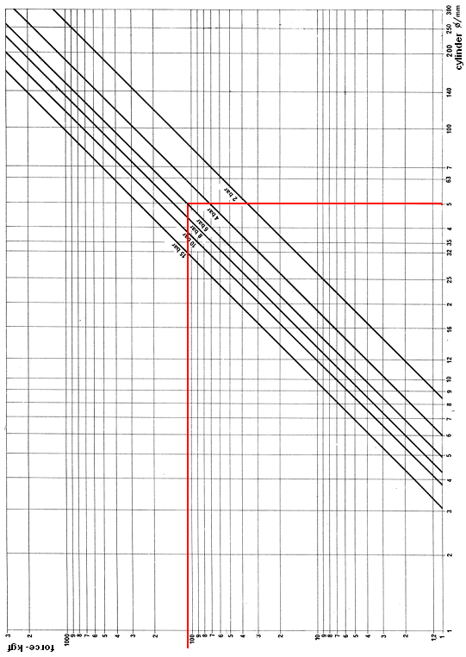

In the following page there is a graph, that depending on the force and on the diameter of the stem of the piston, it can define the useful course to use in previously conditions.

With the force obtained previously (106 Kgf) a perpendicular line is made to the abscissa axis to find the diagonal corresponding to the diameter of the rod piston (12 mm). Starting from the intersection of the lines described previously, a horizontal one is traced parallel to the abscissa axis to find the axis of the ordinates, the spot where we can read the course (28 mm).

Notice that with the previously defined cylinder we can obtain forces rounding the106 Kp but only if the course of the cylinder is of 28 mm, otherwise and for a larger course we name the phenomenon of the buckling (deformation) of the stem. It is evident that with this cylinder we can obtain larger courses, but assuming as commitment the relationship course / forces, that is to say for larger courses, smaller forces.

CALCULATION OF THE AIR CONSUMPTION

It is important to know the air consumption of the installation to produce it and to know which the energy expenses.

Important data: Working pressure, Diameters and useful Courses

Q = Air consumption

Q = Compression ratio (Rc) x Surface of the piston (A) x Course (s)

Compression ratio = P₂ / P₁ and it is calculated like this

Rc | = | 101,3 + Working pressure (Kpa)
Rc | = | 101,3

For the calculation of the air consumption:

For Single-action cylinder

Q = s x n x π x r₁² x Rc ou Q = s x n x A₁ x Rc

For Double-action cylinder

Q = [s x π x r₁² + s x (π x r₁² - π x r₂²)] x n x Rc ou Q = [s x A₁ + s x (A₁ – A₂)] x n x Rc

Q = [ A₁ + (A₁ – A₂)] x s x n x Rc ⇒ Q = ( A₁ + A3) x s x n x Rc

Calculation example:  Q = ?  D = 50 mm  d = 12 mm  S = 100 mm  n = 10  P = 6 bar (600 Kpa)
  Rc | = | 101,3 + Working pressure (Kpa)
  Rc | = | 101,3
Rc | = | 101,3 + 600 (Kpa) | = | 6,9
Rc | = | 101,3 | = | 6,9

Q = [s x π x r₁² + s x (π x r₁² - π x r₂²)] x n x Rc

Q = [10 cm x π x 2,5² cm² + 10 cm x (π x 2,5² cm² - π x 0,6² cm² )] x 10 x 6,9

Q = 26337 cm³ / min ⇒ Q = 26,337 dm³ / min

In the case of using the graph of air consumption:

Q = 2 x (s x n x q (L / min)

Q = 2 x (10 cm x 10 x 0,134 L / cm)

Q = 26,4 L / min

Comparing these two values, it can be concluded that the two methods are complemented, once for the second method it can compare the value obtained in the first method that is the most precise.

Buckling diagram

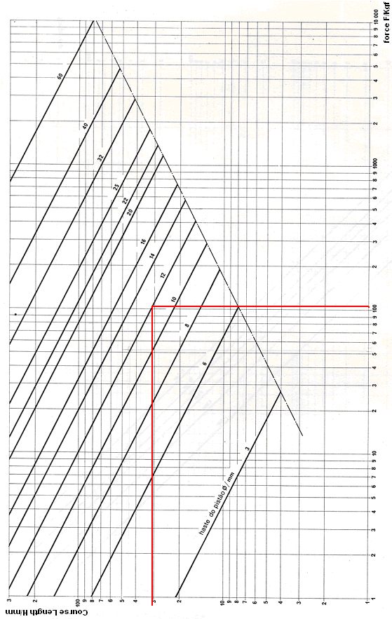

Diagram of air consumption

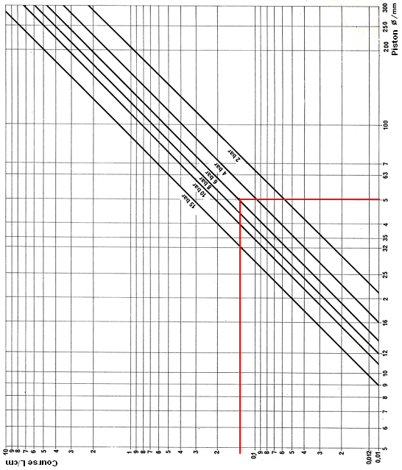

SUMMARY

They elements or pneumatic apparels are those that work using as potency source the energy of the compressed air.

The pneumatic energy will be transformed, by pneumatic cylinders, in rectilinear movements and by the pneumatic motors in rotative movements.

Types of Cylinders: single-action; double-action

Classes of Cylinders: Light; Midium; Heavy; Special (Mini, Membrane, Tandem, Double rod, Torque)

The single-action cylinders, they are worked by compressed air on an alone side, and therefore they only accomplish work in a sense. The return is made by a spring or through external force (see Picture - 40 and Picture - 41).

The pneumatic motor is one of the working elements more used in the pneumatic. The pneumatic motors are classified, according to its constructive aspect, in the following way:
(piston motors; vanes motors; gear motors ; turbo-motors (turbines)).

All these types of motors present the following particularities:

 regulation without rotation scale and of the torque;

great rotation choice

light and small construction;

safe against overloads;

insensitive to dusts, water and temperature;

 safe against explosion;

 conservation and insignificant maintenance;

 rotation sense easy to invert.

Of the theoretical-practical point of view it is advisable to do a taken care analysis of the represented exercise, and for own initiative (arbitrating values) in order to create new study situations.

