Bilingualer Fachunterricht an berufsbildenden Schulen

Unterrichtsmodul

Berufsfeld: Elektrotechnik

Beruf: Elektroniker

ELECTRICAL INSTALLATION

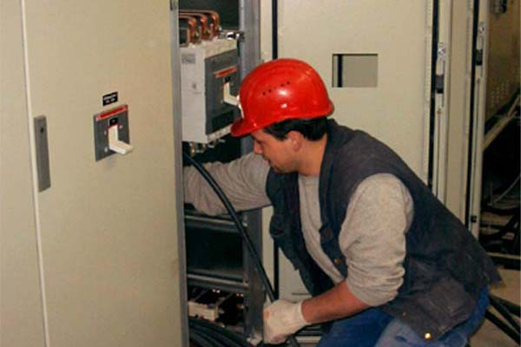

ACTION PROGRAMME OF THE EUROPEAN UNION
LEONARDO DA VINCI
PROJEKT NO.: 2002 LA 112 628 BILVOC
Language Competence Through
Bilingual Teaching at Vocational Colleges

Teaching Modules

Date of production 09/2005

Subject: Electrical technology

Topic: Safety First

Title: electrical installation

Target Group: Any group of electrical engineering students

Prior Knowledge: Basic of electrical engineering

Level of Language Skills: Waystage (A2)

Follow - Ups: Experiments on safety precautions

Objectives: Importance of precautions

Benefits: The danger of electricity and protection from
electric shock
Teaching Module: electrical installation

Teaching Time  (experience) | Contents | Activities | Media | Skills
30 minutes  15 minutes  45 minutes  25 minutes  20 minutes  60 minutes  60 minutes  15 miutes | Safety First  Safety Signs  Electrical shock  Cause and effect  First Aid  electrical installation  Symbols  Installation diagram  practice  evaluation | Discussion with the student  about the worksheet  Check unknown words using the dictionary  Individual work  Work out the contents in 3 groups,  Group presents the  summarised contents  Individual work  Information given by the teacher  Students drawing symbols  Drawing the diagrams  Connect the circuits using the board  Write down the results  evaluation of the material  Write definitions | Board, worksheet  dictionary  transparency  worksheet  Board, transparency and  worksheet  transparency  transparency  electrical board  paper  paper | Questions and answers and  classroom discussion  working independently  giving exact explanation expressing and accepting objective criticism  Questions and answers;  classroom discussion  working indepentently  drawing indepentently  working with electrical board
270 minutes

ELECTRICAL INSTALLATION

Safety First

1. Better safe than sorry !!

- If a current of more than 50 mA flows through the body, brain functions are disturbed.

- Even a weak current of just over 50 mA can kill if it flows through the heart.

- If the current is greatly in excess of 50 mA, it becomes impossible to let go of the conductor, ie to break the circuit

For safety at work check that

Five rules for safe electrical work:

Freischalten → switch off electricity

Gegen Wiedereinschalten sichern → ensure that electricity cannot be
switched on again

Spannungsfreiheit feststellen → double check that no electrical
current is flowing

Erden und kurzschließen → ground the circuit
Abschranken, abdecken, (benachbarter)→ cover or otherwise isolate
unter Spannung stehender Teile components that are still
electrically active

Safety Signs

Warning Signs - Category II or III holding positions sign

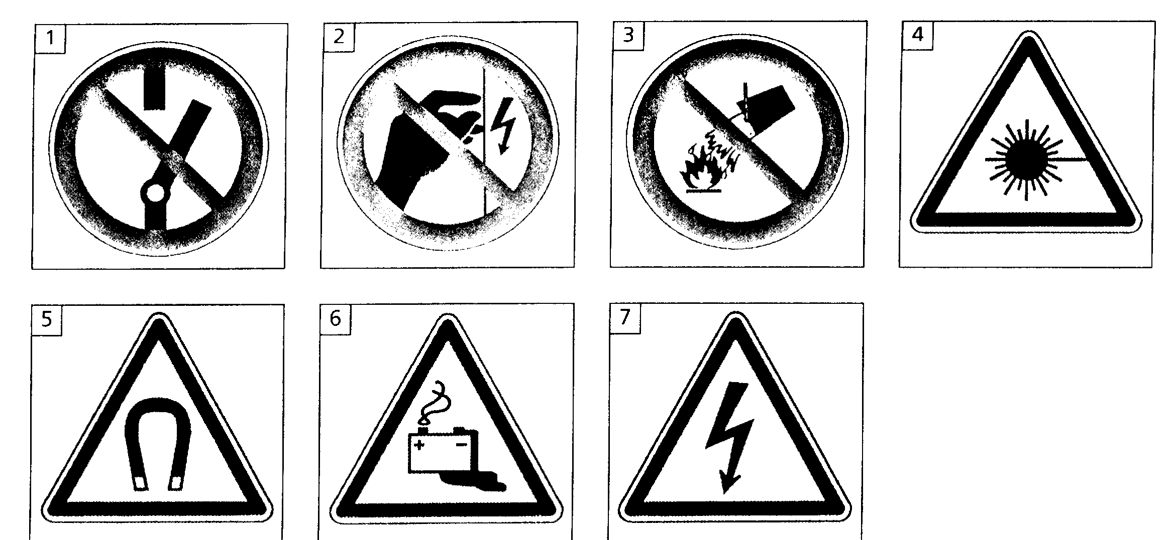

- Don`t switch on
- Don`t touch
- Don`t fight fire with water
- Danger laser beam
- Danger magnetic field
- Danger battery
- Danger high voltage

2. Electrical shock
2.1. Cause and effect

Read the text about the effects of electric shock. Then look at the statements next to the text and tick the right ones.

Effects: An electric current passing through the body causes electric shock. Electrical shock especially affects the heart (upsetting its rhythm and the flow of blood), the muscles and the nervous system. The severity depends on the strength of the current. And the time for which it passes, although age. general health and moistness of the skin are also factors.
The strength of the current depends on the voltage applied to the body and its resistance. The latter may exceed 10 kΩ or it might be less than 1.5 kΩ if the skin is moist. If the voltage is 240 V and the body resistance 1.5 kΩ, the current through someone directly in contact with the earth is 240 V/1.5 kΩ = 160 mA (which would be fatal). The current is less (e.g. 50 mA) because the resistance of the tiles and the wood floor has to be added to that of the body but a severe shock would still be obtained.

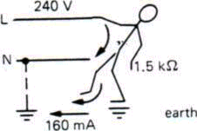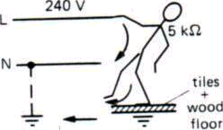

Fatal shock Severe shock

Electric shock
o is caused by electric current.
o upsets the rhythm of the heart.
o causes muscle cramps.
o affects the nervous system.

Electric shock is more severe
o the higher the current is.
o the longer voltage is applied.
o the older the person is.
o the lower the body resistance is.

The value of the current depends
o on the voltage.
o on the body resistance.
o on the person is.
o on where the person stands.

2.2. First aid

First aid is essential in case of electric shock. Breathing must be restored, or death will result. The following procedure should be followed.

a) Switch off the supply
b) If this cannot be done, drag or push the victim away from the live wire, using an insulator!
c) Send for medical help immediately.
d) Apply artificial respiration until help arrives.
This must be continued even if it is for a long period.

- Help

Look at the following words.
o accident o apply
o address o electric shock
o ambulance o unconscious
o artificial respiration

Listen to the telephone call and tick the words when you hear them.

Listen again and complete the bubbles.

A colleague at work just had………………………………………………………………..
He’s suffering from…………………………………………………………………………

Try …………………………………………………………………………………………
We’ ll send an……………………………………………………………………………..

Get an ambulance

You are working in your company and, suddenly, a colleague next to you suffers an electric shock.Work in groups of 3 or 4. One is calling for help. the others give first aid.

3. Installation Symbols

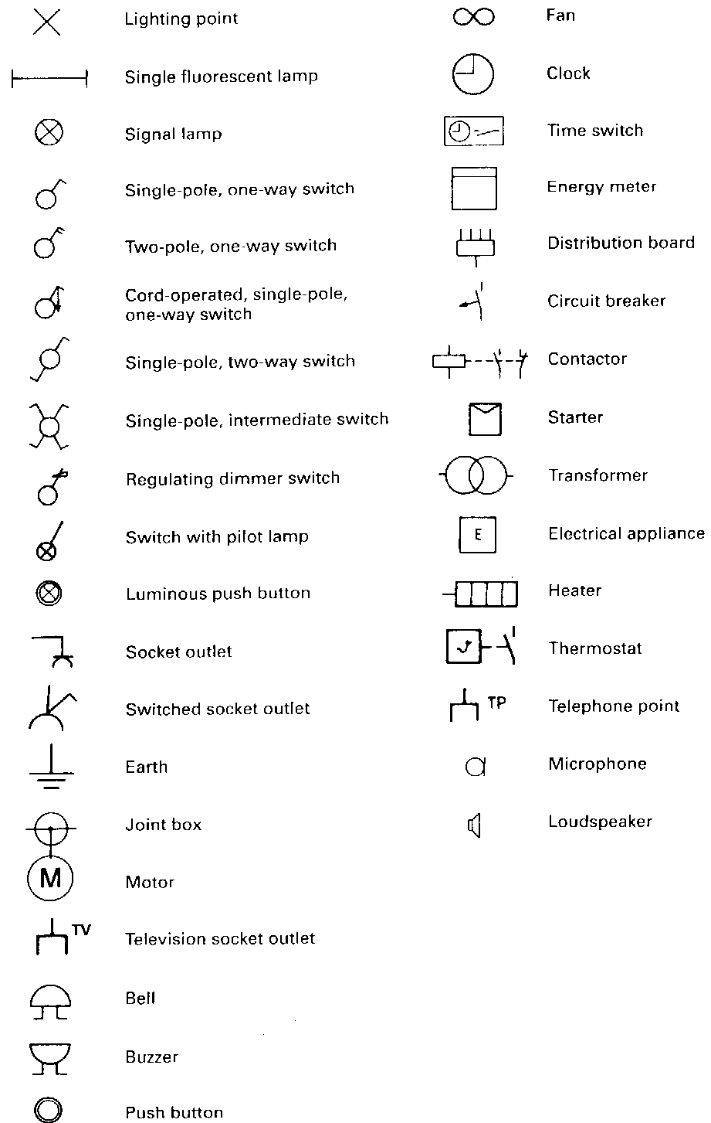

Chek the vocabulary

What do to following symbols mean in english?
a) b) c) d) e) f)
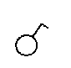
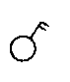
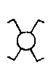
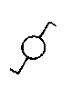
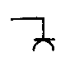
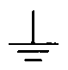

- electrical installation

The wire

Low resistance earth wire → green/yellow
Live or positive wire → brown
Neutral wire → blue

4.1. Ausschaltung → one way circuit

Stromlaufplan schematic diagram

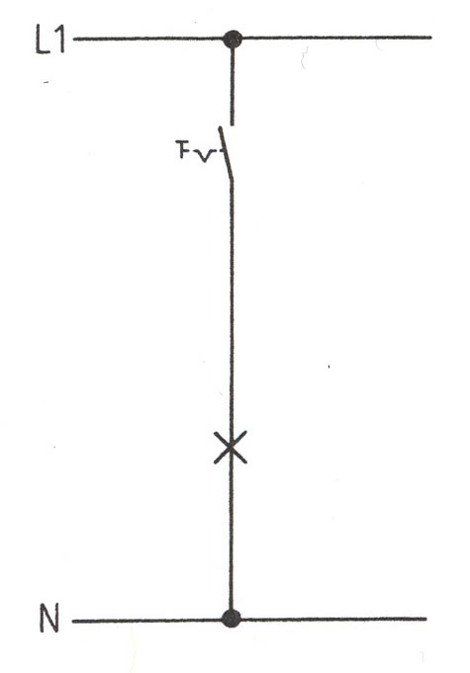

Installationsplan architectural diagram

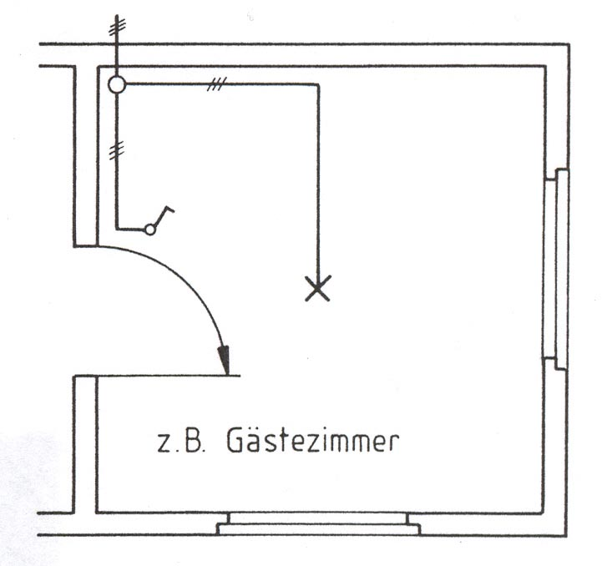

Child´s room

4.2. Serienschaltung → series-parallel connection

Stromlaufplan schematic diagram

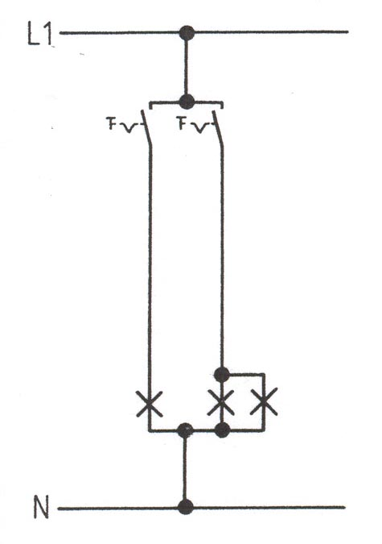

Installationsplan architectural diagram

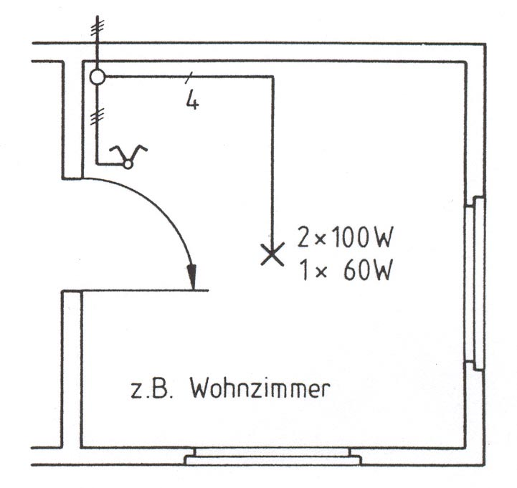

Living room

4.3 Wechselschaltung → two way circuit

Stromlaufplan schematic diagram

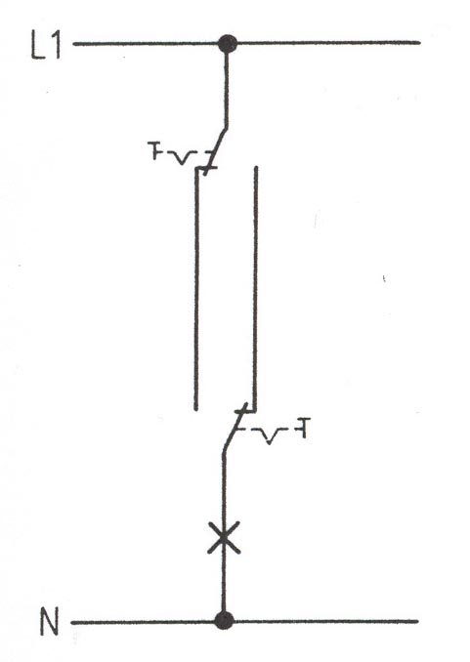

Installationsplan architectural diagram

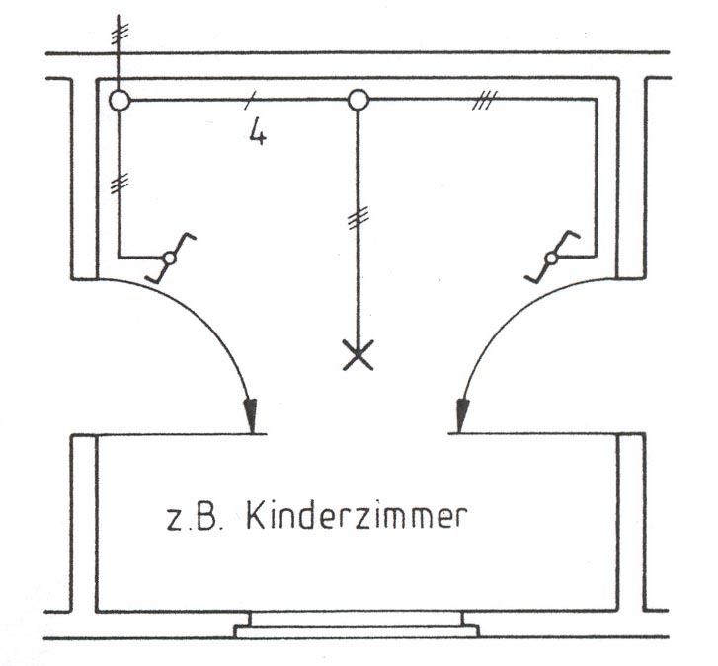

Hallway

4.4 Kreuzschaltung → cross conection

Stromlaufplan schematic diagram
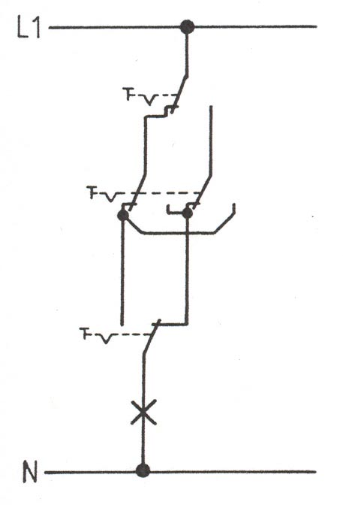

Installationsplan architectural diagram
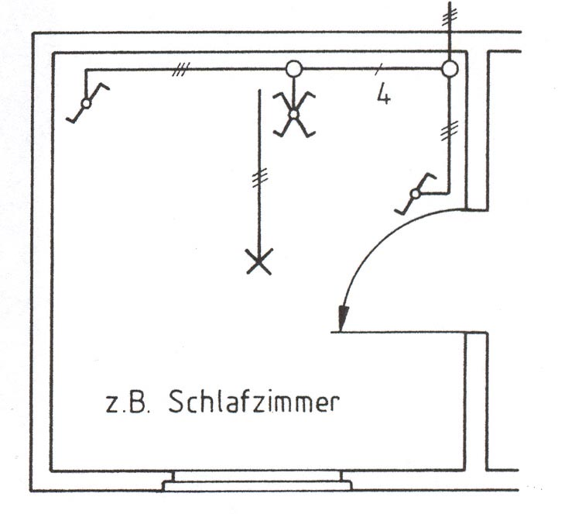

Bedroom

Words:

socket Steckdose
Child room
junction box Abzweigdose
puch button switch Taster
circuit Stromkreis

