ACTION PROGRAMME OF THE EUROPEAN UNION
LEONARDO DA VINCI
PROJEKT NO.: 2002 LA 112 628 BILVOC
Language Competence Through
Bilingual Teaching at Vocational Colleges

Teaching Module 2

Date of production: | October 2004
Subject: | Pneumatics bases
Topic: | Physical principles associated to pneumatics
Title: | Physical bases
Target Group: | Youths and workers whose professional profile is somewhat related to the use of pneumatics
Prior Knowledge: | General knowledge of physics
Level of Language Skills: | Intermediate English
Follow - Ups: | Understand the phenomena associated to pneumatics
Objectives: | Understand and use the main physical principles and the units inherent in pneumatics
Benefits: | At the end of the module, trainees should:  Interpret correctly greatnesses like: pressure, volume and temperature

Module 2
Foreseen time | Contents | Activities / Tasks | Pedagogic means | Pedagogic method
20 minutes | 2 - Physical beginnings | To present general physical concepts that govern the pneumatic, especially notions of FORCE and PRESSURE. | Transparencies; notes; PowerPoit presentation; whiteboard. | Presentation and demonstration for the whole group;
50 minutes | Units of the SI, of Forces and Pressures. | To present the main units of measure, used in the mensuration of forces and pressures. | Transparencies; notes; PowerPoit presentation; whiteboard. | Presentation and demonstration for the whole group; Resolution of exercises using the units.
30 minutes | 2.1- Capacity that the air has, in being compressed. | To present the physical concept and the laws that dominate him. Study of Boyle Mariotte's law. | Transparencies; notes; PowerPoit presentation; whiteboard. | Demonstration for the whole group of the concepts and elementary laws. Resolution of theoretical exercises.
30 minutes | 2.2- Influence of the temperature in the volume of air. | To present the physical concept and the laws that dominate him. Study of Gay-Lussac's law | Transparencies; notes; PowerPoit presentation; whiteboard. | Demonstration for the whole group of the concepts and elementary laws. Resolution of theoretical exercises.
25 minutes | Summary | To do a summary of the main knowledge to acquire in this module. | Transparencies; notes; PowerPoit presentation; whiteboard. | Practical resolution of theoretical exercises

INDEX

2 PHYSICAL FOUNDATIONS 5
2.1 Compressibility of the Air: 6
2.2 Influence of the temperature in the volume of air: 7

PHYSICAL BEGINNINGS

PHYSICAL FOUNDATIONS

The terrestrial surface is totally surrounded by a layer of air. This air that it is of vital interest, is a gaseous mixture of 78% of Nitrogen, 21% of Oxygen and still vestiges of another elements as they are, carbon dioxid, argon, hydrogen, neon, helio, kripton and xeon.

To improve the understanding of the laws and of the state of the air , we should consider the physical greatnesses involved.

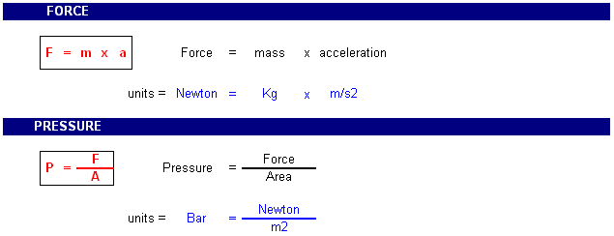

The unit of Pressure in the international system is Pascal (Pa), but due to the fact of this being a small greatness, it is very frequent to use other units, particularly the bar that, although it doesn't belong to any system, it gives a more real perception of the phenomenon. It is common to appear other greatnesses.

Other pressure units

Unit | Equivalent measurements, comments
Pounds per square inch  (psi, PSI, lb/in², lb/sq in) | Commonly used in the U.S., but not elsewhere. Normal atmospheric pressure is 14.7 psi, which means that a column of air, one square inch in area rising from the Earth's atmosphere to space, weighs 14.7 pounds
Atmosphere  (atm) | Normal atmospheric pressure is defined as 1 atmosphere. 1 atm = 14.6956 psi = 760 torr.
Torr  (torr) | Based on the original Torricelli barometer design, one atmosphere of pressure will force the column of mercury (Hg) in a mercury barometer to a height of 760 millimeters. A pressure that causes the Hg column to rise 1 millimeter is called a torr (you may still see the term 1 mm Hg used; this has been replaced by the torr). 1 atm = 760 torr = 14.7 psi.
Bar  (bar) | The bar nearly identical to the atmosphere unit. One bar = 750.062 torr = 0.9869 atm = 100,000 Pa.
Millibar  (mb or mbar) | There is 1,000 millibar in one bar. This unit is used by meteorologists who find it easier to refer to atmospheric pressures without using decimals. One millibar = 0.001 bar = 0.750 torr = 100 Pa.
Pascal  (Pa) | 1 pascal = a force of 1 Newton per square meter (1 Newton = the force required to accelerate 1 Kilogram one meter per second per second = 1 kg/(m.s²); this is actually quite logical for physicists and engineers, honest). 1 pascal = 10 dyne/cm² = 0.01 mbar. 1 atm = 101,325 Pascals = 760 mm Hg = 760 torr = 14.7 psi.
Kilopascal  (kPa) | The prefix "kilo" means "1,000", so one kilopascal = 1,000 Pa. Therefore, 101.325 kPa = 1 atm = 760 torr and 100 kPa = 1 bar = 750 torr.
Megapascal  (MPa) | The prefix "mega" means "1,000,000", so one megapascal = 1,000 kPa = 1,000,000 Pa. Such high pressures are rarely encounterd.
Gigapascal  (GPa) | The prefix "giga" means "1,000,000,000", so one gigapascal = 1,000 MPa = 1,000,000 kPa = 1,000,000,000 Pa = 9,870 atm = 10,000 bar. Pressures of several gigapascals can convert graphite to diamond or make hydrogen a metallic conductor!
Pound  (lb, lbs) | A pound is an English unit of weight. There are 16 ounces or 7,000 grains (a less common unit) or 453.592 grams in a pound.

Did you you know that:

When you put air in the tires of your automobile and someone tells you to put 30 ahead and 28 behind, they are talking in Psi.

When you fill the tires, notice that 28 Psi is equal to the approximately 2 bar (2Kg/cm2).

With the help of the presented basic greatnesses it is possible to explain the physic main characteristics of the air.

Compressibility of the Air:

As all the gases, the air doesn't also have a defined form. The air alters its form to the smallest resistance, that is to say that it adapts easily to the form of the recipient. The air lets to compress itself but it always tends to expand.

We can say that:

 The air adapts to the form of the recipient;

 It is easily compressed;

 Theoretically inside of a recipient we can put air more and more air, that is to say compressing it to the limit of resistance of the recipient.


This law says that if the temperature maintains constant, then the product of the volume for the pressure it is also constant in a in some moment..

V₁
P₁
F1
V₂
P₂
F2
V₃
P₃
F3



Mathematical explanation:

Admitting the constant Temperature and the air a perfect gas we have:
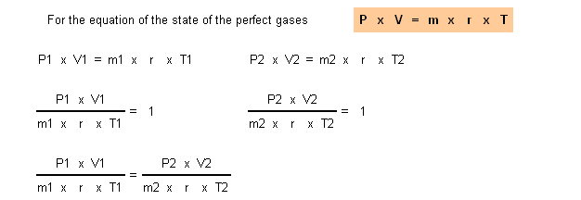

If we admitted the constant Temperature T1=T2, m1=m2, because it is the same recipient, r = constant specifies of the gases, then:

Influence of the temperature in the volume of air:

The temperature of a gas supplies it energy. This energy excites the molecules that tend to stay away from each other, doing with that, that the volume of the gas suffers alterations (it increases). If the recipient is closed the increase of the temperature firstly it makes to increase the volume to the limit of the recipient, when the air it cannot expand plus, then the pressure begins to rise.

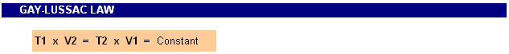

This law says that if the pressure it maintains constant, then the reason between the volume and the temperature it is also constant in some moment.

V₂

V₁

T₁

T₂

Mathematical explanation:

Admitting the constant Pressure and the air a perfect gas we have:

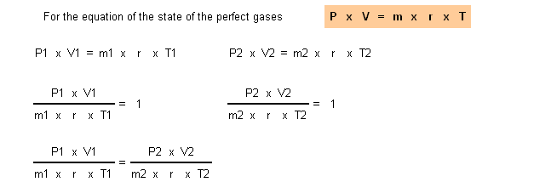

If we admit the constant Temperature P1=P2, m1=m2, because it is the same recipient, r = constant specifies of the gases, then:

