Bilingualer Fachunterricht für berufsbildende Schulen

Unterrichtsmodul

Berufsfeld : Wirtschaft und Verwaltung

beruf: bürokräfte

How to write a business letter



ACTION PROGRAMME OF THE EUROPEAN UNION
LEONARDO DA VINCI – PROJECT
PROJECT No.: 2002 LA 112 628 BILVOC
LANGUAGE COMPETENCE THROUGH BILINGUAL TEACHING AT VOCATIONAL COLLEGES

Teaching Module

Date of production: May 2004

Subject: English for disadvantaged students

Topic: How to write a business letter

Target Group: disadvantaged students

Prior Knowledge: basic

Level of Language Skills: waystage ( A2)

Objectives: - The students learn to describe how to write a business letter

Zeit | Teacher´s activity | Students´  activities | teaching method | Media
25 Min | The teacher hands out Texts and explains the task | The students read the text, discuss the meaning of unknown words with a partner or check it in a dictionary | Work in pairs or small groups | Worksheet  Exercise 1 (given below), dictionary
20 Min | The teacher corrects pronounciation | The students read the text on how Mary writes business letters.  Then the students answer the questions given. | Student’s Presentation, classroom discussion | Worksheet  Exercise 2 (given below)
10 Min | The teacher offers help | The students repeat the new vocabulary and fill the gaps in exercise 3) | Classroom discussion, Individual work | Worksheet  Exercise 3 (given below)
20 Min | The teacher leads the discussion if results differ and hands out paper strips | They are asked to bring the strips into a certain order that reflects all steps necessary for writing a letter. | Work in pairs  discussion | Paper strips (as given below)
15 Min | Who remembers the most words and phrases? | The students try to write down as many phrases as they can remember. The pass on their work to someone else, to have spelling checked. | Individual Work

Verlaufsplanung

Zeit | Lehreraktivitäten | Schüleraktivitäten | Methoden | Medien
25 Min | gibt Text aus, erläutert Aufgabe | lesen Text, diskutieren Bedeutung der unbekannten Wörter mit einem Partner oder schlagen Wörter im Wörterbuch nach | Partnerarbeit oder Arbeit in kleinen Gruppen | Arbeitsblatt Übung 2 , Wörterbuch
20 Min | korrigiert Aussprache | lesen Text , beantworten Fragen | Schülervortrag Unterrichtsge-spräch | Arbeitsblatt  Übung 2
10 Min | Bietet Hilfestellung an | wiederholen neuen Vokabeln und füllen Lücken aus | Unterrichtsge  spräch, Einzelarbeit | Arbeitsblatt Übung 3
20 Min | führt Diskussion wenn Ergebnisse verschieden sind,  gibt Papierstreifen aus | Bringen Papierstreifen in richtige Reihenfolge, die alle notwendigen Schritte beim Schreiben eines Geschäftsbriefes zeigt | Gruppenarbei, Unterrichtsge-spräch | Papierstreifen
15 Min | Wer erinnert sich an die meisten Wörter und Redewendungen? | Schreiben so viele Wörter und Redewendungen auf, an die sie sich erinnern können, geben ihre Resultate an andren Schüler weiter, der die Rechtschreibung korrigiert | Einzelarbeit

Exercise 1) Work with a partner. Read the text and try to find out what the underlined words mean. Use a dictionary if necessary.

A customer is a person or a company that buys things from someone else.
You can hardly use a computer if you don´t turn it on.
´Word processing´ means a computer programme that is used for writing letters.
´Bold letters´means to write a word like this: Bold.
The subject line tells the reader what the letter is about.
The body of the letter is the main part of the letter.
You find a signature at the end of the letter.
Something that comes with a letter or an email is often called an attachement.
´To check spelling` means to check if there are mistakes in a text.
Mary says “I have the letter signed”. That means she does not sign it herself, but her boss does it.
A harddisc is a part of the computer. All data is stored on it.
Someone says “I have my hair cut”. What does he mean?
An envelope is made of paper. It is used to send letters.
Usually you turn a machine off if you don´t need it anymore.

Exercise 2)

Read the text aloud. Pay particular attention to pronounciation.

Decide whether the statements given below are true or false.

Mary tells us how to write a business letter:
- In my job I very often write letters.
- Most of these letters go to customers or to business associates.
- When my boss tells me to write a letter I turn the computer on.
- While the computer starts I check if I have all necessary information such as name and address.
- Then I sit down in front of my screen.
- I take the mouse and start word processing.
- First I have to open a new file.
- Then I write name, date and address.
- Usually I use bold letters for the subject line of the letter.
- Then I start typing the body of the letter.
- At the end I leave some space for the signature.
- Sometimes other documents need to be sent along with the letter. If so, this is called an attachement.
- After this I check spelling and print the letter.
- Then I save it onto the computer´s harddisk.
- Finally I turn off the computer.
- Before sending the letter away in an envelope, I have it signed by my boss.

Are the following statements true or false? True False
Mary does not very often write business letters.  
Important letters are signed by Mary´s boss.  
Only some of her letters go to customers.  
First she leaves some space for the signature.  
While the computer starts she usually has a little tea break.  
She often uses bold letters for the salutation.  
All data is stored on the computer´s harddisc.  

Exercise 3)

Fill the gaps. Use exercises 1) and2) to find words that fit in.


These two people do business with each other .

That means they are b……… a…………… .


This is a m……. .
You can hardly use a computer without it.



This is an e………………………..

It is made of p………………..

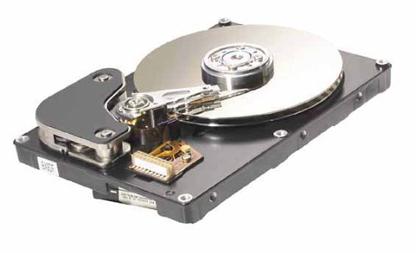

This is a h…………….

All d…. is stored on it.

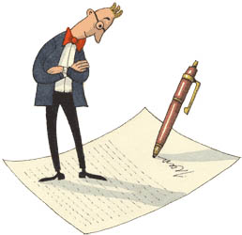

Before her boss s…….. the letter, Mary carefully

c……… s……… in order to avoid mistakes.

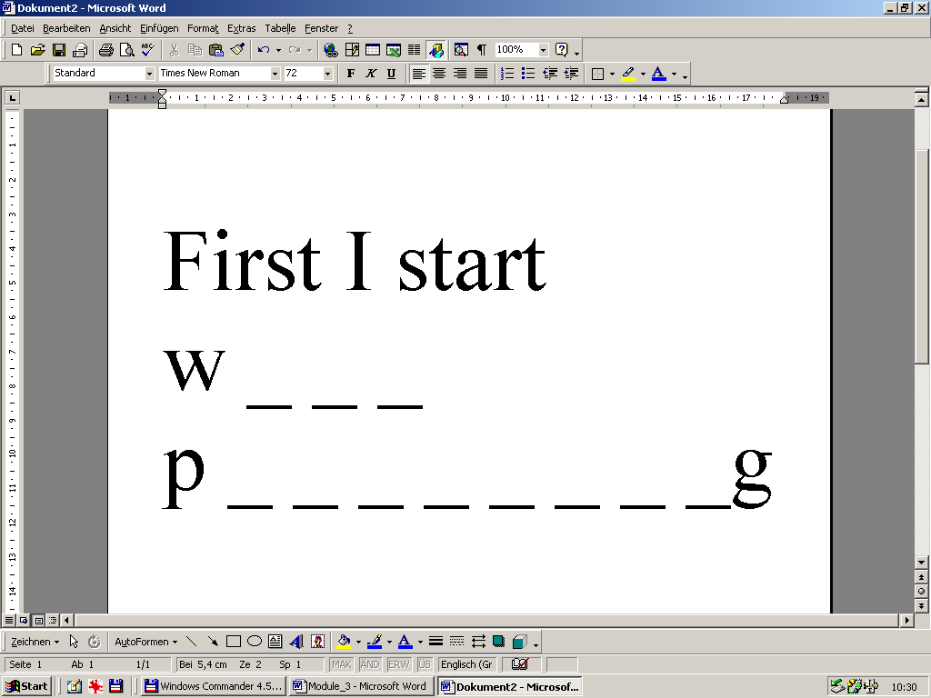

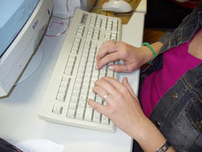
The lady in the picture is typing a b………

l…………. for a c.…………

who buys products from her company.
Note for the teacher: Cut along the lines to prepare the paper strips

I turn the computer on.
While the computer starts I check if I have all necessary information such as name and address.
Then I sit down in front of my screen.
I take the mouse and start word processing.
First I have to open a new file. Then I write name, date and address.
Usually I use bold letters for the subject line of the letter.
Then I start typing the body of the letter.
At the end I leave some space for the signature.
Sometimes other documents need to be sent along with the letter. If so, this is called an attachement.
After this I check spelling and print the letter.
Then I save it onto the computer´s harddisk.
Finally I turn off the computer.
Before sending the letter away in an envelope, I have it signed by my boss.

Vocabulary

business letter Geschäftsbrief
to turn the computer on/off den Computer anschalten / ausschalten
screen / display Monitor
to write a letter einen Brief schreiben
to answer a request auf eine Anfrage antworten
keyboard Tastatur
to open a (new) file eine ( neue) Datei öffnen
mouse / mouse pad Maus / Maus- Pad
to save a file to disk eine Datei auf der Diskette speichern
to write down date and address das Datum und die Adresse aufschreiben
to type a letter einen Brief schreiben
salutation Anrede
subject line of the letter Betreffzeile eines Briefes
body of the letter Text des Briefes
to print / a printer drucken / Drucker
to sign a letter einen Brief unterschreiben
envelope Briefumschlag
hard disc Festplatte
to check spelling die Rechtschreibung überprüfen

