HYDRAULICS

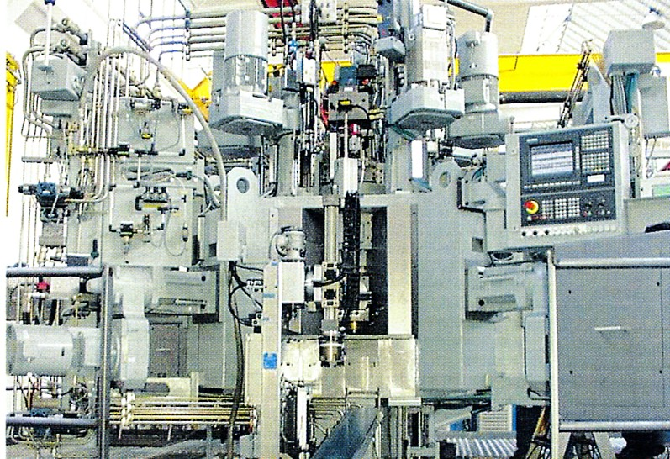
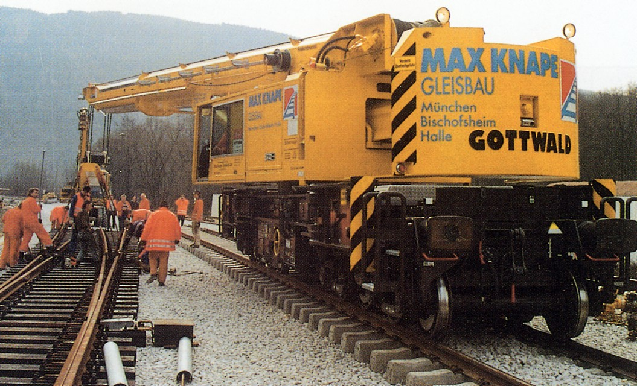
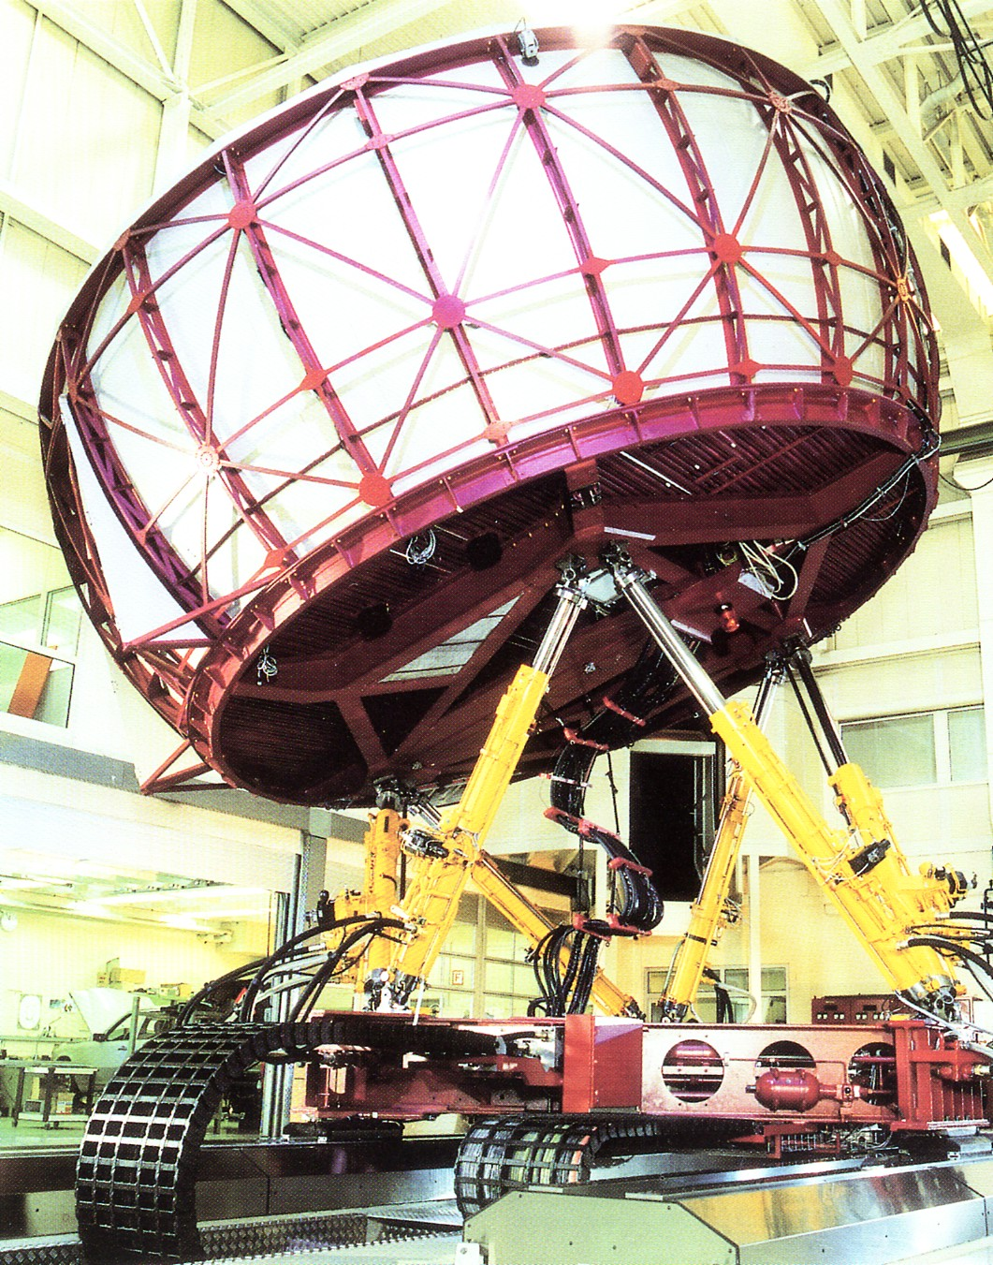
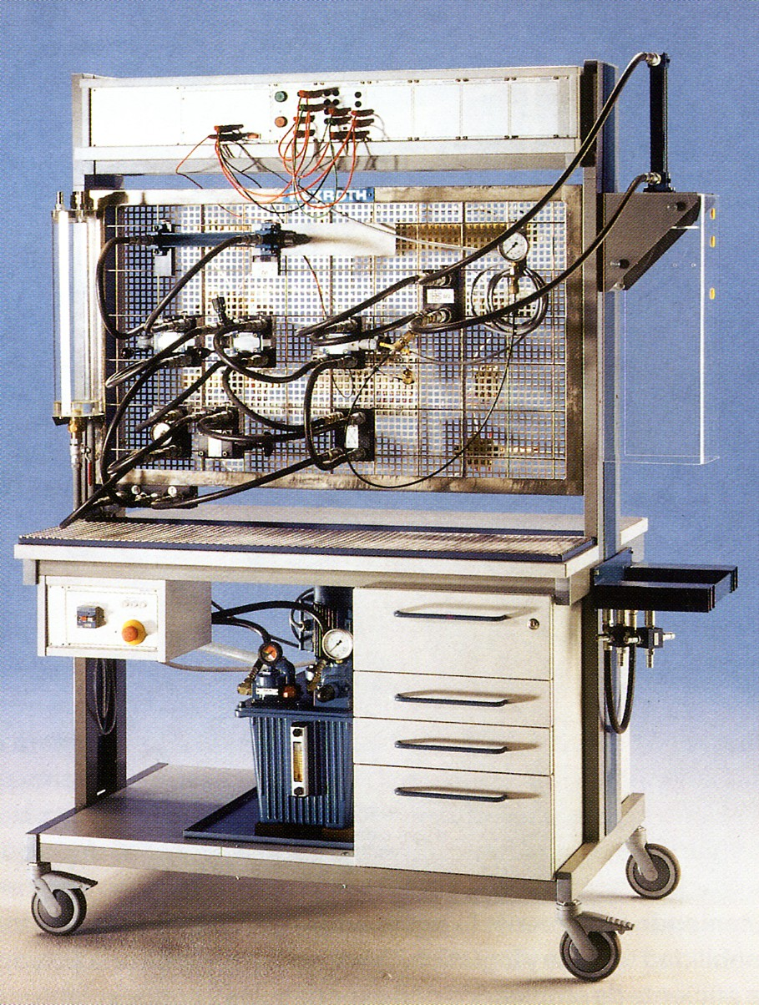
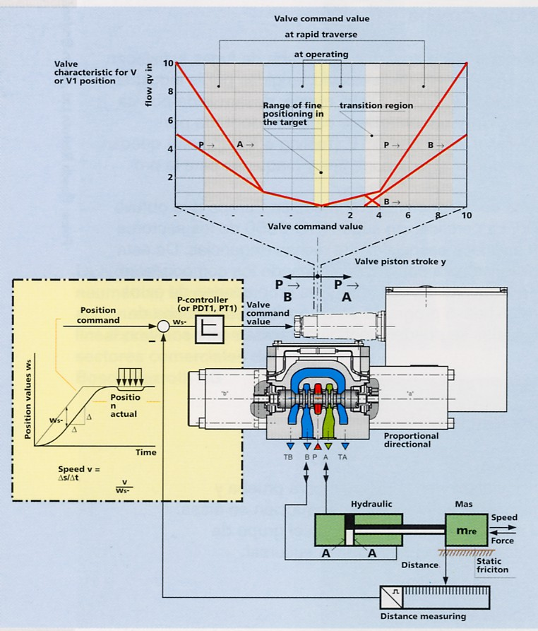

Autor: CENFIM
Ano: JUL 2005

ACTION PROGRAMME OF THE EUROPEAN UNION
LEONARDO DA VINCI
PROJEKT NO.: 2002 LA 112 628 BILVOC
Language Competence Through
Bilingual Teaching at Vocational Colleges

Teaching Module 1

Date of production: | September 2005
Subject: | Oil-hydraulics
Topic: | General issues about oil-hydraulics
Title: | Introduction to oil-hydraulics
Target Group: | Youths and workers whose professional profile is somewhat related to the use of oil-hydraulics
Prior Knowledge: | Prior knowledge is not required
Level of Language Skills: | Intermediate English
Follow - Ups: | Understand what it is and what the advantages and problems associated to oil-hydraulics are
Objectives: | Define oil-hydraulics  Refer the advantages and problems of the use of oil-hydraulics  Distinguish some applications of oil-hydraulics
Benefits: | At the end of the unit, trainees should be able to define:  What oil-hydraulics is?  Advantages of its use.  Problems of its use.  Where and when to use oil-hydraulics?

Module 1
Foreseen time | Contents | Activities / Tasks | Pedagogic means | Pedagogic method
20 minutes | 1 - Introduction. | Present the history of the technology and its evolution | Transparencies; notes; PowerPoint presentation; whiteboard. | Presentation for the whole group; promote the discussion and exchange of ideas.
15 minutes | What is hydraulics? | Present the definition and show the equipment. | Transparencies; notes; PowerPoint presentation; whiteboard; show the equipment itself. | Evaluate the knowledge of the group; promote the exchange of ideas; conclude the discussion with the technical definitions.
15 minutes | 1,1 Advantages of hydraulics | Present in a generic and global way the advantages present in hydraulics. | Transparencies;notes;PowerPoint presentation ; whiteboard; photos; films. | Expose the matter using the demonstrative method supported in practical situations whenever possible; promote the exchange of ideas.
15 minutes | 1,2 Inconveniences of hydraulics | Present in a generic and global way the present inconveniences in hidraulics. | Transparencies; notes; PowerPoint presentation; whiteboard. | Expose the matter using the demonstrative method supported in practical situations whenever possible; promote the exchange of ideas.
15 minutes | 1.3 - Applications | Show practical situations of the use of hydraulics | Transparencies; notes; PowerPoint presentation; whiteboard. | Expose the matter using the demonstrative method supported in practical situations whenever possible; promote the exchange of ideas.
25 minutes | Summary | Do a summary of the main knowledge to acquire in this module. | Transparencies; notes; PowerPoint presentation; whiteboard. | Summarize the matter using the interrogative method.

INDEX

1 INTRODUCTION TO OIL-HYDRAULICS 4
1.1 ADVANTAGES OF THE HYDRAULIC SYSTEMS 5
1.2 LIMITATIONS OF THE HYDRAULIC SYSTEMS 6
1.3 APPLICATIONS 6

INTRODUCTION TO OIL-HYDRAULICS

Hydraulics, derived word from the Greek "hydor" = water and, in the scientific sense of the word, the science that studies the fluids in hydromechanics. When we speak of hydraulics in the domains of the construction of machines, vehicles and aircrafts, it must be understood as the advantage of this domain of physics, whether in the transportation and conversion of energy or in its regulation and control either in open or closed mesh.

Oil-hydraulics is a mechanical engineering domain that deals with the transmission of the energy and with the controlled production of mechanical work through the displacement of an almost incomprehensible fluid under static pressure.

ADVANTAGES OF THE HYDRAULIC SYSTEMS

When taking other forms of energy transmission into account, the hydraulic systems offer the following advantages:

Forces, binary, and very high potencies obtained with organs of reduced dimensions;

Reduced inertia of the movable organs related to the produced forces, which, combined with the compressibility of the oil, allows to shorten the response times in transitory periods - relevant characteristic in the field of the servomechanisms;

Easiness in the attainment of rectilinear movements with constant available force and in the control of those movements;

Great softness of movements, thus improving the life of the tools;

Easiness in the attainment of both rotation and linear variable speeds, and almost independent of the load;

Easiness in limiting the forces or potencies efficiently - protection against overloads;

Absence of bulky and complex mechanical transmissions with maintenance, lubrication and wear and tear problems;

Great flexibility in the disposition of the component organs of a system, since they are only interlinked by tubing;

Easiness of functional interconnection of the different organs of a system, of automation and of association to other command circuits, whether they are electric, electronic or pneumatic;

Possibility of accomplishment of a multiplicity of functional schemes, whether elementary or sophisticated, with resource to normalized elements;

Easiness in altering the characteristics of a system or of modifying it organic and functionally;

Easiness of control and rehearsal through measure instruments (manometers, flux-meters, thermometers);

Durability and trust - self-lubrication.

LIMITATIONS OF THE HYDRAULIC SYSTEMS

As limitations to the hydraulic systems, we can mention:

Load losses in the tubing and accessories, with consequent degradation of energy and heat. For the reduction of those losses the speeds in the tubing are limited from 9 to 10 m/s, and the resource to cooling systems (radiators and switchers of heat) may sometimes be necessary.

Internal escapes that affect the volumetric and global incomes, and the kinetic properties of the systems;

Sensibility to the alteration of physical conditions, namely: temperature fluctuations and viscosity of the hydraulic fluid; compressibility of the fluid and elasticity of the tubing. The resulting effects are higher if the volume of interested oil is high as well;

Possibility of external escapes of liquid by failure or tightness flaw, and of oil steams with subsequent pollution of the atmosphere, fire danger (which can be obviated by use of synthetic incombustible hydraulic fluids);

Inherent noise to the phenomena of hydrodynamic vibration and mechanical vibration in the rotary machines. The phenomena are worsened by the increase of pressure, of the rotation and of the drainage speeds. This inconvenience is a serious obstacle to the full exploration of the domain of the high pressures (a level of noise of 80 dB is currently considered as the acceptable maximum);

Demand of high mechanical quality of the hydraulic organs, that is, precise tolerances, high superficial and material completions with strict mechanical properties (special cast irons, appropriate thermal treatments, etc.), resulting in a tendency for high costs, compensated only by production in quantity with resource to advanced technologies;

Need to consider, at the project level, the consequences of side effects (internal escapes, compressibility, heating, load losses) in the functional properties, whether static or dynamic, demanded for the system in study, which can outlaw the use of elementary circuits; subsequent need of specialized and interdisciplinary knowledge (association to electric and electronic commands, automatisms, servomechanisms).

APPLICATIONS

Hydraulics, due to its characteristics, is applied in the most varied industrial sectors. Let us see some examples:

Industrial hydraulics  Injectors of plastic and other materials;  Press;  Heavy industry (metal works, lamination);  Machine-tools; | 
Hydraulics in fluvial and marine constructions  Flood-gates and dams;  Activation of bridges;  Mining machines;  Turbines; | 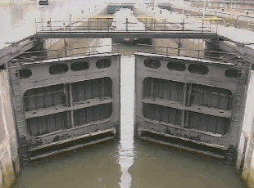
Hydraulics in the movable sector  Bulldozers, dredges and cranes;  Road and agricultural machines;  Car mechanics; | 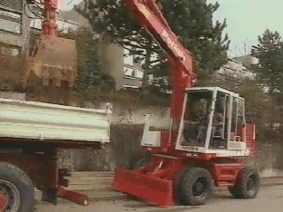
Hydraulics in special technical applications  Activators of telescopes and antennas;  Buoys of marine investigation;  Landing gears;  Control of aircrafts; | 
Hydraulics in the naval industry  Activation of rudders;  Board cranes;  Platforms; | 

