ACTION PROGRAMME OF THE EUROPEAN UNION
LEONARDO DA VINCI
PROJEKT NO.: 2002 LA 112 628 BILVOC
Language Competence Through
Bilingual Teaching at Vocational Colleges

Teaching Module 2

Date of production: | September 2005
Subject: | Oil-hydraulics bases
Topic: | Physical principles associated to oil-hydraulics
Title: | Physical bases
Target Group: | Youths and workers whose professional profile is somewhat related to the use of oil-hydraulics
Prior Knowledge: | General knowledge of physics
Level of Language Skills: | Intermediate English
Follow - Ups: | Understand the phenomena associated to oil-hydraulics
Objectives: | Understand and use the main physical principles and the units inherent in oil-hydraulics
Benefits: | At the end of the unit, trainees should know:  Basic notions of hydrostatics (Force, pressure, work, pressure multiplication)  Notions of hydrodynamics (flow, cylinder capacity, power)  Circuits’ calculation (pumps, cylinders, tubing)

Module 2
Foreseen time | Contents | Activities / Tasks | Pedagogic means | Pedagogic method
20 minutes | 2 - Physical principles | Present general physical concepts that rule hydraulics, namely the notions of FORCE; PRESSURE; FLOW. | Transparencies; notes; PowerPoint presentation; whiteboard. | Presentation and demonstration for the whole group;
30 minutes | 2.1- Hydrostatics | Present the phenomena associated to hydrostatics, as well as the main measure units, used in the measurement of forces and pressures. | Transparencies; notes; PowerPoint presentation; whiteboard. | Demonstration, for the whole group, of the phenomena, concepts and elementary laws. Resolution of theoretical exercises.
30 minutes | 2.2- Hydrodinamics | Present the phenomena associated to hydrodynamics, as well as the main measure units, used in the measurement of flows and cylinder capacities. | Transparencies; notes; PowerPoint presentation; whiteboard. | Demonstration, for the whole group, of the phenomena, concepts and elementary laws. Resolution of theoretical exercises.
90 minutes | Calculation of pumps and of hydraulic cylinders | Do practical exercises of calculation on pumps and cylinders. | Transparencies; notes; PowerPoint presentation; whiteboard. | Demonstration, for the whole group, of the resolution methods for theoretical problems.
25 minutes | Summary | Do a summary of the main knowledge to acquire in this module. | Transparencies; notes; PowerPoint presentation; whiteboard. | Summarize the matter using the interrogative method.Practical resolution of theoretical exercises

INDEX

2 PHYSICAL FOUNDATIONS 3
2.1 HYDROSTATICS 4
2.2 HYDRODYNAMICS 7
2.3 CALCULATION EXAMPLE Nº 1 8
2.4 CALCULATION EXAMPLE Nº 2 9

PHYSICAL FOUNDATIONS

The field of the hydromechanics or mechanics of the fluids is divided into: Hydrostatics and Hydrodynamics.

Hydrostatics means the mechanics of the static fluids, that is, the study of the conditions of the fluids’ static balance.

Hydrodynamics is understood as the mechanics of the dynamic fluids (fluids in motion), in other words, the study of the conditions of the fluids’ static movement (theory of the flow).

In order to understand these laws better, we must, first of all, consider the physical greatnesses involved.

HYDROSTATICS

Pascal's Law

Pascal's Law (also called Pascal's Principle) is only applied to incompressible liquids and it says that ‘changes in pressure at any point in an enclosed fluid at rest are transmitted undiminished to all points in the fluid and act in all directions’.

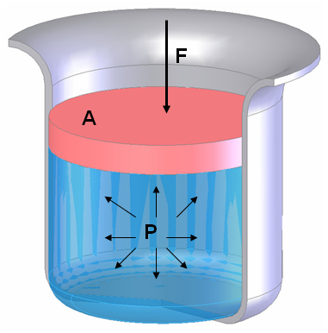 | 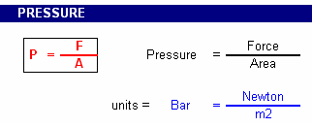

The unit of Pressure in the international system is Pascal (Pa), but due to the fact of this being a small greatness, it is very frequent to use other units, particularly the Bar that, even though it doesn't belong to any system, gives a more real perception of the phenomenon. It is common to appear other greatnesses.

Other pressure units

Unit | Equivalent measurements, comments
Pounds per square inch  (psi, PSI, lb/in², lb/sq in) | Commonly used in the U.S., but not elsewhere. Normal atmospheric pressure is 14.7 psi, which means that a column of air, one square inch in area rising from the Earth's atmosphere to space, weighs 14.7 pounds
Atmosphere  (atm) | Normal atmospheric pressure is defined as 1 atmosphere. 1 atm = 14.6956 psi = 760 torr.
1Torr  (torr) | Based on the original Torricelli barometer design, one atmosphere of pressure will force the column of mercury (Hg) in a mercury barometer to a height of 760 millimeters. A pressure that causes the Hg column to rise 1 millimeter is called a torr (you may still see the term 1 mm Hg used; this has been replaced by the torr). 1 atm = 760 torr = 14.7 psi.
Bar  (bar) | The bar is nearly identical to the atmosphere unit. One bar = 750.062 torr = 0.9869 atm = 100,000 Pa.
Millibar  (mb or mbar) | There are 1,000 millibar in one bar. This unit is used by meteorologists who find it easier to refer to atmospheric pressures without using decimals. One millibar = 0.001 bar = 0.750 torr = 100 Pa.
Pascal  (Pa) | 1 pascal = a force of 1 Newton per square meter (1 Newton = the force required to accelerate 1 Kilogram one meter per second per second = 1 kg/(m.s²); this is, actually, quite logical for physicists and engineers). 1 pascal = 10 dyne/cm² = 0.01 mbar. 1 atm = 101,325 Pascals = 760 mm Hg = 760 torr = 14.7 psi.
Kilopascal  (kPa) | The prefix "kilo" means "1,000", so one kilopascal = 1,000 Pa. Therefore, 101.325 kPa = 1 atm = 760 torr and 100 kPa = 1 bar = 750 torr.
Megapascal  (MPa) | The prefix "mega" means "1,000,000", so one megapascal = 1,000 kPa = 1,000,000 Pa. Such high pressures are rarely encountered.
Gigapascal  (GPa) | The prefix "giga" means "1,000,000,000", so one gigapascal = 1,000 MPa = 1,000,000 kPa = 1,000,000,000 Pa = 9,870 atm = 10,000 bar. Pressures of several gigapascals can convert graphite to diamond or make hydrogen a metallic conductor!
Pound  (lb, lbs) | A pound is an English unit of weight. There are 16 ounces or 7,000 grains (a less common unit) or 453.592 grams in a pound.

Did you you know that…

when you put air in the tyres of your automobile and someone tells you to put 30 ahead and 28 behind, they are talking in Psi?

when you fill the tyres, 28 Psi is equal to the approximately 2 bar (2Kg/cm2)?

with the help of the presented basic greatnesses, it is possible to explain the main physic characteristics of the air?

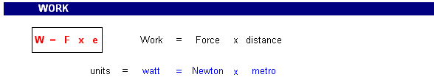

Let us see the illustration and analyze the phenomenon:

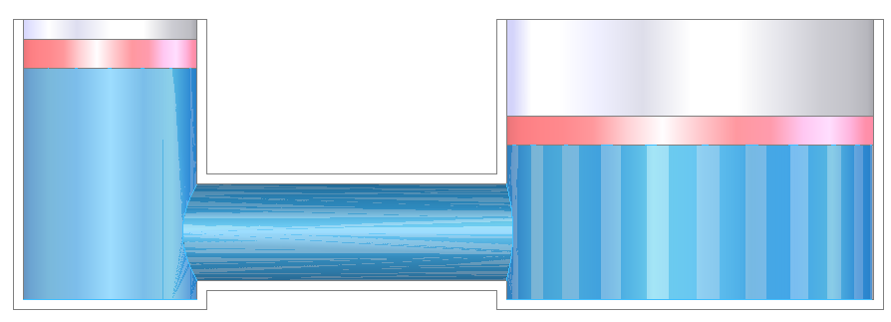 | 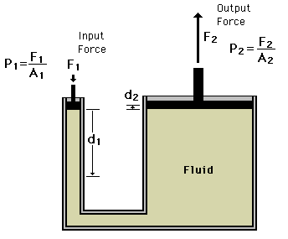

As nothing is lost nor won in terms of accomplished work, we can conclude that:

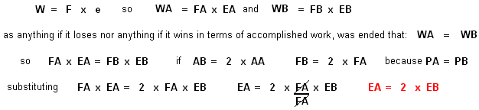

From this analysis we can learn that in hydraulics too what is won in terms of force is lost in displacement. In this example we can verify that if area B is the double of area A, the force in A will be half of the force in B, as well as the displacement in B is also half of the displacement in A.

A practical example of this phenomenon is the hydraulic jack of the mechanics of automobiles. In fact, the mechanic makes little manual force to elevate the vehicle but, nevertheless, for each displacement of his arm, the car raises very little... | 

HYDRODYNAMICS

To determine the flow that goes through a certain tubing, it is enough to define the area of the tube and a certain space. | 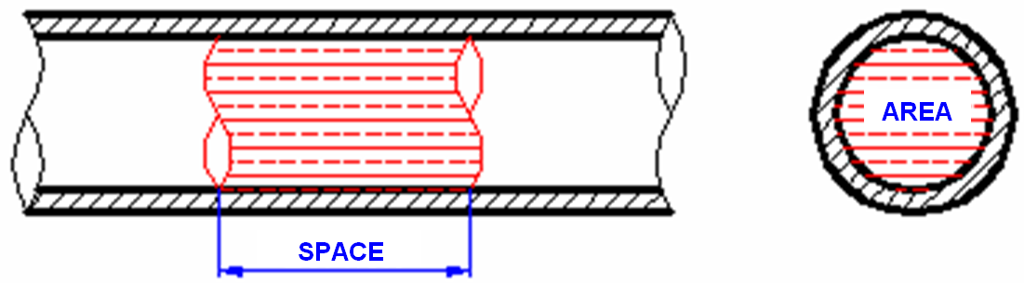
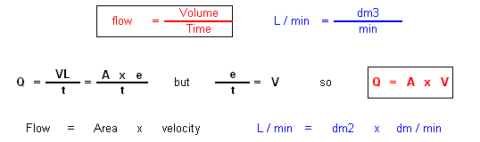

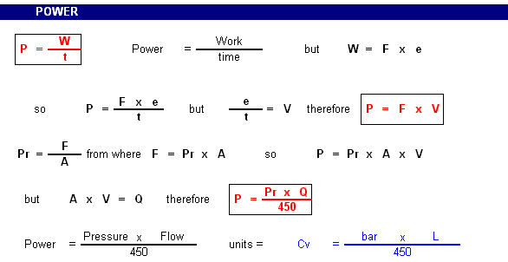

CALCULATION EXAMPLE Nº 1

We intend to know the characteristics of the hydraulic pump that we should put in the circuit, so as to satisfy the following needs: Speed coming from the piston = 5 cm/s; Necessary forces 5 ton.; Activation with electrical motor in which n = 1500 rpm.

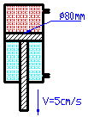 | DATA
 | D = Cylinder diameter  V1 = Speed of descent  n = Rotations of the motor  F = Forces to apply | D = 80 mm = 8 cm  V1 = 5 cm / s  n = 1500 rot / min  F = 5000 Kg

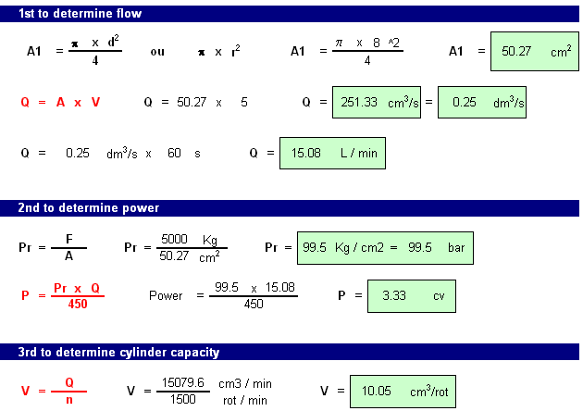

We conclude that the pump must: supply a flow of 5,08 L/min; have 3,33 cv of power; have a cylinder capacity of 10,05 cm3 / rot.

CALCULATION EXAMPLE Nº 2

For a certain mechanism, we arrange a hydraulic cylinder, whose piston has a diameter of 100 mm, develops a 50-ton force and it is activated by a pump of cylinder capacity 20 cm3 to 1500 rpm. Find out the pressure of the system, the installed power and the speed of descent of the cylinder.

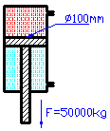 | DATA
 | D = Cylinder Diameter  C = Cylinder capacity of pump  n = Rotations of the motor  F = Forces to apply | D = 100 mm = 10 cm  C = 20 cm³ / rot  n = 1500 rot / min  F = 5000 Kg

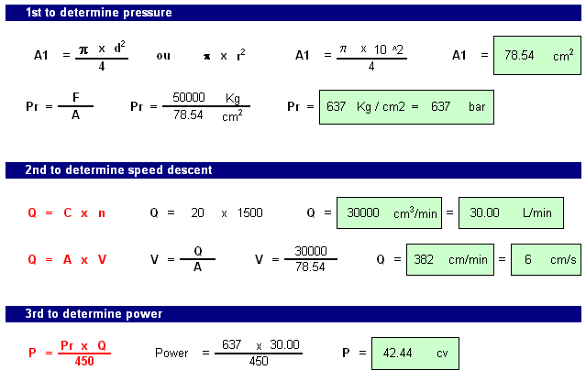

With this cylinder and this pump the system develops: a pressure of 637 bar; the cylinder has a speed of descent of 6 cm/s; a power of 42,44 cv.

