ACTION PROGRAMME OF THE EUROPEAN UNION
LEONARDO DA VINCI
PROJEKT NO.: 2002 LA 112 628 BILVOC
Language Competence Through
Bilingual Teaching at Vocational Colleges

Teaching Module 3

Date of production: | September 2005
Subject: | Production of oil-hydraulics energy
Topic: | Energetic units in oil-hydraulics
Title: | Hydraulic generators
Target Group: | Youths and workers whose professional profile is somewhat related to the use of oil-hydraulics
Prior Knowledge: | Knowledge of teaching units 1 and 2
Level of Language Skills: | Intermediate English
Follow - Ups: | Understand the phenomena associated to the production of oil hydraulic energy and identify the main generators of that same energy
Objectives: | Identify and define the main hydraulic generators  Refer the advantages and problems inherent in hydraulic generators  Distinguish the elements by its symbology
Benefits: | At the end of the unit, trainees should know:  What hydraulic generators are and what they are for  The symbology inherent in the different generators

Module 3
Foreseen time | Contents | Activities / Tasks | Pedagogic means | Pedagogic method
20 minutes | 3 - Hydraulic generators | To present the different types of hydraulic generators, its operation, characteristics and performances. | Transparencies; notes; PowerPoint presentation; whiteboard; Films of the specialty; catalogs, to show the own equipment. | Presentation for the whole group; to promote the discussion and exchange of ideas.
15 minutes | 3.1- Gear pumps | To present the different types of gear pumps, its operation, construction aspects, characteristics and performances. | Transparencies; notes; PowerPoint presentation; whiteboard; Films of the specialty; catalogs, to show the own equipment. | Presentation for the whole group; to promote the discussion and exchange of ideas.
15 minutes | 3.2- Blade pumps | To present the different types of blade pumps, its operation, construction aspects, characteristics and performances. | Transparencies; notes; PowerPoint presentation; whiteboard; Films of the specialty; catalogs, to show the own equipment. | Presentation for the whole group; to promote the discussion and exchange of ideas.
15 minutes | 3.3- Screw pumps | To present the different types of screw pumps, its operation, construction aspects, characteristics and performances. | Transparencies; notes; PowerPoint presentation; whiteboard; Films of the specialty; catalogs, to show the own equipment. | Presentation for the whole group; to promote the discussion and exchange of ideas.
20 minutes | 3.4- Piston pumps | To present the different types of piston pumps, its operation, construction aspects, characteristics and performances. | Transparencies; notes; PowerPoint presentation; whiteboard; Films of the specialty; catalogs, to show the own equipment. | Presentation for the whole group; to promote the discussion and exchange of ideas.
25 minutes | Summary | Do a summary of the main knowledge to acquire in this module. | Transparencies; notes; PowerPoint presentation; whiteboard. | Summarize the matter using the interrogative method. Practical resolution of theoretical exercises

INDEX

3 HYDRAULIC GENERATORS 4
3.1 GEAR PUMPS 5
3.1.1 Pumps of external gear 5
3.1.2 Pumps of internal gear 6
3.2 BLADE PUMPS 6
3.3 SCREW PUMPS 7
3.4 PISTON PUMPS 7
3.4.1 Axial piston pumps 7
3.4.2 Radial piston pumps 8
3.5 SUMMARY 9

HYDRAULIC GENERATORS

The hydraulic generators are machines capable to transform mechanical energy in hydraulics in a continuous way. Correntemente are designated by bombs since his/her function is to produce energy hidrostática, that is, to supply flow under pressure.
Many of the bombs can be used as motors for conversion of the energy hidrostática in mechanics. Therefore, it would be more appropriate to denominate them for you plan hidrostáticas.
The pressures used in oil-hydraulics are always high, reaching until the order of the 1000 bar.

They can be considered, "thick way", the following ranges of pressures:

p < 50 bar - very low pressure
50 < p < 100 bar - low pressure
100 < p < 200 bar - average pressure
200 < p < 400 bar - high pressure
p > 400 bar - very high pressure

The hydraulic pump aspirates the hydraulic fluid, in rule, of a reservoir (aspiration side or of entrance) and it impels him/it for the exit (side of the pressure). Of this point the fluid is led to a distributing organ (command organ), from where can be reconduzido to the reservoir or supplied to the receiver.

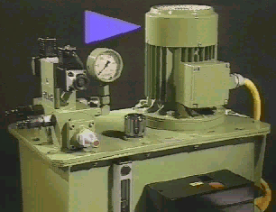 | 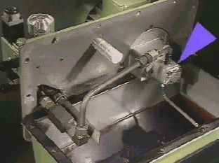 | 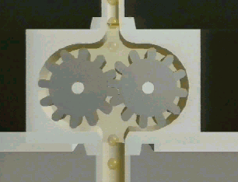

As a consequence of the opposite forces to the movement of work of the receiver (for instance during the rising of a load for a cylinder) it is generated in the oil a pressure, so high as necessary to win the forces opponents.

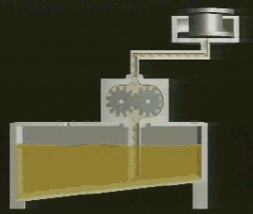 | 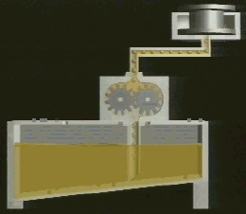 | 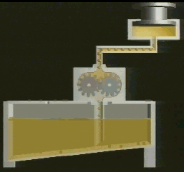

The pressure in a waterworks is not, therefore, beforehand generated by the bomb, but before it results of the opposition offered by the system to the drainage of the oil. This opposition, it is resulted of the external forces (payload and mechanical attritions) and of the interior forces (viscous attrition in the tubagens, junctions and valves).

GEAR PUMPS

Pumps of external gear

These kinds of pumps are preferentially used due to the following advantages:

- relatively low price;
- security of functioning, even in bad conditions;
- good performance in a large range of viscosity corresponding to the flowing hydraulic fluids and to the lubrication oils;
- indifferent position;
- wide range of activation velocities;
- good aspiration characteristics;
- strong construction;

The greatest disadvantages we have to consider are the impossibility of variation of the cylinder capacity, the difficulty in supporting high pressures (up to 210 bar, generally), the bad performance at low activation velocities (up to 500 rot./min) and the big pulsation of the flow, besides the pressure, and subsequent noise.

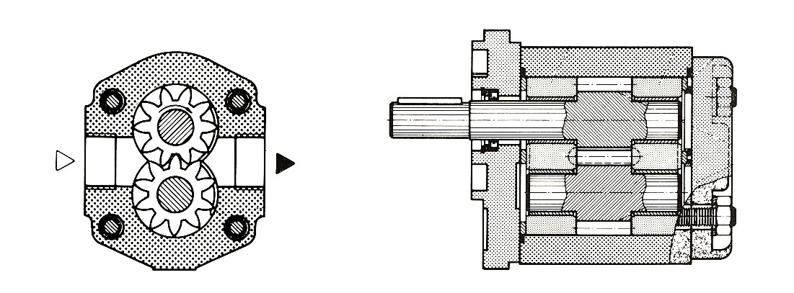

The external gear pumps (see picture 1) are basically composed by a pair of pinions, usually right-wheeled, closed in a metallic box (steel, bronze or light alloy).

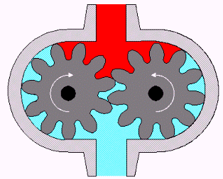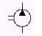

Picture 1

The vein of one of the pinions is activated, while the other revolves crazily. In each pinion, the spaces between the teeth, after disengagement, aspirate oil from the admission chamber and drag it during the rotation to the exhaust chamber.
The tightness between the aspiration and the expulsion is achieved by the little space between the teeth’s crest and the pump’s body, by the contact between the teeth and by the lids that hold the pinions laterally.
The greatest activation velocities vary between 1500 and 3000 rot./min, depending on the dimensions and on the construction. On the current applications, the 1500 rot./min are rarely surpassed because of the noise.

Pumps of internal gear

These types of pumps (see picture 2) have smaller level of noise than the external gear ones, allow higher activation velocities - can reach up to 5000 rot./min – and support pressures up to 100 bar.

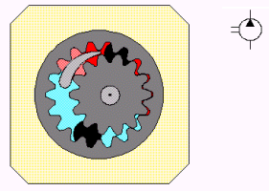

Picture 2

The internal gear pumps are composed by an internal pinion (conductor) dragging an external wheel of internal wheeled. The oil is aspirated between the teeth through an aspiration window carved in the lateral lids and transported to the exhaust chamber.
The tightness between the two chambers is reached on one side through the engagement and on the other through the teeth’s crest in contact with a piece of geometrical specificity of the carcass.
The higher the pressures and the duration of the load are the smaller the internal pinion will be.

BLADE PUMPS

In these types of pumps, the rotor has in its external outline radial seats, where the blades are stored and guided. These blades are compressed against the stator’s sliding track because of the centrifugal force and pressure. This sliding track presents an eccentricity in the rotor, resulting from stator and rotor’s axis deviation. In some types of pumps, this eccentricity can be regulated as shown in picture 3.
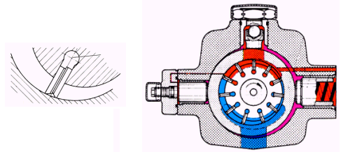

Picture 3

Technical data: Displacement volume: up to 125 cm3/rot, operational pressure up to 160 bar.

SCREW PUMPS

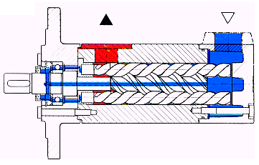

Picture 4

In a carcass two or more endless shafts are disposed (see picture 3). The central shaft, with a right screw thread, is activated by means of an axis and transmits the rotary movement to the two external shafts, with a left screw thread. This way, closed chambers between external shafts, the carcass and the central shaft are formed and its volume doesn’t change but it moves continuously with the rotation of the suction connection shafts (blue), until the pressure side (red). This is how we get a continuous constant flow and without pulsations of the fluid.

PISTON PUMPS

Axial piston pumps

The axial piston pumps and motors (picture 5) are volumetric machines, in which the cylinders are disposed in parallel with the body’s axis of rotation (cylinders’ carcass housing).

The transformation of the activation rotary movement into the pistons’ alternative movement happens in a similar way but according to three different basic principles: swash plate pump, bent pump, wobble plate.
In a generic way we can say that the pump’s vein activates the swash plate pump, bent pump or wobble plate by the way it is linked with these systems, which transmits to the pistons (non-rotary) its axial alternative movement. The cylinder capacity of these pumps is function of the angle the plate makes with the normal to the vein of activation.
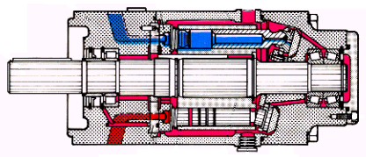

Picture 5

Radial piston pumps

In an axial pump of pistons, these are disposed in the shape of a star, in a radial way to the activation axis. The pistons’ movement is done in the radial direction, that is, perpendicular to the axis. The flow in the radial piston pumps is commanded using the principle of valves or slots, being this displacement volume constant or variable. The pumps can still be divided into two more separate groups. Curve of internal activation (the pistons are disposed externally) and curve of external activation (the pistons are disposed internally). In picture 5 it is shown a pump commanded by valves with internal self-sucking track and fixed flow.

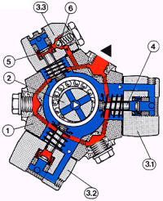 | It is basically composed by: carcass 1; eccentric axis 2; and pumping elements 3; with piston 4; suction valve 5 and pressure valve 6.  A pumping element, observed separately, is a piston’s pump fixed in the carcass. The pistons are guided in the pumping elements and move when pressured by springs against the eccentric axis.
Picture 6

Each piston makes a double course for one rotation of the axis. With the eccentric axis rotation, the fluid is sucked (in blue by an axial opening that is thrown out through radial holes and conducted to the suction valves).

These valves are composed by a disc that is pressed out by a weak spring, against an edge joint. With the piston’s movement towards the main axis, the volume of the cylinder’s chamber increases. The pressure drop provokes a suction that lifts the disc from its seat, and the cylinder’s chamber is filled with fluid (element 3.1). When the cylinder is displaced out, the disc is pressed again against the edge joint (element 3.2). At the same time, the pressure 6 valve’s joint sphere lifts from its seat (element 3.3.).

The fluid of each of the elements moves, thus, through the carcass existing channels, towards the pump’s pressure connections. The displaced volume is established by the diameter, course and quantity of elements. The potency depends on the work pressure and on the displaced volume. If the diameter of the used pistons varies, so does the maximum pressure that the pump may reach. The odd number of cylinders is chosen so as to obtain the minimum fluctuation possible in the supplied volume.

Technical data:

 | Diâmetro interno do pistão / Piston’s internal diameter
 | 8 mm | 10 mm | 12 mm | 14 mm
Displacement volume in cm3/rot. For 1 element. | 0,4 | 0,63 | 0,91 | 1,23
Bar pressure up to | 630 | 500 | 350 | 250

SUMMARY

 The hydraulic generators are machines capable of transforming mechanical energy into hydraulic in a continuous way. They are commonly designated by pumps since their function is to produce hydrostatic energy, that is, to supply flow under pressure.

 Many of the pumps can be used as motors to convert hydrostatic energy into mechanical energy. Therefore, it would be more appropriate to denominate them as hydrostatic machines.

 The pressures used in oil-hydraulics are always high, reaching up to 1000 bar.

 The hydraulic pump aspirates the hydraulic fluid, generally, of a tank (aspiration side or of entrance) and it impels it for the exit (side of the pressure).

 As a consequence of the opposite forces to the receiver’s movement of work (for example, during the raising of a load by a cylinder), a pressure, as high as necessary to win the opposing forces, is generated in the oil.

 Therefore, the pressure in a hydraulic system is not generated previously by the pump. It results of the opposition of the system to the drainage of the oil.

 The types of pumps or motors are: pumps or motors of external gear; pumps or motors of internal gear; screw pumps or motors; axial piston pumps or motors; radial piston pumps or motors.

