ACTION PROGRAMME OF THE EUROPEAN UNION
LEONARDO DA VINCI
PROJEKT NO.: 2002 LA 112 628 BILVOC
Language Competence Through
Bilingual Teaching at Vocational Colleges

Teaching Module 4

Date of production: | September 2005
Subject: | Oil-hydraulic control
Topic: | Oil-hydraulic valves
Title: | Hydraulic control elements
Target Group: | Youths and workers whose professional profile is somewhat related to the use of oil-hydraulics
Prior Knowledge: | Knowledge of teaching units 1, 2 and 3
Level of Language Skills: | Intermediate English
Follow - Ups: | Understand the phenomena associated to oil-hydraulic control and identify the main elements used in circuit control
Objectives: | Study and identify the main hydraulic elements of control (valves)  Distinguish the elements by their symbology  Study, read, interpret and perform simple oil hydraulic plans  Solve simple situations using oil-hydraulics
Benefits: | At the end of the module, trainees should know:  The types of hydraulic control elements and their use  Choose the control elements (valves) according to the intended applications and their specifications  Interpret the symbology  Draw and interpret schematic plans of oil-hydraulics  Solve simple problems of oil-hydraulics

Module 4
Foreseen time | Contents | Activities / Tasks | Pedagogic means | Pedagogic method
 | 4- Hydraulic elements of command
10 minutes | 4.1- Introduction | To present general concepts. | Transparencies; notes; PowerPoint presentation; whiteboard. | Presentation to the whole group; to promote the discussion and exchange of ideas.
45 minutes | 4.2- Directional valves | To present the different valve types, its operation, characteristics, constructive aspect and performances. | Transparencies; notes; PowerPoint presentation; whiteboard; Films of the specialty; catalogs, to show the own equipment. | Presentation to the whole group; to promote the discussion and exchange of ideas.
30 minutes | 4.3- Distribution valves | To present the different valve types, its operation, characteristics, constructive aspect and performances. | Transparencies; notes; PowerPoint presentation; whiteboard; Films of the specialty; catalogs, to show the own equipment. | Presentation to the whole group; to promote the discussion and exchange of ideas.
20 minutes | 4.4- Manometer valves | To present the different valve types, its operation, characteristics, constructive aspect and performances. | Transparencies; notes; PowerPoint presentation; whiteboard; Films of the specialty; catalogs, to show the own equipment. | Presentation to the whole group; to promote the discussion and exchange of ideas.
20 minutes | 4.5- Flow valves | To present the different valve types, its operation, characteristics, constructive aspect and performances. | Transparencies; notes; PowerPoint presentation; whiteboard; Films of the specialty; catalogs, to show the own equipment. | Presentation to the whole group; to promote the discussion and exchange of ideas.
30 minutes | 4.6- Non-return valves | To present the different valve types, its operation, characteristics, constructive aspect and performances. | Transparencies; notes; PowerPoint presentation; whiteboard; Films of the specialty; catalogs, to show the own equipment. | Presentation to the whole group; to promote the discussion and exchange of ideas.
30 minutes | 4.7- Proportional valves | To present the different valve types, its operation, characteristics, constructive aspect and performances. | Transparencies; notes; PowerPoint presentation; whiteboard; Films of the specialty; catalogs, to show the own equipment. | Presentation to the whole group; to promote the discussion and exchange of ideas.
20 minutes | 4.8- Servo-valves | To present the different valve types, its operation, characteristics, constructive aspect and performances. | Transparencies; notes; PowerPoint presentation; whiteboard; Films of the specialty; catalogs, to show the own equipment. | Presentation to the whole group; to promote the discussion and exchange of ideas.
30 minutes | Summary | To do a summary of the main knowledge to acquire in this module. | Transparencies; notes; PowerPoint presentation; whiteboard. | To summarize the matter using the interrogative method.

INDEX

4 HYDRAULIC ELEMENTS OF COMMAND 4
4.1 VALVES 4
4.2 DIRECTIONAL VALVES 6
4.2.1 Positions and functional openings 6
4.2.2 Types of drive 7
4.3 DISTRIBUTION VALVES 8
4.3.1 Open-center’ distributor 8
4.3.2 ‘Closed-center’ distributor 9
4.3.3 Distributor with dead center ‘y center’ 10
4.3.4 Open center and closed cylinder distributor 10
4.4 MANOMETER VALVES 10
4.4.1 Pressure relief valves (safety) 11
4.4.2 Sequence valve 12
4.4.3 Three-opening pressure reducing valve 13
4.5 FLOW VALVES 14
4.5.1 Stranglers (restrictors) 15
4.5.2 Two-opening flow regulator valves 16
4.5.3 Flow divider valves 16
4.6 NON-RETURN VALVES 17
4.6.1 Anti-return 17
4.6.2 Piloted anti-return 18
4.7 PROPORTIONAL VALVES 19
4.7.1 Directional proportional valves 19
4.8 SERVO-VALVES 20
4.8.1 Two-stage directional servo-valves 21
4.8.2 Pressure servo-valves 22
5 BASIC HYDRAULIC CIRCUITS 23
5.1 Basic hydraulic circuit – linear motion 23
5.2 DOUBLE ACTING HYDRAULIC CYLINDER DRIVE 24
5.2.1 With 4/3 directional valves, manual drive 24
5.2.2 With 4/2 directional valves, manual drive 26
5.2.3 With 4/2 directional valves, electric drive 26
5.2.4 With 4/3 directional valves, electric drive 27
5.2.5 Association of directional valves in succession 28
5.2.6 Association of directional valves in parallel 29
5.3 BASIC HYDRAULIC CIRCUIT WITH ROTARY MOTION 30
5.4 SPEED CONTROL IN HYDRAULIC CYLINDERS 31
5.4.1 Speed control by means of flux-meter valves 31
5.4.2 Regenerative circuit 33
5.4.3 Rectifier circuit (Graetz bridge) 33
5.4.4 Speed variation controls 34

HYDRAULIC ELEMENTS OF COMMAND

VALVES

Valves are organs whose function is to alter the typology of a circuit or control the greatness of a hydraulic variable. They are divided into two big groups:

- directional valves
- regulator valves

For the directional valves, two big subgroups are considered:

- two-way valves (or dipolar), in which there is only one opening of entrance and other of exit (picture 1)
- manifold valves (picture 2).

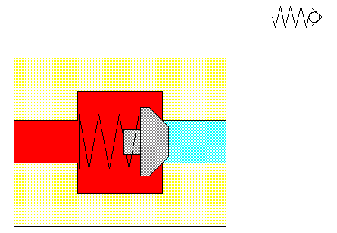

Picture 1 - [7] - Two-way valves (dipolar)

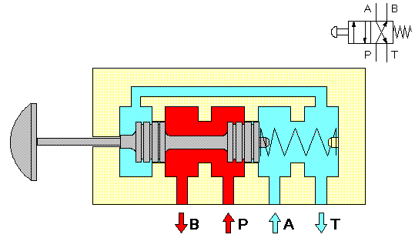
Picture 2 - [7] - Manifold valves

For the regulator valves, two big subgroups are considered; depending on whether the variable controlled is a pressure or a flow:

- manometer valves;
- flux-meter valves;

two-way (dipolar)
Directional
manifold
Válvulas - valves
Manometer
Regulator
Flux-meter

Regarding the constructive form, we can classify them the following way;

 |  | Cylindrical
 | Rotary valves
 |  | Facial
 |  | Spherical
Valves | Seat valves
 |  | Conical
 | Slide valves

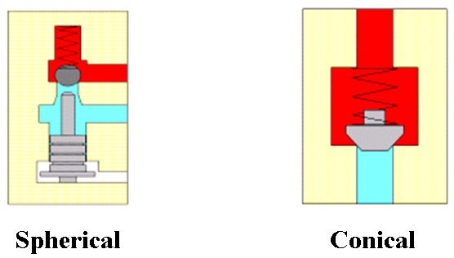
Picture 3 - [7] - Seat valves

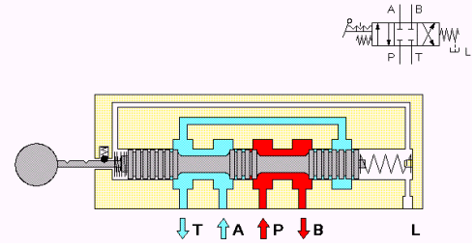

Picture 4 - [7] - Slide valve

DIRECTIONAL VALVES

The directional valves’ function is to promote the isolation or the interconnection between the affluent tubing and establish several possibilities of internal course. When operating on these valves we influence the flow circulation direction and the pressure spread, so as to carry out the control of receivers (cylinders or hydraulic motors) in terms of stopping, start and direction of movement.

Positions and functional openings

In a directional valve it is specifically significant the number of openings and of functional positions. They are both part of the directional valves’ designation. Each of the functional positions is symbolically represented by a square. The courses between the openings are represented by arrows. The complete symbolic representation consists of several contiguous squares. The designation of the openings by the letters P, T, A and B appears in the square that represents the rest position.

X - Number of functional openings
Directional valve x/y
Y - Number of functional positions

Directional valves

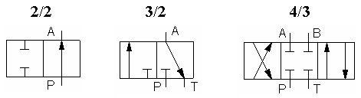

P – Pressure opening (pump)
T – Return opening (Tank)
A, B – Work openings (Receiver)

Types of drive

The different functional positions are activated by signals of control coming from the outside. The nature of the signal of command is also highlighted by the symbol of the valve, being the following the most important ones:

Manual drive
General symbol
Pushbutton operated | 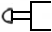
Lever | 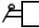
Blocking lever | 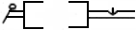
Pedal | 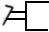
Mechanical drive
Spring actuated | 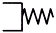
Spring centered | 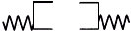
Soller actuated
Roller actuated only in one direction | 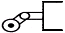
Pneumatic drive
Pneumatic (direct)
Indirect pneumatic actuation piloted
Electric drive
Single solenoid operation
Double solenoid operation |  | 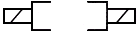
Combined drive
Double solenoid valve, piloted, with manual overrid |  | 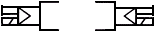

DISTRIBUTION VALVES

As directional valves, the distribution valves have as purpose the alteration of the typology of the circuits, that is, to guide the drainage of the hydraulic fluid.
The distributors can be of different kinds, depending on the most important connections in its neutral position (rest).

Open-center’ distributor

In the neutral position, the openings are connected and the pump flow is discharged to the deposit (tank).
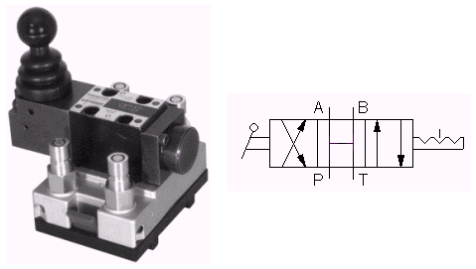

Picture 5 - [7] - ‘Open-center’ valve (photo/symbol)

We use this kind of distributor in cases in which the receiver must not be retained whether in rest or in the moment of inversion. When the intention is a smooth and shock-free inversion, the ‘open-center’ distributor is also recommended because it allows the momentary discharge of the pump to the deposit during the passage through the neutral position.

‘Closed-center’ distributor

In neutral position, all openings are filled.

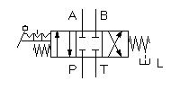
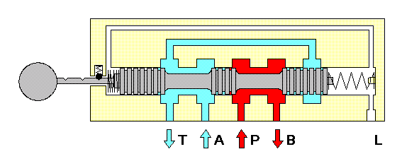
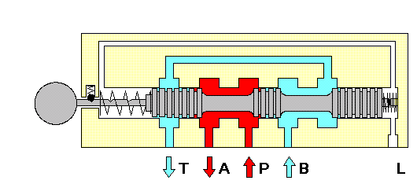

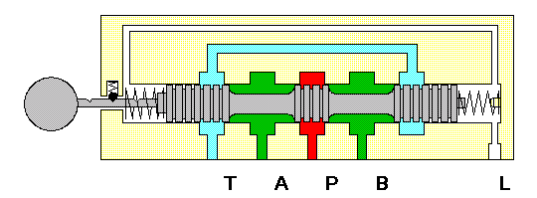

Picture 6 - [7] - ‘Closed-center’ distributor (symbol and its three operating positions)

This kind of distributor is used especially in cases in which the same generator feeds several receivers in parallel (circuit in pressure source) or when we intend to avoid a pressure break during the valve inversion. These are the kind of distributors normally used in the circuits that have accumulators to avoid their extemporaneous discharge.

Distributor with dead center ‘y center’

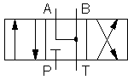 | This kind of distributor, also designated by closed center and open cylinder, closes in its neutral position the entrance of the pump and connects the exits to the receiver or to the reservoir.  Its use is for the cases in which it is intended that, in rest, the receiver does not get retained and that the generator serves to feed other receivers – circuit in pressure source.

This kind of distributors is of typical application in the piloting circuits.

Open center and closed cylinder distributor

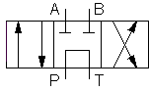 | This kind of distributor has in neutral position the openings of connection to the receiver filled, and connected to one another, those of pump entrance and reservoir exit.  This kind of distributor is generally used when we intend, in the neutral position, to block the receiver and the discharge of the pump to the deposit. These types of valves are also used for the serialized connection of several receivers.

MANOMETER VALVES

The manometer valves are hydraulic organs whose function is to control the hydraulic pressure. The manometer valves are therefore hydraulic organs that modify its characteristics by action of greatness pressure.

The main kinds of manometer valves used in hydraulic circuits are: the pressure relief valves, the sequence valves, the back pressure valves and the non-return pressure valves.

In a general way, the manometer valves are represented by a square with an imprinted arrow. The position of the arrow indicates the drainage direction, and also clarifies if the entrance and exit openings communicate or are isolated in the situation of rest. That is, if the valve is normally open or normally closed (see the following picture). The way the activation of the valve is executed, whether by springs or pressures, is represented in the square periphery.

 | 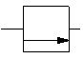
Normally open | Normally closed

Pressure relief valves (safety)

The pressure relief valves are manometer valves whose function is to stop the pressure in a hydraulic system, or in part of a hydraulic system, to exceed an established value. Being the pressure limited to a maximum value, the maximum force or the maximum binary developed by a hydraulic receiver are consequently limited.
In any hydraulic circuit there is always, at least, a pressure relief valve situated next to the generator group, that functions as safety valve, establishing an absolute maximum limit of the pressure according to the admissible maximum pressure by the hydraulic components that are part of the circuit.
The pressure relief valves are always put in derivation in a hydraulic circuit and their exit is always to the reservoir, and it is symbolically represented as shown.

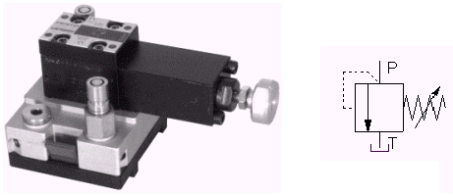 | In the normal position, the valve is closed. If the opening pressure of the valve is reached in P, then the valve opens and P communicates with T. If the pressure lowers, the valve closes again. The direction of oil circulation is indicated by the arrow.
Picture 7 - [7]

The pressure relief valves are always constructively of the axial seat kind (conical or spherical) and in its simpler way can simply have a sphere or a cone loaded by a spring (see pictures 8 and 9).

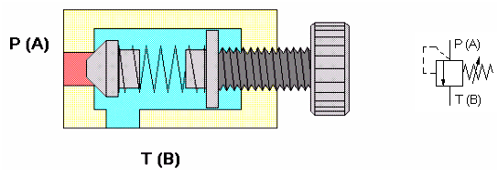
Picture 8 - [7] - closed valve

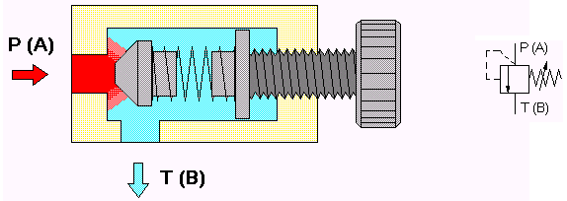
Picture 9 - [7] - open valve

Sequence valve

The sequence valves are manometer valves, whose function is to allow the passage of flow, when the pressure of the circuit itself at the entrance of the valve or when the pressure of a distinct circuit surpasses an established limit in the valve itself.
These valves are applied in hydraulic circuits with the purpose of guaranteeing movements of receivers in a sequence determined by pressure development.
The sequence valves are constructively different from the pressure relief valves so as to make it possible that either the entrance or the exit opening can admit the maximum pressure of a circuit, which justifies that these valves have a third opening (the “escape opening” that should be directly linked to the deposit) that gives access to the spring chamber (see picture 10).
Other differences between the sequence valves and the pressure relief valves concern the various kinds of sequence valves.

The sequence valves can be:

of internal piloting, (or self-piloted), when their action is determined by the value of the pressure at the valve entrance; |  | 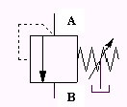
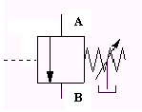 | of external piloting, when their action is determined by a signal of pressure coming from another circuit, or even of another branch of the same circuit.

In the normal position, the valve is closed. If the opening pressure of the valve is reached in P, then the valve opens and P communicates with B. If the pressure lowers, the valve closes again. The direction of oil circulation is the indicated by the arrow.

Once opened, the sequence valve stops offering resistance to the flow passage.

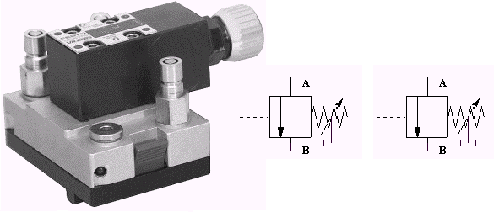
Picture 10 - [7]

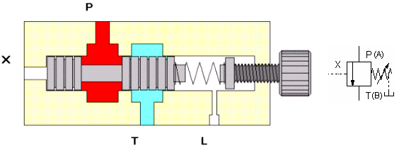

Picture 11 - [7] - Closed valve

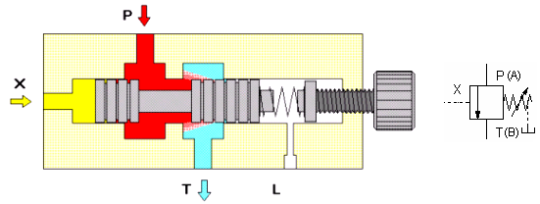

Picture 12 - [7] - open valve

Three-opening pressure reducing valve

A three-opening pressure reducing valve is a manometer valve meant to maintain the pressure in the downstream circuit steady, independently of the flow that travels through it, and of the upstream pressure (despite being necessarily higher than the pressure that we intend to maintain steady downstream).

The three-opening pressure reducing valves are, therefore, placed, generally, at the entrance of a hydraulic sub-circuit that should never surpass a certain value of pressure, despite being fed from an upper pressure circuit.

The three-opening pressure reducing valves are, contrarily to the remaining manometer valves, valves that are opened while the calibration pressure is not reached. Constructively they are of slide type (see component illustration).

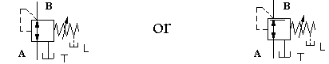

The direction of oil circulation is from A to B. Normally, they seem to be associated in parallel with an anti-return.

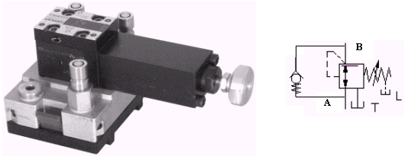
Picture 13 - [7]

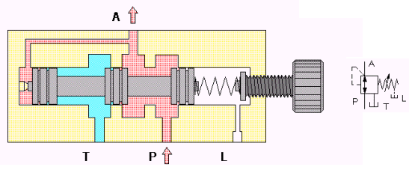

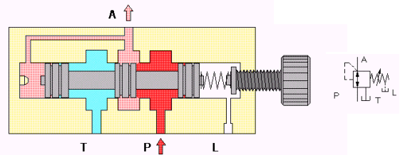
Picture 14 - [7]

FLOW VALVES

The function of flow valves is to act on the flow (Q), because of the variation of a strangler section, thus providing the control of the cylinders and hydraulic motors speed.
The flow debited in excess by the pump is resent to the reservoir through the pressure relief valve. In case of variable cylinder capacity pumps, the torrent debited is adjusted to the value of torrent absorbed by the circuit.
Frequently, the action of the strangler and flow regulator valves is only required in one direction of the flow. In these cases, these valves are generally combined with a non-return valve (unidirectional strangler).

Stranglers (restrictors)

The restrictors are flux-meter valves whose impedance to the flow varies, generally, in a linear way with it. The restrictors are organs of extremely simple construction, because the effect of restraint is obtained simply by means of an oil passage strangling section.

The restrictors are used as rudimentary speed control elements of hydraulic receivers, as volume decompression pressurized fluid promoter elements, as dynamic stabilization elements of other hydraulic components (ex. manometer valves).

The restrictors can be:
- fixed, if their geometry is unchangeable;
- adjustable, if their geometry is changeable by means of a tool;
- variable, when endowed with control (handle) easily usable to alter the geometry of the restricted one.

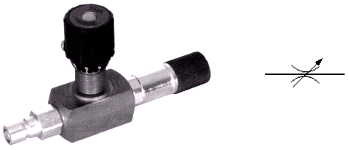
Picture 15 - [7]

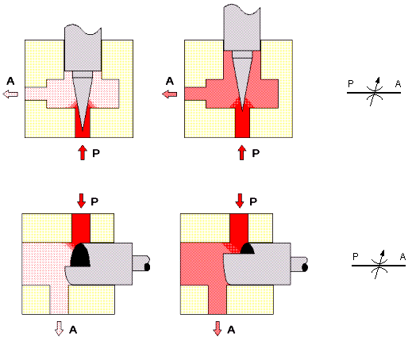
Picture 16 - [7]

Two-opening flow regulator valves

As válvulas reguladoras de caudal de 2 orifícios são válvulas fluxométricas cuja função é determinar o caudal que as atravessa quase independentemente das pressões a montante e a jusante, por variação muito grande da sua impedância para valores de caudal diferentes do que pretendem manter constantes.

The two-opening flow regulator valves are flux-meter valves whose function is to determine the flow that travels through them almost independently of the upstream and downstream pressures, by a great variation of their impedance to different flow values than they want to maintain constant.

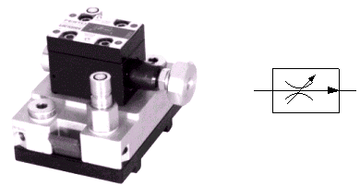
Picture 17 - [7]

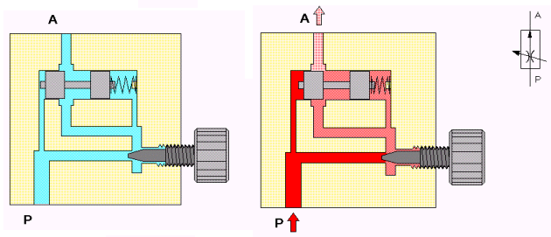
Picture 18 - [7]

Flow divider valves

A flow divider valve (commonly known by flow divisor), is a three-opening flux-meter valve, being one of entrance and two of exit, whose function is to divide the entrance flow by the exits in equal parts.

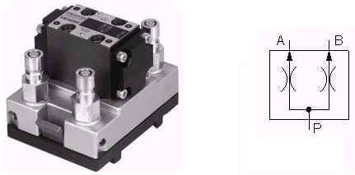
Picture 19 - [7]

NON-RETURN VALVES

The function of non-return valves is to stop the flow passage in one direction, allowing, however, the free passage in the contrary direction. From this function derives also the designation anti-return valves. The internal tightness of this valve has to be absolute, which determines its constructive form of axial seat.

Anti-return

This valve, as the name itself indicates, establishes a unique direction for the passage of the oil: from A to B.
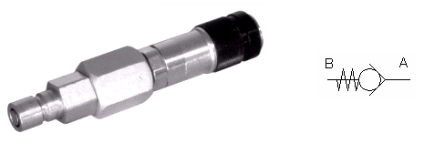
Picture 20 - [7]

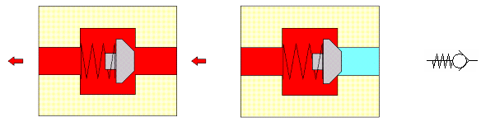

Picture 21 - [7]

As a shutter element, it can be used as a spherical body, conical (as the one on picture 21) or plain. These elements are impelled in the closing direction against the respective seat, by a relatively weak spring. The beginning of functioning clearly stands out from the illustrations of the component.

Piloted anti-return

The distinctiveness of the piloted non-return valves lies in the fact that their shutter can be hydraulically raised, so as to allow the passage of the oil in the normally blocked direction.

These valves are applied in cases in which, in the position of rest, there should be stopped the minimum movement of return (for example load descent by gravity effect, due to the existence of leaks of a directional valve) and on the other hand to make it possible to trigger the return movement.

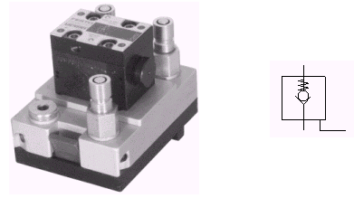
Picture 22 - [7]

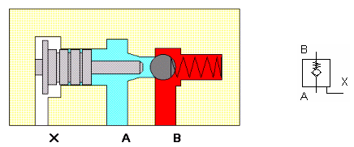

Picture 23 - [7] - without a piloting signal

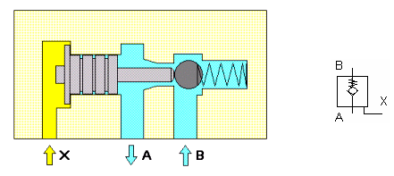

Picture 24 - [7] - with a piloting signal

PROPORTIONAL VALVES

Directional proportional valves

With a directional proportional valve there can be built complex controls, sequence of programmes, such as: acceleration, slowing down and different consumer movements.

4-way directional proportional valves

The speed and the direction of movement are determined by an only device. For that, the greatness of exit (for example: outflow) is proportional to the tension of an electric signal of entrance.  The servo-valves have similar behaviour. The proportional valves control not only the operation but also the regulation of a hydraulic circuit. | 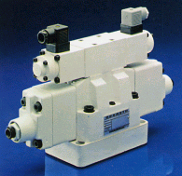
 | Picture 25 - [6]

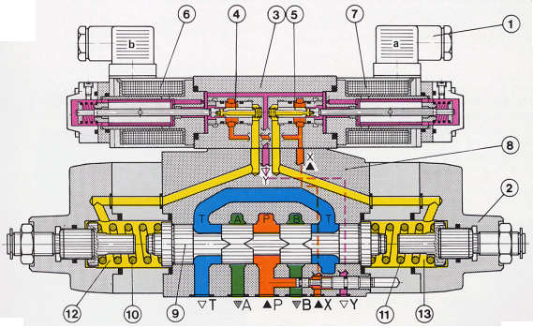

Picture 26 - [6]

The 4-way directional proportional valves are constituted by a pre-operator valve 1 and a main valve 2. (Picture 26)
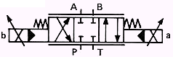

The pre-operator valve is a pressure regulator valve with proportional solenoids, that is, regulative, of continuous current in oil bath, that transforms an electric signal of entrance into a proportional force to this signal. An increase in the electric current corresponds to an addition of force in the solenoid. In order to obtain a linear and stable transference of that force, we only use a part of the available course for the passage of the nucleus.

Basically the pre-operator valve is constituted by a carcass 3, two pre-operated pistons 4 and 5 and two proportional solenoids 6 and 7. The main valve is a directional valve and has essentially carcass 8, main piston 9 and centering springs 10 and 11.

Pressure relief valve with proportional solenoid

Pre-operated pressure relief valve with additional security of maximum pressure.

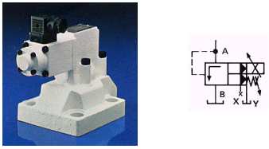 | This valve is constituted by a pre-operator valve 1 with proportional solenoid 2, optionally with security for maximum pressure 3 and main valve 4.
Picture 27 - [6]

The basic function corresponds to the pre-operator pressure relief described in chapter "Valves of pressure". The difference is in the pre-operator valve. A proportional solenoid was put in the place of the spring and the pre-operator cone was adapted to the individual characteristics. The adjustment of the pressure is done according to an electric current through a proportional solenoid. A higher current of entrance corresponds to a bigger force of the solenoid and that leads to bigger pressure. In picture 29 it is also represented the security for the maximum pressure. This prevents, for example, the admissible maximum pressure of the system to surpass when an electronic failure occurs.  Technical data:  Operational pressure: up to 315 bar;  Outflow: up to 600 l/min | 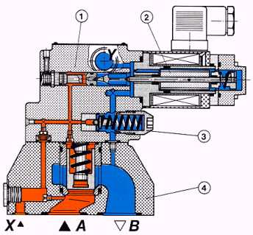
 | Picture 28 - [6]

SERVO-VALVES

The name ''servo" is used as a very broad concept. In a very general way, it indicates a function, in which, a small greatness of entrance (signal of entrance) corresponds to a bigger greatness of exit (signal of exit). The most known example is the steering wheel of a car, where a small force performed by the driver corresponds to a big force in the wheels. Similarly, that happens with servo-hydraulics.

A control signal of small intensity, for example of a 0.08 Watt power, can analogically control hundreds of kW powers. However, the servo-valves are apt, not only for analog control functions, but also (and mainly) to be employed in electro-hydraulic regulation circuits, contrarily to proportional valves.
For example: positioning circuit (maintain in position during the load) or speed regulation circuits (maintenance of a certain speed).
As concepts “control” and “regulate” are used frequently, it is better to define them.

Control: it means, in the regulation technique, when a reference value is imposed and the consequent value appears obligatorily from equipment. This real value is not controlled and it is not corrected.

Regulate: it means that, given a reference standard value, the real value is controlled and measured constantly, being transformed in a compatible value and compared to the standard greatness. In case the values are different, the difference of pressure emits signal that influences the system until values, both standard and real, are equalized.

The regulation has, therefore, the function of, despite having interference greatnesses, maintaining the real value always the same as the standard value.
In the servo-valve a small electric signal is generated and it is analogically transformed into a signal of hydraulic exit (pressure, outflow).

Two-stage directional servo-valves
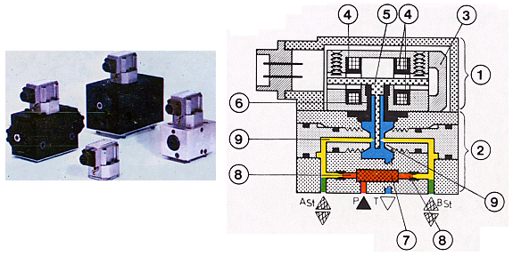
Picture 29 - [6]

The two-stage directional servo-valve has basically the 1st stage (electric servo-motor of command 1 and hydraulic amplifier 2) and the 2nd stage (directional).

Symbol | 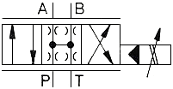

Control motor 1: Transforms electric current "i" in movement "S".
Hydraulic amplifier 2: Transforms movement "s" in a difference of pressures ΔP

Pressure servo-valves

The 3-way pressure servo-valve, shown in picture 33 is used to reduce the pressure of the pump, a smaller, proportional pressure to an electric current of entrance.

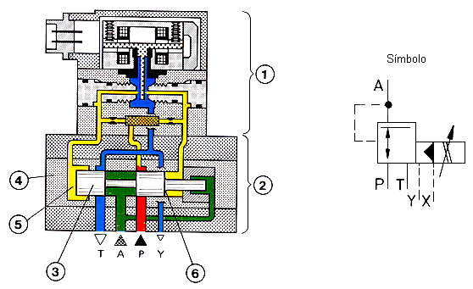
Picture 30 - [6]

As intial control element we use the already known first stage of directional servo-valves. The regulation piston 3 moves in the plug/bung/stopper/wad/sparkplug of command 4. It acts the half of the pressure of command taken in P on surface 5 and on the area of the circular crest 8 (relation of areas 1:2). The remaining half of the area of the piston is connected to the pressure of the connection A, being this the pressure that we want to reduce. This communication works as signal of hydraulic return.
The piston moves to the right until the pressure in the connection of utilization in A has reached the half of the pressure of the system, this way the piston being in balance.
A deflection of the impact plate, involves a proportional variation to the pressure of the consumer, until the piston is in balance again, being this in the field pT <= pA >= PST.
All the valves’ sizes can be calibrated externally, making it possible to adjust the diagram of the pressure according to the electric current so that when i = 0 we have pA = 0.

BASIC HYDRAULIC CIRCUITS

Although the constituent elements of the circuit, can be recognized through the symbology presented throughout these support texts, we did not forget (in the introductory examples) their captioning, for a quicker understanding of the plans presented.

Next, we will present some considerations that must be followed whenever possible:

* for better clearness and easiness of interpretation, the symbols are arranged from below upwards, according to the energetic flux, not being necessary to respect the physical arrangement of the devices they represent;

* directional valves are represented preferably in the horizontal. The tubing must be, whenever possible, straight lines without intersections;

* manifold valves are represented in their rest position, that is, in the position they assume in the absence of pressure, tension or control action. In certain cases, the valves may also be represented in the corresponding position to the cycle beginning situation;

* for the electro-hydraulic systems, it should be created, separately, a hydraulic plan and an electric plan. The sensor elements, such as micro-switches or pressure indicators, appear in both plans, as well as the electro-valves. The interaction of both systems is clarified by the sequence diagram.

* The hydraulic plan can be completed with characteristic facts of the pumps, cylinders or hydraulic motors it consists of, as well as pressures, times, tubing diameters, powers, rotation speeds, etc.

Basic hydraulic circuit – linear motion

This first example of a hydraulic circuit has some of the basic (linear) motions that we can find in any hydraulic circuit (advance and retracted movement of a cylinder). This circuit can function so as to position a table of work or any another element of a machine. The operations the cylinder performs are: the advance, the retracted movement (or return) and the stopping.

Legend
1 - Reservoir or oil deposit
2 - Electric motor
3 - Hydraulic pump with only one direction of rotation and constant cylinder capacity
4 - Manometer
5 – Pressure relief (its task is to function as a security valve, not allowing the pressure to surpass a certain pre-established value)
6 – 4/3 manual control directional valve
7 - Double acting cylinder

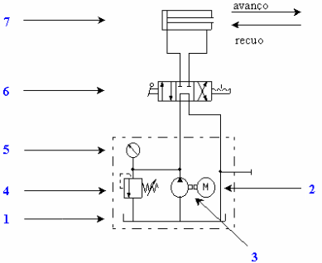
Example 1

DOUBLE ACTING HYDRAULIC CYLINDER DRIVE

With 4/3 directional valves, manual drive

The direction of operation of the cylinder is controlled by the position of the operating lever of the distribution valve. When, by that action, the connections of the valve stay as they are represented on the left box, then the oil coming from the pump gets to the main chamber of the cylinder, forcing it to move in the direction of advance (picture 2). The oil contained in the other chamber of the cylinder is forced to come out entering in the distribution valve, thus reaching the deposit.
When the lever is activated so as to obtain the connections represented on the right box, the operation is analogous, with only the oil flux being inverse to the previous, thus obtaining the retracted movement of the cylinder (picture 3).

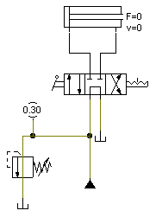 | 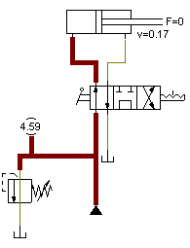
Picture 1 | Picture 2

When the cylinder shaft reaches any of its extreme positions, the pressure in the system rises until it reaches the value for which the pressure relief valve (safety) is regulated. Then, it opens, allowing the discharge of the flux pump directly to the reservoir keeping the pressure continuous inside the cylinder, in the maximum value reached (picture 4).

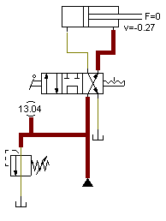 | 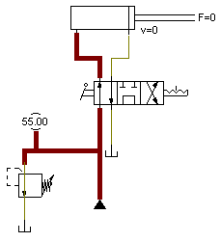
Picture 3 | Picture 4

With the operating lever in a position that corresponds to the central box of the distribution valve (neutral position), the cylinder finds itself blocked preventing any movement. In this situation the pump discharges its flux directly to the deposit under minimum or practically void pressure. (picture 1).

This circuit can be controlled by the different types of 4/3 directional valves, depending on the function that we intend. In fact, the advance and the retracted movement work in an analogous way (pictures 5 and 6).

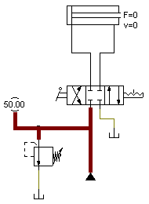 | 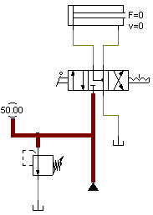
Picture 5 | Picture 6

With 4/2 directional valves, manual drive

The direction of operation of the cylinder is controlled by the position of the operating lever of the distribution valve. When, by that action, the connections of the valve stay as they are represented on the left box (picture 8), then the oil coming from the pump gets to the main chamber of the cylinder, forcing it to move in the advance direction.
The oil contained in the other chamber of the cylinder is forced to leave, entering in the distribution valve, thus reaching the deposit. When the lever stops being activated, because of the spring, we obtain the connections represented on the right box. The operation is analogous, being just the direction of the flux of inverse oil of the previous one, thus obtaining the retracted movement of the cylinder (picture 9).

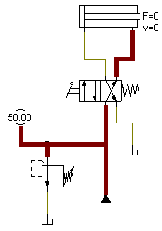 | 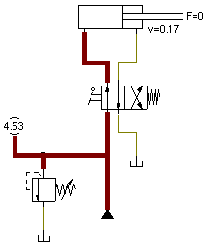 | 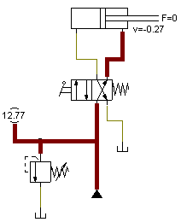
Picture 7 | Picture 8 | Picture 9

If the lever is not activated, the connections remain on the right box, that is, in the retracted movement direction, where the cylinder reaches its extreme position. In extreme cases (advance and total retracted movement), the pressure in the system rises until it reaches the value for which the pressure relief valve (safety) is regulated. Then, it opens, allowing the discharge of the flux pump directly to the reservoir, keeping the pressure inside the cylinder constant, in the maximum value reached (picture 7).

Note: While it is possible to stop the cylinder in an intermediate position with valves 4/3, with valves 4/2 that is not possible.

With 4/2 directional valves, electric drive

In terms of functions, these valves are exactly like those studied previously. There is only a difference: it only varies the operating way that, as we know by the symbol, is electric.

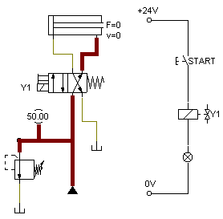 | 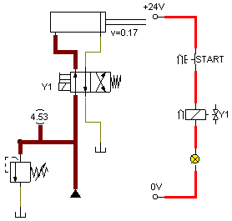
Picture 10 | Picture 11

If the activation of the valve is electric, then together with the hydraulic plan comes the electric plan so as to help us understand its functioning. Pressuring the START button, we establish the passage of current to solenoid Y1, which will activate the valve positioning it on the left box, which, in this case, will initiate the advance of the cylinder. When we stop pressuring the START button, we consequently interrupt the circuit, the Y1 stops having current therefore the valve comes back to its initial position because of the spring, then the retracted movement happens.

With 4/3 directional valves, electric drive

For the valves 4/3 electrically activated, everything goes the same way; we only have to have electric signal on both sides (Y1 and Y2).

When the ADVANCE is activated, it transfers current into Y1; there is the change of position of the valve and the respective advance of the cylinder.

When the RETRACTED MOVEMENT is activated, it transfers current to Y2; there is the change of position of the valve and the respective retracted movement of the cylinder.

When neither the ADVANCE nor the RETRACTED MOVEMENT are activated, the valve remains in the central position, which means a blockade of the cylinder regarding any of the cases of advance or retracted movement.

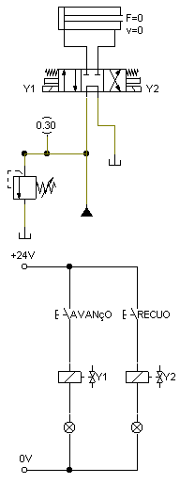 | 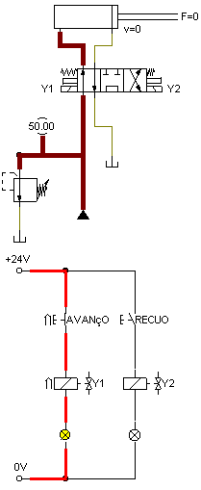 | 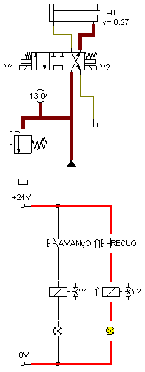
Picture 12 - (Neutral position) | Picture 13 - (Advance) | Picture 14 - (Retracted movement)

Association of directional valves in succession

With this kind of arrangement of the directional valves we cannot drive more than one work element without influencing the outflow or the pressure. The system privileges the receivers according to their hierarchical order.

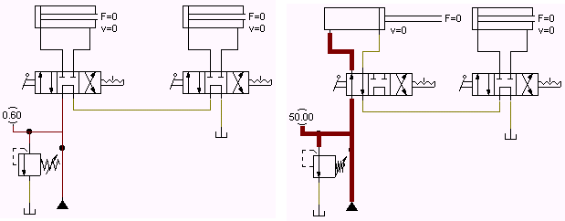

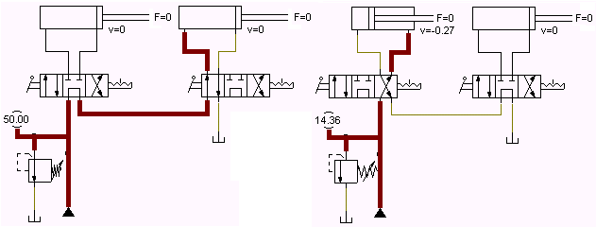

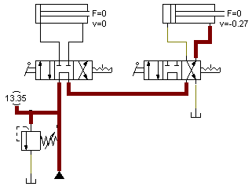

Association of directional valves in parallel

With this kind of arrangement of the directional valves, we can drive each one of the cylinders in an independent way. The system does not obey to any hierarchical order because of its independence.

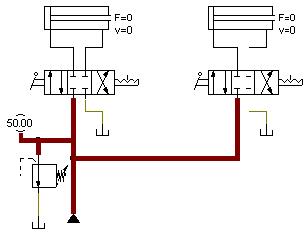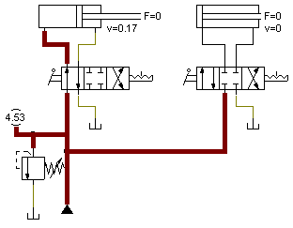

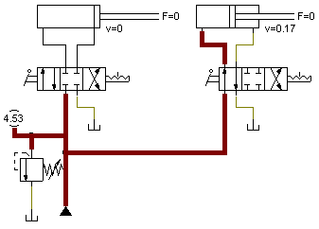

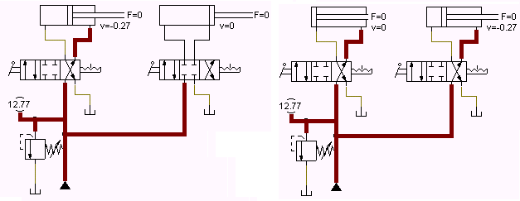

BASIC HYDRAULIC CIRCUIT WITH ROTARY MOTION

When a rotary motion is requested, a hydraulic motor is used instead of a cylinder. In the picture we can see how to supply a bidirectional rotary motion with hydraulic motor braking.

In this circuit, the distribution valve allows the hydraulic motor to rotate in both directions of the rotation, but allows its blockade even when in neutral position. In the cases that a big load of inertia can cause in the axis of the motor an excessive increase of pressure (when the distribution valve is in the central position), there should be used some means of protection, such as the braking circuit shown, which is like a valve of security in each feed-line of the motor.

SPEED CONTROL IN HYDRAULIC CYLINDERS

Speed control by means of flux-meter valves

The cylinder’s speed control can be obtained if we use the flux-meter valves. The picture sequence allows us to infer, that is, the more we strangle the valve, which means diminishing the percentage of available area, the less will the speed of advance or retracted movement of the cylinder be.

Speed control in the advance and not in the retracted movement.

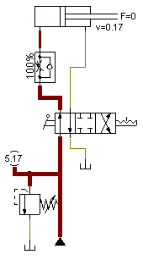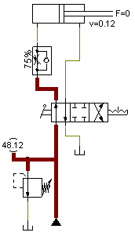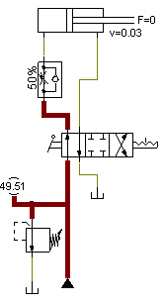

Speed control in the retracted movement and not in the advance.

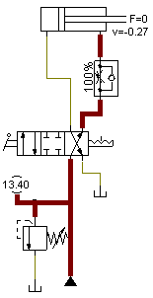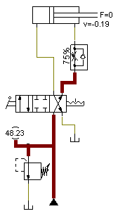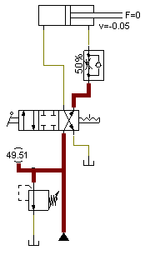

Notice that, despite the fact that the imposed restraints to the valve have the same value in the advance and in the retracted movement, the speeds are different, because of the difference of areas of the piston and of the piston ring. We can also see that the valve strangles in a direction but does not interfere in the other.

Let us imagine a circuit without a strangler (picture 15). We see that the speed of advance is 0,17 m/s, and the speed of retracted movement is 0,27 m/s, that is, bigger than that of advance, by the difference of the involved areas. If we want, for example, to diminish the speed of advance, we will have to apply a strangler in the corresponding line and adjust to the values demanded, (picture 16). In this situation, we see that the speed of advance is 0,07 m/s, and the speed of retracted movement is 0,27 m/s, that is, the same speed obtained without any valve. From this, we conclude that the strangler only affects the line where it is put.

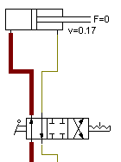 | 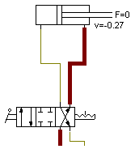 | 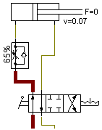 | 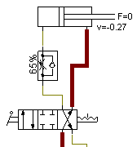
Picture 15 |  | Picture 16

If we intend to interfere in both speeds (advance and retracted movement) by this process, we can apply one of the solutions exposed in pictures 17 and 18.

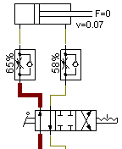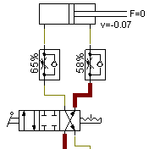
Picture 17

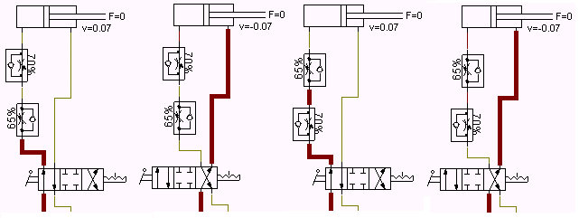
Picture 18

Notice that the adjustment of the valves is not the same for the cases of pictures 17 and 18, because, as the areas and the volumes are different, the flows will also be distinct.

In picture 18, if we install the valves the reverse way, below or on top of the advance or vice versa, the speed values are not altered, as we can see.

Regenerative circuit

The regenerative circuit is used with the purpose of increasing the advance speed of double-acting cylinders. In this case, both of the piston faces are submitted to the pressure. Since the areas of the faces are different, we verify a differential force that drives the cylinder in the advance direction.

The oil expelled from the ring chamber is re-conducted (regenerated) to the circular chamber of the cylinder. The active section corresponds to the section of the shaft. This way, we see an increase of the speed with decrease of the available force, when compared to a circuit of conventional feeding. Notice that in the retracted movement it does not suffer any variation in terms of speed (picture 20).

The fact that both faces of the piston are submitted to the pressure produces necessarily an increase of the frictions. For this reason, it is only advisable the use of the regenerative circuit with cylinders with a relation of areas up to Ap : As 2:1.

If we try to make the connection the reverse way, so as to increase the speed of retracted movement, we see that such is not possible, as we can see by the analysis of picture 21.

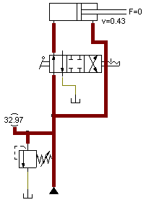 | 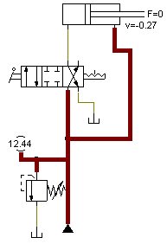 | 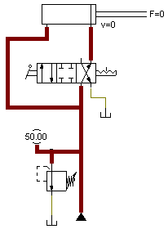
Picture 19 - (Advance) | Picture 20 | Picture 21 - (Retracted movement)

Rectifier circuit (Graetz bridge)

Graetz bridge, produced with non-return valves, enables the speed regulation of both directions (advance and retracted movement) of a receiver, in a completely similar way with just one flow regulator valve.

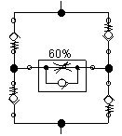 | 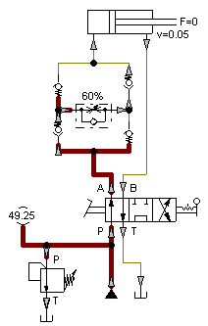 | 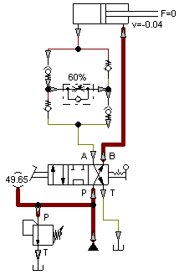

Speed variation controls

This circuit shows how to control a quick speed approach and slow speed work cylinder.

Quick advance – Until it reaches sensor A0, the advance works normally since it goes freely through the 2/2 directional valve.

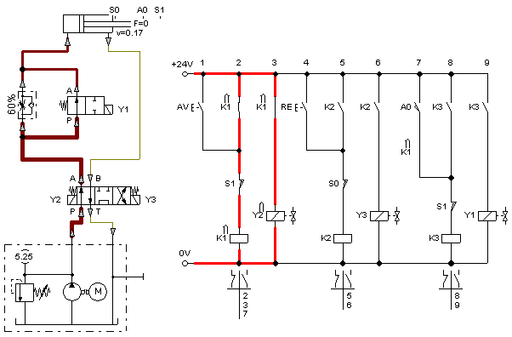

Slow advance – Once the sensor A0 is reached, it emits an electric signal (Y1) to the 2/2 directional valve, and this one blocks the passage of the fluid, forcing it to go through the strangler where it will lose speed and move slowly to the end of the course.

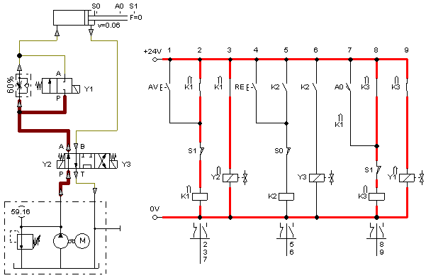

Normal retracted movement – As the return line does not have any obstacle, the retracted movement occurs normally.

