


Hydraulic Generators

1. Label the following pictures using the information in the box.

Blade pump (bomba de palheta) | Screw pump (bomba de parafuso)
Axial piston pump (bomba de êmbolo axial) | Pump of external gear (bomba de engrenagem exterior)
Pump of internal gear (bomba de engrenagem interior) | Hydraulic pump (bomba hidráulica)
Pump of internal gear (bomba de engrenagem interior) | Radial piston pump (bomba de êmbolo radial)

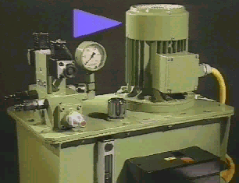  ___________________________________ | 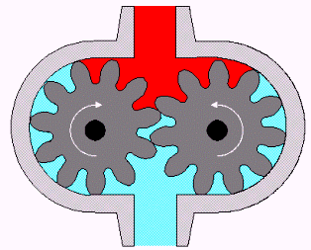  ___________________________________
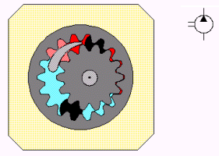  ___________________________________ | 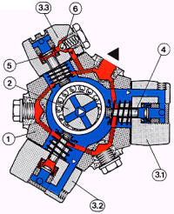  ____________________________________________
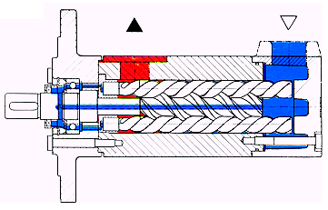

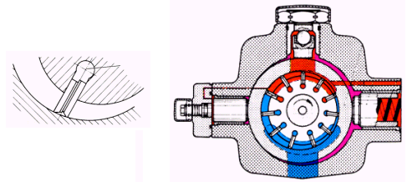
___________________________________
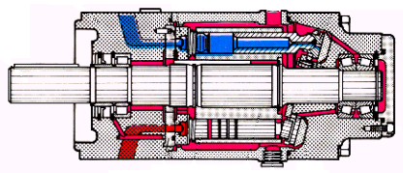
__________________________________________________ Good work!

Hydraulic pump (bomba hidráulica)

Pump of external gear (bomba de engrenagem exterior)

Pump of internal gear (bomba de engrenagem interior)

Blade pump (bomba de palheta)

Screw pump (bomba de parafuso)

Axial piston pump (bomba de êmbolo axial)

Radial piston pump (bomba de êmbolo radial)

