Bilingualer Fachunterricht an berufsbildenden Schulen

Unterrichtsmodul

Berufsfeld: Wirtschaft und Verwaltung

Beruf: Bankkaufmann / Bankkauffrau

Legal Capacity

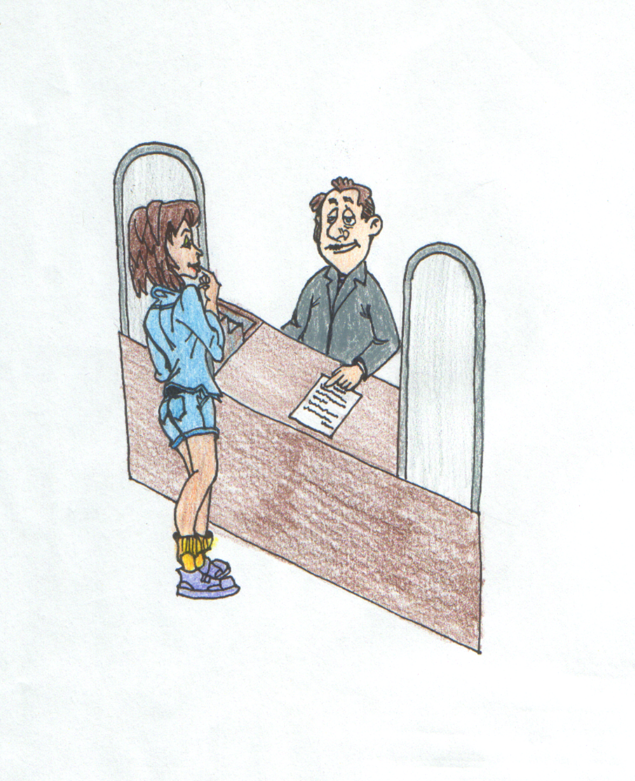

ACTION PROGRAMME OF THE EUROPEAN UNION
LEONARDO DA VINCI – PROJECT
PROJECT No.: 2002 LA 112 628 BILVOC

LANGUAGE COMPETENCE THROUGH BILINGUAL TEACHING AT VOCATIONAL COLLEGES

Teaching Module

Date of Production: February 2004

Subject: Banking Economics

Topic: Legal Capacity and Opening an Account

Title: Legal Capacity

Target Group: Trainees and employees working in banking, students involved
in banking

Prior Knowledge: Capability

Level of Language Skills: Effective Operational Proficiency ( C1)

Follow – Ups: Types of Accounts, Opening an Account

Objectives: Students should know the term legal capacity, explain the
different stages of it and should be able to deal with some
case studies with the help of the German BGB (civil code)

Benefits: Students should be able to answer the following questions:
- What does legal capacity mean?
- What are the different stages of legal capacity?
- What are the features of the different stages of legal capacity?

With the help of this module the students will become familiar with the term legal capacity used in German law. They will be able to name the different stages of legal capacity to explain their main features. And they will be able to deal with several applied cases with the help of the German “ Bürgerliches Gesetzbuch “ (civil code).

This module starts with a role- play that shows the procedure for opening an account. Therefore it is necessary for the students to use real application forms. That is why the teacher should encourage the students to bring forms that are used in their bank .If this isn’t possible some forms of a German bank are provided with this module.

In this module the method “ group puzzle “ is introduced. This method supports the ability to communicate and cooperate between the students. Therefore the class is divided into “basic” groups. Each student in this group gets different exercises, which should be solved individually. After that new groups are formed, “expert” groups. In these groups are the students who had to solve the same case studies. They are “experts” and their task is to speak about the exercises. They should agree on one solution.
After that the students return to their basic group. Now each student in this group reads his exercises and tells the others the solutions.
With the help of this method the learning process is self- organized by the students.

Teaching  Time | Contents | Teacher’s Activities | Student’s Activities | Media | Teaching  Method
10 minutes | What is shown on the transparency? | put transparency on projector  explain the role play, tell other students what they have to observe | discuss with the teacher  two of them perform the role play, others make notes | transparency 1  cards for the role play, some forms | questions and answers  role play
5 minutes | evaluation of the role play  What was shown in the role-play?  explanation of the term legal capacity | discuss with the students  name the topic, write it on the blackboard, explain the term legal capacity | discuss with the teacher | blackboard | questions and answers
30 minutes | stages of legal capacity and explanations | divide the class into three groups, explain the task, offer help | working in groups, read texts, take notes on a poster, look up unknown words | posters (different colours), worksheets 1-3, the German “ BGB” | group work
15 minutes | stages of legal capacity and explanation | supervise presentation, correct mistakes | put posters on the blackboard, present results | posters, blackboard | presentation
5 minutes | looking back on the role play  Was the reaction of the bank clerk in the role play right or is there anything he or she has to change? | discuss with the students | discuss with the teacher |  | questions and answers
15 minutes | stages of legal capacity | draw up an overview together with the students | draw an overview | blackboard, worksheet, transparency “limited capacity” | questions and answers
5 minutes | introducing the method of the group puzzle | explain the method of the group puzzle to the students | listen, ask if something is unclear, form groups | transparency “group puzzle” | teacher’s presentation
30 minutes | exercises | offer help | read case studies, work on exercise, try to find a suitable answer for the situations on the worksheet, look up unknown words | worksheets “group puzzle” | group puzzle
15 minutes | exercises | supervise presentation, correct mistakes | present results | worksheets | presentation
5 minutes | exercises | offer help, correct mistakes | read case studies, try to find the right answer, discuss answers in the class | transparency | questions and answers, discussion

blackboard: 1

legal capacity  legal capacity=  - ability of a person to enter legal transactions | legal capacity  limited capacity | legal incapacity

blackboard 2

Legal capacity  legal incapacity  - children 0-6 years  - mentally ill persons  limited capacity  - 7-18 years  - from 7 to 17 years  legal capacity  - from 18 years onwards | ⇨declarations of intention are invalid (§ 105 BGB)  ⇨the legal representatives act  ⇨ but a person who is incapable of acting in law can act as a  messenger  ⇨ declarations of intention are in abeyance  ( worksheet)  ⇨declarations of intention are valid / legally effective | legal persons ( e.g. a private limited company or a public limited company) gain their legal capacity at the same time they acquire their capability.  they are represented by  - authorities that are determined by operation of law (legal representatives)  - persons that are determined by virtue of power of attorney (business agents)

transparency 1

I’d like to open an
account
What kind of account.... ?

role cards

role card customer
You are 17 years old and you are serving your apprenticeship. You are very interested in opening a current account, where your monthly wage has to be credited. That is why you go to a customer advisor of your bank.

role card bank clerk

You are the customer advisor of the local bank. Your task is to give customers advice on their banking transactions. Your diary shows you that a customer who wants to open an account has made an appointment with you. This customer is going to arrive in a few minutes.

form “Girovertrag“ (page 1 and 2)


form “Girovertrag“ (page 3)
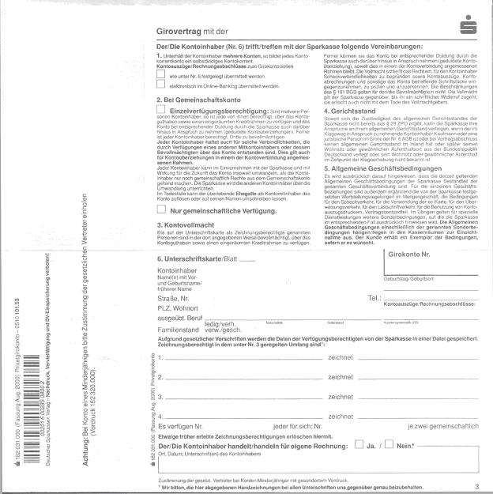

form “Girovertrag“ (page 4)
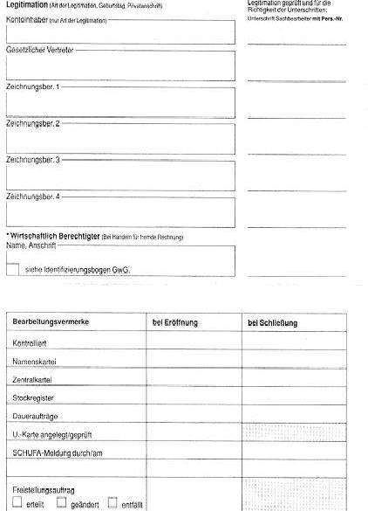

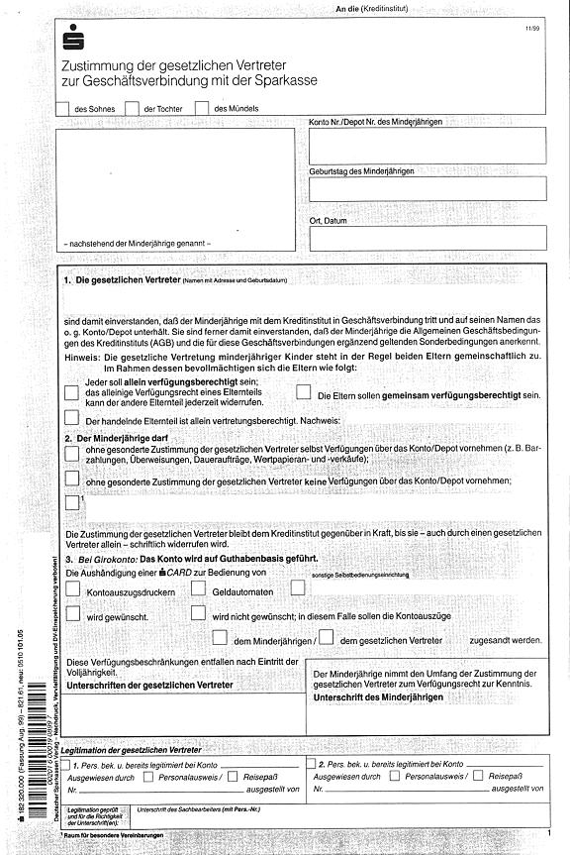
form “ Zustimmung der gesetzlichen Vertreter“ (page 1)

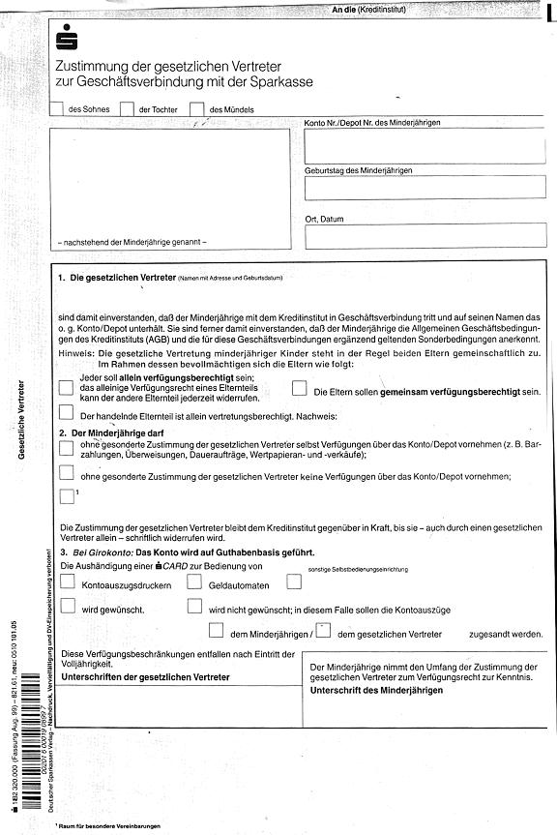
form “Zustimmung der gesetzlichen Vertreter“ (page 2)

worksheets: “stages of legal capacity“

task: group 1 ¹ working time: 30 minutes

legal incapacity

Read the §§ 104 and 105 of the Civil Code and the following text!
Write down the essential parts of the stage “ legal incapacity” on a poster!
Choose one person of your group to present the results in front of the whole class!

You can find the essential parts of the legal incapacity in the §§ 104 and 105 BGB.
It falls within the articles 104 and 105 BGB that the declarations of intention, which are expressed by a person with a disability, are void ab initio. That means the declaration of intention is invalid right from the beginning. Only the legal representatives can express declarations of intention, which oblige the persons with a disability. The legal representatives of minors are principally the parents together.
A declaration of intention which is expressed vis- a`- vis a person with a disability is not effective before it reaches the legal representatives (§ 131 BGB). If for instance, a 5-year-old child inherits a block of flats, the notice of a tenant is not going to be effective until it is transmitted to the parents.

If a person with a disability acts as a messenger, the legal incapacity doesn’t matter. This is because the messenger doesn’t declare their own intention but only transmits already finished declarations of intentions of another person.

worksheet: “ stages of legal capacity“

task group 2 ¹ working time 30 minutes

limited capacity

Read the §§ 106 – 108 (1) and §§ 110-113 of the Civil Code and the following text!
Write down the essential parts of the stage “limited capacity” on a poster!
Choose one person of your group to present the results in front of the whole class!

You can find the essential part concerning limited capacity in the articles 106- 108 BGB. These articles show that a person of limited capacity normally needs the advice and consent of the legal representative to enter into a transaction. Declarations of intention expressed by persons of limited capacity are in abeyance. They will be valid if the legal representatives give their previous consent or their later permission. If the permission is given, the legal transaction will be valid, and if the permission is refused the legal transaction will be void.
However, there are some exceptions to the rule, which allow a person who is incapable of managing his / her own affairs to enter into a transaction without the advice and consent of the legal representative.
These are
legal transactions which have only advantages for the person of limited capacity (§ 107 BGB)
legal transactions that are financed by pocket money (§ 110 BGB)
self-employed business operations (§ 112 BGB)
employment (§ 113 BGB) (this article doesn’t apply to professional trainings)

worksheet 3: “stages of legal capacity“

task group 3 ¹ working time 30 minutes

legal capacity

Read the following text.
Write down the essential parts of the stage “legal capacity” on a poster!
Choose one person of your group to present the results in front of the whole class!

‘Natural persons’ aged 18 years and above are of full legal capacity as long as they are not declared incapable of managing their own affairs. The declarations of intention of persons of full age and capacity are legally effective.

Legal persons gain their legal capacity at the same time they acquire their capability. They are represented by authorities that are determined by operation of law (legal representatives). This could be the managing board of a registered association or the manager of a limited company, for instance.
Furthermore, legal persons can be represented by persons that are determined by virtue of power of attorney (business agents). This could be a proxy or an authorized signatory.

worksheet „ limited capacity“

effects
exceptions

as long as

before conclusion of an agreement
after conclusion of an agreement

or

solution worksheet “limited capacity“
limited capacity ( 7-18 years)

effects
exceptions

as long as
legal transactions are valid
before conclusion of an agreement
after conclusion of an agreement

no consent
no permission

or

pocket money
§ 110 BGB
legal transactions, which only have advantages
§ 107 BGB
legal transaction is in abeyance

no agreement
agreement

legal transactions within employment
§ 113 BGB
Self- employed business operations
§ 112 BGB

legal transaction is invalid
legal transaction is valid

poster „ group puzzle“
task group puzzle

work in the basic group ·working time 5 minutes
solve the exercises individually with the help of the Civil Code
work in the expert groups: · working time 10 minutes
exchange information
work on the exercises in the group, clarify questions
choose a group speaker to present the common results
exchange in the basic group: ·working time 10 minutes
explain the results of the expert group to the other persons in the basic group
everybody presents his / her results
presentation in front of the class: ·time 10 minutes
group speaker of the expert group presents the solutions of the exercises and gives reasons for this result

transparency „ group puzzle“
procedure “group puzzle”

basic group (same symbol)

2. expert group
(same colour)

3.basic group

4. presentation

worksheets “group puzzle”
exercises group puzzle:

- 5 – year old Peter is buying some sweets for 2 Euros. Has he entered a sales agreement?
- 17-year old apprentice Andrew is renting a small flat. The landlady Mrs Smith charges only 4 Euros per square metre. Is the described legal transaction valid?
- 16-year old banking apprentice Barbara has given her bank an instruction to buy shares valued 300 Euros. This amount is to be debited from her current account. This account presents a balance of 150 Euros to her debit. Is the described legal transaction valid?

exercises group puzzle:

- 5 – year old Peter is buying some sweets for 2 Euros. Has he entered a sales agreement?
- 17-year old apprentice Andrew is renting a small flat. The landlady Mrs Smith charges only 4 Euros per square metre. Is the described legal transaction valid?
- 16-year old banking apprentice Barbara has given her bank an instruction to buy shares valued 300 Euros. This amount is to be debited from her current account. This account presents a balance of 150 Euros to her debit. Is the described legal transaction valid?

exercises group puzzle:

- 5 – year old Peter is buying some sweets for 2 Euros. Has he entered a sales agreement?
- 17-year old apprentice Andrew is renting a small flat. The landlady Mrs Smith charges only 4 Euros per square metre. Is the described legal transaction valid?
- 16-year old banking apprentice Barbara has given her bank the instruction to buy shares valued 300 Euros. This amount is to be debited from her current account. This account presents a balance of 150 Euros to her debit. Is the described legal transaction valid?

exercises group puzzle

- 5 – year old Peter is buying some sweets for 2 Euros. Has he entered a sales agreement?
- 17-year old apprentice Andrew is renting a small flat. The landlady Mrs Smith charges only 4 Euros per square metre. Is the described legal transaction valid?
- 16-year old banking apprentice Barbara has given her bank the instruction to buy shares valued 300 Euros. This amount is to be debited from her current account. This account presents a balance of 150 Euros to her debit. Is the described legal transaction valid?

exercises group puzzle:

- 5 – year old Peter is buying some sweets for 2 Euros. Has he entered a sales agreement?
- 17-year old apprentice Andrew is renting a small flat. The landlady Mrs Smith charges only 4 Euros per square metre. Is the described legal transaction valid?
- 16-year old banking apprentice Barbara has given her bank the instruction to buy shares valued 300 Euros. This amount is to be debited from her current account. This account presents a balance of 150 Euros to her debit. Is the described legal transaction valid?

exercises group puzzle:

- 16 – year old student Sarah is interested in opening a current account. She wants her monthly pocket money of 60 Euros and the money from her holiday job to be transferred to this account. Is Sarah allowed to express the necessary declaration of intention for opening this account on her own?
- His mother is sending 5 – year old Ralph to the bakery to buy a loaf of bread. Ralph pays 2 Euros and receives the bread. Is a sales agreement reached?
- 16- year old Teresa is giving notice that she wants to end her business training because she wants to do another job. Her parents don’t know about that. Is this possible?

exercises group puzzle:

- 16 – year old student Sarah is interested in opening a current account. She wants her monthly pocket money of 60 Euros and the money from her holiday job to be transferred to this account. Is Sarah allowed to express the necessary declaration of intention for opening this account on her own?
- His mother is sending 5 – year old Ralph to the bakery to buy a loaf of bread. Ralph pays 2 Euros and receives the bread. Is a sales agreement reached?
- 16- year old Teresa is giving notice that she wants to end her business training because she wants to do another job. Her parents don’t know about that. Is this possible?

exercises group puzzle

- 16 – year old student Sarah is interested in opening a current account. She wants her monthly pocket money of 60 Euros and the money from her holiday job to be transferred to this account. Is Sarah allowed to express the necessary declaration of intention for opening this account on her own?
- His mother is sending the 5 – year old Ralph to the bakery to buy a loaf of bread. Ralph pays 2 Euros and receives the bread. Is a sales agreement reached?
- 16- year old Teresa is giving notice that she wants to end her business training because she wants to do another job. Her parents don’t know about that. Is this possible?

exercises group puzzle:

- 16 – year old student Sarah is interested in opening a current account. She wants her monthly pocket money of 60 Euros and the money from her holiday job to be transferred to this account. Is Sarah allowed to express the necessary declaration of intention for opening this account on her own?
- His mother is sending 5 – year old Ralph to the bakery to buy a loaf of bread. Ralph pays 2 Euros and receives the bread. Is a sales agreement reached?
- 16- year old Teresa is giving notice that she wants to end her business training because she wants to do another job. Her parents don’t know about that. Is this possible?

exercises group puzzle

- 16 – year old student Sarah is interested in opening a current account. She wants her monthly pocket money of 60 Euros and the money from her holiday job to be transferred to this account. Is Sarah allowed to express the necessary declaration of intention for opening this account on her own?
- His mother is sending the 5 – year old Ralph to the bakery to buy a loaf of bread. Ralph pays 2 Euros and receives the bread. Is a sales agreement reached?
- 16- year old Teresa is giving notice that she wants to end her business training because she wants to do another job. Her parents don’t know about that. Is this possible?

exercises group puzzle:

- 13- year old Susan is buying a CD for 12 Euros from her pocket money without her parent’s knowledge. Has she entered a valid contract?
- Hans Meier, who is 16 years old, is starting an employment with a firm in Frankfurt. His boss is asking him to open an account at a bank to transfer his monthly salary to. Is Hans allowed to open this account?
- Rich uncle Karl is giving his 17 – year old niece Rebecca a golden bracelet as a present. Rebecca’s parents don’t approve of this gift at all, because they don’t get on well with Karl. Has Rebecca become the owner of the bracelet?

exercises group puzzle

- 13- year old Susan is buying a CD for 12 Euros from her pocket money without her parent’s knowledge. Has she entered a valid contract?
- Hans Meier, who is 16 years old, is starting an employment with a firm in Frankfurt. His boss is asking him to open an account at a bank to transfer his monthly salary to. Is Hans allowed to open this account?
- Rich uncle Karl is giving his 17 – year old niece Rebecca a golden bracelet as a present. Rebecca’s parents don’t approve of this gift at all, because they don’t get on well with Karl. Has Rebecca become the owner of the bracelet?

exercises group puzzle

- 13- year old Susan is buying a CD for 12 Euros from her pocket money without her parent’s knowledge. Has she entered a valid contract?
- Hans Meier, who is 16 years old, is starting an employment with a firm in Frankfurt. His boss is asking him to open an account at a bank to transfer his monthly salary to. Is Hans allowed to open this account?
- Rich uncle Karl is giving his 17 – year old niece Rebecca a golden bracelet as a present. Rebecca’s parents don’t approve of this gift at all, because they don’t get on well with Karl. Has Rebecca become the owner of the bracelet?

exercises group puzzle:

- 13- year old Susan is buying a CD for 12 Euros from her pocket money without her parent’s knowledge. Has she entered a valid contract?
- Hans Meier, who is 16 years old, is starting an employment with a firm in Frankfurt. His boss is asking him to open an account at a bank to transfer his monthly salary to. Is Hans allowed to open this account?
- Rich uncle Karl is giving his 17 – year old niece Rebecca a golden bracelet as a present. Rebecca’s parents don’t approve of this gift at all, because they don’t get on well with Karl. Has Rebecca become the owner of the bracelet?

exercises group puzzle:

- 13- year old Susan is buying a CD for 12 Euros from her pocket money without her parent’s knowledge. Has she entered a valid contract?
- Hans Meier, who is 16 years old, is starting an employment with a firm in Frankfurt. His boss is asking him to open an account at a bank to transfer his monthly salary to. Is Hans allowed to open this account?
- Rich uncle Karl is giving his 17 – year old niece Rebecca a golden bracelet as a present. Rebecca’s parents don’t approve of this gift at all, because they don’t get on well with Karl. Has Rebecca become the owner of the bracelet?

exercises group puzzle:

- 17 – years old Benjamin has opened a furniture shop with the agreement of his parents and the guardianship court. After he bought some French beds, which he cannot sell, he refused to pay the purchase price. He objects that his parents didn’t agree to him buying the beds. Does Benjamin have to pay?
- The very neat looking, not recognizably mentally ill 25- year old Gustav is buying a car at a car dealer in Berlin. Gustav pays cash and receives the car immediately. After the car has been damaged in an accident, his legal visitor demands the purchase price back from the car dealer. Is this possible?
- Mr Cruise enters a bank. He wants to open an account for his 17- year old daughter, who wants to study law after passing the school- leaving exam. Is it possible to open this account?

exercises group puzzle:

- 17 – year old Benjamin has opened a furniture shop with the agreement of his parents and the guardianship court. After he bought some French beds, which he cannot sell, he refused to pay the purchase price. He objects that his parents didn’t agree to him buying the beds. Does Benjamin have to pay?
- The very neat looking, not recognizably mentally ill 25- year old Gustav is buying a car at a car dealer in Berlin. Gustav pays cash and receives the car immediately. After the car has been damaged in an accident, his legal visitor demands the purchase price back from the car dealer . Is this possible?
- Mr Cruise enters a bank. He wants to open an account for his 17- year old daughter, who wants to study law after passing the school- leaving exam. Is it possible to open this account?

exercises group puzzle:

- 17 – year old Benjamin has opened a furniture shop with the agreement of his parents and the guardianship court. After he bought some French beds, which he cannot sell, he refused to pay the purchase price. He objects that his parents didn’t agree to him buying the beds. Does Benjamin have to pay?
- The very neat looking, not recognizably mentally ill 25- year old Gustav is buying a car at a car dealer in Berlin. Gustav pays cash and receives the car immediately. After the car had been damaged in an accident, his legal visitor demands the purchase price back from the car dealer. Is this possible?
- Mr Cruise enters a bank. He wants to open an account for his 17- year old daughter, who wants to study law after passing the school- leaving exam. Is it possible to open this account?

exercises group puzzle:

- 17 – year old Benjamin has opened a furniture shop with the agreement of his parents and the guardianship court. After he bought some French beds, which he cannot sell, he refused to pay the purchase price. He objects that his parents didn’t agree to him buying the beds. Does Benjamin have to pay?
- The very neat looking, not recognizable mentally ill 25- year old Gustav is buying a car at a car dealer in Berlin. Gustav pays cash and receives the car immediately. After the car had been damaged in an accident, his legal visitor demands the purchase price back from the car dealer. Is this possible?
- Mr Cruise enters a bank. He wants to open an account for his 17- years old daughter, who wants to study law after passing the school- leaving exam. Is it possible to open this account?

exercises group puzzle:

- 17 – year old Benjamin has opened a furniture shop with the agreement of his parents and the guardianship court. After he bought some French beds, which he cannot sell, he refused to pay the purchase price. He objects that his parents didn’t agree to him buying the beds. Does Benjamin have to pay?
- The very neat looking, not recognizably mentally ill 25- year old Gustav is buying a car at a car dealer in Berlin. Gustav pays cash and receives the car immediately. After the car had been damaged in an accident, his legal visitor demands the purchase price back from the car dealer. Is this possible?
- Mr Cruise enters a bank. He wants to open an account for his 17- year old daughter, who wants to study law after passing the school- leaving exam. Is it possible to open this account?

worksheet “ group puzzle” (all exercises)
exercises

- 5 – year old Peter is buying some sweets for 2 Euros. Has he entered a sales agreement?
___________________________________________________
- 17-year old apprentice Andrew is renting a small flat. The landlady Mrs Smith charges only 4 Euros per square metre. Is the described legal transaction valid?__________________________________________________
- 16-year old banking apprentice Barbara has given her bank the instruction to buy shares valued 300 Euros. This amount is to be debited from her current account. This account presents a balance of 150 Euros to her debit. Is the described legal transaction valid?_____________________________________________________
- 16 – year old student Sarah is interested in opening a current account. She wants her monthly pocket money of 60 Euros and the money from her holiday job to be transferred to this account. Is Sarah allowed to express the necessary declaration of intention for opening this account on her own? __________________________________________________
- His mother is sending 5 – year old Ralph to the bakery to buy a loaf of bread. Ralph pays 2 Euros and receives the bread. Is a sales agreement reached? ___________________________________________________
- 16- year old Teresa is giving notice that she wants to end her business training because she wants to do another job. Her parents don’t know about that. Is this possible?______________________________________________________________
- 13- year old Susan is buying a CD for 12 Euros from her pocket money without her parent’s knowledge. Has she entered a valid contract? __________________________________________________
- Hans Meier, who is 16 years old, is starting an employment with a firm in Frankfurt. His boss is asking him to open an account at a bank to transfer his monthly salary to. Is Hans allowed to open this account? ________________________________________________
- Rich uncle Karl is giving his 17 – year old niece Rebecca a golden bracelet as a present. Rebecca’s parents don’t approve of this gift at all, because they don’t get on well with Karl. Has Rebecca become the owner of the bracelet? _______________________________________________
- 17 – year old Benjamin has opened a furniture shop with the agreement of his parents and the guardianship court. After he bought some French beds, which he cannot sell, he refused to pay the purchase price. He objects that his parents didn’t agree to him buying the beds. Does Benjamin have to pay? _____________________________________________
- The very neat looking, not recognizably mentally ill 25- year old Gustav is buying a car at a car dealer in Berlin. Gustav pays cash and receives the car immediately. After the car had been damaged in an accident, his legal visitor demands the purchase price back from the car dealer. Is this possible? _________________________________________________
- Mr Cruise enters a bank. He wants to open an account for his 17- years old daughter, who wants to study law after passing the school- leaving exam. Is it possible to open this account?______________________________________________________

key to the exercises “ group puzzle”
exercises

- 5 – year old Peter is buying some sweets for 2 Euros. Has he entered a sales agreement?

no, §§104(1), 105 (1) BGB Peter is incapable of acting in law
- 17-year old apprentice Andrew is renting a small flat. The landlady Mrs Smith charges only 4 Euros per square metre. Is the described legal transaction valid?

Andrew is responsible to a limited extend§§106-108 BGB, legal transaction is in abeyance
- 16-year old banking apprentice Barbara has given her bank the instruction to buy shares valued 300 Euros. This amount is to be debited from her current account. This account presents a balance of 150 Euros to her debit. Is the described legal transaction valid?
Barbara is responsible to a limited extend§§106-108 BGB; legal transaction is in abeyance without the agreement of the parents and the guardianship court, because the account is overdrawn
- 16 – year old student Sarah is interested in opening a current account. She wants her monthly pocket money of 60 Euros and the money from her holiday job to be transferred to this account. Is Sarah allowed to express the necessary declaration of intention for opening this account on her own?
limited capacity §§ 106-108 BGB, the agreement of the legal representatives is necessary
- His mother is sending 5 – year old Ralph to the bakery to buy a loaf of bread. Ralph pays 2 Euros and receives the bread. Is a sales agreement reached?

yes, Ralph is incapable of acting in law but he is only a messenger
- The 16- year old Teresa is giving notice that she wants to end her business training because she wants to do another job. Her parents don’t know about that. Is this possible? Notice is invalid, § 111 BGB, permission of the legal representatives is necessary
- 13- year old Susan is buying a CD for 12 Euros from her pocket money without her parent’s knowledge. Has she entered a valid contract?

yes, pocket money § 110 BGB
- Hans Meier, who is 16 years old, is starting employment with a firm in Frankfurt. His boss is asking him to open an account at a bank to transfer his monthly salary to. Is Hans allowed to open this account? yes, legal transaction within employment, § 113 BGB
- Rich uncle Karl is giving his 17 – year old niece Rebecca a golden bracelet as a present. Rebecca’s parents don’t approve of this gift at all, because they don’t get on well with Karl. Has Rebecca become the owner of the bracelet?

yes, § 107 BGB legal transaction has no disadvantages
- 17 – year old Benjamin has opened a furniture shop with the agreement of his parents and the guardianship court. After he bought some French beds, which he cannot sell, he refused to pay the purchase price. He objects that his parents didn’t agree to him buying the beds. Does Benjamin have to pay?
yes, § 112 BGB, self- employed business operations
- The very neat looking, not recognizably mentally ill 25- year old Gustav is buying a car at a car dealer in Berlin. Gustav pays cash and receives the car immediately. After the car had been damaged in an accident, his legal visitor demands the purchase price back from the car dealer. Is this possible?
yes, can demand the whole purchase price back, Gustav is incapable of acting in law, § 104 (2) BGB
- Mr Cruise enters a bank. He wants to open an account for his 17- year old daughter, who wants to study law after passing the school- leaving exam. Is it possible to open this account?
no, §§ 106- 108 BGB, limited capacity, mother and father have to agree

exercises (transparency)

Solve the following case studies with the help of the “ German Civil Code“!

- 16-year old Anna works as a shop assistant in a shoe shop. She has saved her salary for a holiday trip and bought a cruise for 1500 Euros. Her parents neither agree with the holiday date nor with the cruise.

- 12-year-old Thomas gets a savings book to the value of 500 Euros from his uncle. The parents refuse the gift.

- 24 – year old Daniel meets his landlady after a long pub crawl and gives notice that he is moving out of his flat. The next day his landlady speaks to him about his nightly declaration of intention. Daniel is shocked.
  - Is his notice valid?
  - Was Daniel legally competent at the time of expressing the declaration of intention?

key to the exercises

Solve the following case studies with the help of the “ Civil Code“!

- 16-year old Anna works as a shop assistant in a shoe shop. She has saved her salary for a holiday trip and bought a cruise for 1500 Euros. Her parents neither agree with the holiday date nor with the cruise.
limited capacity §§ 106-108 BGB, the agreement of the legal representatives is necessary when booking the cruise, the holiday date can be determined by Anna herself (employment § 113 BGB)

- 12-year-old Thomas gets a savings book to the value of 500 Euros from his uncle. The parents refuse the gift.
Parents can’t refuse it, § 107 BGB legal transaction has no disadvantages

- 24 – year old Daniel meets his landlady after a long pub crawl and gives notice that he is moving out of his flat. The next day his landlady speaks to him about his nightly declaration of intention. Daniel is shocked.
  - Is his notice valid?
  - Was Daniel legally competent at the time of expressing the declaration of intention?
    - the notice is invalid § 105(2)BGB
    - Daniel is legally competent (§104(2) BGB

vocabulary list English- German

capability | Rechtsfähigkeit
declaration of intention | Willenserklärung
in abeyance | schwebend unwirksam
incapable of acting in law | geschäftsunfähig
invalid | nichtig
legal capacity | Geschäftsfähigkeit
legal incapacity | Geschäftsunfähigkeit
legal person | juristische Person
legal representative | gesetzlicher Vertreter
legal transaction | Rechtsgeschäft
legally effective | rechtswirksam
limited capacity | beschränkte Geschäftsfähigkeit
minor | Minderjähriger
void ab initio | von vornherein ungültig

Unterrichtszeit | Inhalt | Lehreraktivität | Schüleraktivität | Medien | Methoden
10 Minuten | Was ist auf der Folie zu sehen ? | legt Folie auf den Projektor  erklärt Rollenspiel, erklärt restlichen Schülern der Klasse ihre Beobachtungsaufgabe | diskutieren mit Lehrer  2 Schüler tragen Rollenspiel vor, die anderen fertigen Notizen an | Folie 1  Karten für das Rollenspiel, Formulare | Lehrer- Schüler Gespräch  Rollenspiel
5 Minuten | Auswertung des Rollenspiels  Was wurde im Rollenspiel dargestellt?  Erklärung des Begriffs Geschäftsfähigkeit | diskutiert mit Schülern  benennt Thema, schreibt Thema an Tafel, Erklärt den Begriff Geschäftsfähigkeit | Diskutieren mit Lehrer | Tafel | Lehrer- Schüler Gespräch
30 Minuten | Stufen der Geschäftsfähigkeit und Erklärungen | teilt Klassen in drei Gruppen ein, erklärt den Arbeitsauftrag, bietet Hilfe an | arbeiten in Gruppen, lesen Texte, erstellen Plakate, schlagen unbekannte Wörter nach | Plakate (verschiedene Farben), Arbeitsblätter 1-3, BGB | Gruppenarbeit
15 Minuten | Stufen der Geschäftsfähigkeit und Erklärungen | beaufsichtigt Präsentation, korrigiert Fehler | hängen Plakate an Tafel, präsentieren Gruppenergebnisse | Plakate, Tafel | Präsentation der Gruppenergebnisse
5 Minuten | Rückbezug auf das Rollenspiel  War die Reaktion des Bankangestellten im Rollenspiel richtig oder muss etwas geändert werden? | diskutiert mit Schülern | diskutieren mit Lehrer |  | Lehrer- Schüler Gespräch
15 Minuten | Stufen der Geschäftsfähigkeit | erstellt zusammen mit den Schülern eine Übersicht | erstellen eine Übersicht | Tafel, Arbeitsblatt, Folie „ beschränkte Geschäftsfähigkeit“ | Lehrer- Schüler Gespräch
5 Minuten | Vorstellung der Methode des Gruppenpuzzles | erklärt Methode „ Gruppenpuzzle“ | hören zu, fragen, wenn Unklarheiten auftreten, bilden Gruppen | Folie „Gruppenpuzzle“ | Lehrervortrag
30 Minuten | Übungen | gibt Hilfestellung | lesen Fallstudien, lösen Aufgaben, versuchen eine geeignete Lösung für die Situationen, schlagen unbekannte Wörter nach | Arbeitsblätter „Gruppenpuzzle“ | Gruppenpuzzle
15 Minuten | Übungen | beaufsichtigt Präsentation, korrigiert Fehler | präsentieren Ergebnisse | Arbeitsblätter „Gruppenpuzzle“ | Präsentation
5 Minuten | Übungen | gibt Hilfestellungen, korrigiert Fehler | lesen Fall, versuchen richtige Antwort zu finden, diskutieren Antwort in Klasse | Folie | Lehrer- Schüler Gespräch, Diskussion

