Bilingualer Fachunterricht an berufsbildenden Schulen

Unterrichtsmodul

Berufsfeld: Ernährung/Hauswirtschaft

Beruf: Restaurantfachleute
Hotelfachleute
Köche

Rules for the planning of a menu

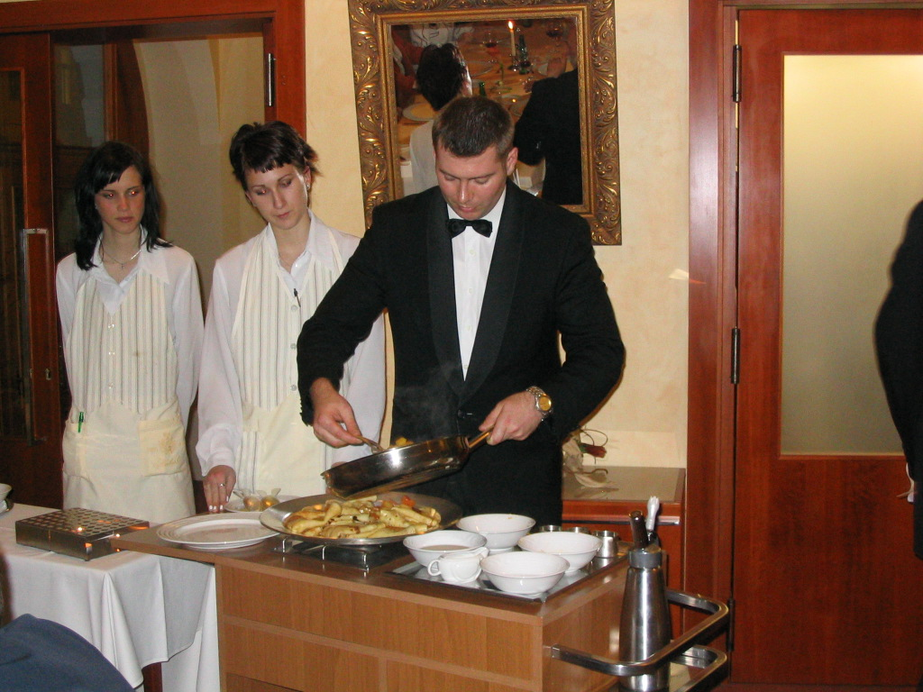

ACTION PROGRAMME OF THE EUROPEAN UNION
LEONARDO DA VINCI
PROJEKT NO.: 2002 LA 112 628 BILVOC
Language Competence Through
Bilingual Teaching at Vocational Colleges

Teaching Module

Date of production 09/2005

Subject: catering

Topic: composing of menus

Title: rules for the planning of a menu

Target Group: any group of catering students (third year)

Prior Knowledge: basic knowledge of cooking proceeding,
Raw materials, nutritional aspects

Level of Language Skills: waystage (A2)

Follow - Ups: terms for professional menu planning

Objectives: knowledge of basic planning rules

Benefits: order of courses, variety, increase

Teaching module: Rules for the planning of a menu

time contents activities media skills___________________________

5 min motivation: discussion transparency discussion
2 faulty menus finding faults by professional experience
20 min survey above aspects of menu planning Brainstorming board realizing the various aspects to be
discussion considered in planning a menu

10 min order of courses in a menu work with a partner worksheet 1 making of a rational decision

10 min lecture board discussion
discussion questioning facts and reasons

10 min individual work handout 1 applying of what has been learned

5 min discussion handout 1/ presenting of deliverables
transparency

15 min further rules of planning a menu lecture handout 2 understanding of rules
discussion

15 min individual work handout 2 using rules to detect faults

10 min faultless menus work with a partner worksheet 2 application and practising of what was learned

10 min discussion board prresenting one`s own results

10 min work with a partner worksheet 2 applicate knowledge in a widened manner

10 min change of deliverables correct screening of other persons results

20 min a faulty advential menu buzz groups worksheet 3 summarizing application of knowledge witht
view on futher topics

10 min discussion comparing results
_______

170 min

RULES FOR THE PLANNING OF A MENU

A menu is a list of dishes that may be ordered (as in an restaurant) or that are to be served (as at a banquet). The dishes are served in a determined sequence. The second case is subject to this module.

transparency

Assess both following menus

tomatoe cream soup

:::

spaghetti Napoli

:::

icy raspberries
________________________________________________

game pie

:::

veal fricassée

:::

bavarian cream

faults: menü 1: 2x tomatoes
3x red coulour
2 consecutive bound courses

menu 2: spicy before mild
2 consecutive light courses

aspects for menu planners

Order
of
courses

occasion

alternation

types of guests

increase

Planning
of a
menu

season

Optical effects

Company’s
efficiency

economy

health

worksheet1

Order of courses in a menu
cold
starter
cheese
sorbet
hot
starter
dessert

Arrange the courses listed below into the correct order of a modern menu.
Give reasons for your decision.

main course
fish

soup

Correct order of courses:

:::

:::

:::

:::

:::

:::

:::

handout 1

Order of courses in a menu

The order of courses in a modern menu corresponds to the order in a classic menu. But nowadays the number of courses is reduced to seven maximum. According to the number of courses we distinguish between the basic menu, consisting of three to four courses and the extended menu, consisting of five to seven courses..

Order of courses in a modern menu

cold starter
:::
soup
:::
hot starter
:::
fish
:::
sorbet
:::
main dish
:::
cheese
:::
dessert

The chosen courses are served according to the order above. Courses which are not chosen, are cancelled.

The order to mention the component parts of a dish is determined as well:
main component (meat) – garnish – sauce – vegetables – carbohydrate providing dish – salad – cold side dish.

Exercise 1: Arrange the courses listed below in the correct way!

- soup – dessert – main dish – cold starter
- hot starter – soup – dessert – main dish
- hot starter – cold starter – meat – sorbet – dessert - cheese
- fish – cold starter – sorbet – main dish - dessert

handout 2

Alternation
To avoid culinary boredom, you have to attach importance to heterogenity and variety of the different courses.

No duplication of raw materials!
Raw materials processed in one course may not be repeated in other courses. Meat may be repeated as long as different animals are involved. Potatoes may be offerd more than once, as long as the ways they are coooked differ.

Alternation in binding!
Bound and clear dishes should alternate.

Change in coulour!
Light and dark dishes should be served alternately. Contrasts of colours should also be consideres within one dish.

Variation of cooking procedures!

Variation of performance!
Variation prevents monotonousness.

Variation in wording!
Avoid repetition of words, even in different contexts (e.g. fillets of trout, fillet of pork, fillets of oranges).

Increase
Whithin a menu you should plan an increase in diferent regards:.
Proceeding: boiled before roasted/fried
Seasoning: mild before spicy
price: inexpensive before more expensive components

Aspects of health
A modern menu should be balanced in the composition of nutrients and adequate to contemporary living. To go into details:
- Spare fat, prefer vegetable fat!!
- Reduce animal proteins in favour of vegetable proteins!
- For a sufficient supply with vitamins, minerals and fibres use largely vegetable.
- Serve whole grain products whenever aspects of tast don’t object.

Season
For food should be processed as fresh as possible, prefer regional and seasonal products.

Further principles
Further relevant aspects for a menu planner are the types of guests, the number of persons to be supplied, the cause of the meal, the number of cooks and waiters at disposal and their capability (company’s efficiency) and the economical background.
These will be topics later.

Exercise 2: Name the faults hidden in the following orders!

- celery cream soup – fillet of sole with white wine cream sauce – saddle of venison
with game cream sauce
- clear beef soup julienne – tenderloin steak gardener’s style
- clear beef soup – steak of deer – cream of chocolat
- cold roast sirloin – oxtail soup
- smoked trout fillet with creamed horseradish – asparagus cream soup
- sole in riesling – beef Burgundian style
- chicken liver with rice – tournedos Rossini
- ham in bread – fillet of beef Wellington
- steak of deer with croquettes – apple rounds in beer batter
- game pastry – veal fricassée

Worksheet 2

Exercise 3: Compose two 3-course-menus according to the rules for planning a menu
by making use of the dishes below.
Thereafter present them and give reasons for your decision.

calf’s tongue
champignon sauce
asparagus
rice
smoked trout fillet with creamed horderadish
strong clear beef soup julienne
mit Gemüsestreifen
clear beef soup royale
roast goshing
red cabbage
potatoe dumplings
clear beef soup with liver dumpling
clear oxtail soup

gratinated
onion soup
braised leg of
venison
rose-hip sauce
croquettes
broccoli cream
soup

cream soup
Agnes Sorel
fillet of beef
madeira sauce
spätzle
cucumber salad

goulash soup
soup hunter’s style
Cold andalusian soup

roast lamb saddle
spinach
gratinated potatoes
fried quails
almond sauce
chicory-orange-salad

chicken liver skewers
veal escalop
florentine style
mornay sauce
noisette potatoes
wild duck galantine
double clear
fish soup
salad of celery, fennel and apples
leef salads
with turkey breast
field salad with
bacon sauce
lLeef salads with crabs
game cocktail with
cumberland sauce
avocado cocktail
carpaccio
blinis with sour cream and smoked salmon
fennel soufflée
small cutlet of beef Esterhazy
cream sauce
noisette potatoes
choux pastry gnocchi with ham
venison skewers
with calvados
snails
Burgundian style
bavarian cream
gratinated
mussels
Porto pears
mixed fruit salad
swedish pudding with vanilla sauce
omelet with fruit

cucumber coup with smoked salmon

Exercise 4: Compose now a 4-course-menu.
Exchange your result to another group.
Screen the other groups’ result.
worksheet 3

Final exercise: Find the faults hidden in the advent menu.
Suggest alternatives to change the menu into a qualified one.

Advent menu

strong clear chicken soup Dubarry

:::

potatoe salad with dandelion and bacon

:::

stewed fillet of codfish
kardinal sauce
cauliflower

:::

sliced fillet of porc
Brussel Style
asparagus tips
chateau potatoes
madeira sauce

:::

vanilla ice cream with fresh raspberries

