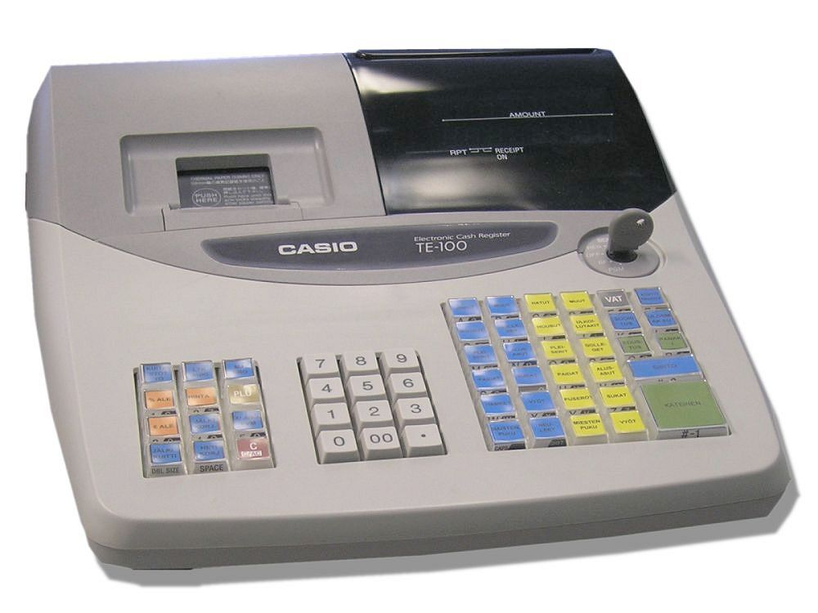
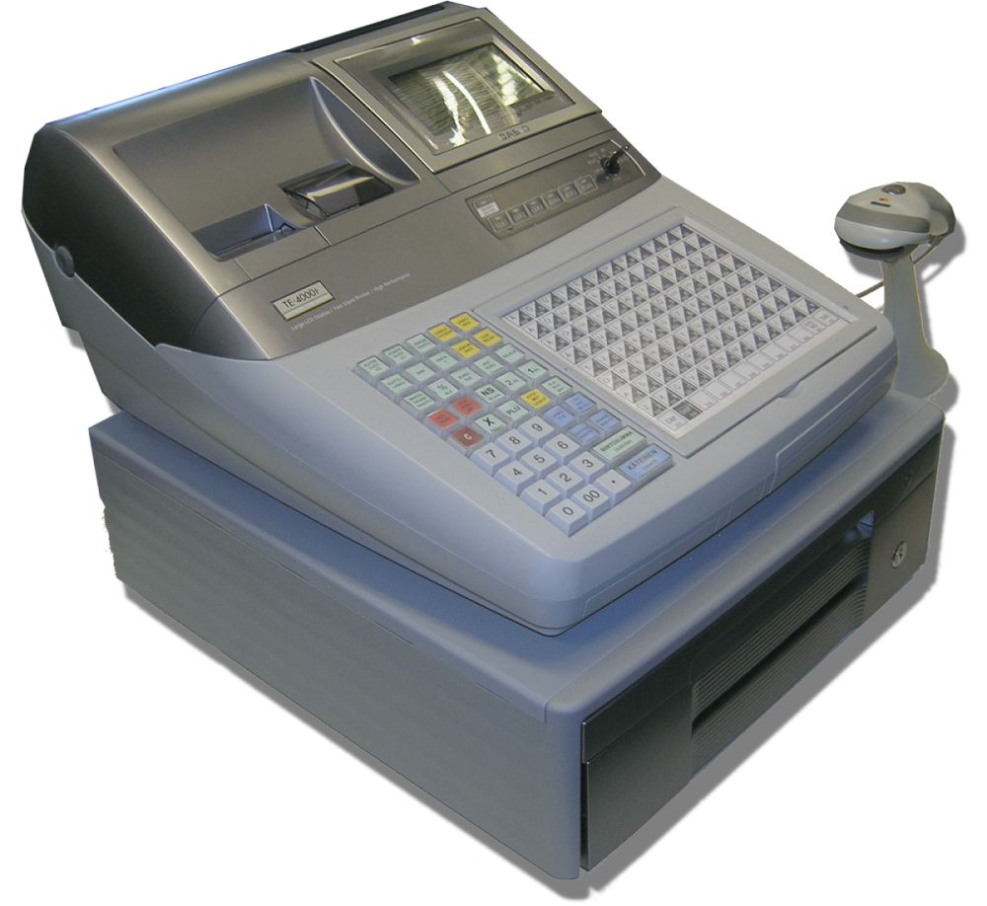

bbbb

Vocational Qualification: Business and Administration

Degree: Business College Graduate

Topic: Cash System Based On It

Bilingual Teaching at Vocational Colleges

Sample Module

ACTION PROGRAMME OF THE EUROPEAN UNION
LEONARDO DA VINCI-PILOT PROJECT
Project No.:2002 LA 112 628 BILVOC
BILINGUAL TEACHING AT VOCATIONAL COLLEGES

Teaching Module

Date of production March 2004; updated April 2005

Subject Marketing and Data Processing

Title Cash System in a Supermarket

Topic Cash System Based on IT

Target Group Students in Vocational Business Studies

Prior Knowledge To Understand a Cash System Based on IT

Level of Language Skills B 1

Follow-Ups How to Order Articles to a Market

Objectives The Students Will Be Able to Work as Check-out-Persons

Benefits The Students Will Be Able to Work in an Office of a Supermarket

RAAHE BUSINESS COLLEGE

Cash system based on IT- technology

Teaching time | Contents | Activities | Media | Teaching method | Skills
45 minutes | system of totality | writing and asking | transparency | teacher explains | understanding system
45 minutes | benefits to follow up sales of different articles | writing and discussion | writing after conversation | teacher and students | understanding system
45 minutes | planning of purchase | writing and discussion | writing after conversation | teacher and students | understanding system
45 minutes | planning of marketing | writing and discussion | writing after conversation | teacher and students | ready to visit a super market
After these lessons the students visit a supermarket with their teacher.

LESSON 1 The teacher explains what “a cash system based on IT-technology “ means.

The model of totality ( whole system )
- cash when a customer pays
- computer system in an office of a supermarket
- follow up sales
- connections to suppliers of goods

LESSON 2 The totality of different articles in a supermarket and the influence of each article on sales numbers. Total sales and figures of different articles. Assortments and ranges.
Sales coverage.

LESSON 3 The importance of ordering the right goods to a supermarket.
Direct connections to suppliers today.

LESSON 4 Planning marketing based on knowledge of cash system.
Efficiency of advertising, image of company, quality
and prices.

These lessons have been planned for the visit of the Hungarian students to Finland.

Vocabulary
Important words
- Sales shares of different article groups and articles
- Product assortments and ranges
- Gross profit and gross revenue target
- Average purchase
- Cash press
- Right prices
- Follow up wastage
- Efficiency of workers
- Efficiency of advertising
- Profitable marketing
- Image of company, quality and prices
- Payment cards and credit cards
- Budget and statistics
- Follow up stock
- Invoicing and sales account receivable
- Purchase and follow up purchase account payable

Vocabulary
Tärkeitä sanoja - eri tuoteryhmien ja tuotteiden myyntiosuudet
- lajitelmat ja valikoimat
- bruttotuotto ja myyntikate
- keskiostos
- kassapaine
- oikeat hinnat, EAN-koodi
- hävikin seuranta
- työtehokkuus
- mainonnan teho
- kannattava markkinointi
- yrityskuva, laatu-hinta-suhde
- maksukortit
- budjetointi ja tilastointi
- varaston seuranta
- laskutus ja myyntisaamiset
- ostot ja ostolaskut

Sales comprises different article groups and articles. An article group is the whole product totality e.g. beverages and foodstuff. An article always belongs to some article group e.g. lemonade belongs to beverages and tunny belongs to foodstuff. Product assortments and ranges refer to the products that are available in supermarkets and how the products are assorted.

Gross profit is the profit of a single product and gross revenue target is the profit of several products.

Average purchase refers to the a mean sum with which a customer buys.

Cash press refers to the number of cash points that are needed to be open in different days and in different hours.

EAN ( European article number ) is a fast way for customers to pay, and there will not be any errors.

Payment cards, also international credit cards are useful to customers. In a supermarket, one has to be very careful, when a customer pays with these cards. The system helps to know the available cards.

You can find out the wastage by following the stock and sales figures.

Efficiency of employees refers to the sales figures per one worker. The cash system helps to do the counting.

Advertising brings more customers. Keep an eye on the sales figures. Is marketing really profitable?
You must also remember the costs.

Image of a company is a very important issue. What does the company look like? Which price level does it have? What is the quality of the products?

A continuous follow-up provides necessary statistics for the assessment of sales results. Possible prospective changes for the next period are made on the basis of this information and data. Follow-up of stock is needed for additional orders. Now there is a system that the cash system program itself automatically order certain products.

Invoicing and sales account are receivables. A part of sales is done by invoicing, especially when a customer is a company. The more you have sales transactions, the more you have to send invoices. It is important to follow up sales account with the help of available figures.

Purchases and follow-up purchases are accounts payable. It is possible to pay the invoice after selling some of the merchandise that has been bought for retail.

Private practising

In our college we have for teaching a new cash system based on IT. Every student has possibilities to set new products and new prices into the programme. They learn the function of the system. At the same time they have customers (students from the group)
to serve.

Practising in our cafeteria

Every student shall work minimum one day in our cafeteria as check-out-person.

Job learning

Many students are as check-out-persons in supermarkets during their job learning.

Special things in teaching, very important to a check-out-person

Special rules concerning sales of alcohol and cigarettes

Shoplifters

Pools coupons
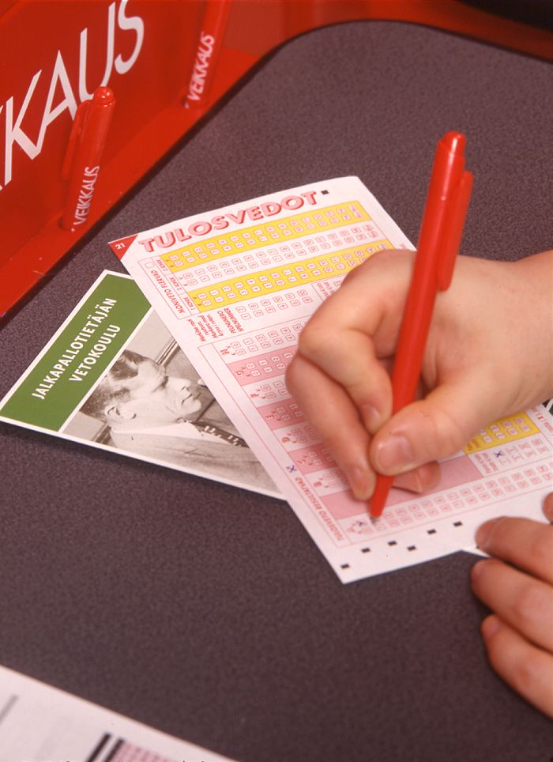

Payments cards
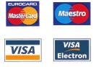

VAT Value Added Tax

