Bilingualer Fachunterricht an berufsbildenden Schulen

Unterrichtsmodul

Berufsfeld: Wirtschaft / Verwaltung

Beruf: Kaufmännischer Assistent für Informationsverarbeitung

Operating Systems

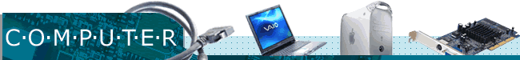

ACTION PROGRAMME OF THE EUROPEAN UNION
LEONARDO DA VINCI – PROJECT
PROJECT No.: 2002 LA 112 628 BILVOC

LANGUAGE COMPETENCE THROUGH BILINGUAL TEACHING AT VOCATIONAL COLLEGES

Teaching Module

Date of Production: | October 2003
Subject: | English for Computer Users
Topic: | Operating Systems (introductory lesson)
Title: | What is an operating system ?
Target Group: | Trainees and students who will have to be able to talk about computers and what one can do with them in their future job
Prior Knowledge: | Being able to use basic English words for computer hardware and software as well as a general knowledge of English
Level of Language Skills: | Threshold ( B1)
Follow-Ups: | None
Objectives: | Students should be able to understand and talk about basic ideas of operating systems
Unit Structure
Time | Contents | Teacher’s activities | Students’ activities | Media | Teaching method
10 min | introduction to the topic:  Describe what you can see on the transparency! | Show transparency on the OHP | look at transparency - describe what function an operating system has | transparency | classroom discussion
5 min | summary of results:  The Operating System – a definition | writes a definition of the term “operating system” on the board | take down the definition | blackboard,  copybooks | presentation teacher
5 min | finding examples:  Which operating systems can you think off? | gives students the task (question on the bottom of the transparency);  collects students’ ideas on the board | give examples and write them down in a brainstorming | blackboard, copybooks | classroom  discussion
35 min | How can operating systems be distinguished? – three examples | divides students into groups and gives them the texts 1, 2, or 3  (students who work quite slowly should receive the shortest text) | read their text and discuss it within the group (look up unknown words if necessary) | sheet of paper with texts, dictionaries | group work
35 min | How can operating systems be distinguished? | supervises presentation and corrects mistakes | present results and take notes | texts 1, 2, 3, copybooks, blackboard | presentation students, individual work
10 min | What do these commands stand for? | gives students the sheet of paper with the exercise | read the task and take notes | sheet of paper with exercise | individual work
15 min | Checking the correct answers on the PC | asks students to check their answers by using DOS and Windows on the computer | check their answers | computer, copybooks | individual work
5 min | Comparison of the results in class | asks students to read out their results | read out their results and discuss it if necessary | sheet of paper with exercise | classroom  discussion
5 min | Give your opinion on advantages and disadvantages of the operating systems DOS and Windows | asks students to give their opinion | give their opinion on this topic |  | classroom discussion
Verlaufsplanung
Zeit | Inhalte | Lehreraktivitäten | Schüleraktivitäten | Medien | Methoden
10 min | Hinführung:  Beschreiben Sie, was auf der Folie zu sehen ist! | Zeigt Folie auf OH-Projektor | schauen sich Folie an  beschreiben die Funktionen eines Betriebssystems | Folie | Unterrichtsgespräch
5 min | Zusammenfassung der Ergebnisse:  Das Betriebssystem – eine Definition | Schreibt eine Definition des Begriffes „Betriebssystem an Tafel“ | übernehmen Definition | Tafel, Übungshefte | Lehrervortrag
5 min | Finden von Beispielen:  Welche Betriebssysteme kennen Sie? | gibt Schülern die Aufgabenstellung ( Frage am Ende der Folie);  sammelt Schülerideen an Tafel | geben Beispiele und schreiben diese in einer Brainstorming- Phase auf | Tafel, Übungshefte | Unterrichtsgespräch
35 min | Wie können Betriebssysteme unterschieden werden?  3 Beispiele | teilt Schüler in Gruppen ein und gibt ihnen die Texte 1 , 2 oder 3  ( Schüler, die langsam arbeiten, sollten den kürzesten Text erhalten)  divides students | Lesen ihre Texte und diskutieren sie in der Gruppe ( schauen, wenn notwendig, unbekannte Wörter nach) | Arbeitsblätter mit Texten, Wörterbücher | Gruppenarbeit
35 min | Wie können Betriebssysteme unterschieden werden? | leitet Präsentation und korrigiert Fehler | präsentieren Ergebnisse und machen sich Notizen | Texte 1,2,2, Übungshefte, Tafel | Schülervortrag, Einzelarbeit
10 min | Wofür stehen diese Befehle? | gibt Schülern Arbeitsblatt mit der Übung | lesen Aufgabenstellung und machen Notizen | Arbeitsblatt mit Übung | Einzelarbeit
15 min | Überprüfung der richtigen Antworten am PC | bittet die Schüler, ihre Antworten zu überprüfen indem sie DOS und Windows am Computer benutzen | Überprüfen ihre Antworten | PC, Übungshefte | Einzelarbeit
5 min | Vergleich der Ergebnisse | Bittet Schüler, ihre Ergebnisse vorzulesen | lesen ihre Ergebnisse vor und diskutieren sie, wenn es notwendig ist | Arbeitsblatt mit Übung | Unterrichtsgespräch
5 min | Stellen Sie Ihre Meinung zu den Vorteilen und Nachteilen der Betriebssystemen DOS und Windows dar. | bittet Schüler ihre Meinung zu äußern | äußern ihre Meinung zu dem Thema |  | Unterrichtsgespräch
Appendix

Transparency

What is the function of the operating system?
Look at these pictures and describe it in your own words, please!

Peripherals
(printer, mouse,
keyboard, etc.)
Applications /
programs
(word processors,
databases, etc.)

USER
Computer
(CPU, main memory)
Which operating systems can you think of?
Give as many examples as possible, please!
OPERATING SYSTEM

Blackboard/copybooks:

Definition:

An operating system is those procedures which control the hardware and software resources within a computer system. It can be described as a set of programs and files that supervises the running of other programs and that controls all the elements that the user can see, e.g. applications, peripherals.

Brainstorming: (blackboard/copybooks)

JavaOS (JavaSoft)
Microsoft Windows
MS-DOS
OS/2 Warp (IBM)
EXAMPLES OF OPERATING SYSTEMS

Mac OS

LINUX

Solaris

UNIX

Text 1 WINDOWS
(source: http://members.fortunecity.com/pcmuseum/windows.htm -
abbreviated and modified)
Microsoft first began development of the Interface Manager (subsequently renamed Microsoft Windows) in September 1981. Although the first prototypes used Multiplan and Word-like menus at the bottom of the screen, the interface was changed in 1982 to use pull-down menus and dialogs. Microsoft finally announced Windows in November 1983. Windows promised an easy-to-use graphical interface, device-independent graphics and multitasking support.
The development was delayed several times, however, and the Windows 1.0 hit the store shelves in November 1985.
Windows 1.0 package, included: MS-DOS Executive, Calendar, Cardfile, Notepad, Terminal, Calculator, Clock, Reversi, Control Panel, PIF (Program Information File) Editor, Print Spooler, Clipboard, RAMDrive, Windows Write, Windows Paint.
Windows 1.0
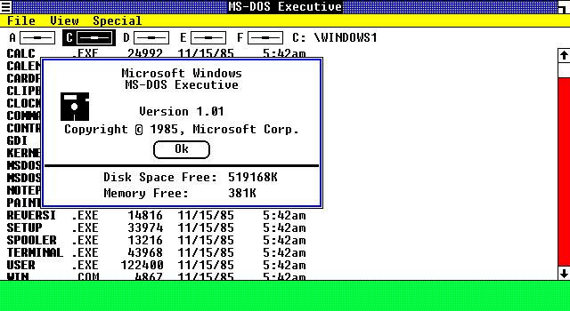
Windows 3.1, released in April, 1992 provides significant improvements to its previous version Windows 3.0 (released in May 1990).
Windows 3.1
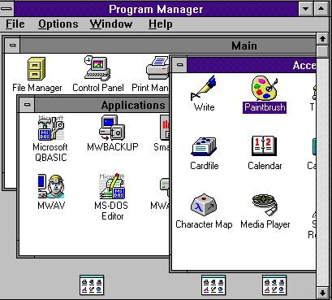
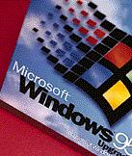 | Windows 95, released in August of 1995. A 32-bit system providing full pre-emptive multitasking, advanced file systems, threading, networking and more. Includes MS-DOS 7.0, but takes over from DOS completely after starting. Also includes a completely revised user interface.
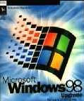 | Windows 98, released in June of 1998. Integrated Web Browsing gives your desktop  a browser-like interface. Active Desktop allows you to setup your desktop to be  your personal web page, complete with links and any web content. Internet  Explorer 4.0 was a new browser that supports HTML 4.0 and has an enhanced  user interface. The system includes Outlook Express for e-mail, NetMeeting c  conferencing software, a chat program and a Web-page editor.  Furthermore, ACPI supports OnNow specs for better power management of PCs.  Multiple Display Support can expand your desktop onto up to 8 connected monitors.  New Hardware support supports the latest technology such as DVD, Firewire, USB,  and AGP.

Feb. 17 2000, Windows 2000 provides an impressive platform of Internet, intranet, extranet, and management applications that integrate tightly with Active Directory. You can set up virtual private networks - secure, encrypted connections across the Internet - with your choice of protocol. You can encrypt data on the network or on-disk. You can give users consistent access to the same files and objects from any network-connected PC. You can use the Windows Installer to distribute software to users over the LAN. It was mainly designed for business uses. | 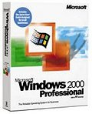
Thursday Sep. 14, 2000 Microsoft released Windows Me, short for Millenium Edition, which is aimed at the home user. The Me operating system boasts some enhanced multimedia features, such as an automated video editor and improved Internet plumbing. But unlike Microsoft's Windows 2000 OS which offers advanced security, reliability, and networking features Windows Me is basically just an upgrade to the DOS-based code on which previous Windows versions have been built. | 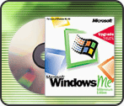

WINDOWS XP | Microsoft officially launches it on October 25th. 2001.
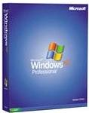 | XP is an update to all Windows versions for consumers. Naturally it has a new visual design and several new features that no previous version of Windows has, but it also doesn't ignore the past--old DOS and Windows programs will still run, and may even run better. XP comes in two versions: Home and Professional. It offers support for the latest technologies.
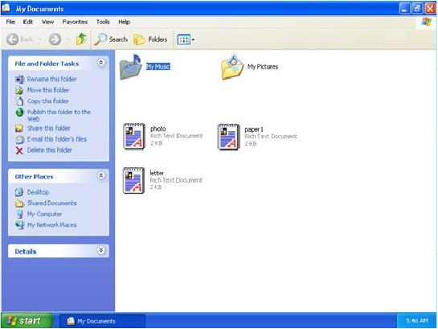
Text 2 UNIX
(source: http://hsrl.rutgers.edu/ug/unix_history.html - abbreviated and modified)

HISTORY OF UNIX AND REASONS FOR ITS POPULARITY
UNIX was originally developed at Bell Laboratories as a private research project by a small group of people starting in 1969. This group had experience with a number of different operating systems research efforts in the 1970's. The goals of the group were to design an operating system to satisfy the following objectives:
- To be simple and elegant
- To be written in a high level language rather than assembly language
- To allow re-use of code
Typical vendor operating systems of the time were extremely large and all written in assembly language. UNIX had a relatively small amount of code written in assembly language (this is called the kernel) and the remaining code for the operating system was written in a high level language called C.
The group worked primarily in the high level language in developing the operating system. As this development continued, small changes were necessary in the kernel and the language to allow the operating system to be completed. Through this evolution the kernel and associated software were extended until a complete operating system was written on top of the kernel in the language C.

UNIX APPLICATION PROGRAMMING INTERFACE
Many proprietary operating systems have a simplified view of application behaviour. The typical application reads some data from disk, tape or a terminal and does some processing. Output is produced onto disk, tape, terminal, or printer. The operating systems generally provide easy-to-use, well-implemented facilities to support these types of facilities.
As applications become more sophisticated they need new features such as network access, multi-tasking, and interprocess communications. In traditional operating systems, these features are often hard to use, not well documented, and only callable from assembly language. When a program makes use of these features, the program may be much more complex and much more difficult to maintain.
In UNIX because the C language was written to be used to implement an operating system rather than a traditional "input-processing-output" application, use of these sophisticated features is quite easily done from the C language without writing any assembly language. In addition, the documentation for these sophisticated features is in the same format and location as the documentation for the normal application calls. The pattern of development in UNIX when adding new features such as multi-tasking or networking is to provide an application program interface from the C language to access the new features.
In general UNIX system developers and application developers program in the same language using the same application programming interface. This is usually different. An assembly language would be used for programming and application developers would not have access to many capabilities. UNIX also became an operating environment for software development, available for any type of machine, from IBM PS/2s to Macs to Cray supercomputers. UNIX is also the most commonly used system for advanced CAD programs.

UNIX NETWORKING
In 1984, the University of California at Berkeley released version 4.2BSD which included a complete implementation of the TCP/IP networking protocols. Systems based on this and later BSD releases provided a multi-vendor networking capability based on Ethernet networking. The networking support included remote login, file transfer, electronic mail, and other important features. As UNIX was ported onto more and more different types of computer hardware the UNIX networking allowed many different types of systems to share and mutually use data. Networks consisting of many different systems could be used as a large distributed system.

UNIX POPULARITY
There are three primary causes for UNIX's popularity:
- Only a very small amount of code in UNIX is written in assembly language. This makes it relatively easy for a computer vendor to get UNIX running on their system. UNIX is nearly the unanimous choice of operating system for computer companies started since 1985. The user benefit which results from this is that UNIX runs on a wide variety of computer systems. Many traditional vendors have made UNIX available on their systems in addition to their proprietary operating systems.
- The application program interface allows many different types of applications to be easily implemented under UNIX without writing assembly language. These applications are relatively portable across multiple vendor hardware platforms. Third party software vendors can save costs by supporting a single UNIX version of their software rather than four completely different vendor specific versions requiring four times the maintenance.
- Vendor-independent networking allows users to easily network multiple systems from many different vendors.

Text 3: LINUX
(source: http://members.fortunecity.com/pcmuseum/windown.htm - abbreviated and modified)
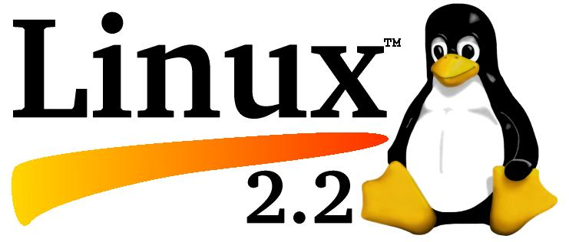

A Brief History of Linux
Linux is a UNIX-like operating system that is largely (and increasingly) POSIX-compliant. It was first written by Linus Torvalds, who started in 1991 with the idea of learning the capabilities of an 80386 processor for task switching. Originally named Freax , it was originally hosted using the Minix operating system. Linus' complaints with Minix were that it was written:
- As an academic/educational operating system
- To be portable using only the lowest common denominator features.
Both of these design assumptions seemed crippling, sacrificing performance for academics. The assumptions for Linux have changed slightly since then; portability now is a goal, and it is certainly not simply an ``academic'' requirement for software. It notably moved up on the priority list when Digital Equipment Corporation (now a Compaq company ) gave Linus an Alpha-based system; today there are commercial enterprises actively selling and supporting products based on the various ports to IA-32, PowerPC, MIPS , Alpha, and ARM architectures.
Since that time thousands of people have contributed patches, fixes, and improvements to the kernel, adding improved performance and support for many devices and file systems, as well as an increasing variety of platforms.

The Development Process
Linux is being developed under the GPL, and thus is freely redistributable in source codeform. It is particularly notable as an operating system truly developed over the Internet. Many of those who have participated in its development are in different countries, and most have never physically met. This bazaar-like ``peer review'' at a source code level on an exceedingly wide scale has led to it becoming a remarkably featureful and stable system.
There is an experimental set of OS versions (currently the 2.5. x series) where version numbers move steadily upwards on a weekly basis; the ``stable'' edition (e.g. 2.2.10) changes only as a result of bugs being found and fixed in the ”experimental'' series, and hence does not change nearly as often.
Linux users acknowledge system bugs, and quickly work to resolve them. As a result, security problems tend to be very quickly solved. There obviously is no guarantee that all users will immediately fix their systems if they are not being affected (or don't notice that they are affected) by problems, but certainly fixes are quickly available, sometimes distributed across the Internet within hours of being detected. Work is ongoing on creating highly stable Linux systems; properly configured Linux kernels with suitably configured software on top of that commonly run for hundreds of days without any need to reboot.
Key: (blackboard/copybooks)
The notes the students take down will differ. This is just a suggestion of notes which the class could agree on. They will be written on the blackboard and every student will take some notes into his/her copybook to be able to distinguish between different operating systems.

Windows:
Examples for versions:
Windows 98
- internet access becomes part of the user interface
- active desktop makes it possible to find information easily with the same view of content on your PC, network or the Web
- system includes Outlook Express for e-mail, NetMeeting conferencing software, a chat program and a Web-page editor
- it offers USB and multimedia extensions
Windows XP
- is an update to all Windows versions
- new visual design
- more secure and reliable
- offers support for the latest technologies

Unix:
- designed by Bell Laboratories for minicomputers and workstations
- widely adopted by many corporate installations
- first designed to be a multi-tasking system
- written in C language
- has become operating environment for software development
- available for any type of machine (e.g. IBM, Macs)
- most commonly used system for advanced CAD programs

Linux:
- is an open source
- cooperatively-developed
- multi-tasking operating system
- used as high value, fully-functional UNIX workstation for applications from Internet Servers to reliable work group computing
Exercise:
Match these commands on the left with the explanations on the right. Some commands are abbreviations of English words. Then decide which ones are DOS and which ones are Windows commands.

Command | Description | DOS/Windows
1 FORMAT | a) erases files and programs from your disk
2 select all | b) copies all files from one floppy disk to another
3 CD (or CHDIR) | c) if you click this symbol it will open an existing file
4 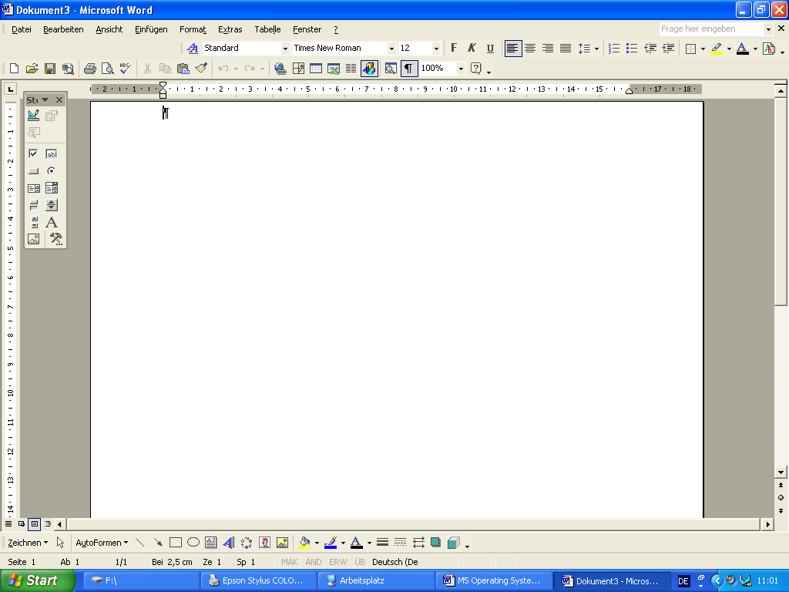 | d) changes your current directory
5 DIR | e) initializes a floppy disk and prepares it for use
6 DEL | f) saves the contents of the hard disk on floppy disks for security proposes
7 MD (or MKDIR) | g) displays a list of files of a disk or directory
8 DISKCOPY | h) marks all information
9 BACKUP | i) by clicking this your current link will be saved and you will be able to access it much faster next time
10 | j) creates a subdirectory
11 REN (or RENAME) | k) if you click this symbol it will print something
12 add to favourites | l) changes names of your files
13 | m) if you click this symbol it will save your data
Key:
DOS commands
1 e
3 d
5 g
6 a
7 j
8 b
9 f
11 l
Windows commands
2 h
4 c
10 m
12 i
13 k
Word list:

English | German
application | Anwendung
assembly language | Assemblersprache
bug | Programmfehler
CPU | Mikroprozessor
encrypt | chiffrieren
graphical interface | Grafikschnittstelle
high-level language | höhere Programmiersprache
input-processing-output | Eingabe – Verarbeitung - Ausgabe
interface | Anschlussstelle, Schnittstelle, Übergangsstelle
interprocess communication (or IPC) | Interprozesskommunikation
kernel | Kern, Nukleus (eines Programms)
multitasking or multi-tasking | Mehrprogrammverarbeitung, Multitaskbetrieb
operating system (or OS) | Betriebssystem
peripheral | peripheres Gerät, Peripheriegerät
platform | Hardwarebasis, Plattform
port | Anschluss, Standardschnittstelle, Steckanschluss
proprietary operating system | systemgebundenes (auch: proprietäres) Betriebssystem
reboot | wiederanlaufen (neu starten), Warmstart
vendor | Lieferant, Verkäufer, Anbieter

DOS and Windows are used here because the computers at school only provide these operating systems. Therefore, the students can check their solutions on a PC later on.
DOS and Windows are used here because the computers at school only provide these operating systems. Therefore, the students can check their solutions on a PC later on.

