Bilingualer Fachunterricht an berufsbildenden Schulen

Unterrichtsmodul

Berufsfeld: Wirtschaft und Verwaltung

Beruf: Bilingual Secretarial Students

Ordering Meals in Pubs and Restaurants

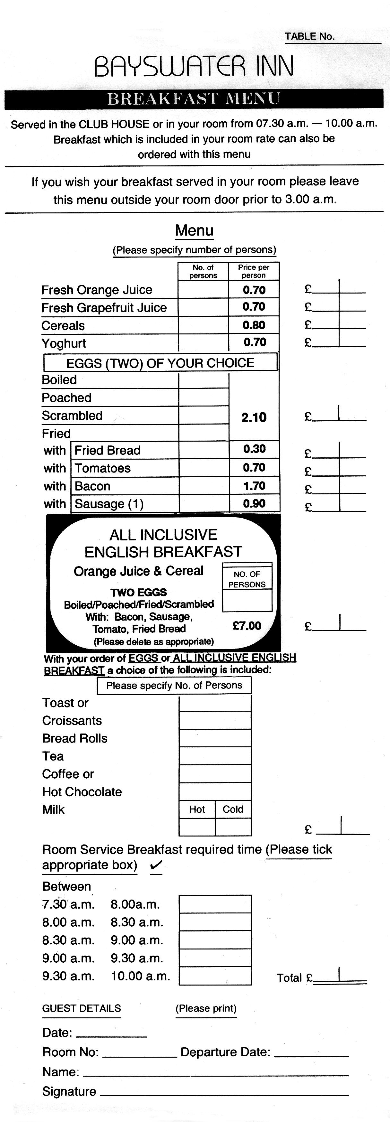

ACTION PROGRAMME OF THE EUROPEAN UNION

LEONARDO DA VINCI- PROJECT
PROJECT No.: 2002 LA 112 628 BILVOC
LANGUAGE COMPETENCE THROUGH BILINGUAL TEACHING AT VOCATIONAL COLLEGES

Teaching Module

Date of production: January 2004

Subject: Business Communication Course

Topic: Secretarial Activities

Title: Ordering Meals in Pubs and Restaurants

Target Group: Bilingual secretarial students

Prior Knowledge: None

Level of Language Skills: Threshold/ Vantage ( B1/ B2)

Follow-Ups: Making reservations at hotels and restaurants

Objectives: Students should know how to order meals in pubs and restaurants

Benefits: Students should be able to answer the following questions:

- When and where can I/we have meals?
- What meal/drink would I/we like to order?
- How can I help someone who does not understand the English or German menu properly
With the help of this module the students will be able to order meals in pubs and

restaurants. They will learn to find out when and where they can have their meals and they

will be able to compare prices and services. Furthermore they will be able to help other

people who do not speak the respective language to choose meals and drinks in a pub or

restaurant.
Unit Structure

Time | Content | Teacher’s activities | Student’s activities | Method | Media
5 minutes | Read the first task.  Where is the BAYSWATER INN situated ? | put transparency on the projector or uses map | find out where the hotel is situated | group work | transparency or map
10 minutes | Look into the leaflets “ Breakfast Menu” and find out what meals and services the hotel offers. | hand out leaflets | read leaflets, discuss in small groups | individual work, group work | leaflets
5 minutes | What problems do you have when reading the “ Breakfast Menu”? | answer questions | name words or items which caused problems | discussion | leaflets
15 minutes | Find the answers to the questions 1.1 to 1.3. | offer help | answer questions, explain their answers or correct wrong answers | individual work, questions and answers | copybooks, workshets
7 minutes | Read the second task. Where are Dover and Nottingham situated ? | put transparency on projector or uses map | find out where Dover and Nottingham are situated | group work | transparency or map, worksheets
10 minutes | Read the menu and find out what meals the “ Thirsty Farmer” offers. | hand out the menus | read menus and discuss in small groups | group work | menus, dictionaries (if necessary)
17 minutes | Find the answers to the questions 2.1 to 2.5. | offer help | submit answers and suggestions and discuss them | discussion | menus , worksheets
5 minutes | Read the third task and the German menu. | hand out the German menus | read task and menus | individual work | menus , worksheets
16 minutes | practising, control, correction | supervises presentation and correction | practise dialogues in pairs and correct their mistakes | pair work | menus

Verlaufsplanung
Zeit | Inhalte | Lehreraktivitäten | Schüleraktivitäten | Methoden | Medien
5 Minuten | Lesen der 1. Aufgabe  Wo befindet sich das BAYSWATER INN ? | Legt Folie auf Projektor oder benutzt Landkarte | finden heraus, wo sich das Hotel befindet | Gruppenarbeit | Folie oder Landkarte
10 Minuten | Anschauen der Broschüre “ Breakfast Menu” und Herausfinden der Gerichte, die dasd Hotel anbietet | gibt Broschüren aus | lesen Broschüren, diskutieren in kleinen Gruppen | Einzelarbeit, Gruppenarbeit | Broschüren
5 Minuten | Probleme beim Lesen des “Breakfast Menus” | beantworten Fragen | nennen Wörter oder Dinge, die ihnen Probleme bereitet haben | Diskussion | Broschüren
15 Minuten | Beantworten der Fragen 1.1 bis 1.3 | bietet Hilfestellung an | beantworten Fragen, erklären ihre Antworten und korrigieren falsche Antworten | Einzelarbeit, Unterrichtsgespräch | Hefte, Arbeitsblätter
7 Minuten | Lesen der 2. Aufgabe,  Herausfinden, wo sich Dover und Nottingham befinden | legt Folie auf Projektor oder benutzt Landkarte | finden heraus, wo sich Dover und Nottingham befinden | Gruppenarbeit | Folie oder Landkarte, Arbeitsblätter
10 Minuten | Lesne der Speisekarten und Herausfinden , welche Gerichte der “ Thirsty Farmer” anbietet | gibt Speisekarten aus | Lesen Speisekarten und diskutieren in kleinen Gruppen | Gruppenarbeit | Speisekarten, Wörterbücher (wenn notwendig)
17 Minuten | Finden der Antworten zu den Fragen 2.1. bis 2.5. | bietet Hilfestellung an | unterbreiten Vorschläge und diskutieren sie | Diskussion | Speisekarten, Arbeitsblätter
5 Minuten | Lesen der 3. Aufgabe und der deutschen Spiesekarte | gibt deutschen Speisekartena aus | lesen Aufagbenstellung und Speisekarten | Einzelarbeit | Speisekarten, Arbeitsblätter
16 Minuten | Übung, Kontrolle, Korrektur | leitet Präsentation, Korrektur | üben Dialoge und korrigieren ihre Fehler | Partnerarbeit | Speiskarten

Appendix

Ordering Meals in Pubs and Restaurants

Imagine the following situations and solve the tasks below.

1 You are on business in London and are staying in the BAYSWATER INN, a hotel
in the centre of London. During the day you are busy and have your meals in
restaurants in the city, but you always have your breakfast in Bayswater Inn.
Now answer these questions and do these tasks.

  - When and where can you have your breakfast?

1.2 What will you order for breakfast for the first and second morning?
(Make a short list and find out what price you are expected to pay.)

  - The morning you leave the hotel you wish your breakfast served in your hotel room. What are you expected to do?

2 This time you are on a business trip to Britain by car. You are on your way from
Dover to the north of England and feel hungry. Near Nottingham you have noticed a sign of the "Thirsty Farmer", a cheap restaurant near the open-air museum "The World of Robin Hood". You decide to stop there and have a meal. Look at the questions and answer them.

2.1 What time does the "Thirsty Farmer" serve meals?

2.2 Why is this restaurant really cheap?

2.3 What do you get with your meals?

2.4 What meal would you like to order?

2.5 Your boss, who accompanies you on this trip, has problems when reading the
menu and asks you for help. Explain her/him the meals and give recommen-
dations.

3 In our college students and teachers can also get their meals during the week.
Each week there is a different menu. From time to time foreign guests visit our
college. Some of them don't speak German but English. Help them with the
German menu and explain the dishes so that they finally know what to order.
Here are some words to help you.
Mühlhäuser Schulspeisung GmbH

Speiseplan

für die Woche vom 15.03. bis 19.03.

Montag, den 15.03.

Essen I Zigeunerhacksteak mit Reis und Salatbeilage 2,50 €
Essen II Hähnchenschnitzel mit Fingermöhren und Salzkartoffeln 3,00 €
Essen III Tagessuppe 1,75 €

Dienstag, den 16.03.

Essen I Schinkennudeln mit Tomatensoße und Obst 2,00 €
Essen II Schlachteplatte auf Sauerkraut und Salzkartoffeln 3,00 €
Essen III Tagessuppe 1,75 €

Mittwoch, den 17.03.

Essen I Schweinekammbraten mit Mischgemüse und Kartoffelbrei 3,00 €
Essen II Reisbrei mit Zucker, Zimt und Kompott 1,75 €
Essen III Tagessuppe 1,75 €

Donnerstag, den 18.03.

Essen I Hefeklöße mit heißem Obst 1,75 €
Essen II Herzragout mit Kartoffelbrei und Salatbeilage 2,50 €
Essen III Tagessuppe 1,75 €

Freitag, den 19.03.

Essen I Marinierter Hering mit Salzkartoffeln und 1 Pudding 2,50 €
Essen II Grüne Bohnensuppe und 1 Pudding 1,75 €
Essen III Nudeln mit Wurstgulasch 2,00 €

Änderungen vorbehalten !

G U T E N A P P E T I T

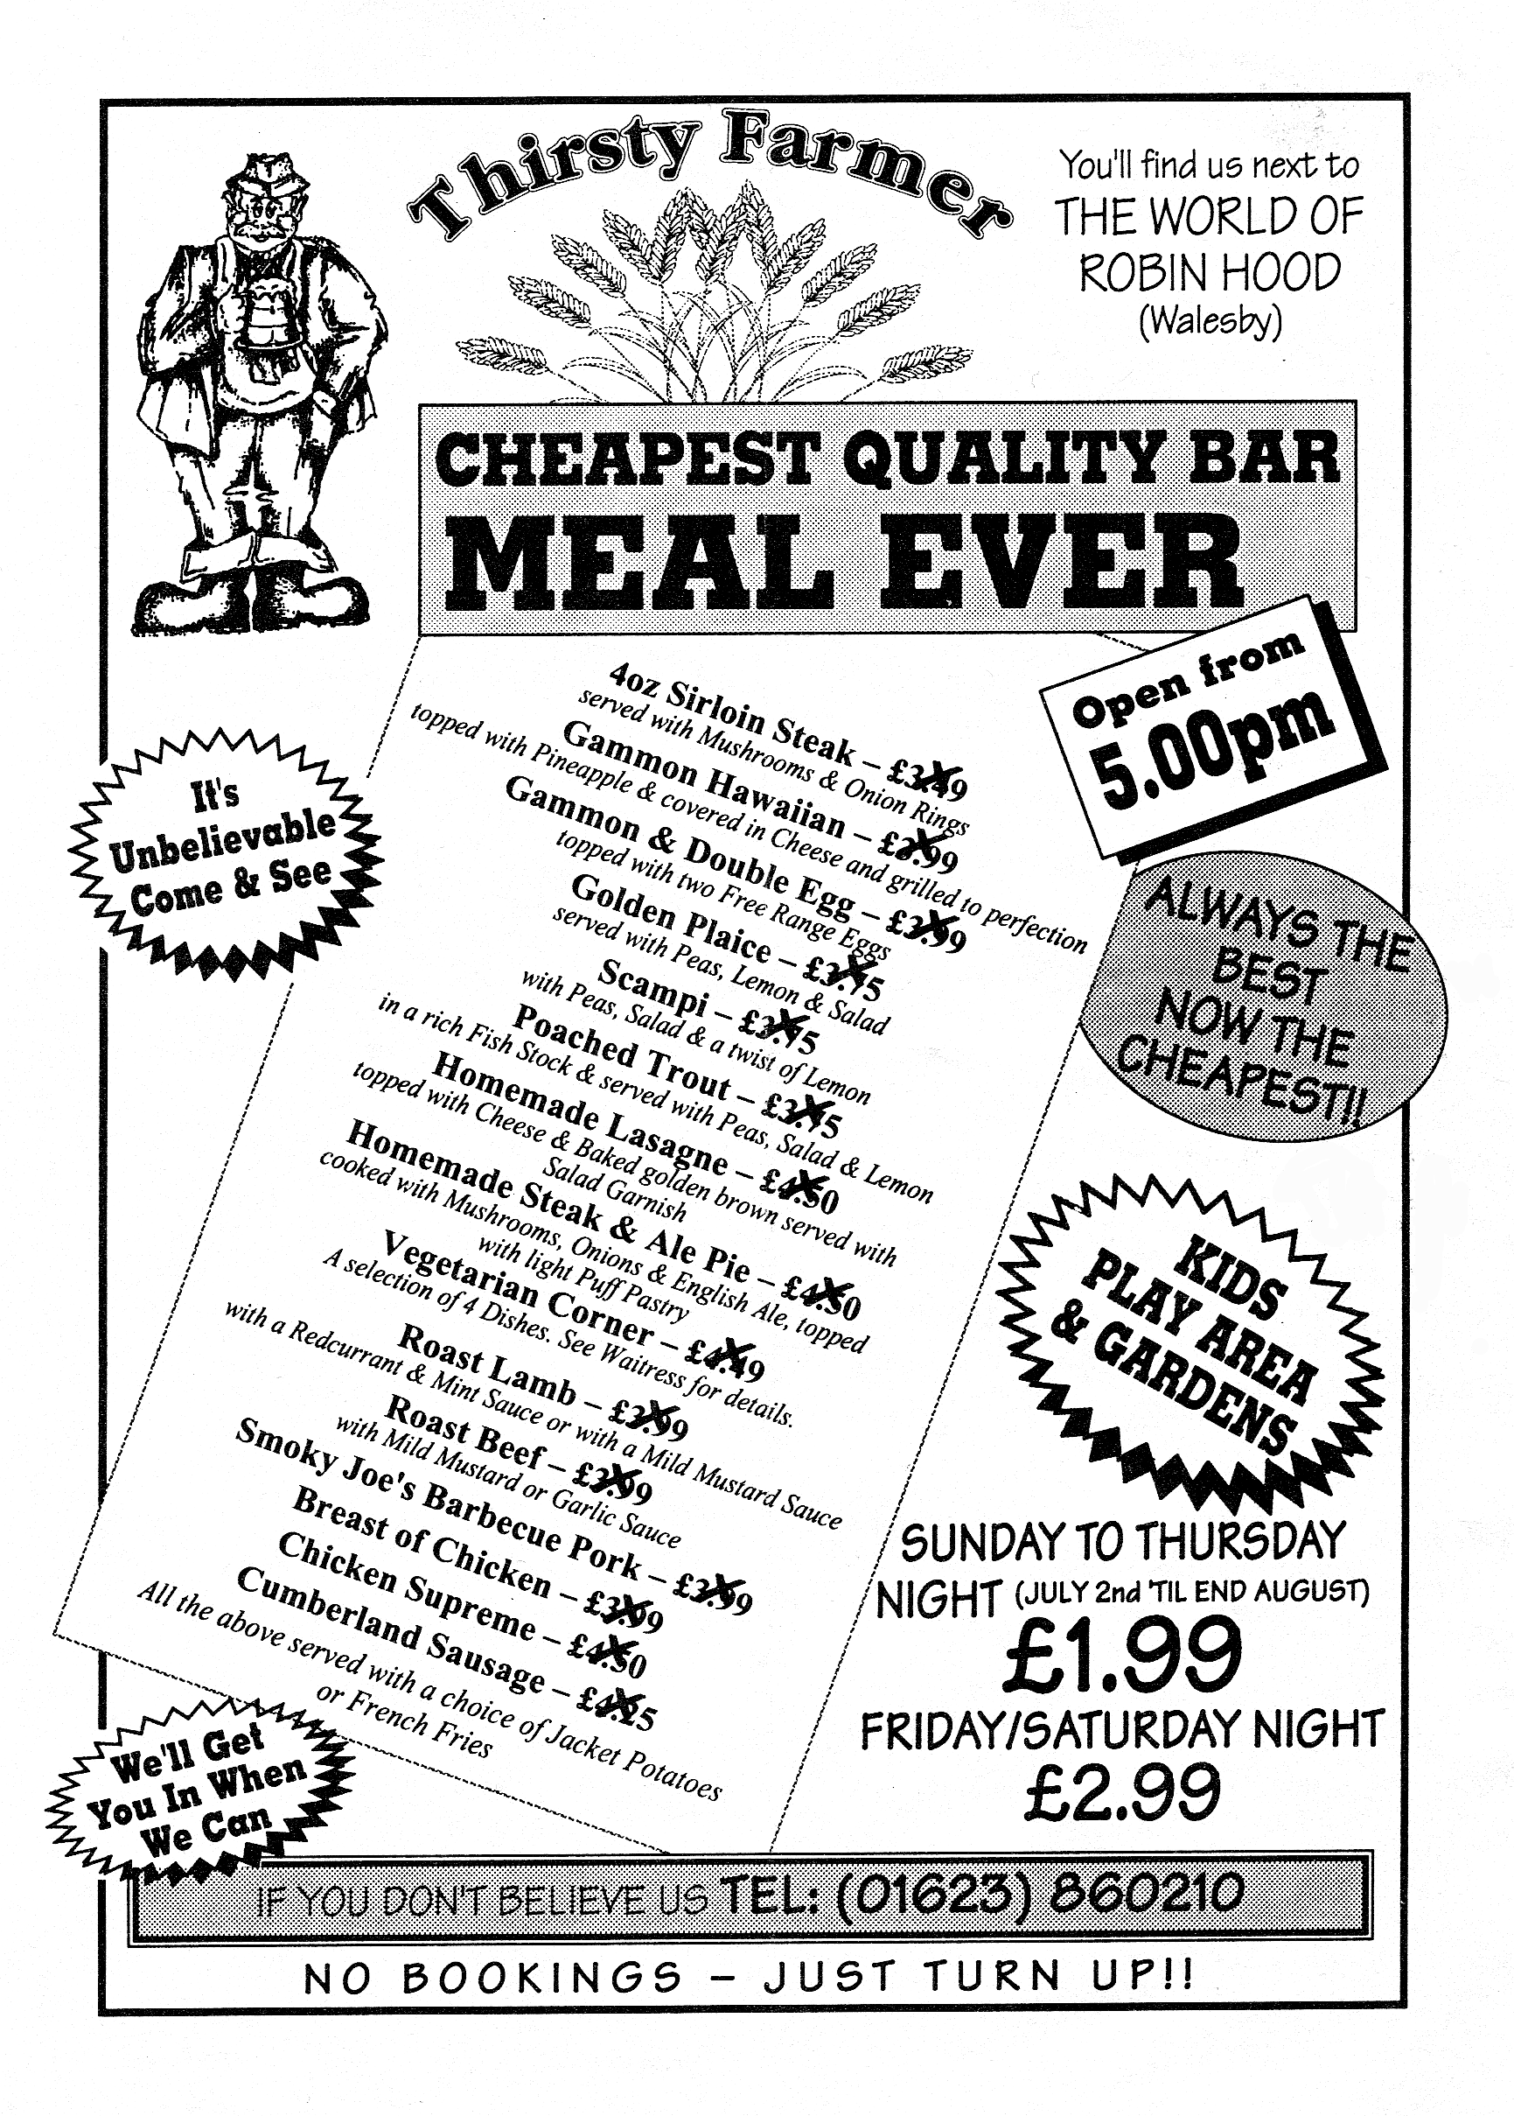

Vocabulary

- Zigeunerhacksteak gypsy steak made with minced meat

- Hähnchenschnitzel chicken escalope

- Schinkennudeln noodles with ham

- Schlachteplatte auf Sauerkraut ham and German sausages, made with
meat from freshly slaughtered pigs, served with sauerkraut

- Schweinekammbraten roast spare ribs (roast pork)

- Reisbrei / Zimt creamed rice / cinnamon

- Hefeklöße yeast dumplings

- Herzragout heart ragout

- Kartoffelbrei mashed potatoes

- Marinierter Hering pickled hering

