Bilingualer Fachunterricht an berufsbildenden Schulen

Unterrichtsmodul

Berufsfeld: Monoberuf

Beruf: Augenoptiker

Assembling eyeglasses


ACTION PROGRAMME OF THE EUROPEAN UNION
LEONARDO DA VINCI
PROJEKT NO.: 2002 LA 112 628 BILVOC
Language Competence Through Bilingual Teaching at Vocational Colleges

Teaching Modules

Date of production 09/2005

Subject: optics technology

Topic: Eyeglasses

Title: Assembling eyeglasses

Target Group: Optician students, 2nd year

Prior Knowledge: Basic of optics technology

Level of Language Skills: Waystage (A2)

Follow - Ups: refraction

Objectives: Students get an overview on
techniques and devices / tools for
assembling glasses

Benefits: Students should be able to get
information out of texts and take short
notes.They can speak and write about
a certain topic only with the help of
short notes.

Teaching Module: Assembling eyeglasses

Teaching time | Contents | Activities | Media | Teaching methods | Skills
45 minutes | 1. Vocabulary for assembling glasses  (parts of glasses,  vocabulary in the workshop) | Students label illustration,  compare results  Students study word list | Illustration of glasses  Dictionary  Word list | Individual work  Partner work | Using the dictionary, word list
45 minutes | 2. Steps of assembling glasses | Students read texts in groups  Students underline main facts  Students give summaries of text parts in German | Read excerpt  Word list / dictionary | Group work  (4 groups) | Reading skills  Marking skills  Translation skills
45 minutes | 3. Summary | Students label worksheets (activities, tools)  Students compare/ discuss results  Students (1 or 2) give summary of assembling glasses | Worksheet  Transparency | Classroom discussion  Presentation by students | Note- taking  Speaking skills
45 minutes | 4. Control / Test | Students take notes of steps and tools / devices of assembling glasses in tabular form |  |  | Summary writing
180 minutes

Techniques of assembling eyeglasses

In the optician’s workshop the standard size lenses, which are delivered in a raw round shape, have to be centred, grinded and bevelled before you can insert them into the frame. During this procedure only the edge of the lens is worked at. The front side of the lens and the back surface as well must not be damaged e. g. by scratches. There are two different ways of grinding lenses: by machine or by hand- but generally this operation is done by the automatic edging machine. After grinding and bevelling the lenses you can insert them into the frame professionally so that the product meets the standard required. No matter how accurate the visual examination / the refraction has been: if the lenses, either single vision, bifocal or multifocal, are improperly centred, grinded, inserted, aligned or adjusted, the finished product is of inferior quality.

1. Grinding lenses
At first you verify the correctness of the frame and the lenses as ordered and check their quality. Then you put the lenses into the focimeter one after the other to check lens power (sph and maybe cyl) and mark them at three points each. Before you can start grinding the lenses you must look for the right pattern. If there is no suitable pattern in stock, you have to make one yourself. After that you centre the lenses and suck them on. When the first lens is grinded, you bevel it and check its shape and size. If the result is satisfying, you turn the pattern round, put the second lens into the edging machine and repeat the procedure. As soon as both lenses are ready you can insert them into the frame.

2. Inserting a lens into a frame
Before inserting lenses into a plastic frame you have to heat the frame. Then you press the lenses into the eyewire one after the other and make sure that each lens is entirely in the groove of the eyewire. Be careful not to damage any part of the frame during that procedure.

Before inserting a lens into a metal frame you at first have to unscrew the eyewire of the frame. After adjusting eyewire and lens to each other and inserting the lens properly you screw on the eyewire and check the strain. At last you secure the screws so that they cannot get lost.

3. Aligning a pair of glasses
Next the frame has to be brought into a standard alignment. A frame in standard alignment has been adjusted to certain impersonal standards that are independent of the type of face it is to be fitted. A general rule for standard alignment is to begin with the bridge, then work with the endpieces and handle the temples last. Plastic frames must always be heated to be aligned. Metal frames and parts do not require heating, except metal parts that are covered with plastic.

4. Final check
Before you clean the finished eyeglasses a final check is necessary. Now you make sure that:
- the distance between the lenses’ optical centres and their height is correct,
- the lenses are secure in the frame,
- there is no strain on the lenses due to improper frame fit,
- the surfaces and the edges of the lenses are free of defects,
- the frame finish is free of scratches and discolouration,
- the temple hinges are secure and moving freely.
At last you place the eyeglasses in a protective case and contact the customer through mail or by telephone that the glasses are ready.

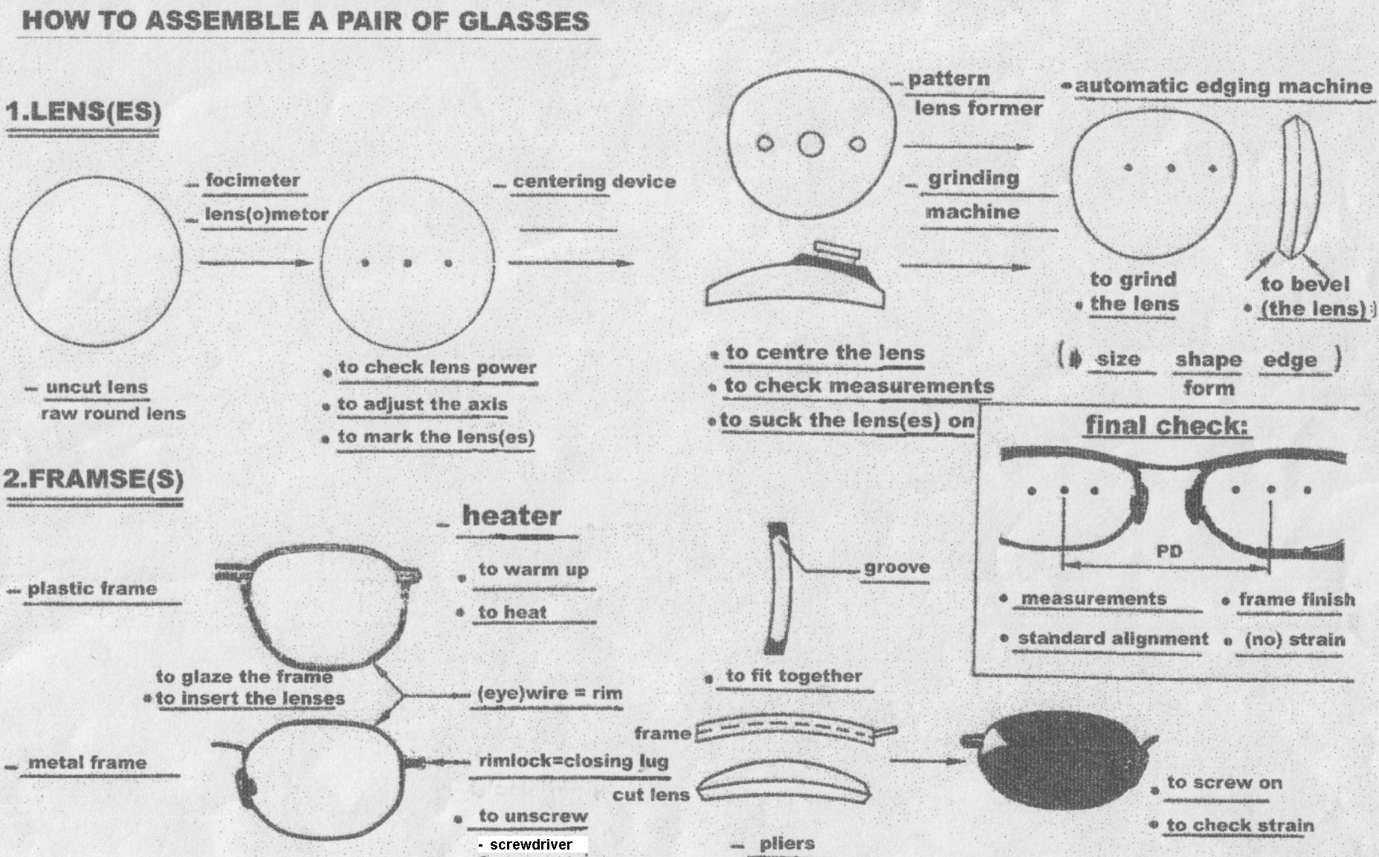

Parts of Glasses / Brillenteile

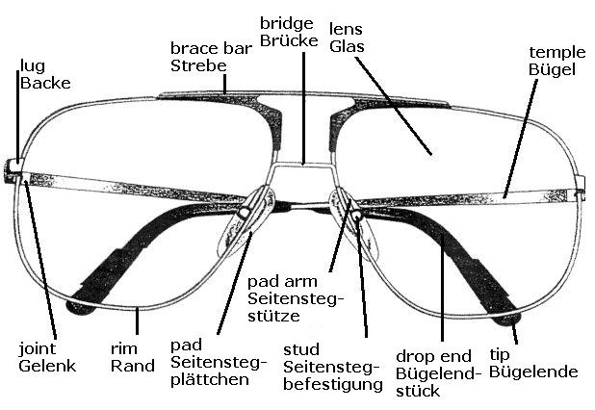

Parts of Glasses / Brillenteile

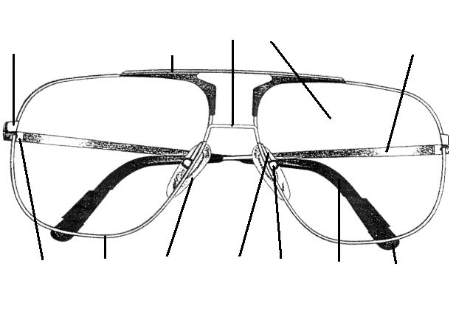

Word list for assembling glasses / Wortliste zur Brillenfertigung

Techniques | Techniken
to bevel | abkanten
to unscrew | aufschrauben
to point on | anpunkten
to mark | anzeichnen
to suck on | aufblocken
to align | ausrichten
to order | bestellen
to drill | bohren
to heat | erhitzen
to warm up | erwärmen
to form / to shape | formen
to measure | messen
to check | prüfen
to edge | randen
to groove | rillen
to grind | schleifen
to screw on | zuschrauben
to glaze | verglasen

Tools / Devices | Werkzeuge / Geräte
edging machine | Schleifautomat
screwdriver | Schraubendreher
lensmeter / focimeter | Scheitelbrechwertmesser
centering device | Zentriergerät
drilling machine | Bohrmaschine
frame heater | Erwärmungsgerät
pattern | Formscheibe
PD ruler | Pupillenabstandsmesser
lens groover | Rillgerät
grinding machine | Schleifmaschine
pliers | Zange

