Bilingualer Fachunterricht an berufsbildenden Schulen

Unterrichtsmodul

Berufsfeld: Wirtschaft und Verwaltung

Berufe: Bürokaufmann / Bürokauffrau / Kaufmännische Assistenten

Planning a Business Trip
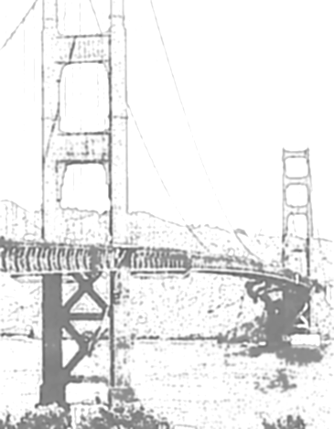

ACTION PROGRAMME OF THE EUROPEAN UNION

LEONARDO DA VINCI- PROJECT
PROJECT No.: 2002 LA 112 628 BILVOC
LANGUAGE COMPETENCE THROUGH BILINGUAL TEACHING AT VOCATIONAL COLLEGES

Teaching Module

Date of Production: July 2005

Subject: English for office clerks

Topic: Secretarial Activities

Title: Planning a Business Trip

Target Group: Trainees and employees working in an office, students involved
in office work

Prior Knowledge: none

Level of Language Skills: Threshold ( B1)

Follow – Ups: booking a room in a hotel

Objectives: Students should explain what is necessary when arranging a
business trip and they should decide on a suitable hotel.

Benefits: Students should be able to answer the following questions:
- What information would a businessman be interested in before arranging a business trip?
- What is a suitable hotel?
Unit Structure
Teaching time | Content | Teacher’s activities | Student’s activities | Methods | Media
15 minutes | Please have a look at this transparency and tell me which situation is shown in this picture? What do you think?  Could you two please read the little dialogue that describes the situation shown in the picture?  Imagine the following situation. You are working for a big company. Your boss is going to buy new computers for the whole company at Hewlett Packard in Silicon Valley. He is going to ask you to plan this business trip.  What information would a businessman be interested in before arranging a business trip? What is different from a tourist who is planning a trip?  Your first task will be to book a room in a suitable hotel. | put transparency on projector  hand out worksheets (dialogues)  write topic on blackboard  ask questions, supervise presentation | students describe the situation shown in the picture  two students read the dialogue  Students write down their ideas in cards, put them on the blackboard and explain their ideas | questions and answers  student’s presentation  teacher’s presentation  individual work, student’s presentation, questions and answers | transparency  worksheet (for two students)  blackboard  mind map
10 minutes | new words  matching exercise | Hand out worksheets, explain the task, offer help | work on the new words, use dictionaries ( if necessary) | Individual work | worksheets, dictionaries
10 minutes | comparison  Read the definition and match it with the right word. Start with the first definition. | correct ( if necessary) or let the students correct | compare their results, read the definitions and match them wit the new vocabulary | questions and answers | worksheet
10 minutes | As I said your company intends to organise a business trip to buy computers in Silicon Valley. To find a suitable hotel near Silicon Valley you’ve already written a letter to the office of the Californian Tourist Board to get some material about hotels in this region. You and your boss decided to stay in San Francisco for one week, because it is near Silicon Valley and because you can do some sightseeing in San Francisco. Your task will be to make a decision on a suitable hotel in San Francisco and to give reasons for your decision.  Therefore we need some phrases for giving reasons.  Useful phrases for giving reasons | explain the task  collect student’s ideas and complete them | listen  name phrases to express reasons, write them on blackboard | teacher’s presentation  questions and answers | cards, blackboard
30 minutes | Deciding on a suitable hotel  . | explain the task  offer help | form groups, read texts, decide on a suitable hotel, use dictionaries ( if necessary) | teacher’s presentation, group work, role play | poster  worksheet “information sheet“, group worksheet “deciding on a suitable hotel“
15 minutes | Deciding on a suitable hotel and giving reasons  Role plays  Present your boss your results. | supervise presentation, correct mistakes  put the introductory transparency again on the projector | Students present their group results and their role plays | student’s presentation, questions and answers, role plays | transparency

Veraufsplanung
Zeit | Unterrichtsinhalte | Lehreraktivitäten | Schüleraktivitäten | Methoden | Medien
15 Minuten | Schauen Sie sich die Folie an und beschreiben Sie, was dargestellt ist.  Lesen des Dialogs  Stellen Sie sich bitte folgende Situation vor. Sie arbeiten für ein großes Unternehmen. Ihr Chef möchte neue Computer bei Hewlett Packard im Silicon Valley kaufen. Er bittet Sie, eine Geschäftsreise zu organisieren.  Welche Informationen benötigt ein Geschäftsmann, bevor er eine Geschäftsreise arrangieren kann. Was ist der Unterschied zu einem Touristen.  Ihre erste Aufgaben wird darin bestehen, ein geeignetes Hotel zu finden | legt Folie auf den Projektor  gibt Arbeitsblätter aus  schreibt Thema an Tafel  leitet Unterrichtsgespräch | Schüler beschreiben dargestellte Situation  zwei Schüler lesen Dialog  Schüler bringen Ideen dar, schreiben Ideen auf Karten, heften diese an Tafel und erläutern sie | Lehrer- Schüler Gespräch  Lehrer- Schüler Gespräch  Lehrervortrag  Lehrer- Schüler Gespräch, Mind Map | Folie  Arbeitsblatt ( für zwei Schüler)  Stundenthema an die Tafel" planning a business trip "  Erstellen des Mind- Maps gemeinsam mit Schülern an Tafel
10 Minuten | neue Vokabeln  Zuordnungsübung | gibt Arbeitsblätter aus, erklärt Arbeitsaufgabe, bietet Hilfestellung an | Schüler erarbeiten neue Vokabeln, benutzen, wenn nötig, die Wörterbücher | Einzelarbeit | Arbeitsblatt, Wörterbücher
10 Minuten | Vergleich der Ergebnisse  Lesen Sie die Definition und ordnen Sie sie dem richtigen Wort zu. | korrigiert, falls Fehler auftreten | Schüler vergleichen ihre Lösungen mit gemachten Vorgaben | Lehrer- Schüler Gespräch | Arbeitsblatt
10 Minuten | Ihr Unternehmen beabsichtigt eine Geschäftsreise nach Silicon Valley durchzuführen. Um ein geeignetes Hotel in der Nähe von Silicon Valley zu finden, haben Sie bereits an das “ California Tourist Board “ geschrieben, um einige Materialien über Hotels in der Region zu bekommen.  Sie und Ihr Chef haben sich entschieden für eine Woche in San Francisco zu bleiben, weil es in der Nähe von Silicon Valley ist und weil es in San Francisco viele Sehenswürdigkeiten gibt  Ihre Aufgabe wird es sein, sich für ein geeignetes Hotel zu entscheiden und Ihre Entscheidung zu begründen..  Dafür benötigen Sie Redewendungen, um Gründe anzugeben.  Redewendungen um Begründungen auszudrücken | erläutert Aufgabenstellung  sammelt Schülerideen und ergänzt diese | hören zu  nennen Ausdrücke, um Begründungen zu geben und schreiben sie an Tafel, fehlende werden durch Lehrer ergänzt | Lehrervortrag  Lehrer- Schüler Gespräch | Metaplankarten, Tafel
25 Minuten | Entscheidung für geeignetes Hotel  . | erläutert Arbeitsaufgabe | bilden Gruppen, lesen Texte, entscheiden sich für ein geeignetes Hotel, schlagen unbekannte Wörter im Wörterbuch nach | Lehrervortrag  Gruppenarbeit, Rollenspiel | Plakat,  Arbeitsblatt “information sheet“, Gruppenarbeitsblatt “deciding on a suitable hotel“, Wörterbücher
20 Minuten | Entscheidung für Hotel und Begründung  Rollenspiele  Einstiegsfolie erneut auflegen  Tragen Sie Ihrem Chef ihre Ergebnisse vor. | leitet Präsentation, korrigiert | Schüler tragen ihre Gruppenergebnisse und ihr Rollenspiel vor | Schülervortrag, Lehrer- Schüler Gespräch, Rollenspiel | Folie

blackboard ( depends on the student’s answers)
Planning a business trip  to attend  conferences  passport maps  things you  business trip  need  dictionary | to attend meetings to visit  other  companies  reasons  to  book an  accommodation  things to  plan  to book to  arrange  a flight  activities | useful phrases for giving reasons  My choice would be... because  I’d take... because  I’d prefer ... because  I wouldn’t take ... because…  I wouldn’t be interested in…  because…  I’d suggest ... because

transparency
Are there any problems
with the computers? Let’s
go on a business trip to
buy some new ones !

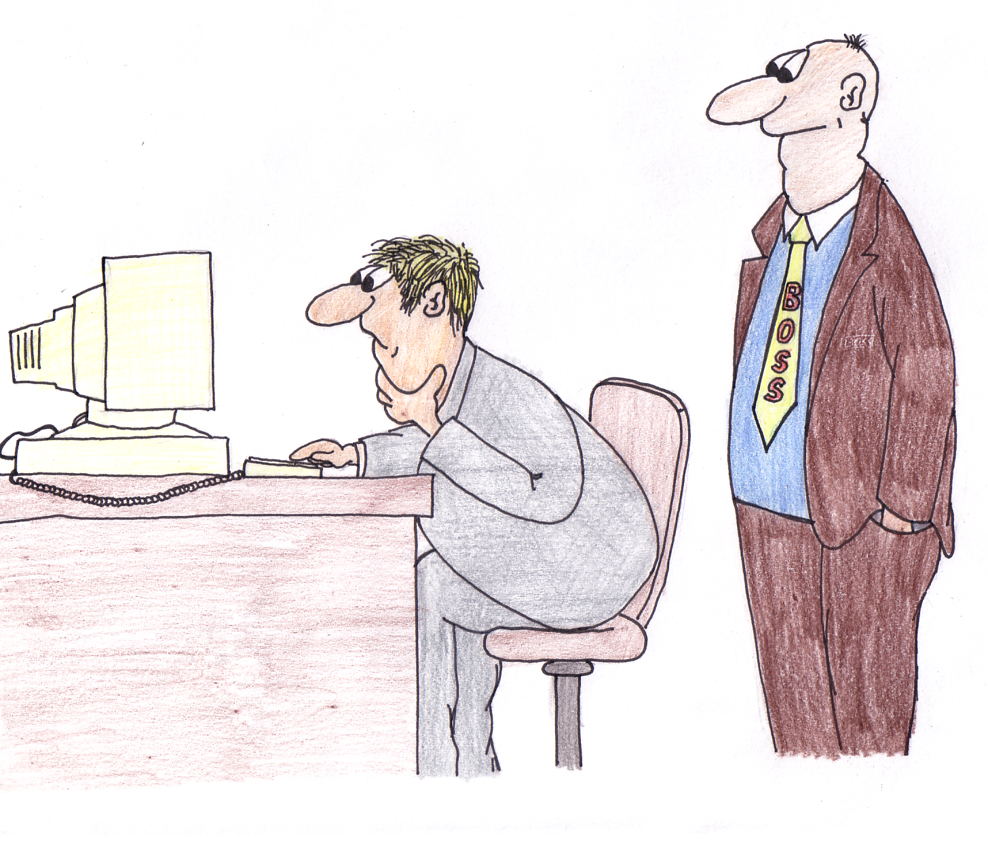
business trip ?

dialogue

Boss: Good morning Mr Meier. I heard there are problems with the
computers again.

Mr Meier: Good morning. It’s enough to drive you to despair. The
computers don’t work. They are too old and don’t have enough
memory capacity.

Boss: I know we have to buy new ones. Last week I spoke to the
manager of Hewlett Packard in Silicon Valley. He asked me and
some of the employees to come there to visit the company.
Moreover they are going to show us the latest developments in
the computer technology. That’s why our company or at least 15
of our best engineers should go on a business trip to Silicon Valley.
Mr. Meier I ask you to plan this business trip.

Mr Meier: Hmm…?. What do I have to do?

worksheet „ matching exercise“
 Match the words with the appropriate definition below!
direct dial-telephone

fax and photocopying facilities
adjoining rooms
to confirm
twin-bedded room
double room
room amenities

______________features of a room that makes life there easy or pleasant______________a piece of equipment or a service for the purpose of faxing and photocopying______________a room for one person only
______________a room for two people with a double bed
______________a room with equipment for conferences e.g. an overhead projector, a video recorder…______________a room with two single beds in it
______________a telephone you can phone someone directly with
______________accommodation plus breakfast plus dinner
______________accommodation plus breakfast plus lunch plus dinner______________rooms next to each other
______________the reserving of rooms in advance
______________to show that something is certainly true or will definitely happen

Arbeitsblatt „ matching exercise“
 Match the words with the appropriate definition below!
direct dial-telephone

fax and photocopying facilities
adjoining rooms
to confirm
room amenities
twin-bedded room
double room

room amenitiesfeatures of a room that makes life there easy or pleasantfax and photocopying facilitiesa piece of equipment or a service for the purpose of faxing and photocopyingsingle rooma room for one person only
double rooma room for two people with a double bed
conference facilitiesa room with equipment for conferences e.g. an overhead projector, a video recorder…twin-bedded rooma room with two single beds in it
direct dial- telephonea telephone you can phone someone directly with
half boardaccommodation plus breakfast plus dinner
full boardaccommodation plus breakfast plus lunch plus dinneradjoining roomsrooms next to each other
bookingthe reserving of rooms in advance
to confirmto show that something is certainly true or will definitely happen

poster
group work  25-30 minutes
task :
Read the “ information sheet” !
Use the given information to make your decision on a suitable hotel for your business trip.
Give reasons why you have decided in this way.
Make up a telephone conversation to book the rooms in the hotel.
one plays the role of Mr Meier who wants to book the rooms
one plays the role of the receptionist

Arbeitsblatt “ information sheet”
Renaissance Parc 55   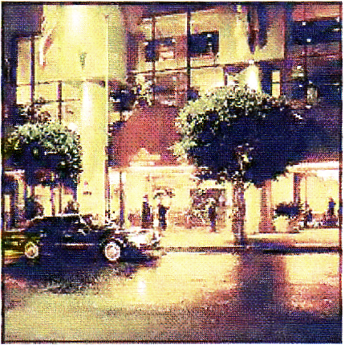  55 Cyril Magnin Street  Union Square Area  $ 98-132 | The Renaissance Parc 55 provides the ultimate in luxury and service. Located in the heart of San Francisco it is a hotel with beautiful event and meeting facilities. For those travelling on business, you will find that the rooms are ideal whether you are using them as an office or as a place to “get away from it all” after a hard day. The hotel offers several dining options and a bar. The hotel is minutes to fine dining, shopping and entertainment. The renaissance Parc 55 offers you a business and conference centre, fitness facilities, a sauna and several meeting facilities. The room amenities of all 52 newly renovated rooms are: air conditioning, direct dial telephone, fully socked mini-bars, an in- room safe, a modem and data port connection. All rooms are with panoramic city views.  ( airport shuttle $ 10 )
Holiday Inn Chinatown   “ Great location for business and leisure”    750 Kearny Street  6 blocks to Union Square  $ 84 -146 | The Holiday Inn Chinatown is a first class hotel in San Francisco. It is within walking distance of the city’s most famous attractions. The comfortable guest rooms feature a breathtaking view of San Francisco Bay or the city skyline. The Holiday Inn Chinatown is convenient to a multitude of fine dining, shopping and entertainment possibilities. The hotel is a good choice for both the business and the leisure traveller. The facilities include an outdoor heated pool, a restaurant, a business and conference centre and meeting facilities, extra meeting space, fitness facilities and a free airport shuttle. The Holiday Inn has 95 bedrooms with air conditioning, a direct dial telephone and a modem and data port connection. All rooms are non- smoking.
Canterbury   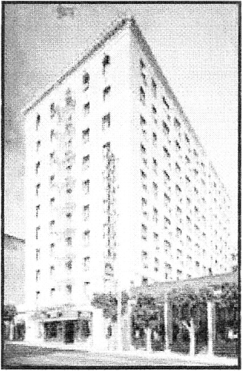  750 Sutter Street  Union Square  $ 90-115 (half board) | The Canterbury is a first class hotel in downtown, three blocks from the world famous Cable Cars and only a short distance to Union Square, theatres, nightlife and fine dining. It features a wonderful mix of elegance and style and all the comforts of home. The guest rooms are clean and comfortable. The hotel offers a full service restaurant and a bistro bar and 24 hour- fitness facilities, so come and enjoy. For the business traveller, the hotel features a business centre. Non-smoking guest rooms are available. The room amenities of all 250 rooms are air conditioning, a direct dial telephone. We offer to use our airport shuttle ( $ 15)

Arbeitsblatt: “ deciding on a suitable hotel”
Work sheet: deciding on a suitable hotel

The Californian Tourist Board has sent your company a lot of catalogues about hotels in San Francisco. The choice has been narrowed down to the three hotels described on the information sheet. Your boss has instructed you to choose between the three suggested hotels. To help you to make your choice he has provided you with the notes below.
number of rooms required: rooms for 15 personsdate: 1st to 5th Julyfacilities and amenities: conference facilities
meeting facilities
direct dial telephone
good restaurant
fully –licensed barcharges:maximum price: no more than 100 $
per person/ per nightlocation: pleasant surroundings
within easy reach to the airport

 Please fill in the following table:
criteria  hotel | number of rooms | facilities and amenities | charges | location

Vocabulary

accommodation | Unterkunft
half board | Halbpension
full board | Vollpension
facilities | Einrichtung, Möglichkeiten
single room | Einzelzimmer
double room | Doppelzimmer
amenities | Annehmlichkeiten, Vorzüge
adjoining rooms | Angrenzende Zimmer
twin- bedded room | Zweibettzimmer
to confirm | bestätigen

