ACTION PROGRAMME OF THE EUROPEAN UNION
LEONARDO DA VINCI
PROJEKT NO.: 2002 LA 112 628 BILVOC
Language Competence Through
Bilingual Teaching at Vocational Colleges

Teaching Module 3

Date of production: | October 2004
Subject: | Pneumatic generators
Topic: | Energetic units in pneumatics
Title: | Production of compressed air
Target Group: | Youths and workers whose professional profile is somewhat related to the use of pneumatics
Prior Knowledge: | Knowledge of teaching units 1 and 2
Level of Language Skills: | Intermediate English
Follow - Ups: | Understand the phenomena associated to the production of pneumatic energy and identify the main generators of that same energy
Objectives: | Distinguish the different methods of compression as well as the compressors within those same methods  Decide, from external data study, the different types of compressor drive and cooling
Benefits: | At the end of the unit, trainees should know:  The main methods of compression  Types of dynamic compressors  Types of volumetric compressors  Ways of compressor drive  Compressor cooling techniques

Module 3
Foreseen time | Contents | Activities / Tasks | Pedagogic means | Pedagogic method
 | 3 - Production of compressed air
15 minutes | 3.1- Introduction. | To present general concepts. | Transparencies; notes; PowerPoit presentation; whiteboard. | Presentation for the whole group; to promote the discussion and exchange of ideas.
20 minutes | 3.2- Compression methods | To present the different compression methods and its characteristics. | Transparencies; notes; PowerPoit presentation; whiteboard;Films of the specialty. | To expose the matter using the demonstrative method, whenever possible method supported in practical situations. To promote the exchange of ideas
20 minutes | 3.3- Dynamic compressors | To present the different types of dynamic compressors, its operation, characteristics and performances. | Transparencies; notes; PowerPoit presentation; whiteboard;Films of the specialty. | Presentation for the whole group; to promote the discussion and exchange of ideas.
35 minutes | 3.4- Volumetric compressors | To present the different types of volumetric compressors, its operation, characteristics and performances. | Transparencies; notes; PowerPoit presentation; whiteboard;Films of the specialty. | Presentation for the whole group; to promote the discussion and exchange of ideas.
10 minutes | 3.5- Energy systems of operation of the compressors | To present the different energy systems of operation of the compressors. | Transparencies; notes; PowerPoit presentation; whiteboard;Films of the specialty. | Presentation for the whole group; to promote the discussion and exchange of ideas.
10 minutes | 3.6- Refrigeration of the compressors | To present the different types of refrigeration of the compressors. | Transparencies; notes; PowerPoit presentation; whiteboard;Films of the specialty. | Presentation for the whole group; to promote the discussion and exchange of ideas.
25 minutes | Summary | To do a summary of the main knowledge to acquire in this module. | Transparencies; notes; PowerPoit presentation; whiteboard. | To summarize the matter using the interrogative method.

INDEX

3 PRODUCTION OF COMPRESSED AIR 5
3.1 Introduction. 5
3.2 Compression methods 7
3.2.1 Dynamic compression 8
3.3 Dynamic compressors 10
3.3.1 Centrifugal or radiate compressors 10
3.3.2 Axial compressors 11
3.4 Volumetric compressors 11
3.4.1 Alternative compressors 11
3.4.1.1 Piston compressors 11
3.4.1.2 Membrane compressors (diaphragm) 12
3.5 Rotative compressors 12
3.5.1 Spiral compressors 12
3.5.2 Screw compressors 14
3.5.3 Vane compressors 15
3.5.4 Compressors of cogs or gears 16
3.6 Compressors operation 16
3.7 Compressors Refrigeration 17
3.8 SUMMARY 19

PRODUCTION
OF
COMPRESSED AIR

PRODUCTION OF COMPRESSED AIR

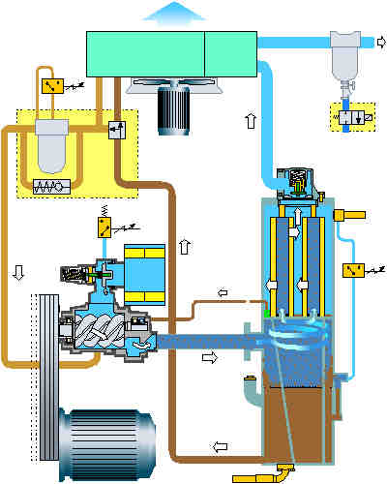

Introduction.

As it was already refered in the previous chapter, the compressed air constitutes an efficient source of energy, which use doesn't offer any problem practically. It confirms this statement the countless mechanical applications in what the compressed air is the energy fluid, having substituted other sources of energy (see Picture. 12).

Picture 12

So that the compressed air can supply energy, it is necessary to compress it, as it is evident; therefore we should supply work to increase its intern energy, so that over a convenient process, transform the internal energy of the compressed air into mechanical energy.
A typical installation of compressed air production can be seen, in a summarized way, in Picture. 13

1. | External air | 5. | Filter of oil removal and condensed
2. | Compressor | 6. | Absorption columns for water steam removal
3. | Water | 7. | Removal filter of solid particles
4. | Powder-cooler with condensed separation | 8. | Application / reservation of dry air

Picture 13

In the facilities of compressed air, the air in the exit of the powder-cooler of the compressor it is saturated of water (and of oil, in lubrificated compressors). To 7 Kg/cm2 and 40 º C, that are usually the conditions of exit of the air, the same contains about 50 g of water for m3. Part of this water steam, it contains, in condensed form, gases usually included in the atmosphere (CO2, CO, H2S, etc.) resulting an acid composition (ph: 3-4) and extremely corrosive. This way, independently of its application, the air should always be treated before being used. Filters should be foreseen for oil removal (in lubrificated compressors), humidity and solid particles.

In technological terms, the production of compressed air is accomplished by compressors. The compression has to debit a gas to a superior pressure to that the one that it meets in its original form, as atmospheric air for example. This can reach low or high pressures and, still to be debited in small flows of some liters per hour, even thousands of cubic meters per hour. Obviously, these hypotheses have to do with the capacity, the potency and the machine type and, having in mind the objectives that we intends to reach.

Now, there are several types of compressors and each type is built in a vast range of sizes and speeds to go to the encounter of the different requirements of volumes and pressures (see picture 14).

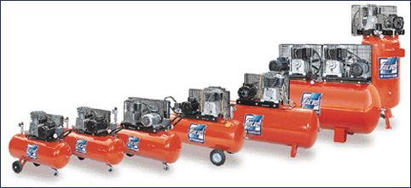

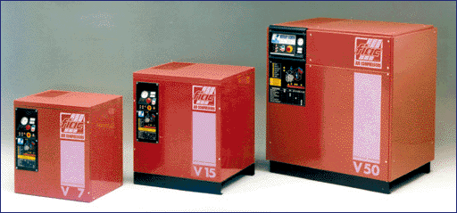

Picture 14

In terms of industry, nor all the types of compressors that here will be studied will have the same application degree and use, however, the point is that the user is aware of the several technological options and selects the one that best defends its objectives, considering several factors, such as, fiability, specific consumption of energy and maintenance costs.
In didactic terms, the options here presented are so many, so that we can have a clear vision of the existent options.

Compressors

To generate the compressed air, we use compressors that transport the air to the wanted service pressure. The command mechanisms are generally fed with compressed air starting from a central station. In this case the transformation problem and of the transmission of energy it will be resolved. The compressed air is driven, through canalizations, of the compression station to the devices and machines of pneumatic command.

As several types of compressors exist, the choice should be made assisting to approaches that we will speak right now.

Compression methods

With relationship to the compression process the one that the air is subject, the compressors can be divided in volumetric, and dynamic (see picture. 15).

Compressors
dynamic |  |  | volumetric
Radial | Axial |  | Alternative | Rotative
 |  |  | Single stage | Screw
 |  |  | Double stage | Sliding vane
 |  |  |  | Carriages
 |  |  |  | spiral
Picture 15

Dynamic compression

This compression type results of the transformation of kinetic energy in pressure, that is to say, we spent energy to move the air captured to the atmosphere strongly and when this loses speed, the pressure it increases.
The picture 16 exemplifies in a simple way, this concept, that is, in a dynamic compressor, the atmospheric flow is accelerated to the entrance of the shovels, being the exit area superior to the entrance area.
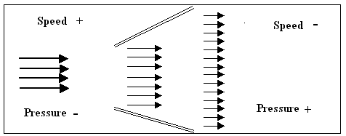

Picture 16

This difference of pressures, existent in the impelling shovel (see Picture 24 and Picture 25), as well as the high speed that it is encouraged, they are responsible for the energy transformation, being this phenomenon continued in the difusor (see Picture. 26), in snail shape, whose area is going increasing progressively, that is to say the speed of the air, to its exit, decreases and, consequently, the pressure of the air increases.

Picture - 17 Picture - 18

So, the kinetic energy, that the gas comes lively, it is transformed into pressure energy, due to the continuous loss of acceleration of the referred flow.

Picture - 19

3.2.2 - Volumetric compression

In this compression type, the air is admitted in a compression camera, or cylinder, whose volume it is going to be reduced due to the action of a mobile wall (piston or diaphragm). Once reached the exit pressure, the air abandons her referred camera through the discharge valve.
The volumetric compression, also known by positive displacement or intermittent flow, it is the one that results of the decrease of a volume, that is to say, the pressure of the gas increases if the volume, where it is contained, decreases.
The Picture. 20 illustrates what happens in an alternative compressor (piston or piston) of simple effect ( compression just in one of the faces of the piston) and for atmospheric air.

Picture - 20

In the position 1 the air is admitted (aspired) for suction (valve of open admission), what is equal to say that the air doesn't enter to the atmospheric pressure, but slightly below this. It should always be present this pressure difference (vacuous partial), because it is responsible for the decrease of the debit to the exit of the unit.
In the position 2 (valve of shut admission), we can see that the volume initially aspired it begins to decrease, for the increase of pressure of the air is inevitable.
In the position 3, the volume was reduced to the minimum and the pressure to the maximum, with the consequent opening of the discharge valve (delivery valve).
The way of operating an alternative compressor is similar to the one that happens in a bicycle bomb.

Dynamic compressors

The dynamic compressors can be - centrifugal or radial and axial - and they operate to superior speeds to the volumetric compressors.

In the Aeronautical or Space industry, the centrifugal units reach 50000 to 100000 r.p.m. for force of the mass problems, because altitude interferes, negatively, in the density of the air.
In the industry, in a general way, they operate with 20000 r.p.m., although superior speeds are more and more common.
The one who studies a dynamic compressor, simultaneously he studies a turbine, because, except for with some differences, a turbine is a compressor working in an opposite way. In fact, from a fall of water, from a gas or steam, the turbine transforms the pressure in speed; but a dynamic compressor transforms the speed of the air in pressure.

Centrifugal or radiate compressors

These compressors are denominated centrifugal (see Picture. 21), because the compression is processed in a perpendicular way to the vein motor and the discharge of the air is made according to the tangent to the ray of the impelling shovels and they are units indicated for they produce air without oil.
The Picture. 22 show us a centrifugal compressor with 4 compression floors destined to a range of pressures between 17 and 24 bar. In this illustration we can observe the vein motor placed to the center that works two jagged wheels, corresponding to each one of them two compression apprenticeships, and 4 tangent diffusors to the respective impelling shovels.

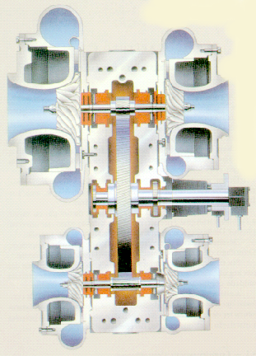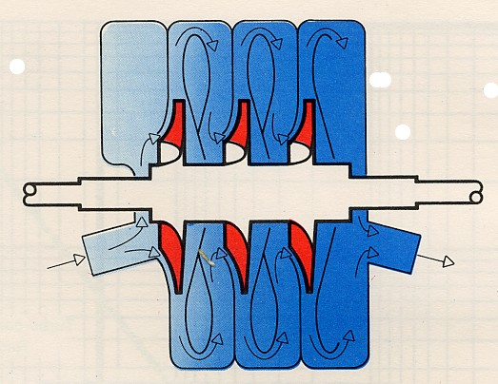

Picture - 21 Picture - 22
Figure - 21 - Working for long periods of time, with a minimum of maintenance, this centrifugal compressor, supplies compressed air exempt of oil, having capacities varying between 6.000 to 51.000 m3/h and pressure of 5.0 to 24 bar.

These units in order to be profitable they need flows that are not a lot common to our industry, although there are applications that justify its use, mainly in pressures of 3 to 3,5 bar (for example in the glass industry) or of 6 to 10 bar (3 floors) in the cellulose industries, paper, textile, chemistry, petroleum, etc..

Axial compressors

For analogy, the compression in this unit is processed parallelly to the vein motor, of there the designation of axial.
As to this type, the problem is still more important because the minimum flow is so high (900 m3/min) that difficultly is destined to the production of compressed air, at least, for industrial dimensions as ours.
However, it constitutes a hypothesis its use, in the quality of process compressor, as for example, in the supply of natural gas, through conducts with kilometers of extension along the country.
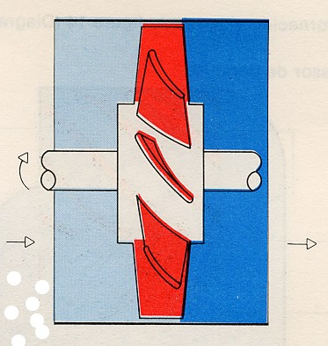

Volumetric compressors

The volumetric compressors are classified in alternative and rotative, because of the type of movement imposed to the organ propeller of the fluid to compress.

Alternative compressors

When the production of compressed air is intended up to 14 bar, this type of compressors has been coming to be substituted progressively, by rotative compressors of screw. Its extraordinary usefulness is not in case for superior pressures and /or as process compressor.
If, for example, we need debits as for example 6 m3/min to 35 bar, 50 m3/min to 200 bar or 90 l/s to 1000 bar, the only current technological solution is still, in the resource to the alternative compressor.
In fact, in spite of its substitution, that doesn't presuppose that it is no longer produced or has lost its technological value. In fact the applications are countless, for several reasons, this compressor type stays active, justifying for that reason, our interest.

Piston compressors

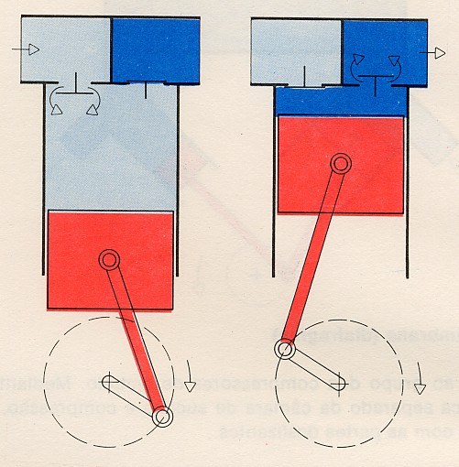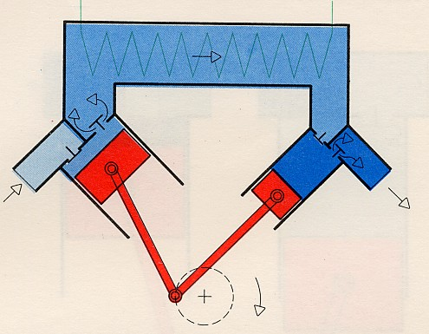

Picture - 23

For the compression the pressures are higher, they are necessary compressors of several apprenticeships (picture. 23). The aspired air will be compressed by the first piston (piston), refrigerated in the intermediate point and again compressed by the next piston.

Membrane compressors (diaphragm)

With a membrane, the piston is separate from the suction camera and compression, that is to say, the
air won't have contact with the parts that slide. The air, therefore, will always be free from oil residues,
These compressors are the favorite ones and more used in the nutritious, pharmaceutical and chemical Industry,
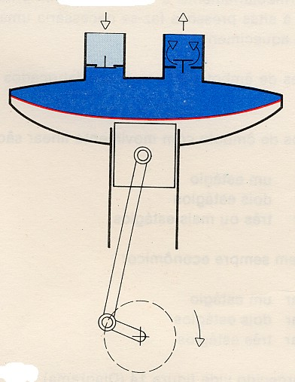

Rotative compressors

Spiral compressors

A type of rotative compressor is the spiral compressor (see Picture. 24). This compressor type possesses an innovative operation and extreme simplicity system: it understands a fixed spiral and another mobile, and the compression of the air is processed by the movement group of these two spirals.

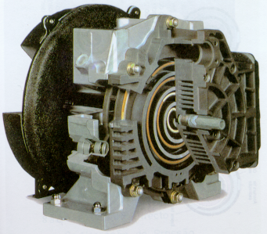

Picture - 24

So, thanks to a mobile spiral (see picture 24), and to an eccentric, the air it is going ti be compressed progressively in a smaller volume.

Contrarily to what we may think, the mobile spiral piece doesn't rotate in the traditional sense (360 on 360 degrees). It executes a movement in an elliptic way capable of reducing the volume of air among the spirals whenever this movement occurs.

Along the 10 different positions presented in the (picture 25) it can be verified that the admission air penetrates outside of the mobile element. As soon as that air locates inside the camera, the mobile spiral hinders the entrance opening and we can also see that in its movement the space among both them(fixed and mobile) decreases, producing for that middle a continuous flow of compressed air (exempt of oil and of pulsations) that leaves of the element through an opening of located discharge in the center of the fixed spiral.

Although for small flows (2,7 to 6,7 l/s and pressures up to 10 bar) and, naturally, for small potencies (1,5 - 2,2 and 3,7 Kw) it is truly a conception revolutionary, because it produces compressed air exempt of oil destined to applications highly demanding, for example, dental medicine.

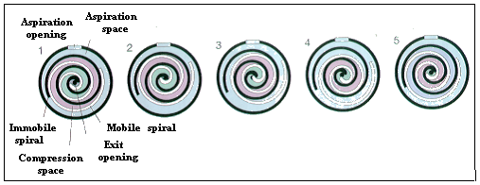

The compression of the air is obtained by the movement group of a fixed spiral and a mobile spiral. As the spiral continues to orbit, the air is going to be compressed progressively in a smaller space. The air to the admission pressure penetrates in the compression camera, on the outside of spiral element.


Once inside the camera, the spiral hinders the entrance opening. It is produced a continuous flow of compressed air that leaves the element through a discharge opening in the center of the fixed spiral. The compression process repeats continually, generating a flow of exempt air of pulsations.
Picture - 25
This concept includes a reduced number of mobile pieces, providing it manufactures of compact models (see picture 26), extremely silent, between 52 and 59 dB(A), thanks to a camera with protection of the sound, with incorporate reservoir, that allows the installation of these units even near working areas.

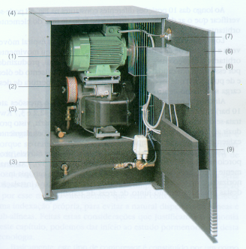

1 - Electric motor | 6 – Access door
2 - Filter of air | 7 – System to save energy
3 - Integrated reservoir | 8 –Direct Start up
4 - Flexible installation | 9 – Pressure alteration
5 – Camera with sound isolation

Picture - 26

Screw compressors

In fact in the current transformation industry, the rotative compressors of screw are the more used (see Picture 27), that’s why, we will pay them special attention.
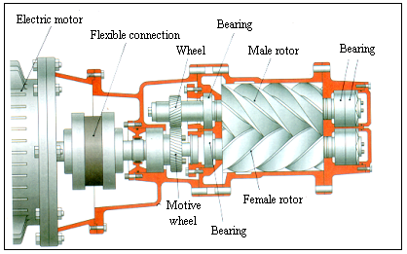

Picture - 27 Picture - 28

Its operation consists basically of two rotors that rotate inside of a fixed block, among an admission opening (entrance) and one of discharge (exit).
These rotors possess appropriate forms: one of lobes, or also denominated male, and the another in form of re-entrances, called female (fig. 28)

The male rotor usually rotates about 3600 r.p.m. The female rotor rotates to a smaller speed, 2400 r.p.m. In a general way, the operation motor acts on the male rotor, however we can find built compressors in such a way that the female rotor is the one that works. In this case, the speeds are 50% superiors to the ones of the conventional case.

The air will occupy the empty spaces among two adjacent lobes. As the screws rotate, the gas is going to be driven to smaller spaces, that is to say, it is being compressed by direct reduction of its volume.

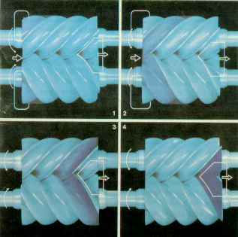

Picture - 29

Analyzing the (picture 29) we can conclude the process of compression of the air better, due to the resultant of the joining among lobes:

state 1; the extremities of the rotors discover the admission and the atmospheric air fills the free space completely (mobile helical bag) that is created between male and female;
state 2; the fluid is retained in the compartment, begining the compression (clear blue);
state 3; as the rotors rotate, the helical volume becomes smaller and the air is going to be compressed progressively (darker blue);
state 4; finally, the air in the service pressure (blue dark) abandons the element screw by the exit road.

Vane compressors

In a cylindrical compartment, with entrance openings and exit, it rotates a housed rotor in an eccentric way. The rotor has in its tears, vanes that together with a wall, they form small compartments (cells), When encouraged by rotation, the vanes will be, by the centrifugal force, thrown against the wall. Due to the idiosyncrasy of location of the rotor there are a decrease and increase of the cells.
The advantages of these compressors are in its construction: economic in space, as well as in continuous and balanced operation, and in the uniform supply of air free from any pulsation.

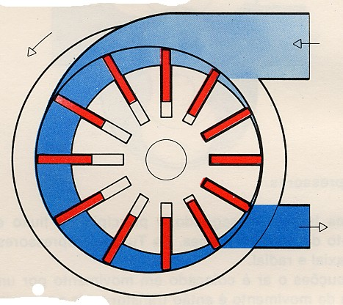

Compressors of cogs or gears

In these compressors the air is transported from a side to another side, (without volume alteration) through the spaces among the cogs, of the gears. The compression (packing) it is made on the side of the pressure, by the cogs of the jagged wheels.

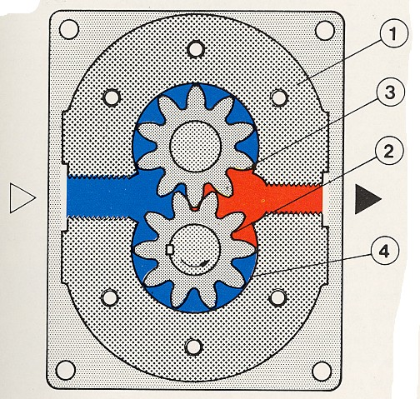
1- carcass
2- rotor coupled to the motor
3- drive wheel
4- compression camera

Compressors operation

The compressors are worked by electric or thermal motors (Combustion). When the compressor is a fixed element, (in a factory, garage or shop) therefore with adapted assembly chassis and compressor room, the favorite motive organ is the electric motor, once its assembly is easier, because it releases connections to deposits of fuel, system of refrigeration for water and battery, being also plenty more silent than the combustion motor and, above all, it doesn't pollute the atmosphere (see picture 30).

Picture - 30

For portable units compressors, gasoline or Diesel motors are used (see picture 31), that are set up in an own car or tow (they are used in the civil construction, highways, etc.)

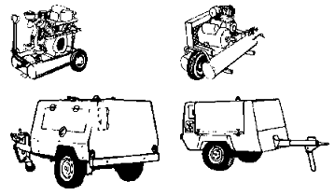
Picture - 31

The makers of compressors already supply ready to install compact units: the connection of the motor to the compressor is made itself by an elastic connection denominated joining, being the carcasses of these two elements united by an intercalary flange This operation type is used independently of the compressor debit, that is, so much can be applied in small units as in the big ones (see picture 32).

Picture - 32

In industry terms, nor all the types of compressors that here will be shown will have the same installation degree and use, however, the important is that the operator should be aware of the several technological options and select the one that best defends its objectives, considering several factors, such as, fiability, specific energy consumption and maintenance costs.
In didactic terms, the options here presented are sufficient, in order to have a clear vision of the several options.

Compressors Refrigeration

Provoked by the compression of the air and by the friction among the metallic elements in movement , a heat is created in the compressor, a heat that should be dissipated. The choice of the most appropriate refrigeration depends on the temperature degree developed in the compressor.
In the considered small compressors it will be enough the refrigeration for vanes (picture. 33). The compressors of larger capacity are equipped with ventilators.

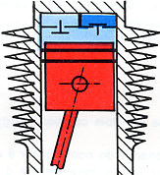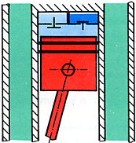

Picture - 33 Picture - 34

Having a compressors station with a potency of superior operation to 30 KW (40 HP), a refrigeration of air would be insufficient. The compressors then should be equipped with a water refrigeration or with a current water system (picture. 34). Frequently it is not taken in consideration an installation of complete refrigeration with a tower of refrigeration, due to its high cost, even so, an appropriate refrigeration takes care of the useful life of the compressor.

SUMMARY

So that the air can supply energy, it is necessary to compress it.

In technological terms, the production of compressed air is accomplished by compressors. The compression has to finally debit a gas to a superior pressure to the one that it meets in its original form, the atmospheric air for example.

In the compression process, the one that the air is subject, the compressors can be divided in volumetric, and dynamic. (to see graph p. 20)

The dynamic Compression, results from the transformation of kinetic energy in pressure, that is to say, we spent energy to move the air captured from the atmosphere and when this loses speed, the pressure increases.

Volumetric compression, the air is admitted in a compression camera, or cylinder, whose volume it is going to reduce due to the action of a mobile wall (piston or diaphragm). once reached the exit pressure, the air abandons its referred camera through the discharge valve.

The dynamic compressors can be - centrifugal or axial - and they operate to superior speeds to the volumetric compressors.

The volumetric compressors are classified in alternative and rotative, in what concerns the type of movement imposed to the organ propeller of the fluid to compress.

The compressors are operated by electric or thermal engines (Combustion).

The refrigeration can be made by water or by vanes.

The air can reach low or high pressures and, still to be debited in small flows of some liters per hour, even thousands of cubic meters per hour. Obviously, these hypotheses have to do with the capacity, the potency and the machine type to select, having in mind our goals.

The approaches have to do with the choice of a healthy compressor:

Volume of supplied air
Pressure
Operation type
Refrigeration
Assembly place
Air Reservoir

