Bilingualer Fachunterricht an berufsbildenden Schulen

Unterrichtsmodul

Berufsfeld: Wirtschaft und Verwaltung

Beruf: Steuerfachangestellte



LANGUAGE COMPETENCE THROUGH BILINGUAL TEACHING AT VOCATIONAL COLLEGES ACTION PROGRAMME OF THE EUROPEAN UNION LEONARDO DA VINCI – PROJECT: PRORJECT No.: 2002 LA 112 628 BILVOC
Teaching Module
Date of Production: January 2004

Subject: English for business administration

Topic: The German Tax System

Title: An Introduction

Target Group: Students in vocational business studies e.g. tax advisor’s assistants

Prior Knowledge: Basic business vocabulary

Level of Language: Vantage (B2)

Follow-Ups: none

Objectives: The students should be able to name and explain some of the most important German kinds of taxes in English.

Benefits: Students should be able to answer the following questions:
- How can direct and indirect taxes be distinguished?
- What kinds of tax brackets are there in Germany?
- Which VAT rates do different European countries have?
- What kinds of goods are taxed at a reduced VAT rate in Germany?
Unit Structure
Time | Contents | Teacher’s activities | Students’ activities | Media | Teaching method
5’ | Introduction What do you think the man is saying? | puts on transparency | look at transparency | transparency 1 | class discussion
10’ | Dialogue | gives three students the text | students read/act the dialogue | role sheets | dialogue
10’ | Task Guess what percentage of VAT our European neighbours have? | hands our the worksheets | fill the worksheets in | worksheet | individual work
10’ | Comparison | asks students to compare their solutions by using the internet | check their results | laptop with internet access (one student checks for the others as well) | class discussion
5’ | Kinds of taxes | asks students to distinguish direct and indirect taxes again | make a list of direct and indirect taxes | copy books | individual work
5’ | Comparison | asks students which examples they put in which column | present their solutions | results are collected on the blackboard | class discussion
5’ | Motivation | shows the transparency | Comment on the transparency | transparency 2 | class discussion
15’ | The German tax brackets | divides the class into six group | each group interprets what kind of people are in each tax bracket | copy books | group work
25’ | Comparison | asks students to write their | each group presents their | blackboard, copy books | students’ presentations

 |  | results on the board | results and writes the main ideas on the board; the other students write everything down into their copy books | (see appendix)
5’ | Motivation: The VAT rate | reminds the students of the introductory dialogue and asks them to repeat the German percentages for VAT; Is there a VAT rate of 16 % on everything? | answer the question: No, there is a reduced tax rate of 7 % on certain goods. | UStG (German VAT law) | class discussion
15’ | The reduced VAT | asks students to have a look at their German law text and to try to translate the exceptions in VAT on certain goods | look up the exceptions and translate them | UStG (German VAT law) | pair work
20’ | Comparison | asks students to write their solutions on the board | write their results on the board and into their copy books | blackboard, copy books | students’ presentations
15’ | Final exercise | hands out the worksheets and explains the task | put the words into the correct order | worksheet – matching exercise | individual work
10’ | Comparison | asks students to read out their results | read out their results and correct fellow students if necessary | worksheet | class discussion

Unterrichtsverlauf
Zeit | Inhalte | Lehreraktivi-täten |  | Schüler-aktivitäten |  | Medien | Methoden
5’ | Einleitung Was denken Sie sagt der Mann im Bild? | Legt die Folie auf |  | Sehen die Folie an |  | Folie I | Unterrichts-gespräch
10’ | Dialog | Gibt zwei Schülern den Text |  | Schüler lesen/spielen den Dialog |  | Rollenkarten | Dialog
10’ | Anwendung Raten Sie, wie hoch die Mehrwert-steuer in verschiedenen Ländern ist. | Gibt die Arbeitsblätter aus |  | Füllen die Arbeitsblätter aus |  | Arbeitsblatt | Einzelarbeit
10’ | Vergleich der Übung | Bittet die Schüler ihre Ergebnisse durch die Benutzung des Internet zu ver-gleichen |  | Vergleichen ihre Ergebnisse |  | Computer | Einzelarbeit
5’ | Steuerarten | Lässt die Schüler die Steuerarten in direkte und indirekte Steuern einteilen und diese Begriffe definieren |  | Fertigen eine Tabelle an |  | Übungshefte | Einzelarbeit
5’ | Vergleich der Arbeitsergeb-nisse | Fragt die Schüler wie sie die Beispiele zugeordnet haben |  | Präsentieren ihre Ergebnisse |  | Ergebnisse werden an der Tafel gesammelt | Unterrichts-gespräch
5’ | Motivation | Zeigt die Folie |  | Kommentieren die Folie |  | Folie 2 | Unterrichts-gespräch
15’ | Die Steuerklassen in Deutschland | Teilt die Klasse in 6 Gruppen |  | Jede Gruppe findet heraus, wer in der jeweiligen der Gruppe zugeordneten Steuerklasse ist |  | Übungshefte | Gruppenarbeit
25’ | Vergleich | Bittet die Schüler ihre Ergebnisse an die Tafel zu schreiben |  | Jede Gruppe präsentiert ihre Ergebnisse an der Tafel, die Mitschüler übernehmen diese in ihre Aufzeichnungen |  | Tafel, Unterlagen der Schüler  (siehe Anlage) | Schüler-präsentationen
5’ | Motivation: Die Mehrwert-steuerrate in Deutschland |  | Erinnert die Schüler an den Einstiegsdialog und bittet sie, die deutschen Prozentzahlen für die MWSt zu wiederholen Frage: Gibt es eine MWSt-Rate von 16 % auf alles in Deutschland? |  | Beantworten die Frage  Nein, es gibt auch einen reduzierten Steuersatz von 7 %. | UStG | Unterrichts-gespräch
15’ | Der reduzierte Mehrwert-steuersatz |  | Bittet die Schüler sich den Text ihres Gesetzbuches UstG anzusehen und die verschiedenen Güter mit einem reduzierten MWSt-Satz zu übersetzen |  | Lesen die Ausnahmen und schreiben diese in englischer Sprache auf | UStG | Partnerarbeit
20’ | Vergleich |  | Bittet Schüler die Ergebnisse an die Tafel zu schreiben |  | Schreiben die Ergebnisse and die Tafel und in ihre Unterlagen | Tafel, Aufzeich-nungen der Schüler | Schüler-vorträge
15’ | Abschließende Übung |  | Gibt die Arbeitsblätter aus und erläutert die Aufgabenstellung |  | Setzen die Wörter in die richtige Reihenfolge | Arbeitsblatt – Zuordnen | Einzelarbeit
10’ | Vergleich |  | Bittet die Schüler ihre Ergebnisse aufzuschreiben |  | Lesen ihre Ergebnisse vor und korrigieren Mitschüler, falls nötig | Arbeitsblatt | Unterrichts-gespräch
Appendix - Transparency 1
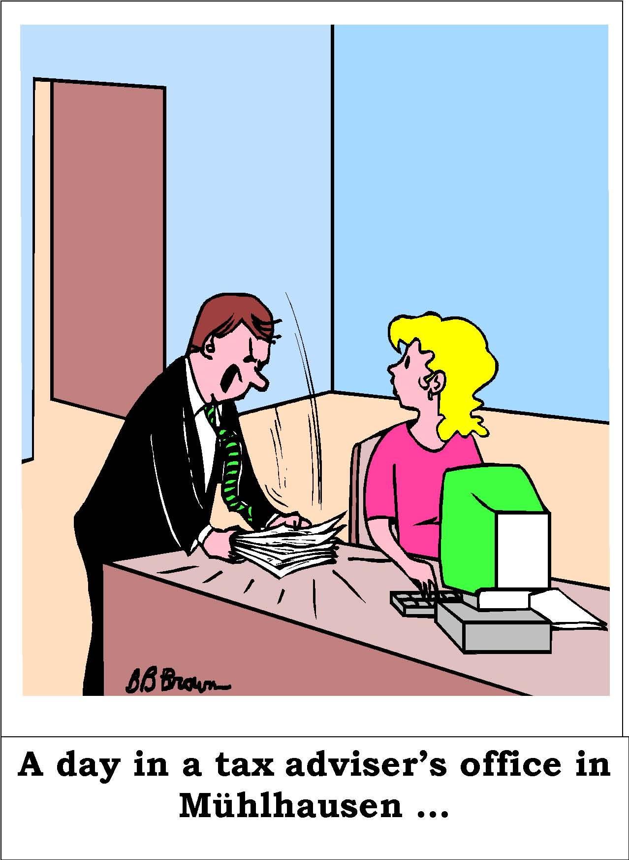
Dialogue: - role sheets
Mr. Keiz: | Oh, Frau Beimer, wir werden gleich Mr. Jones, einen englisch  sprechenden Mandanten begrüßen dürfen. Er kommt aus London und  möchte bei der Expansion seiner Firma auf dem deutschen Markt mit  unserer Kanzlei zusammen arbeiten. Ist das nicht interessant? Bitte  kümmern Sie sich um ihn! Sie sprechen doch Englisch, oder?
Mrs. Beimer: | Ja, gern. Die Sprache ist kein Problem
 | 10 minutes later …
Mr. Jones: | Good morning. Is this Mr. Keiz’ office?
Mrs. Beimer: | Yes, or course. You must be Mr. Jones from London. Nice to meet you.
Mr. Jones: | That’s right. Nice to meet you, too.
Mrs. Beimer: | Have a seat, Mr. Keiz will be available in some minutes. Would you  like to have a cup of tea or coffee?
Mr. Jones: | A cup of tea, please. And some milk would be nice.
Mrs. Beimer: | No problem. Here you are! Well, I am quite embarrassed, but I am not sure, if I should put the milk in first or afterwards.
Mr. Jones: | (is laughing) Never mind! I prefer to put the milk in first, but it differs from person to person. Anyway, thank you very much for the tea.
Mrs. Beimer: | Oh, you are very welcome! By the way, did you find the way to our office with no problems?
Mr. Jones: | It was no problem at all. I arrived at Erfurt airport, coming from  London Stansted, took a taxi to the main train station and walked from the station in Mühlhausen to your office. Mr. Keiz sent me the directions, which were explained very well.
Mrs. Beimer: | Fine. That’s nice to hear. Is this your first stay in Germany?
Mr. Jones: | No, it isn’t. I had an appointment at the Chamber of Commerce and  Industry in Erfurt last month, but I did not see much of the country itself. I am very curious to learn more about Thuringia in particular and of course about the German tax system in general. It must be very different compared to ours.
Mrs. Beimer: | As far as I know it is. But I am not an expert, you see.
Mr. Jones: | Mr. Keiz wanted to send me a short overview of the most important taxes, but our fax machine broke down after 22 pages. It must be quite complicated, but that’s why I’m here … I am sure Mr. Keiz is able to advise me in tax matters concerning setting up an east German subsidiary of our company.
Mrs. Beimer: | Well, our tax system seems to be complicated indeed. I know that about sixty percent of the total number of the world’s tax laws are German ones. Isn’t this crazy?
Mr. Jones: | Yes, it is.
Mrs. Beimer: | By the way, a week ago I tried to find out about VAT rates, value added tax rates, in different European countries. It is very interesting that we in Germany are – still - at 16 % one of the countries with the lowest VAT rates right now, did you know this? Oh, and I can also tell you some even more interesting facts …
Mr. Jones: | It’s very interesting to hear all this. Which other facts are you thinking of? ….
Mrs. Beimer: | Did you know that once there was a beard tax in Germany, or a tax on each window in a house, a tax on nightingales, and one on playing cards?
Mr. Jones: | I didn’t know about all this. I am amazed what taxes there can be. … (thinks about it)
Mrs. Beimer: | … back to VAT. We divide taxes into direct and indirect taxes. VAT for example is an indirect tax. You pay direct tax on income and indirect tax is a tax on expenditure.
Mrs. Jones: | Could you give me further examples of direct or indirect taxes, please? What about income tax, it must be direct then, am I right?
Mrs. Beimer: | Yes, of course. Other examples of direct taxes are motor-vehicle tax, corporate income tax, real estate or property tax, trade tax, inheritance tax, gift tax, or capital gains tax. Further examples of indirect taxes are motor fuel tax, tobacco tax, alcohol tax, sales tax, or tariffs.
Mrs. Jones: | I am quite surprised that you know all this and I am looking forward to talking to Mr. Keiz to learn even more on this topic. Oh, there he is, I guess … (the door opens and Mr. Keiz comes in)
Mr. Keiz: | Welcome to my office, Mr. Jones. Nice to meet you … (they both go into Mr. Keiz’ room)

transparency 2

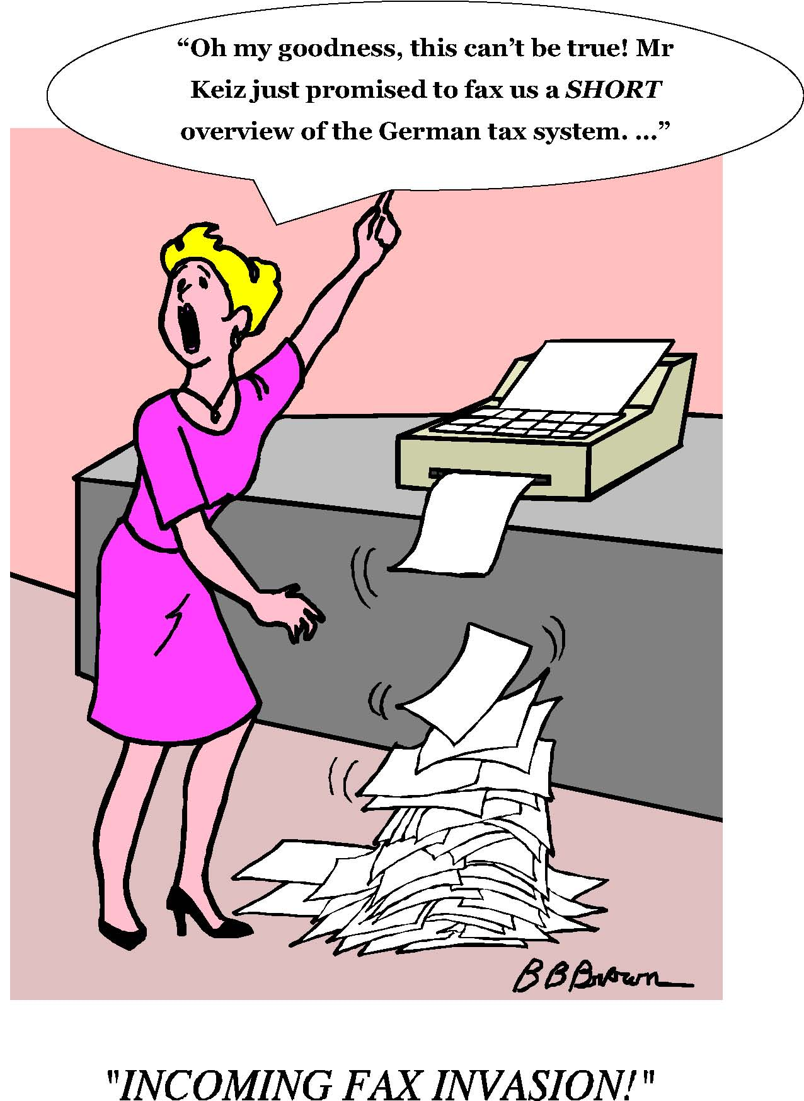

Tax brackets
There are six tax brackets in Germany:

I | - single and divorced employees  - widowed employees, whose partner died not longer than 2 years before  - married employees, if one partner is living abroad or who live permanently apart
II | - all employees mentioned above if they are a single parent and entitled to housekeeping allowance  -condition: at least one child for whom child benefit is paid who is registered at a German residence (the residence of the child has to be in the household of the parent who is taxed according to tax bracket II)
III | - married employees if both partners live in Germany, do not live permanently apart and one partner does not receive any salary or wage, or is taxed in tax bracket V
IV | - married employees if both partners receive a salary/wage, live  in Germany and are not permanently separated

V | - instead of tax bracket IV if the other partner is taxed in tax bracket III
VI | - if an employee receives a salary/wage from different employers .. then the tax card with tax bracket VI should be given to the employer who the employee receives the lowest salary/wage from - this tax bracket is also applied if an employee loses his/her tax card or if he/she forgets to hand it in at the employer’s office

How much do you know about our neighbours` taxes?
What is the VAT rate (value added tax rate) in different
European countries?⁵
15 % - 16 % - 16 % - 18 % - 18 % - 19 % -19 % - 19,6% - 20 % - 20 % - 21 % -21 % - 22 % - 25 % - 25 %
Country | VAT
Ireland
Finland
Spain
Denmark
Great Britain
Luxembourg
Italy
Sweden
Belgium
Austria
Portugal
Greece
The Netherlands
France
Germany

⁵ In all countries mentioned (exept for Denmark), there is a reduces VAT rate on certain kinds of goods.

Key:
Country | VAT
Ireland | 21 %
Finland | 22 %
Spain | 16 %
Denmark | 25 %
Great Britain | 18 %
Luxembourg | 15 %
Italy | 20 %
Sweden | 25 %
Belgium | 21 %
Austria | 20 %
Portugal | 19 %
Greece | 18 %
The Netherlands | 19 %
France | 19,6 %
Germany | 16 %

Conclusion: Germany has one of the lowest VAT rates in the European comparison

The German Umsatzsteuergesetz (VAT law) – extracts:
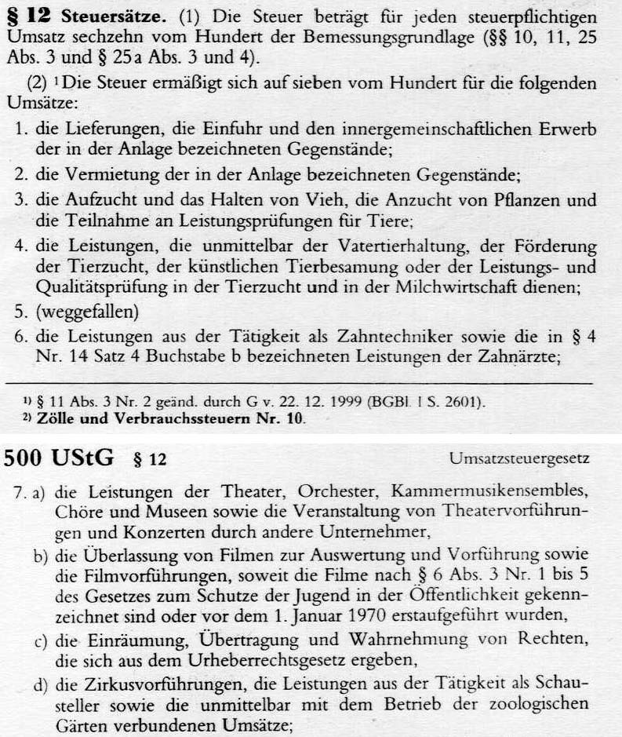
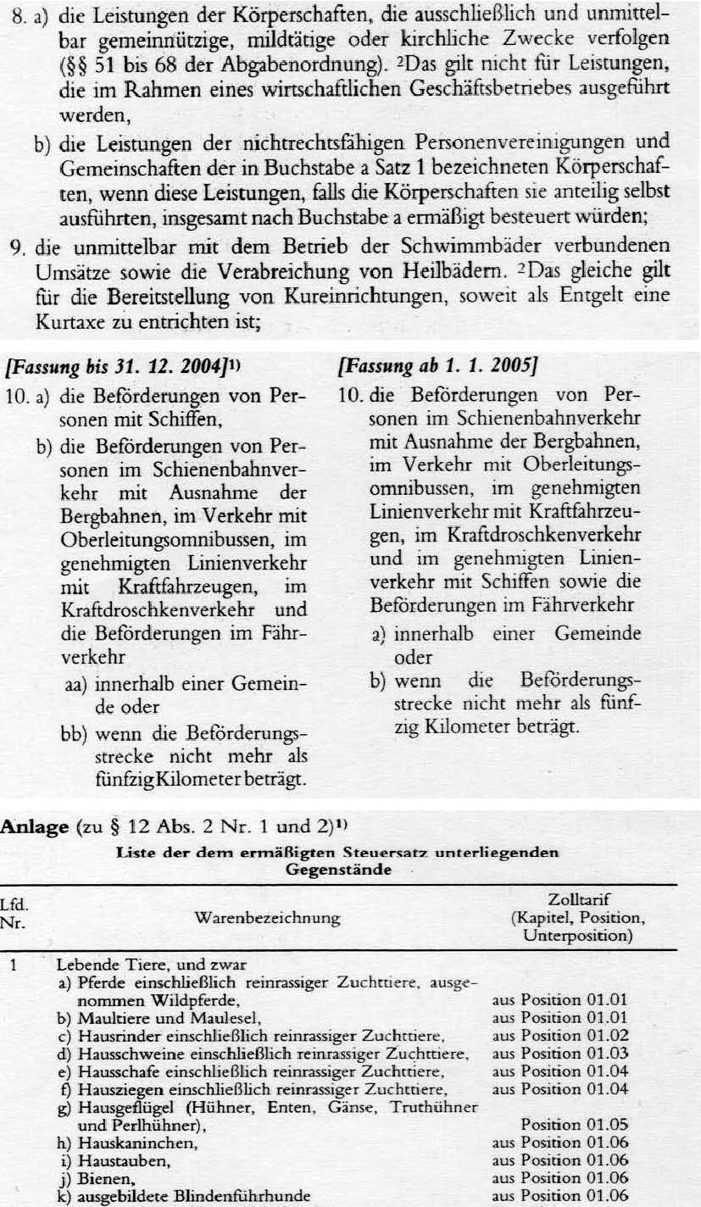
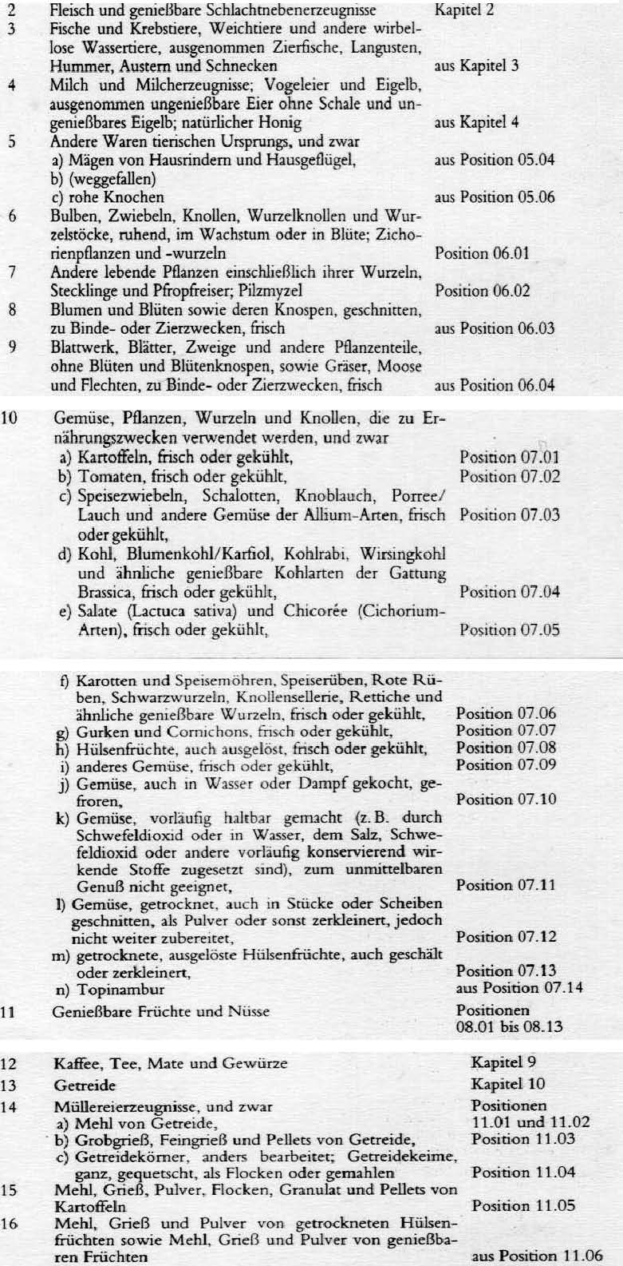
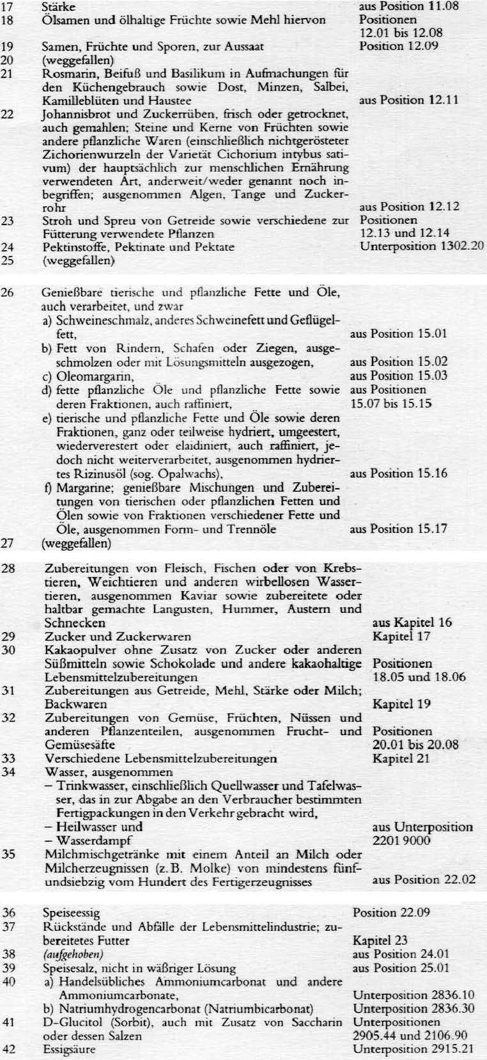
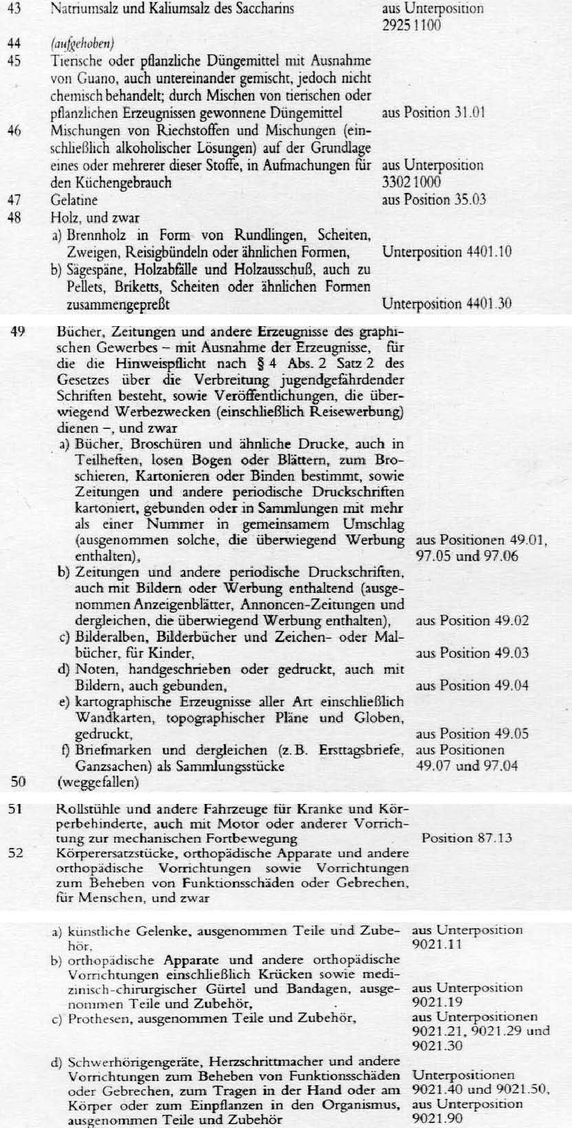
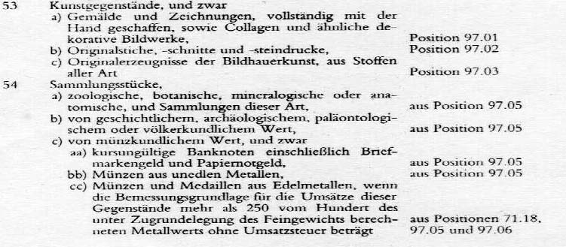
blackboard:
Examples of reduced VAT rate in Germany: There is a tax rate of 7 % on: …
-grain
-vegetables
-fertilizer
-wood
-books
-wheelchairs
-groceries such as sugar, water, meat, margarine, salt etc.
-tickets for the theatre
-dental services
-tickets for public transport
-livestock
-newspapers
W O R K S H E E T
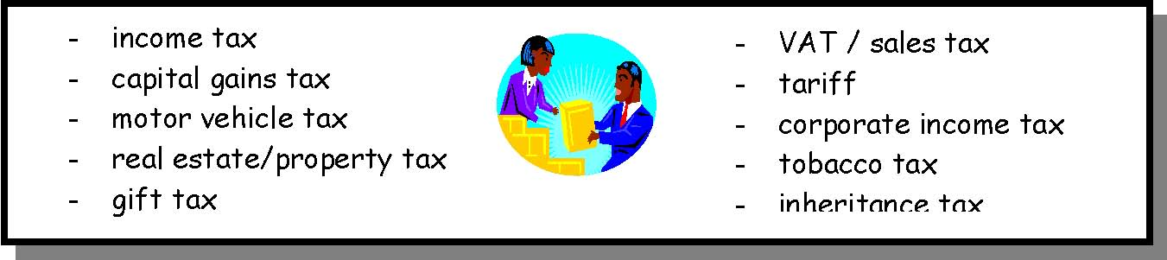
German term English Term Meaning Direct/Indirect
a tax on salaries and wages
an income tax paid by companies
a tax on sold products
a tax paid on gifts (but there are different allowences)
a tax on a profit a tax paid on cigarettes
a tax on import and export
a tax paid on things you get after a person has died
a tax on a plot of land
a tax on your car
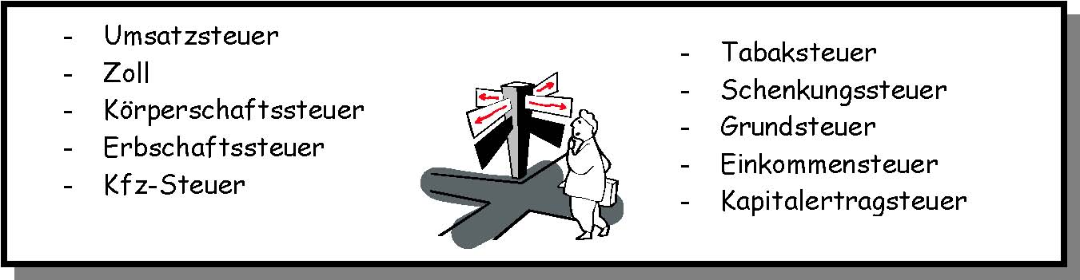

K E Y T O W O R K S H E E T
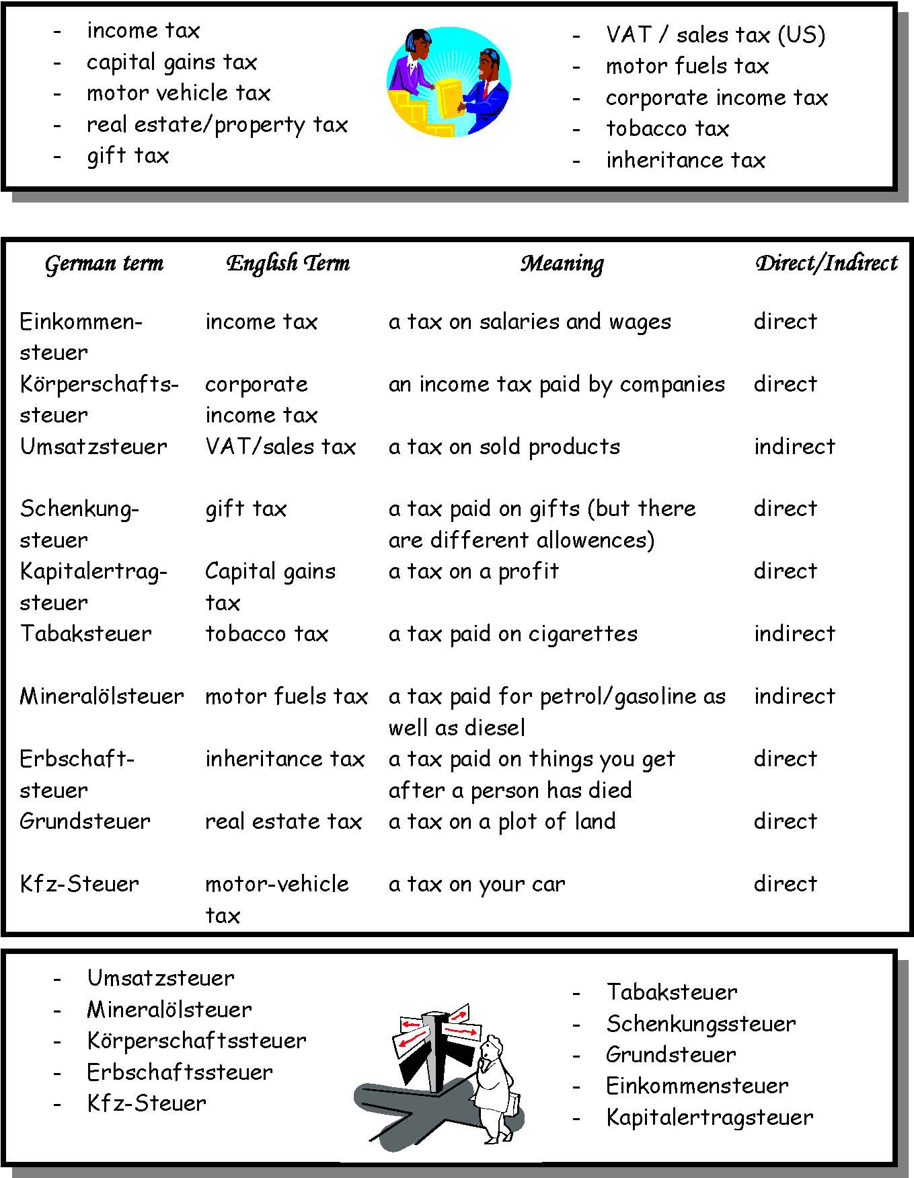

This is not the case anymore after January 1st 2004. Instead there is a special allowance for children, which life in the same household like the parent(s) which take(s) care for them.
This means that the partner pays more taxes in tax bracket V.
If one partner is taxed according to this tax bracket, the husband/wife automatically has to choose this tax bracket as well.

