Bilingualer Fachunterricht an berufsbildenden Schulen

Unterrichtsmodul

Berufsfeld: Wirtschaft und Verwaltung

Berufe: Bürokräfte

Things I need for my daily work


ACTION PROGRAMME OF THE EUROPEAN UNION
LEONARDO DA VINCI – PILOT PROJECT
PROJECT No. 2002 LA 112 628 BILVOC
LANGUAGE COMPETENCE THROUGH BILINGUAL TEACHING AT VOCATIONAL COLLEGES

Teaching Module

Date of production: May 2004

Subject: English for disadvantaged students

Topic: The office

Title: Things I need for my daily work

Target Group: disadvantaged students

Prior Knowledge: little or none

Level of Language Skills: waystage (A2)

Objectives: Students learn to talk about things they need for their daily word right on their desk

Benefits: Students should be able to name items on their desk and to tell how often and what they are used for

Teaching  Time | Contents | Teacher´s  activity | Students´  activities | Media | Teaching method
15 min | new vocabulary | hand out material according to list of vocabulary | find the english words /equivalence for the 4-5 items they were given | dictionary, objects | individual work
15 min | comparison | watches discussion to avoid misunderstanding | present their results  compare the results by asking their classmates simple questions like  “This is …. Am I right ?” | objects | student’s presentation,  discussion
10 min | getting familiar with the new vocabulary | explain task  offer help | group the new vocabulary according to how often certain items are used | worksheet (given below) | individual work
15 min | getting familiar with the new vocabulary | explain task  offer help | do the crossword | crossword (given below) | individual work
15 min | practice | explain task  offer help | illustrate their place of work and label all items on their virtual desk and in the drawers | copies of the draft “My desk”  (given below)  coloured crayons | individual work
15 min | usage | explain task  offer help | make up sentences in order to describe the draft of exercise 3 in simple sentences | exercise books | individual work or work in pairs
5min | description of pictures | shows pictures | describe the pictures | picture | questions and answers

Unterrichts-zeit | Inhalte | Lehreraktivitäten | Schüleraktivitäten | Medien | Methoden
15 min | neues Vokabular | gibt Material aus gemäß Vokabelliste | finden die englischen Entsprechungen | Wörterbuch, Objekte | Einzelarbeit
15 min | Vergleich | leitet Diskussion | präsentieren Ergebnisse durch Fragestellung an die Klasse | Objekte | Präsentation
10 min | neue Vokabeln erschließen | Aufgabenklärung  Hilfe | gruppieren die neuen Vokabeln nach Häufigkeit des Gebrauchs | Arbeitsblatt (gegeben) | Einzelarbeit
15 min | neue Vokabeln erschließen | Aufgabenklärung  Hilfe | Wortsuche | Worträtsel (gegeben) | Einzelarbeit
15 min | Übung | Aufgabenklärung  Hilfe | stellen ihren Arbeitsplatz dar und beschriften die Darstellung | Kopien der Schreibtischskizze “My desk” (gegeben)  Farbstifte | Einzelarbeit
15 min | Anwendung | Aufgabenklärung  Hilfe | bilden auf Grundlage der Skizze Sätze zur verbalen Beschreibung ihres Schreibtisches |  | Einzelarbeit oder Gruppenarbeit
5 min | Bilder beschreiben | Bilder zeigen | beschreiben Bilder | Bilder | Lehrer- Schüler Gespräch




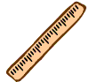

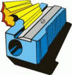

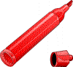

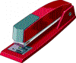
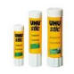
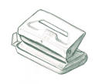
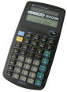
Exercise 1 Group the following items according to your own preferences:

I often use | I sometimes use | I hardly use | I never use

Exercise 2 Crossword

L | D | C | G | Q | K | L | Z | G | J | S | C | B | E | T | H | F | D | B | X | N
P | D | A | D | U | Z | I | U | O | A | F | G | H | J | K | L | R | P | H | H | E
A | S | L | G | H | Y | E | P | I | O | H | N | K | L | S | E | T | E | S | R | T
I | H | C | Y | J | H | T | E | G | M | A | R | K | E | R | P | E | N | J | K | L
K | N | U | X | B | D | D | N | B | O | O | H | H | B | R | O | I | V | X | S | A
H | O | L | E | P | U | N | C | H | W | B | I | S | N | M | A | U | Z | T | Z | E
F | T | A | N | A | E | K | I | I | L | F | N | M | S | C | I | S | S | O | R | S
H | E | T | S | T | A | P | L | E | R | M | N | C | Z | P | O | L | E | I | B | D
A | P | O | I | Z | R | F | B | N | U | K | D | Z | D | V | N | M | C | R | T | E
T | A | R | S | X | C | B | O | U | L | L | K | S | G | Z | J | K | E | Q | E | S
K | D | S | J | I | P | L | B | C | E | Y | C | G | L | U | E | S | T | I | C | K
B | A | F | G | K | P | A | P | E | R | C | L | I | P | K | G | T | W | E | V | U

 |  | C
 |  | A |  |  |  |  |  |  |  |  |  |  |  |  |  |  | P
 |  | L |  |  |  |  | P |  |  |  |  |  |  |  |  |  | E
 |  | C |  |  |  |  | E |  | M | A | R | K | E | R | P | E | N
 | N | U |  |  |  |  | N |  |  |  |  |  |  | R
H | O | L | E | P | U | N | C | H |  |  |  |  |  |  | A
 | T | A |  |  |  |  | I |  |  |  |  |  | S | C | I | S | S | O | R | S
 | E | T | S | T | A | P | L | E | R |  |  |  |  |  |  |  | E |  |  | D
 | P | O |  |  |  |  |  |  | U |  |  |  |  |  |  |  |  | R |  | E
 | A | R |  |  |  |  |  |  | L |  |  |  |  |  |  |  |  |  |  | S
 | D |  |  |  |  |  |  |  | E |  |  | G | L | U | E | S | T | I | C | K
 |  |  |  |  | P | A | P | E | R | C | L | I | P

Exercise 3 “My Desk” : Use coloured crayons and show how you arrange things on your desk. Use different colours for each group as of exercise 1

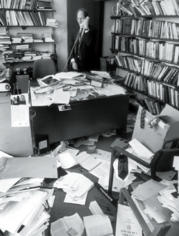

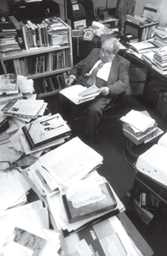
Take a look at the photographs. Would you like to work here?
Try to guess the meaning of the word “mess”.
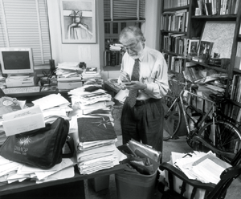



Vocabulary:

English German

desk Arbeitsplatz, Schreibtisch
drawer Schublade
pen Stift, Füller
pencil Bleistift, Zeichenstift
pencil case Federtasche
ruler Lineal
pencil sharpener Bleistiftspitzer
hole punch Locher
stapler Tacker
calculator Taschenrechner
documents Dokumente
eraser/rubber Radiergummi
glue stick Klebestift
marker pen Textmarker
dictionary Wörterbuch
pair of scissors Schere
whiteboard (weisse) Wandtafel
Post-it® note Haftnotiz
pinboard Pinnwand
notepad Notizblock
paper clip Büroklammer
telephone Telefon
telephone directory Telefonverzeichnis
mess, a complete mess ( totales) Durcheinander

