ACTION PROGRAMME OF THE EUROPEAN UNION
LEONARDO DA VINCI
PROJECT NO.: 2002 LA 112 628 BILVOC
LANGUAGE COMPETENCE THROUGH
BILINGUAL TEACHING AT VOCATIONAL COLLEGES

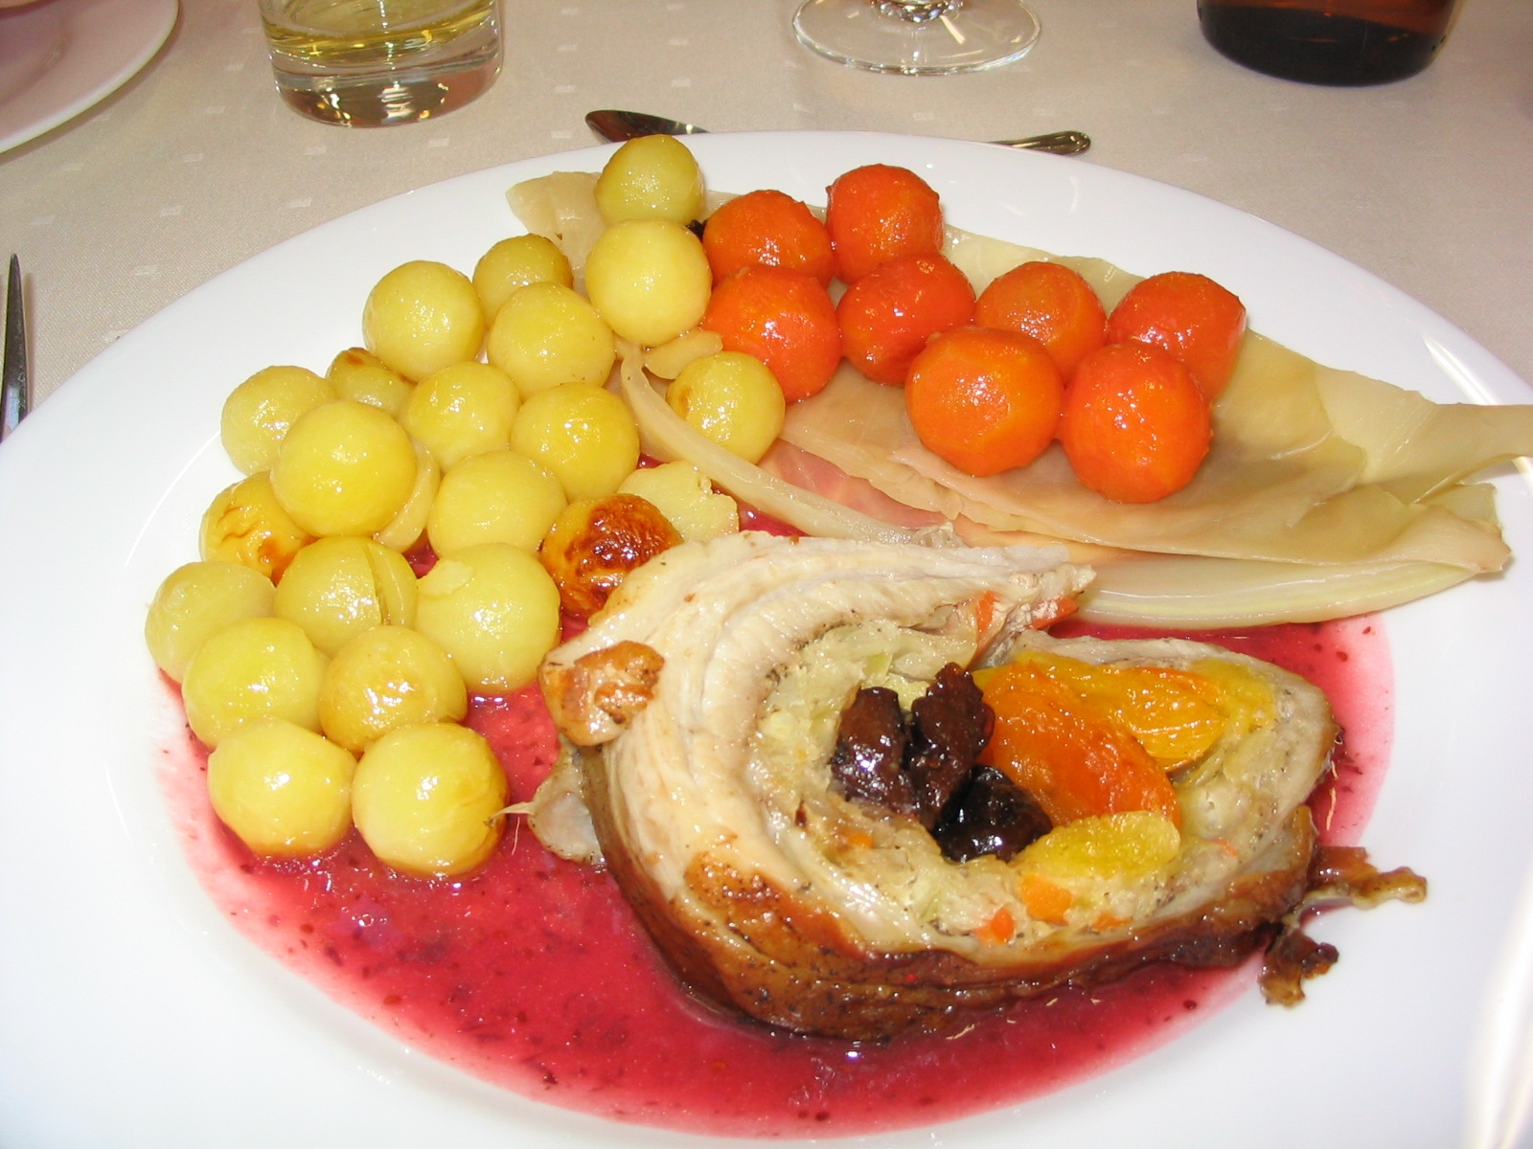
German for cookery students

ESTNISCHE KÜCHE

Juta Laatsit/ Tiina Libek

Date of production 05/2004

Subject Cooking

Topic National food

Title “Estnische Küche”

Target group Students of Vocational school

Prior Knowledge basic knowledge about edibles and cooking

Language skills : Waystage / Treshold (A2/B1)

Follow-ups To make estonian national food

Objectives Pupils know names of components and technology of estonian national food. They could to describe and to prepare typical Estonian national food.

Benefits Students should know how to prepare some Estonian national foods.
 Dateigrösse: 526 kb 

