Bilingualer Fachunterricht an berufsbildenden Schulen

Unterrichtsmodul

Berufsfeld: Elektrotechnik

Beruf: Elektroniker

Introduce, tools and practice for electrical engineers

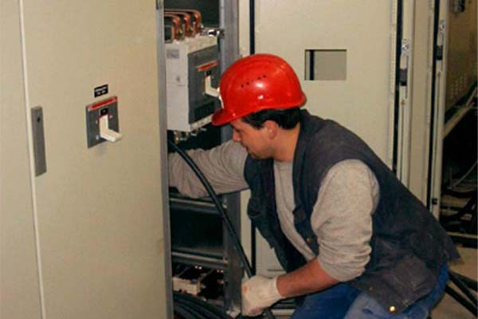

ACTION PROGRAMME OF THE EUROPEAN UNION
LEONARDO DA VINCI
PROJEKT NO.: 2002 LA 112 628 BILVOC
Language Competence Through
Bilingual Teaching at Vocational Colleges

Teaching Modules

Date of production 09/2005

Subject: Electrical technology

Topic: basic for bilingual teaching

Title: Introduce, tools and practice for electrical engineers

Target Group: Any group of electrical engineering students

Prior Knowledge: Basic of electrical engineering

Level of Language Skills: Waystage (A2)

Follow - Ups: Experiments on safety precautions

Objectives: Importance of precautions

Benefits: The danger of electricity and protection from
electric shock

Teaching Module: electrical installation

Teaching Time  (experience) | Contents | Activities | Media | Skills
45 minutes  90 minutes  45 minutes  180 minutes  45 minutes  540 minutes  45 minutes | Welcome and Introduction  Education and Curriculum Vitae  Introducing people  Tools and practice for electrical engineers  5. Saying Numbers  practice  evaluation | Discussion with the student  about the worksheet  Work out the contents in 3 groups,  Group presents the  summarised contents  Individual work  Information given by the teacher  Discussion with the student  about the worksheet  Discussion with the student  about the worksheet  Connect the circuits using the board  Write down the results  evaluation of the material  Write definitions | Board, worksheet  dictionary  transparency  worksheet  Board, transparency and  worksheet  transparency  transparency  electrical board  paper  paper | Questions and answers and  classroom discussion  working independently  giving exact explanation expressing and accepting objective criticism  Questions and answers;  classroom discussion  Questions and answers;  classroom discussion  working with electrical board
990 minutes

1. Welcome and Introduction

Crossword - Welcome –

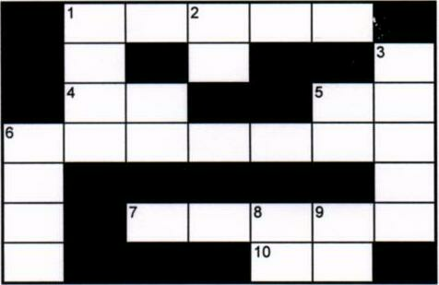

ACROSS:
1 Is this the English ............?
4 Excuse........
5.......... Mark. I'm Sandra.
6.......... to this English class.
7 .......... your name on a piece of paper
10 Welcome………….. this class.

Down:
1 "Is this the English class?" • "Yes, it is........... in."
2 You can get the book............ most bookshops.
3 Write your name on a...................... of paper.
6 See you next...............
8 Fold the piece of paper and place....... in front of you.
9 Welcome.......... Jena.

Can you say it in English

- Begrüßen Sie Ihren Kollegen (Nick Parker) aus Leeds.

....................................................................................................................................................
.................................................................................................................................................
...................................................................................................................................................
- Stellen Sie Ihre Kollegen Klaus Müller und Peter Huber vor.

................................................................................................................................................
..............................................................................................................................................
..................................................................................................................................................
3. Fragen Sie Ihren Gast: "Hattest du eine gute Reise?"

..........................................................................................................................................
............................................................................................................................................
...................................................................................................................................................

- Ich möchte mich vorstellen ......................................................................................................................................
....................................................................................................................................
......................................................................................................................................

Crossword - Introduction –

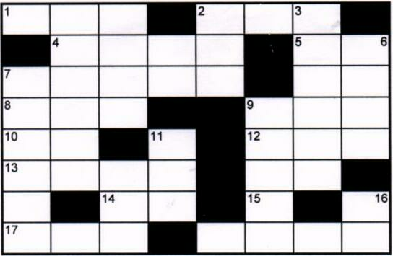

Across:
1 Where are...... from?
2 Oh, are you .......? Welcome to the class.
4 There's a seat………….. there.
5 Fold the piece of paper and place it..... front of you.
7 Sandra is over..........
8....... are you?
10 You can get the book............ most bookshops.
12 Have you ..... a ring binder
13 It's................. to see you again.
14 Come ......in.
15..... am from Dublin.
17...... you next week
18 What's your name ? My name is..................

Down:
3 Shall we shut the..................................?
6 See you ...............Tuesday.
7 "How are you?" I'm fine,.................."
9 Nice to see you ..............
11 I've got a notebook and a ........
16 Shall....... shut the window ?
18 I've got... notebook.

2. Education and Curriculum Vitae
How do the British schools compare to German Schools

Hochschule University
Fachschule Technical school or Commercial school
Fachoberschule College of Further Education
Berufsschule Vocational school
Gymnasium Secondary school "A" Level or Grammar
Gesamtschule Secondary school
Realschule Secondary school
Hauptschule Secondary school
Grundschule Primary school

A new job
You will be looking for a new job.
You will work in England.
You must write a curriculum vitae.

Curriculum vitae

Paul Christopher Welch

Photo
10 Rugby Road
Brighton, Sussex
0273-551977

born 16 September 1973. London
Parents Thomas and Patricia (Parker)
Education St Paul's Primary school 1985 - 1993
Cromwell Secondary school Brighton 1993 - 1997
Hove College of Further Education 1997 - 2000
Qualifications National Certificate in electronics June 2000

Special Training Evening and weekend courses in computing and information technology
References

Brighton, August 2000

Talking about family and profession

Introduction: My name is………………………........................
I come from……………………………................
I live in....………………………………................
(zip-code, city; street)

May I introduce (myself) Mr./Mrs.………………………………….. to you.
This is Mr./Mrs. from ............................................

Greetings: Hello,....................... Nice to meet you. Hi....................................
Good morning / afternoon / evening
Nice to see you (again).
Goodbye ! bye; bye-bye See you later! (See you) See you next………………….!

Questions: Where are you from ? What's your address ?
What's your job (profession) ? What do you do for a living ?
Where do you live ? Where do you work?
How are you (feeling) ?

3. Introducing people

Here are the people who work in a small company in Bristol:
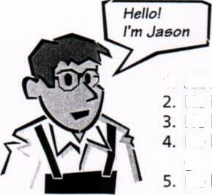
- Jason is an electrician.
- He is 1.80 m tall.
- He is 40 years old and single.
- He likes hamburgers, discos, going out, flirting, and rugby. He hates rap music but loves funky stuff.


- Ahmed is a mechanic.
- He is 1.87 meters tall.
- He is 25 years old and married.
- He has a son and two daughters.
- He likes kebabs, big cars, karate and soccer.
- He loves pop songs and hates
heavy metal.

- Rick is a trainee.
- He is 1.75 meters tall.
- He is 17 years old and has a nice girl-friend.
- He likes coke, hamburgers, motorbikes, American football, wrestling, and beer.
- He dislikes pop but enjoys punk and house music.
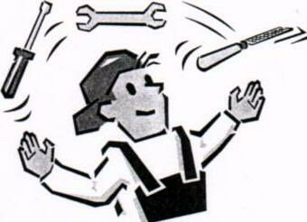

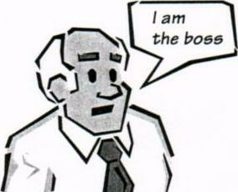
- Duncan is the boss.
- He is very tall.
- He is 58 years old, married and has three children.
- He likes hard work and has no time for sports. His job is his life.
- He sometimes listens to classical music.

What’s your job? How tall are you? How old are you? What do you like?
………………………………………………………………………………………………………………………………………………………………………………………………………………………………………………………………………………………………………………………………………………………………………………………………………………………………………………………………………………………………………………………………………………………………………………………………………………………………………………………………………………………………………………………………………………………………………………………………………………………………………………………………………………………………………………………………………………………………………………………………………………………………………………………………………………………………………………………..................
……………………………………………………………………………………………………………………….....................................................................................................................................
……………………………………………………………………………………………………………

4. Tools and practice for electrical engineers
Tools A tool kit
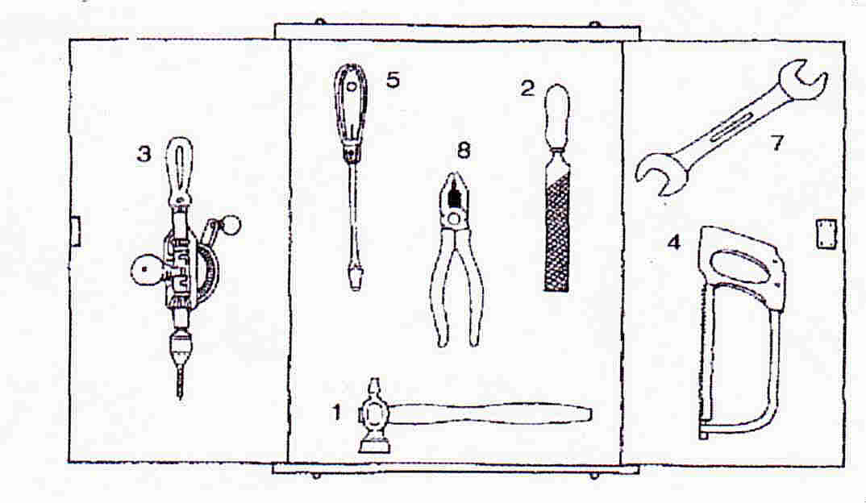
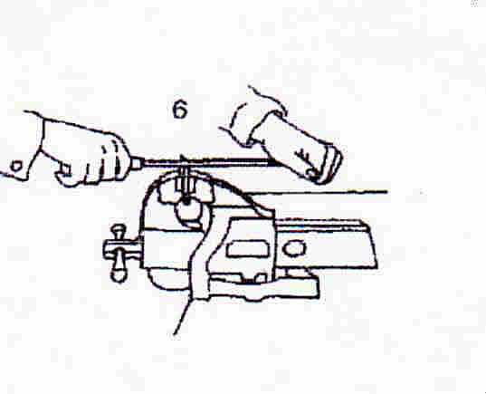

1a hammer 2 a file
3 a drill 4 a saw
5 a screwdriver 6 a vice
7 a spanner/wrench 8 a pair of pliers

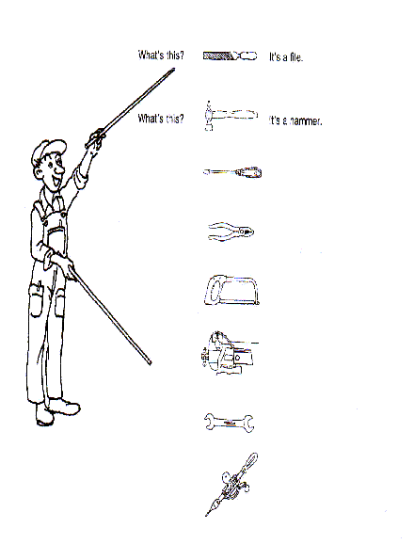

TOOLS – and how to work with them

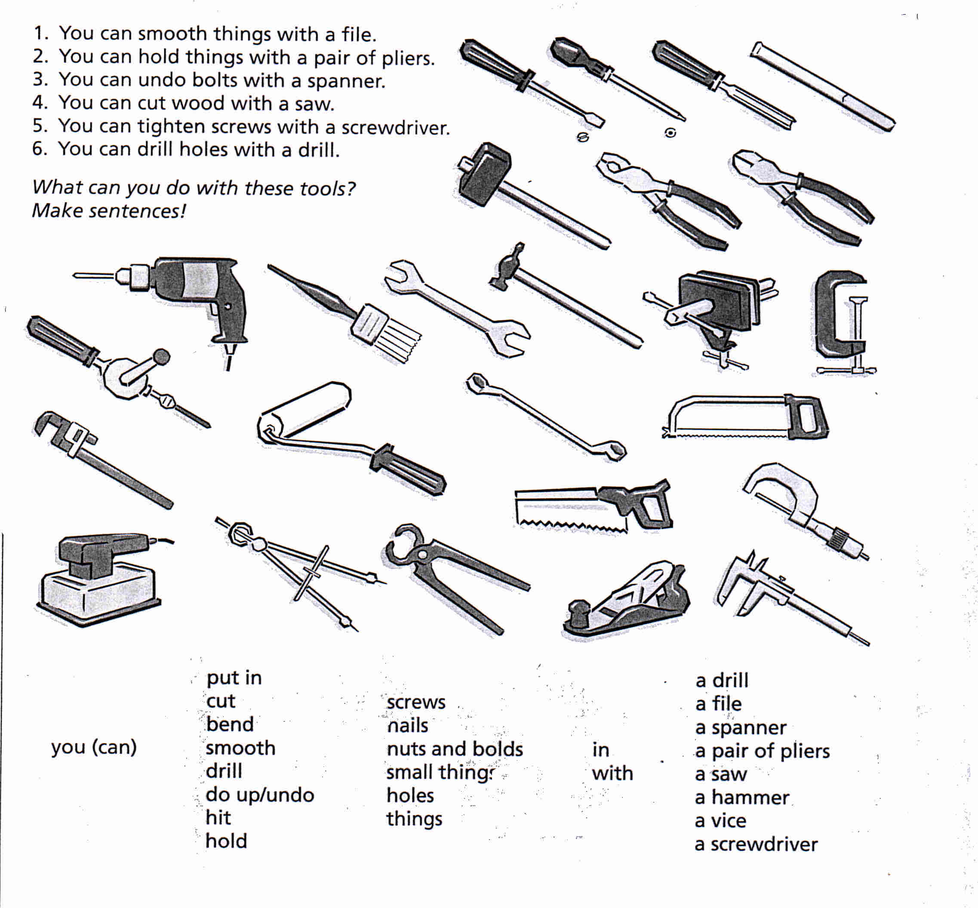

………………………………………………………………………………………………………………………………………………………………………………………………………………………………………………………………………………………………………………………………………………………………………………………………………………………………………………………………………………………………………………………………………………………………………………………………………………………………………………………………………………………………………………………………………………………………………………………………………………………………………………………………………………………………………………………………………………………………………………………………………………………………………………………………………………………………………………………………………………………………………………………………………………………………

TOOLS - and how to work with them
Complete this list.
Tools Job Verbs
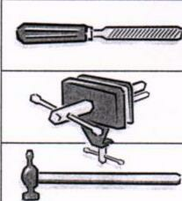
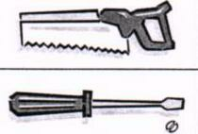
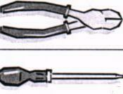

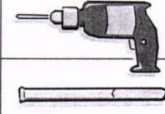

Use the information given to produce questions and small sentences like these:
1. Who uses a file? A mechanic uses a file to smooth rough objects.
2. What can you do with a hammer? With a hammer you can drive nails in.
3. Which tools does a joiner use? A joiner uses a mallet for woodwork.
4. What is a clamp used for? A clamp is used for holding things.

Tools and jobs

Form the sentences this way!
A joiner cuts wood with a saw.
A plumber drills a hole in the pipe.
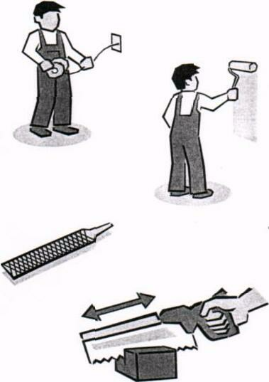
A painter paints ...................................................…….....
A tailor cuts ......................................................……….....
An electrician bends .........................................……….....
A car mechanic repairs ......................................………....
A technical draughtsman ...................................………...
A carpenter ..........................................................………..
With a file you can ..............................................………...
With a pair of pliers you can ..............................………....
With a hammer you can .....................................….......…

to switch off

to press
to push
to pull
to hold
to tighten
to loosen
to plane
to fill
to empty
to switch on
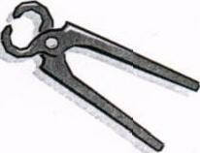
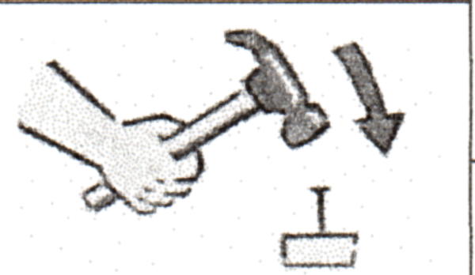

01. The drivers.........................the brake.
02. When I come home l.......................the television.
03. If you want to open the door of the car,
you must................... the handle.
04. If you like your girl-friend you ..................... her tight,
05. If the wood is too rough you.............................it.
06. When leaving the room you must...............the light.
07. At the end of the party you must............. the ashtray
08. Before working with an electric drill
you must............................................. the chuck.
09. Before changing the wheel, you must...........the nuts.
10. To open a can of coke, you .......... ring

Here are some more tools.
Write under each drawing the name of the tool and the job in which it is used.
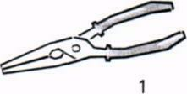
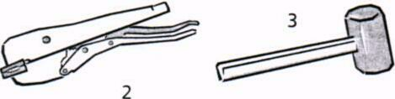

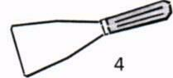

Form sentences like this:
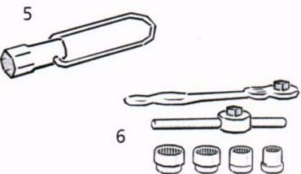

1. A mechanic uses pincers for twisting wires.
2...........................................................................
3..........................................................................
4...........................................................................
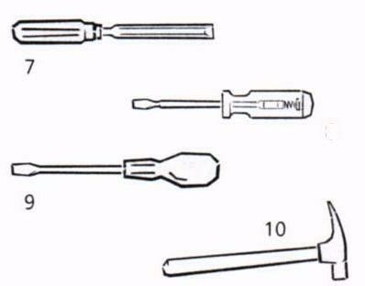
5...........................................................................
6...........................................................................
7...........................................................................
8...........................................................................
9............................................................................
10...........................................................................

Write down the correct English term. | Put in the job in which in tool.
01. Steinmeißel ..........................................................

02. Stechbeitel............................................................

03. Holzhammer........................................................

04. Zange....................................................................

05. Gripzange............................................................

06. Spannungsprüfer ................................................

07. Schraubendreher..................................................

08. Steckschlüssel ......................................................

09. Vierkantschlüssel.....................................'.............

10. Maurerhammer..................................................

11. Universalschlüssel ..............................................

TOOLS and JOBS -working with an electric drill
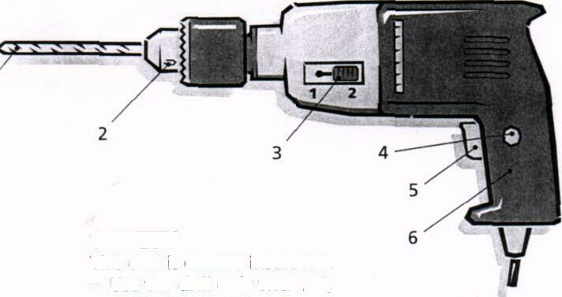

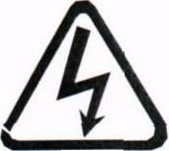
SAFETY
This drill is insulated twice.
Use the drill only with AC, correct voltage is 240. AC
Don't use the drill in wet places. DC
The cable must be in perfect condition.

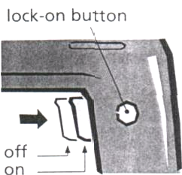
TRIGGER SWITCH
To work with the drill, you pull the trigger to pull
switch in the drill handle. For continuous to release
operation you pull the trigger switch and to operate
press the 'lock-on-button' at the side of
the switch. To stop continuous operation you only pull the trigger switch and release it afterwards.

.

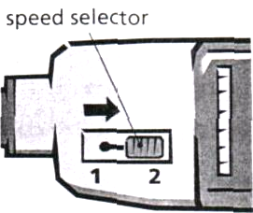
TWO SPEED SELECTOR
The drill has two speeds (1200 r.p.m. to select
and 3000 r.p.m.).
These are called high speed and low speed. To select the correct speed you push the switch in to position 1 or at the side of the drill.

LOOSENING in to THE CHUCK
Only use the correct chuck key. Put to tap
the chuck key in the chuck. Turn the to tighten
key anti-clockwise. If the key is tight, to loosen
tap the key with a small hammer.
To tighten the chuck again, turn the key clockwise.
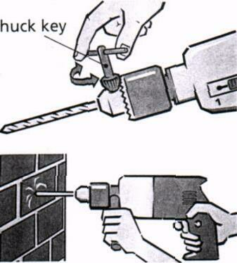

DRILLING
metal - use lubricant
wood - mark point of hole first, low speed
stone - use firm pressure, remove dust

Finish the sentences.

1. To operate the drill, pull........................................................................................
2. To select high speed,................................................................................. .........
3. To loosen the chuck...............................................................................................
4. For continuous operation .....................................................................................

Answer the questions.
- What does the trigger switch do?
………………………………………………………………………………………………
- How many speeds does it have?
……………………………………………………………………………………………
- What is the correct voltage for this drill?
……………………………………………………………………………………………
- Can it drill iron and steel?
……………………………………………………………………………………………
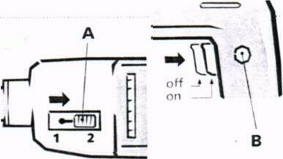
- When do you use high speed and when low speed?.
………………………………………………………………………………………………
- What switches are A and B and what are they used for?
……………………………………………………………………………………………..

Right or wrong? | YES | NO
1. You can use the drill with AC and DC current.

2. To stop continuous operation you tap the trigger with a hammer.

3. It is possible to use the drill when it is wet.

4. You turn the key clockwise to loosen the chuck.

5. The correct voltage is 110 volts.

6. To tighten the chuck you use a chuck key.

7. To operate the drill you press the trigger switch.

8. You must use high speed for small holes.

9. When drilling stone press very hard.

5. Saying Numbers

1. NUMBERS
1 one 11eleven
2 two 12 twelve
3 three 13 thirteen
4 four 14 fourteen
5 five 15 fifteen
6 six 16 sixteen
7 seven 17 seventeen
8 eight 18 eighteen
9 nine 19 nineteen
10 ten 20 twenty
21 twenty-one 200 two hundred
22 twenty-two 220 two hundred and twenty
23 twenty-three 1,000 a / one thousand
30 thirty 1 ,000,000 a/one million
40 forty 3 ,520,000 three million five
50 fifty hundred and twenty thousand

2. OH, Zero, Love, Nought, Nil !

The above are all ways of saying 0 in English.

We say oh after a decimal point 5.03 five point oh three
in telephone numbers 670138 six seven oh one three eight
in bus numbers No. 701 get the seven oh one
in hotel room numbers Room 206 I` m in room two oh one
in years 1905 nineteen oh five

We say nought before the decimal point 0.02 naught point oh five

We say zero for the number 0 the number zero
For temperature - 5º C five degrees below zero

We say nil in football scores 5 – 0 Spain won five nil
We say love in tennis 15 – 0 The score is fifteen love

Now say the following:

- The exact figure is 0.002.
- Can you get back to me on 01244 249071 ? I’ll be here all morning.
- Can you put that on my bill ? I’m in room 804.
- Do we have to hold the conference in Reykjavik ? It’s 30 degrees below 0 !
- What’s the score ? 2 – 0 to Juventus.

- THE DECIMAL POINT

In English, we use a point ( . ) and not a comma ( , ) for decimals. We use commas in figures only when writing thousands.

10, 001 is ten thousand and one

10.001 is ten point oh oh one

When accounts are prepared on computer, commas
Are not used. The number appears as 82103

In English all the numbers after a decimal point are read separately:

10.66 ten point six six Not ten point sixty six

  - naught point three two five

0.001 naught point oh oh one or 10⁻³ , ten to the power minus three

You will also hear people say:

0.05 zero point oh five or oh point oh five

But if the number after the decimal point is a unit of money, it is read like a normal number:

£ 12.50 twelve pounds fifty DM 2.95 two marks ninety five

- PERCENT

The stress is on the cent of per cent ten percent.

Notice the following when talking about interest rates:

0.5 % a half of one per cent

0.25% a quarter of a percentage point

- HUNDREDS, THOUSANDS, AND MILLIONS

In British English you hear: a hundred and twenty three

In American English you usually hear: a hundred twenty three

The number 1,999 is said: one thousand nine hundred and ninety nine

The year 1999 is said: nineteen ninety nine

The year 2000 is said: the year two thousand

The year 2001 is said: two thousand and one

The year 2015 is said: two thousand and fifteen or twenty fifteen

- SQUARES, CUBES, AND ROOTS

10² is ten squared.

10³ is ten cubed.
$$\sqrt{6}$$
is thee square root of 6.

- TELEPHONE AND FAX NUMBERS

We usually give telephone and fax numbers as individual digits:

01273 736344 oh one two seven three, seven three six, three four four

  - can also be said as three double four

44 26 77 double four, two six, double seven

- can be said as seven double seven, or seven seven seven

- FRACTIONS

Fractions are mostly like ordinal numbers (Fifth, sixth, twenty third etc ):

a third a fifth a sixth

Notice, however, the following:

a half a quarter three quarters

three and a half two and three quarters

- CALCULATING

Remember to pronounce the s in equals as /z/. It is singular; the part on the left equals the part on the right.

10 + 4 = 14 ten plus four is fourteen
ten and four equals fourteen

10 – 4 = 6 ten minus four is six
ten take away four equals six

10 x 4 = 40 ten times four is ( or equals) forty
ten multiplied by four is forty

10 : 4 = 2 ½ ten divided by four is two and a half

+ = add - = subtract (or deduct) x = multiply : = divide

For most purposes these units are too large for use in low-power electronic circuits. The following symbols and prefixes are used:

Symbol Prefix Multiplier

M mega one million 10⁶

k kilo one thousand 10³

m milli one thousandth 10⁻³

μ micro one millionth 10⁻⁶

n nano one thousand millionth 10⁻⁹

p pico one million millionth 10⁻¹²

Review
How many of the following can you say aloud in under 1 minute ?

  - 234,567
  - 1,234,567,890
  - 1.234
  - 0.00234 %
  - 3.14159
  - $19.50
  - £7.95
  - 19,999
  - 1,999 years
  - In 1999
  - I think the phone number is 01227-764000
  - Have you got a pen ? Their fax number is: 00 33 567 32 49
  - Please pay it into my account-number G4.744.440
  - He was born in 1905 and died in 1987
  - It’s a white Lamborghini Diablo, registration number MI 234662, and it look as if it’s doing 225 kilometers an hour !
  - 30 x 25 = 750
  - 30 + 25 = 55
  - x² + y³ = z

6. ELECTRICAL INSTALLATION

Safety First

6.1. Better safe than sorry !!

- If a current of more than 50 mA flows through the body, brain functions are disturbed.

- Even a weak current of just over 50 mA can kill if it flows through the heart.

- If the current is greatly in excess of 50 mA, it becomes impossible to let go of the conductor, ie to break the circuit

For safety at work check that

Five rules for safe electrical work:

Freischalten → switch off electricity

Gegen Wiedereinschalten sichern → ensure that electricity cannot be
switched on again

Spannungsfreiheit feststellen → double check that no electrical
current is flowing

Erden und kurzschließen → ground the circuit
Abschranken, abdecken, (benachbarter)→ cover or otherwise isolate
unter Spannung stehender Teile components that are still
electrically active

Safety Signs

Warning Signs - Category II or III holding positions sign

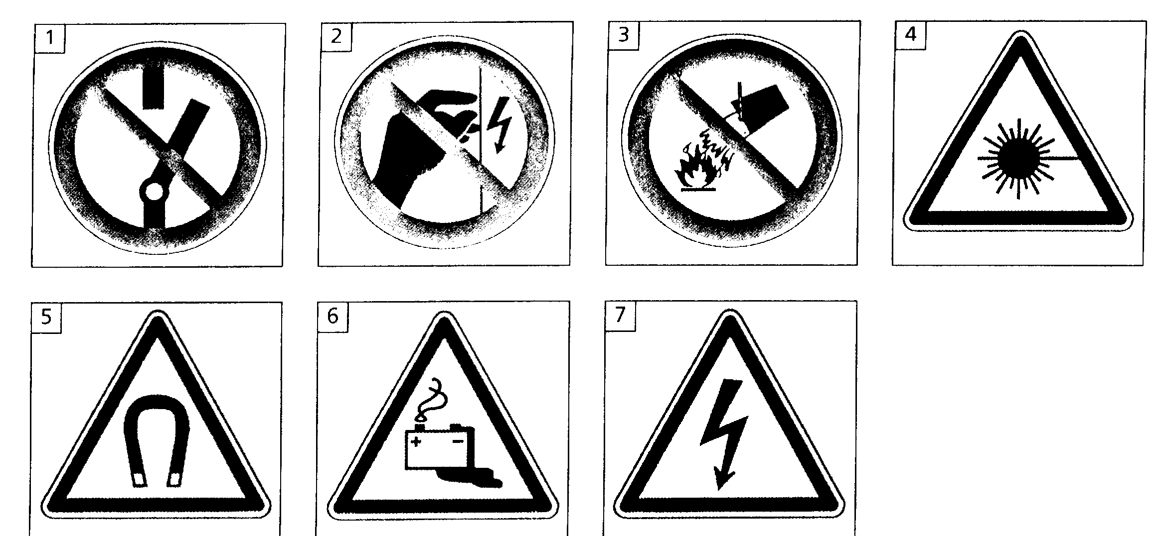

- Don`t switch on
- Don`t touch
- Don`t fight fire with water
- Danger laser beam
- Danger magnetic field
- Danger battery
- Danger high voltage

6.2. Electrical shock
6.2.1. Cause and effect

Read the text about the effects of electric shock. Then look at the statements next to the text and tick the right ones.

Effects: An electric current passing through the body causes electric shock. Electrical shock especially affects the heart (upsetting its rhythm and the flow of blood), the muscles and the nervous system. The severity depends on the strength of the current. And the time for which it passes, although age. general health and moistness of the skin are also factors.
The strength of the current depends on the voltage applied to the body and its resistance. The latter may exceed 10 kΩ or it might be less than 1.5 kΩ if the skin is moist. If the voltage is 240 V and the body resistance 1.5 kΩ, the current through someone directly in contact with the earth is 240 V/1.5 kΩ = 160 mA (which would be fatal). The current is less (e.g. 50 mA) because the resistance of the tiles and the wood floor has to be added to that of the body but a severe shock would still be obtained.

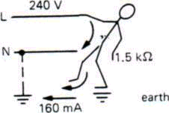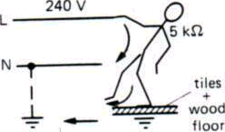

Fatal shock Severe shock

Electric shock
o is caused by electric current.
o upsets the rhythm of the heart.
o causes muscle cramps.
o affects the nervous system.

Electric shock is more severe
o the higher the current is.
o the longer voltage is applied.
o the older the person is.
o the lower the body resistance is.

The value of the current depends
o on the voltage.
o on the body resistance.
o on the person is.
o on where the person stands.

6.2.2. First aid

First aid is essential in case of electric shock. Breathing must be restored, or death will result. The following procedure should be followed.

a) Switch off the supply
b) If this cannot be done, drag or push the victim away from the live wire, using an insulator!
c) Send for medical help immediately.
d) Apply artificial respiration until help arrives.
This must be continued even if it is for a long period.

- Help

Look at the following words.
o accident o apply
o address o electric shock
o ambulance o unconscious
o artificial respiration

Listen to the telephone call and tick the words when you hear them.

Listen again and complete the bubbles.

A colleague at work just had………………………………………………………………..
He’s suffering from…………………………………………………………………………

Try …………………………………………………………………………………………
We’ ll send an……………………………………………………………………………..

Get an ambulance

You are working in your company and, suddenly, a colleague next to you suffers an electric shock.Work in groups of 3 or 4. One is calling for help. the others give first aid.
6.3. Installation Symbols

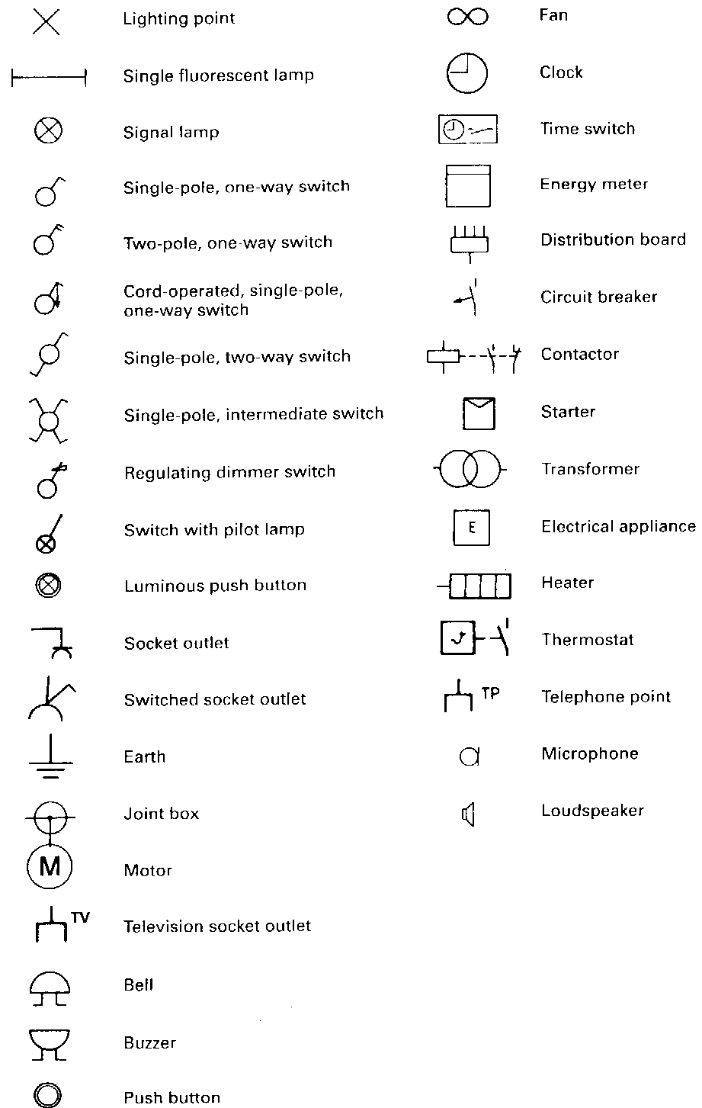

Chek the vocabulary

What do to following symbols mean in english?
a) b) c) d) e) f)
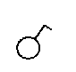
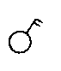
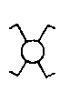
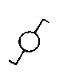
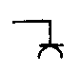
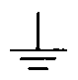
  - electrical installation

The wire

Low resistance earth wire → green/yellow
Live or positive wire → brown
Neutral wire → blue

6.4.1. Ausschaltung → one way circuit

Stromlaufplan schematic diagram

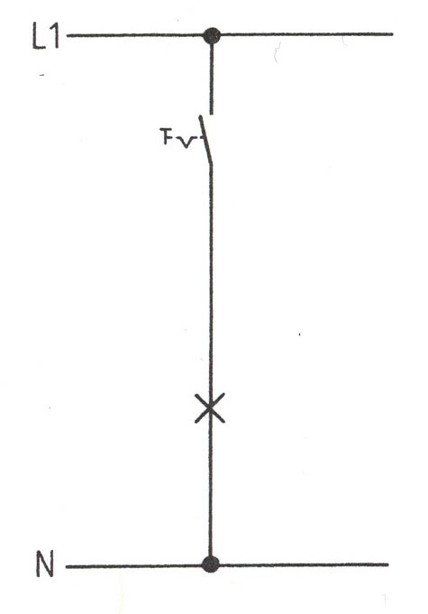

Installationsplan architectural diagram

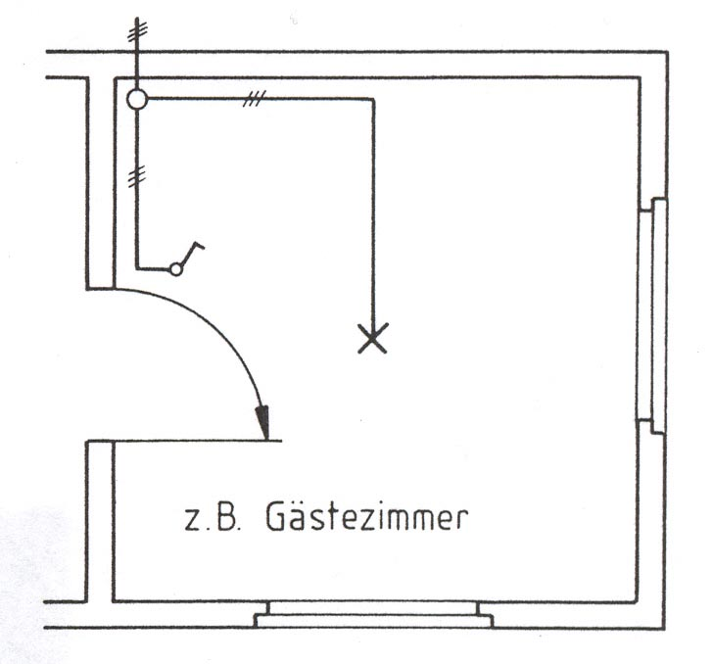

Child´s room

6.4.2. Serienschaltung → series-parallel connection

Stromlaufplan schematic diagram

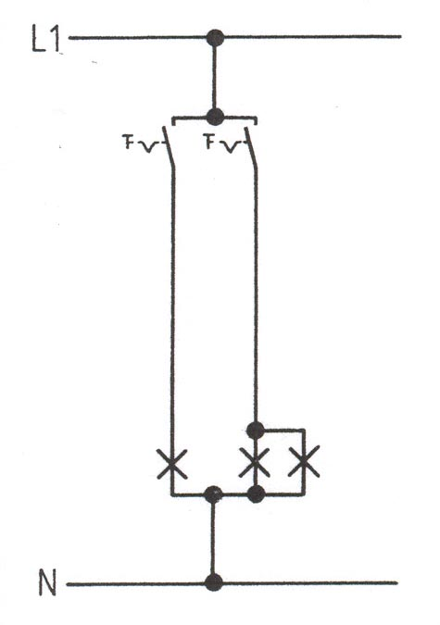

Installationsplan architectural diagram

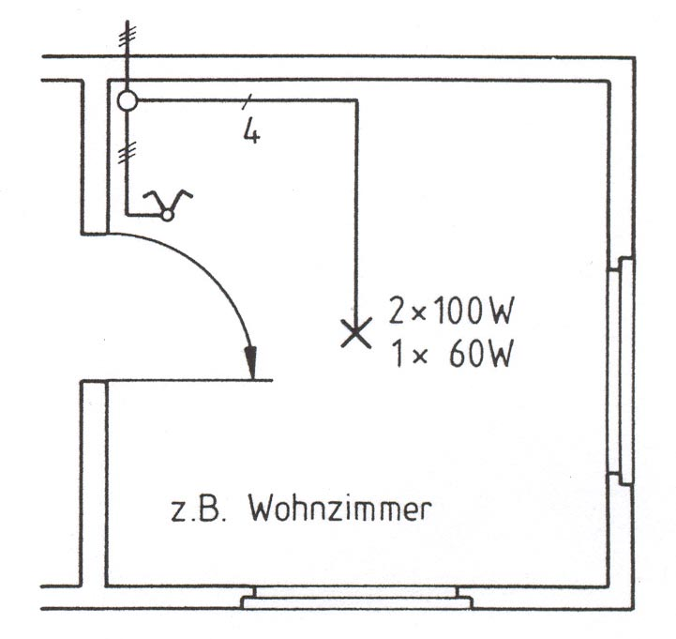

Living room

6.4.3 Wechselschaltung → two way circuit

Stromlaufplan schematic diagram

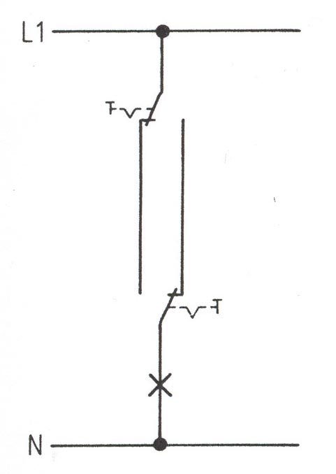

Installationsplan architectural diagram

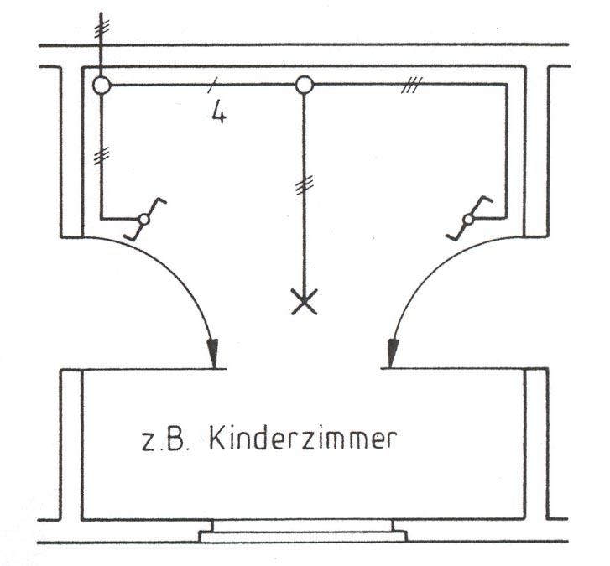

Hallway

6.4.4 Kreuzschaltung → cross conection

Stromlaufplan schematic diagram
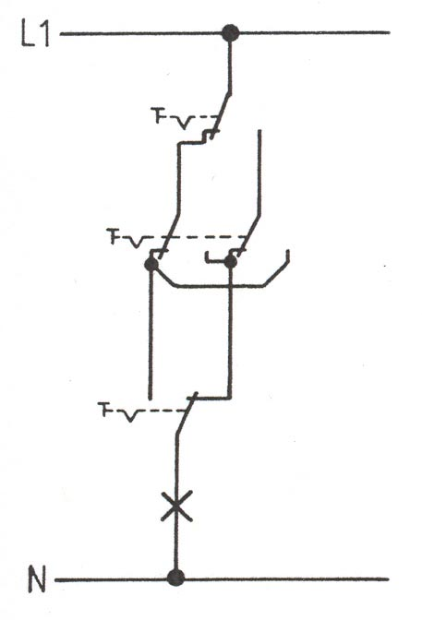

Installationsplan architectural diagram
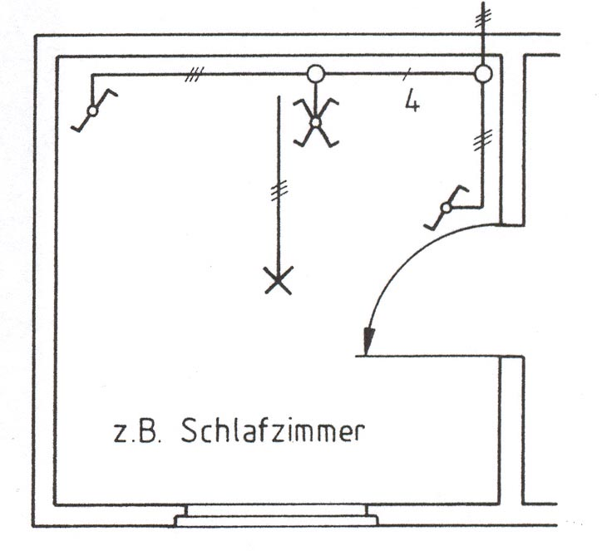

Bedroom

Words:

socket Steckdose
Child room
junction box Abzweigdose
puch button switch Taster

7. Electric Current and Electric Circuits

Using a multimeter to take measurements

Voltage
When measuring voltage, the meter and the component must be in parallel. First place the
probes on the two points you want to measure, making sure that the probes are in parallel with
the circuit. Switch the multimeter to the correct voltage range, and then switch the circuit on. The
display will show the difference in voltage between the two points.
IMPORTANT: A voltmeter is always connected in
parallel or across the circuit Never in series. To measure
voltage the circuit does not have to be broken.

Current
When the multimeter is used to measure current, current must flow through the meter itself.
Break the circuit and connect the meter in series with the wire carrying the current. Then set the
meter to a suitable current flow range and switch the circuit on. The display will show the amount
of current flowing through that point of the circuit.
IMPORTANT: An ammeter must always be connected
in series with a circuit Never across or parallel with it
To make a series connection requires breaking the
circuit to connect the meter. A parallel connection may
destroy the meter.

Resistance
To measure the resistance of a component, you have to disconnect the meter from the circuit.
Otherwise the circuit will affect the reading. Switch the meter to the 'Ohms' range. Connect the
probes across the component and read the resistance from the display.

Note:
When measuring an unknown level of voltage range selector or current, you should switch the to
the highest setting possible to avoid damaging the multimeter.

Use information from the text to help a partner. Tell him or her:

1. Why a digital meter is better than an analogue one ?
2. When an analogue meter is more useful than a digital one ?
3. How to place the test probes when measuring voltage ?
4. How to place the probes when measuring current ?
5. How to use the multimeter to measure resistance ?
6. How to set the range selector when measuring unknown quantities ?

EXERCISE 1
OHM'S LAW EXERCISE
EQUIPMENT REQUIRED
Prototype board; avometer or two digital multimeters; Variable power supply; Resistors 220Ώ, 470 Ώ, 1k Ώ

THEORY

Resistor
Resistance is a material property that opposes the flow of a current: the current cannot move easily through the conductor.
Normally, a conductor offers only low resistance whereas an insulator offers high resistance.
Resistors are components in a circuit that have specified values of resistance. The function of a resistor is to control the amount of current flow in a circuit. The unit of measurement for resistance is an ohm. There are different types of resistors.
They vary in resistance as a knob is turned and are often used for changing the sensitivity of a sensing circuit or reducing the feedback to an amplifier, i.e. volume control on a radio or CD player.

Ohm's Law
Ohm’s law is a very important principle to learn. It defines the relationship between the
voltage (U), the current (I), and the resistance (R).
Simply stated: U(Voltage) = I (current) x R(Resistance).

The easiest way to remember this formula and rearrange it is to use the magic
triangle. The magic triangle makes it easy to find the missing unit.
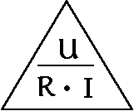
If you know the current (I) and the resistance (R), then U = I x R
If you know the voltage (U) and the resistance (R), then I= U/R
If you know the current (I) and the voltage(V), then R=U/I

This system is now easy to use. For example, an LED in a 6 V circuit requires a resistor to
limit the flowing through it to 15 mA (0.015 A ).
What value resistor is needed ?

( The value of the required resistor is 400 Ώ).

As you know. electrical energy is transformable into other forms of energy. Electrical power (P) is the amount of transformed energy per unit of time. Ohm' s law also helps you to calculate the amount of electrical power in a circuit.

The unit of measurement for electrical power is a watt. The power in watts equals the
product of the amperes and the volts:

P =U x I

But how can you calculate the power if the voltage is unknown?
Look at the formula above: U = R x I. , so P = R x I².

Ohm's Law states that the current flowing through a resistor is directly proportional to the voltage across it, and is inversely proportional to the resistance.

TEST CIRCUIT
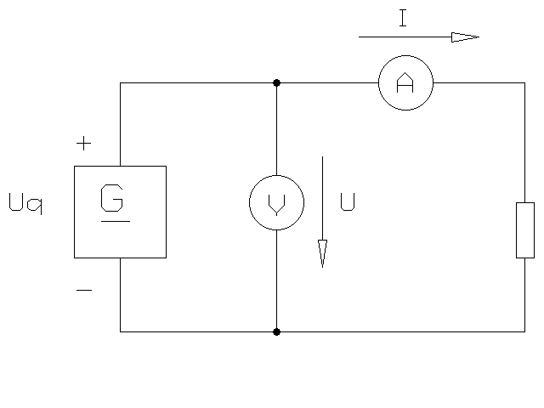

STUDENTS INSTRUCTIONS
- Connect the circuit above on the prototype board, using the 220R resistor. Set the power
supply initially to zero volts. Then, following the table below, increase the voltage in 0.5V
steps - measure and record the current flowing through the resistor each step.
- Repeat the procedure for the 470R and 1k resistors.
- On a single graph, plot the results for all three resistors.

RESULTS
Volts | Current (220R) | Current (470R) | Current (1k)
0
0.5
1.0
1.5
2.0
2.5
3.0
3.5
4.0
4.5
5.0

Please fill in

1 An electric current_________________________(flow) round the circuit.
2 The electrons___________________________ (move) in one direction.
3 The p. d._______________________________ (push) the current through the conductor.
4 Resistors_______________________________________(control) the amount of electrons.
5 Plastics________________________________________(resist) the flow of a current.
6 You____________________________________________(calculate) the current with Ohm's law.
7 A current can_________________________________ (move) through a conductor.

EXERCISE 2
SERIES RESISTORS EXERCISE
EQUIPMENT REQUIRED Prototype board, avometer or two digital multimeters Variable power supply; Resistors 2 x 470 Ώ, 1k Ώ; Leads
Theory

Resistor in series
Resistors in series (one after the other)
The total value of resistors in series is found by simply adding all the separate
values together:
Rtotal = R1 +R2 + R3, etc.
The total resistance is always greater than the value of the largest resistor in the chain.

Current I flows through all series loads which are connected one after the other or the
electricity/current flows in a single path.
That means: I = I₁ = I₂ = I₃ = constant

Each series load needs its own individual voltage.
That means: Utotal = U₁ + U₂ + U₃ + ...

The total resistance of series connections loads, consumers, etc. is equal to the sum
of all these resistances.
That means: R_{total} = R₁ + R₂ + R₃ + ...

In any series circuit the sum of the voltages across each component is equal to the voltage supply. The current through each resistor is identical. The resistors could be replaced by a single equivalent resistor equal to the sum of the other resistors, that would draw the same current from the supply.
You find such series connections in light chains e. g. on Christmas trees. If
one lamp is damaged, the others don't bum either.

TEST CIRCUIT

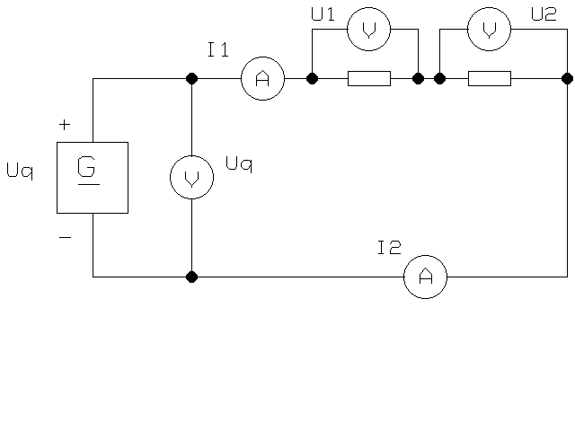

STUDENTS INSTRUCTIONS
Connect the circuit above on the prototype board. Set the power supply initially to 5V. Measure and record the voltages across each resistor, the power supply voltage, and the current flowing in the circuit. Then repeat the measurements for supply voltages of 10V and 15 V.

RESULTS
Measurement | PSU= 5V | PSU= 10 V | PSU= 15 V
Voltage across R₁
Voltage across R₂
Voltage across R₃
Sum of voltages across R1.R2.R3
Measured power supply voltage
Measured current
Sum of the resistors
Calculate the supply current

Ohm's Law states V = I x R. Calculate the voltage across R1, R2, and R3 using the current (measured in section 1) for each of the three supply voltages. Tabulate your calculations on a separate sheet.
Compare the calculations with the measurements. Give two reasons for any errors.

EXERCISE 3
PARALLEL RESISTORS EXERCISE
EQUIPMENT REQUIRED
Prototype board; avometer or two digital multimeters; variable power supply resistors 470 Ώ, 1k Ώ;
THEORY
In any parallel circuit, the sum of the currents in each branch, is equal to the supply current. The voltage across each component is identical.

Parallel circuits
1. Current I flows in individual paths.
That means: I_{total} = I₂ + I₃

2. Each parallel load has the same voltage like the source voltage.
That means: U = U₁ = U₂ = U₃

3. The total resistance is the sum of the individual resistances in a
parallel circuit.
That means: $\frac{1}{\text{Rtotal}}=\frac{1}{R1}+\frac{1}{R2}+\text{.}\text{.}\text{.}$

Notice ! You find such parallel connections in house wiring.
_ _ _

TEST CIRCUIT
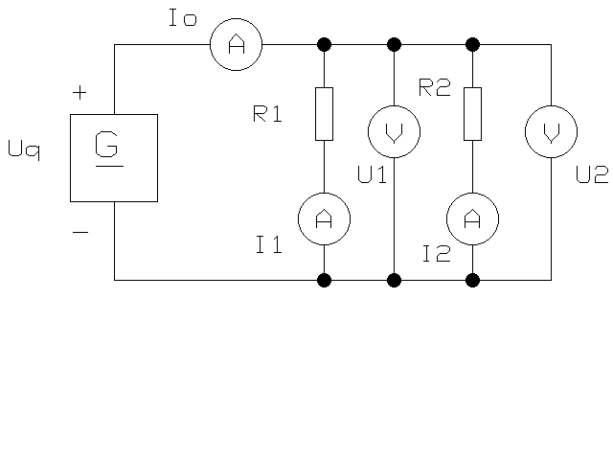

STUDENTS INSTRUCTIONS
Connect the circuit above on the prototype board. Set the power supply to 5V. Record your results in the spaces below. Measure and record the supply voltage and the current flowing in each branch of the circuit (through each resistor). Calculate the sum of the currents flowing through R1, R2, and R3. Measure the total current supplied. Calculate the total resistance of the three resistors in parallel. Using Ohm's Law, and the result from section 3., calculate the total current drawn from the
supply. The supply voltage was increased to 10V and 15 V. What current would be drawn from the PS U now. What would be the current in each resistor at 10 V and 15 V. Confirm your calculations by measurement ?

RESULTS
Measurement | PSU= 5V | PSU= 10 V | PSU= 15 V
Measured supply voltage
Measured current through R1
Measured current through R2
Sum of currents through R1, R2,
Measured total current
Calculated total resistance
Calculated total current

Ohm's Law states I = U / R. Calculate the current trough R1, R2, and R3 using the voltage(measured in section 1.) for each of the three supply voltages. Tabulate your calculations on a separate sheet. Compare the calculations with the measurements. Give two reasons for any error.

EXERCISE 4
Simple circuits - Network with RESISTORS
EQUIPMENT REQUIRED Prototype board, avometer or two digital multimeters Variable power supply; resistors 100 Ώ, 220 Ώ, 470 Ώ, 1k Ώ; 2k Ώ; 4,7k Ώ
Theory In any series circuit the sum of the voltages across each component is equal to the voltage supply. The current through each resistor is identical. The resistors could be replaced by a single equivalent resistor equal to the sum of the other resistors, that would draw the same current from the supply. In any parallel circuit, the sum of the currents in each branch, is equal to the supply current. The voltage across each component is identical.
TEST CIRCUIT

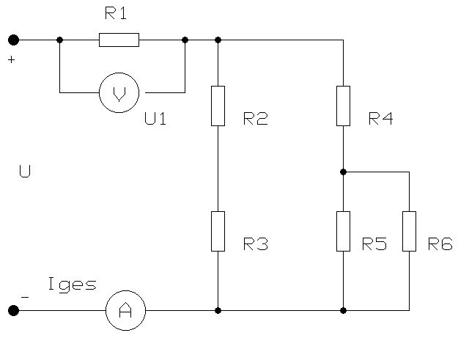
����

STUDENTS INSTRUCTIONS
Connect the circuit above on the prototype board. Set the power supply to 5V. Recordyour results in the spaces below. Measure and record the supply voltage, the voltageacross the resistors and the current flowing in each branch of the circuit (through eachresistor).Calculate the sum of the currents flowing through R1, R2, R3, R4, R5 and R6. Measure thetotal current supplied.Calculate the total resistance .Using Ohm's Law, and calculate all currents and all voltages.Confirm your calculations by measurement.
Results
 | Measurement | Calculate
Measured PSU |  | 5 V
Total resistance
Voltage across R₁
Voltage across R₂
Voltage across R₃
Voltage across R₄
Voltage across R₅
Voltage across R₆
Current through R₁
Current through R₂
Current through R₃
Current through R₄
Current through R₅
Current through R₆
Total current

EXERCISE 5
Thermal Resistors
EQUIPMENT REQUIRED
Prototype board; avometer or two digital multimeters; Variable power supply; Resistors 47R; NTC and PTC
THEORY
Thermal resistors or thermistors are temperature-dependent resistors. They are made of semiconductor materials that are highly sensitive to changes in temperature. This property of thermistors has many important applications such as the measurement and control of temperature, for example in fire alarms. Thermistors can have a negative or a positive temperature coefficient. So there are two types of device: the NTC and the PTC thermistor. Manufacturers also use these typical curves to indicate the dependency of a special NTC-device on the temperature.
The resistance of an NTC can change through
a) external heating or through
b) self-heating. There is only a low current flow in the thermistor so that there is practically no heating. In this way the resistance is only influenced by the temperature outside the NTC. Therefore externally heated NTC’ s are commonly used as temperature detectors. There is a strong current flow in the NTC so that the device heats up. The final temperature depends on the cooling medium (air, water, oil, vacuum). So it is possible to use self-heating NTC’ s as detectors for the flow rate of gases and liquids and for the measuring of vacuums.

TEST CIRCUIT

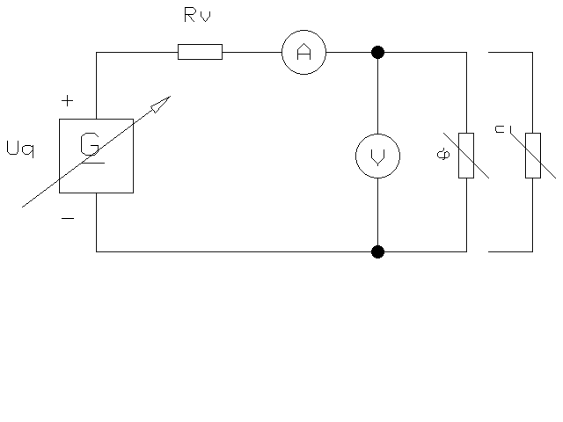

STUDENTS INSTRUCTIONS
Connect the circuit above on the prototype board, using the 47R resistor and the NTC. Setthe power supply initially to zero volts. Then, following the table below, increase thevoltage in 0.5V steps - measure and record the current flowing through the NTC eachstep.Repeat the procedure for the PTC. Repeat the procedure for the lamp (6 V) .On a single graph (I= f(U), plot the results for all three resistors.
RESULTS
Volts | Current NTC | Current PTC | Current (lamp 6V)
0
0.5
1.0
1.5
2.0
2.5
3.0
3.5
4.0
5.0
6.0

EXERCISE 6
Diodes
EQUIPMENT REQUIRED
Prototype board; avometer or two digital multimeters ; variable power supply; resistors 47R; Si-diode and Ge-diode

THEORY
A diode is a two-terminal semi-conductor. It has’ a positive pole, the anode, and a negative pole, the cathode. A diode can have a high or a low resistance depending on the polarity of the voltage supply. That means that a diode is a kind of one-way street: it permits the current to flow in only one direction.
There are two ways in which a diode can operate:
- it can operate in the reverse-biased mode,
- 2) it can operate in the forward-biased mode.

1) A diode has high resistance if the anode is more negative than the cathode
Operating in reverse-biased mode, a diode has a high resistance. The reverse resistance
(R_{R}) can be higher than 10 MΏ. And although the diode blocks the current, there is still a minimal flow: the reverse current I_{R}. Depending on the type of diode, the reverse voltage V_{R} varies between 20 and 1500 volts.

2) A diode conducts if the anode is more positive than the cathode.
Operating in forward direction, the diode has only low resistance and so offers high conductance to the current (Ip). The voltage drop in the forward-biased direction (VR) depends on the intensity of the current (Ip) and the material of which the diode is made (germanium: U_{F} = 0.3V or silicium: UF = 0.7V).

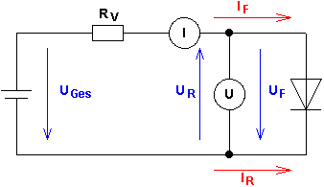
TEST CIRCUIT

���

STUDENTS INSTRUCTIONS

1) A diode has high resistance if the anode is more negative than the cathode.
Connect the circuit above on the prototype board, using the 47R resistor and the Si-diode. Set the power supply initially to zero volts. Then, following the table below, increase the voltage in 0.1V steps - measure and record the current flowing through the diode each step. Repeat the procedure for the Ge-diode.

2) A diode conducts if the anode is more positive than the cathode.
Connect the circuit above on the prototype board, using the 47 Ώ resistor and the Si-diode. Set the power supply initially to zero volts. Then, following the table below, increase the voltage in 1V steps - measure and record the current flowing through the diode each step. Repeat the procedure for the Ge-diode.
On a single graph (I= f(U), plot the results for all diodes.

RESULTS 1) A diode has high resistance if the anode is more negative than the cathode

Volts | Current Si-diode | Current Ge-diode
0
1
2
3
4
5
6
7
8
9
10
11
12
13
14
15

2) A diode conducts if the anode is more positive than the cathode.
Volts | Current Si-diode | Current Ge-diode
0
0. 1
0. 15
0. 2
0. 2.5
0. 3
0. 4
0. 5
0. 6
0.7

EXERCISE 7

Light-Emitting-Diodes

EQUIPMENT REQUIRED
Prototype board; avometer or two digital multimeters; variable power supply; resistors 47Ώ; light emitting diode (LED) green and red
THEORY
This type of diode gives off light when current flows through it in the right direction (called forward biasing). LEDs can only take a small current, usually 20mA maximum otherwise they will be damaged. For this reason they should always be used with a current limiting resistor.

TEST CIRCUIT

���

STUDENTS INSTRUCTIONS
Connect the circuit above on the prototype board, using the 47Ώ resistor and the red-LED. Set the power supply initially to zero volts. Then, following the table below, increase the voltage in 0.2V steps - measure and record the current flowing through the diode each step.
Repeat the procedure for the green-LED.
On a single graph I= f(U), plot the results for all diodes.

RESULTS
Volts | Current LED (green) | Current LED (red)
0
0.2
0.4
0.6
0.8
1.0
1.2
1.4
1.6
1.8
2.0
2.2
2.4

Excercise 8
Capacitors

1. Theory

Capacitors

Capacitors are the constructive elements, which are able to store electrical charges for example electrical energy.

In it’s simplest form a capacitor consists of two metal plates lying opposite each other.

Between these metal plates lies a ‘dilektric materia’, which prevents any electrical connection between the two plates. (Isolator)

When the capacitor is connected to a voltage an electrical field develops between the two plates.

‘Charging-time’ of a Capacitor.

To calculate the charging-time the value of the resistance on the capacitor and of the capacitor itself will be needed.

The level of voltage has no influence on the time it takes to charge.

Charging occurs quicker;

- The smaller the capacitor is.
- The smaller the circuit resistance is.
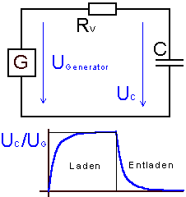

Calculation of the charging-time
R * C is only a fraction of the charging time.
Time constant τ
τ=R*C

After 5 Time constants the capacitor is charged
t_{E} = 5 * τ

Capacitors in a direct current circuit.

- When switched on the capacitor operates as a short circuit.
- The capacitor can store electrical energy.
- Obstructs the direct current
- charges and discharges itself in an E-function.

When switched on the electricity heavily increases.

After which the capacitor becomes high ressistance so that the electricity decreases and the voltage increases.

t

Voltage: $\text{Uc}=U∗(1−e−\frac{t}{RL∗C})$

Current: $\text{Ic}=\frac{U}{RL}∗e−\frac{t}{RL∗C}$

When switched on t= 0s $\text{Ico}=\frac{U}{RL}$

Discharge capacitor
When discharge the voltage diminishes and the current rises. The current runs in the other direction.

Voltage: $\text{Uc}=U∗e−\frac{t}{RE∗C}$

current:

When switched on t= 0s $\text{Ico}=\frac{U}{RE}$

Exercises

1. Measure the voltage charge and discharge in 10 s measurements until the capacitor is charged.
Caution: Amps reverse the charge.
2. Measure the voltage charge and discharge. in 10s until the capacitor is charged.
3. Calculate the starting current.
4. Show the diagrams for the voltage charge and discharge, current charge and discharge on a piece of millimeter squared paper in oblong format.

MEASURING DIAGRAM
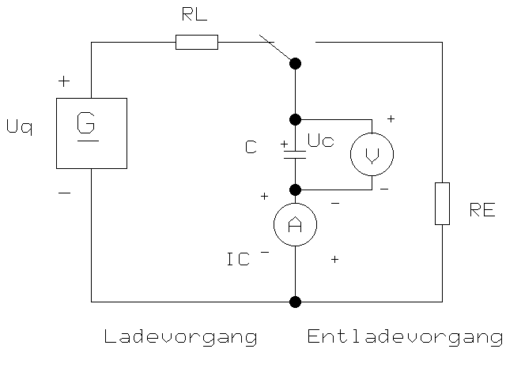

C= 470 µF

RL= 47 kΏ

RE= 47 kΏ

Uq= 15 V

CHARGE
DISCHARGE

Result - Diagram
 | L A D E V O R G A N G |  |  | E N T L A D E V O R G A N G
Zeit in Sek. | Ic in Ampere | Uc in Volt |  | Ic in Ampere | Uc in Volt
0 | 0,000319149 | 0 |  | 0,000319149 | 15
10 | 0,000202951 | 5,46130509 |  | 0,000202951 | 9,53869491
20 | 0,000129059 | 8,93421996 |  | 0,000129059 | 6,06578004
30 | 8,20704E-05 | 11,1426916 |  | 8,20704E-05 | 3,85730835
40 | 5,21896E-05 | 12,5470875 |  | 5,21896E-05 | 2,4529125
50 | 3,31881E-05 | 13,4401611 |  | 3,31881E-05 | 1,55983893
60 | 2,11047E-05 | 14,0080782 |  | 2,11047E-05 | 0,99192185
80 | 8,53444E-06 | 14,5988814 |  | 8,53444E-06 | 0,40111865
100 | 3,4512E-06 | 14,8377935 |  | 3,4512E-06 | 0,1622065
120 | 1,39562E-06 | 14,9344061 |  | 1,39562E-06 | 0,06559393
140 | 5,64366E-07 | 14,9734748 |  | 5,64366E-07 | 0,02652522
160 | 2,28222E-07 | 14,9892736 |  | 2,28222E-07 | 0,01072641
180 | 9,22894E-08 | 14,9956624 |  | 9,22894E-08 | 0,0043376
200 | 3,73205E-08 | 14,9982459 |  | 3,73205E-08 | 0,00175406
240 | 6,10293E-09 | 14,9997132 |  | 6,10293E-09 | 0,00028684
300 | 4,03575E-10 | 14,999981 |  | 4,03575E-10 | 1,8968E-05

DIAGRAM

Evaluation

1. Use the time constant τfrom the measured functions and calculate it from C.
2. Calculate the from U_{rl}=f(t) and add it to the diagram.
3. How do the charge and discharge times change when C; R_{e} and R_{l} change.
4. Name possible uses of capacitors.

Words

Capacitor Kondensator
capacity Kapazität
dielectric material Dielektrikum
charge Ladung
discharge Entladung



Wörterbuch

Elektrotechnik

Dictionary

Electrical Engineering

Deutsch | Englisch
A
abfallverzögertes Relais | dropout-delay relay
Abfallverzögerungszeit | fall delay
abgegebene Leistung | output power
abgeleitete Einheit | derived unit
abgesichert | protected by fuse
abisolieren | to strip
abisolieren, auseinandernehmen | strip
Abisoliergerät | insulation stripper
Abisolierzange | wire stripping pliers
abklemmen | disconnect
abkühlen | cool down
Abkürzung | abbreviation
Ablaufplan | flowchart
Ablenkplatte | deflector plate
Ablenkung | deflection
Ablesefehler | reading error
abreißen | demolish
Abreißfunken | break spark
abschalten | switch off
Abschaltspannung | breaking voltage
Abschaltung | disconnection
Abschaltzeit | operating time
Abschirmung | shield
abschließen, | complete
Abschlusswiderstand | terminating resistor
absoluter Nullpunkt | absolute zero of temperature
Abstimmvorrichtung | tuner
Abteilung | department
abwischen | swab
Abzweigdose | tapping box
Abzweigung | junction
Achse ; Welle | axle
Adapterstecker | adapter plug
Ader (einadrig) | strand
Ader (mehradrig) | core
Aderendhülse | wire end ferrule
Aderkennzeichnung | core identification
ähnlich | similar
Akkumulator | battery
aktivieren, in Betrieb setzen | activate
Aktivum, Aktiv-Form | active voice
akzeptieren | accept
Alarm | alert
allgemein | general
allgm.laufende Angelegenheit | current affair
Amperemeter | ammeter
Anblick | sight
anders,verschieden | different
Anflug, stoßen | touch
Anforderung | requirement
Angabe | rate
angesteckt | plugged in
Anker | anchor
Anmeldung, Eintragung | registration
Annahme | assumption
annehmbar | acceptable
Annehmbarkeit | acceptability
annehmen | suppose
anpassen, montieren | fit
Anpasser, Zwischenstecker | adaptor, adapter
anschließen | connect
anschließen, befestigen | attach
Anschluß | connection
Anschluß | connector
Anschluß | terminal
Anschluß,Buchse | jack
Anschlußklemme | cage terminal
Anschlußplan | terminal diagramm
Anschlußstelle | connection point
Antenne | aerial
anzahlen; einspeichern | deposit
Anzeige | display
Anzeigebereich | display range
anzeigen | indicate
Anzeiger | indicator
Anziehungskraft | gravitation
Apparat; technisches Zubehör | gadget
Arbeiter/in,Telefonist/in | operator
Arbeitsanweisung | work instruction
Arbeitshandschuhe | industrial gloves
Aspekt, Seite | aspect
atmen | breathe
Atmung | breathing
auf | onto
Aufdecker,Anzeigevorrichtung | detector
Aufgabe | task
Aufgabe) lösen | solve
Aufgabe, Auftrag | assignment
aufgeben | quit
aufhängen | suspend
Aufhängung | suspension
aufhören | jacking it in
Auflösung, Beschluß | resolution
Aufmachung | layout
Aufnahmefähigkeit, | capacity
Aufputzinstallation | surface wiring
Aufputzsteckdose | surface-type socket outlet
Aufschrift | label
Aufschub, Verzögerung | delay
Aufsicht | supervision
aus)rufen,Seite | page
aus)wählen | choose
Aus)Wähler | selector
Ausbilder/in | instructor
Ausbildungszentrum | training centre
Ausdruck, Zeit, Frist | term
auseinandernehmen | disassemble
auseinandernehmen | taking apart
auseinandernehmen | taking apart
ausfallen | break down
ausführen | implement
Ausgabe | output
Ausgang | output terminal
Ausgangsspannung | output voltage
Ausgangsverstärker | output amplifier
ausländisch | foreign
auslösen | trip
Auslöser, auslösen | trigger
Ausmaß,Skala | scale
Ausrüstung | gear
Aussage,Erklärung | statement
ausschalten | switch off
Ausschalter | on-off switch
Außendurchmesser | out diameter
ausspannen | relax
ausstecken | unplug
Aus-Taster | off-button
austauschbare Funktionseinheit | modul
auswählen | assort
auswählen,aussuchen | select
auswählen,wegnehmen | pick
auszahlen,rentieren | pay off
Automatisierungstechnik | automation enginneering
B
Bananenstecker | banana plug
Bandbreite | bandwidth
Banderder | earth strip
Bandkabel | ribbon cable
Bandpassfilter | bandpassfilter
Bandsperre | band-stop filfter
Basis | base
Basisstrom | basic current
Batterieladegerät | battery charger
Bau, Gebäude | construction
Bauelement | component
Bausatz | kit
Baustein | Bausatz
Baustromversorgung | constroction site supply
Bauteil, Bestandteil | component
be)rechnen | calculate
be)schützen | protect
bearbeiten | process
Beatmung | respiration
bedenken, in Betracht ziehen | consider
Bedienungsanleitung | instruction for use
Bedienungsanleitung | operating instructions
Bedienungselement | actor
beginnen | commence
begleiten | accompany
begrenzen,Grenze | limit
Begriff | concept
Behälter;Fall | case
behandeln | treat
Behörde,Brett;einsteigen in | board
beibehalten, fortfahren | continue
Beispiel | instance
bekannt machen,einführen | introduce
Bekanntmachung,Kündigungsfrist | notice
Beleuchtung | lighting
Beleuchtungskörper | light fittings
Belichtungsmesser | lightmeter
Beratung, Ratsversammlung | council
Berechnung | calculation
Bereich | range
Bereich, Fläche | area
Bereich,Raum | space
bereit machen | arm
Beruf | profession
beruflich, berufs- | vocational
Berufsschule | vocational school
Berührungsspannung | touch voltage
beschädigen | damage
beschichtete Platte | clad board
beschmutzen,(be)schmieren | smudge
beschreiben | describe
Beschreibung | description
Beschriftung | marking
beseitigen | disposer
beseitigen, entfernen | remove
Besitz | property
bestätigen | confirm
bestehen aus | consist of
bestimmen | determine
Bestimmung | designation
Besuchs (km) Gebühr | call-out charge
beteudent,wichtig | major
Beton | concrete
beträchtlich | considereble
Betriebssicherheit | safety of operation
Bevollmächtigter | commissioner
bevorzugen | prefer
bewähren | approve
bewahren, erhalten | preserve
Bewegung | motion
beweisen, prüfen, er- | prove
Bewerber/-in | applicant
Bewerbung ; Anwendung | application
bewußtlos | unconcious
Bezirk | district
bezüglich | relative
Bezugname | reference
Bezugspotential | reference potential (earth)
bezweifeln | doubt
biegen;Krümmung | bend
Bild | image
Bildpunkt | pixel
Bildröhre | cathode-ray tube
Bildschirm | screen
Bimetallrelais | bimetal relay
Blatt | sheet
Blatt;Klinge | blade
Blindleistung | wattless power
Blindleitwert | susceptance
Blindstrom | reactive current
Blinklicht | strobe light
Blitz | lightning
Blitz | flash
Blitzableiter | lightning protection system
Blockschaltbild | block diagram
Boden | soil
bohren; Bohrer | drill
Bolzen | bolt
Branchenverzeichnis | Yellow Pages
Brandmeldeanlage | fire alarm system
Brandschutz | fire protection
breit | broad
Breitbandfilter | wide-band pass filter
Breitbandkabel | broad-band cable
Bremse | brake
Brenner | torch
Brennstoff | fuel
Briefwechsel | correspondence
Brillen | goggles
Bruchteil | fraction
Brücke | bridge
Brückenschaltung | bridge connection
Brust | breast
buchen,eintragen | book
Buchhaltung | bookkeeping
Buchse | socket
Bucht | bay
Bundesland | province
Büro | office
Büroangestellte/r | clerk
Büroarbeit | clerical work
C
CAD | computer aided design
Chassis | chassis
Chipträger | chip carrier
codieren | code
D
Damm, Wehr | dam
Dämmerungsschalter | lighting switch
Dämpfungsmaß | damping factor
Datei; feilen | file
Dateien | data
Datenblatt | data sheet
Dauerbetrieb | continuos operation
dauerhaft | durable
Dauerlicht | steady light
Dauermagnet | permanent magnet
dauernd,bleibend | permanent
Dauerstrom | pemanent currant
Decke | ceiling
Deckel | lid
Deckenaulaßdose | ceilingoutlet box
Deckenbeleuchtungskörper | ceiling fixture
Deckenleuchte | ceiöing fitting
Dehnungsmeßstreifen | strain gauge
Dekadenschalter | decade switch
dekadischer Logarithmus | common logarithm
Demultiplexer | demultiplexer
Dezimahlzahl | decumal number
Dezimalstelle | decimal place
D-Flipflop | delay flipflop
diagonal; Diagonale | diagonal
Diagramm | chart
Diagramm | graph
Diele; Flur | hallway
Dielektrizitätskonstante | dielectric constant
dienen | serve
dienst,Betrieb,betreuen | service
Differenzverstärker | difference amplifire
Diode | diode
direkt, sofort | straight
direkte Telefonverbindung | hotline
Diskettenlaufwerk | floppy drive
Diskettenspeicher | floppy disk
Doppelsteckdose | double socket outlet
Draht | wire
Draht, Leitung; verdrahten | wire
Drahtanschluß | wire termination
Drahtbrücke | wire jumper
Drahtlitze | strandet wire
drahtlos | wireless
Drahtwiderstand | wire-wound resistor
drehbar befestigt | hinged
Dreheisenmessgerät | moving-iron instrument
drehen | turn(ing)
Drehmoment | torqe
Drehspulmessgerät | permanent magnet moving coil
dreiadriges Kabel | three-core cable
Dreieck | triangle
dreifach | triple
Druck | pressure
Drucksache | printed matter
Durch)schlag | punch
durchaus | quite
Durchflutungsgesetz | Ampere´s law
Durchführung,Radbuchse | bushing
Durchgangsprüfer | continuity tester
durchklingeln | wiring test
Durchmesser | diameter
durchscheinend | translucent
Durchschnitt | average
durchsickern | seep
Dusche | shower
Düse | nozzle
E
Effektivwert | root-mean square value
ehrgeizig | ambitious
Eigenerwärmung | selfheating
eignen,anhaften | inherent
Eimer;Schaufel | bucket
ein)wickeln | wrap
ein-, beschränken | restrict
einadriges Kabel | single-conductor cable
einatmen | inhale
eindringen | invade
einfach | simple
Einfluß | influence
einfügen | insert
Eingangsbuchse | input jack
Eingangsspannung | supply voltage
Einheit | unit
einig werden; zustimmen; | agree
Einphasenmotor | single phase motor
einrichten
einrichten | decorate
einsammeln | collect
einschalten | switch on
Einschaltstrom | peak making current
Einschätzung | assessment
einschließen,enthalten | include
einstellbarer Schlüssel, Franzose | adjustable spanner
einstellbarer Widerstand | adjustable resistor
einstellen, anpassen | adjust
einstufen,einteilen | class
Einwirkung | impact
Einzelheit,Posten | item
einzeln | single
Einziehband | draw-tape
einziehbar | retractable
einzigartig | unique
Eisenchlorid | ferric chloride
elektr. Widerstand | resistance
elektrische Arbeit | electrical energy
elektrische Durchflutung | current linkage
elektrische Entladung | electric discharge
elektrische Feldstärke | electric field strength
elektrische Größe | electrical quanty
elektrische Ladung | electric charge
elektrische Leistung | electrical power
elektrischer Dipol | electric dipole
elektrischer Fluß | electric flux
elektrischer Schlag | electrical shock
elektrisches potential | electric potential
Elektrodenabstand | electrode spacing
Elektrofachkraft | skilled person
Elektronenleitung | electron conduction
Elektrotechnik | electrical engineering
Elektromagnet | electromagnet
empfangen | receive
Empfänger | receiver
empfehlen | recommend
Empfehlung,Einführung | introduction
empfindlich | sensitive
Endlagenschalter | limit switch
Energiequelle | power sorce
energiesparend | energy saving
eng | tight
entdecken | discover
entfernt | remote
enthalten | contain
entscheiden | decide
entsprechen | correspond
entsprechend | according
entstehen,aufbauen | build up
entwerfen;Entwurf | design
entwickeln | develop
Entwicklung | development
Entwurf, Konzept | draft
entziffern, entschlüsseln | decipher
er)scheinen | seem
Erbauer;Bauarbeiter | builder
Erdkabel | underground cable
erfolgreich | successful
ergänzen, addieren | add
Ergebnis,Punktezahl | score
Ergebniss | result
erhalten,erlangen | obtain
Erhaltung,Instandhaltung | maintenance
erhören,vergrößern | increase
erkennen | recognize
Erklärung | declaration
erneuerbar | renewable
erreichen, Reichweite | reach
Ersatzteile | Spare parts
ersetzen | replace
erwähnen | mention
Erwerb, Errungenschaft | aquisition
erzeugen | produce
erzeugen | generate
F
Fabrik | factory
Facharbeiter | skilled worker
fachmannisch, zuverlässig | authorative
Fachschuldiplom | OND Ordinary National Diploma
Fachschuldiplom | HND Higher National Diploma
Fachsprache | jargan
Fähigkeit | ability
Fähigkeit | capability
Fahrmotor | traction motor
Fahrzeug | vehicle
Fallrohr | penstock
falsch | false
Familienstand | marital status
Farbe,malen | paint
Farbfernsehverfahren | PAL Phase Alternating Line
Faser | fibre
Fassung,Steckdose | socket
Fehler | fault, error
Fehler | failure
Fehler; Defekt | fault
Fehlerstromschutzschalter | residual current device
Feile | files
fein, empfindlich | delicate
Feld | field
Feldlinie | field line
Fernmeldewesen | telecommunication
Fernschreiber | teleprinter
Fernsteuerung | remote control
fest)halten | grip
feste Anlage | fixture
festmachen | fasten
Festplatte | hard disk
feucht | moist
Firma; Gesellschaft | company
FI-Schalter | circuit breaker
flach,Ebene | plain
Flächentransistor | junction transistor
Flachkabel | flat cable
Flansch | flange
Fliesband | assembly-line
Fliese | tile
Flugblatt | leaflet
Flugzettel | spreadsheet
Flußdiagramm | flow chart
flüssige Masse, Flüssigkeit | flux
Flüssigkkristallanzeige | liquid-crystal display
Flußmittel | soldering flux
Fokusierung | focusing
folglich | subsequently
folglich, daher | consequently
Form | die
Formelzeichen | letter symbol
formen,(geometrische)Form | shape
formen,gießen | mould
Formular | form
formulieren | formulate
forschen | research
fortschreitend | progressive
fortschrittlich, fortgeschritten | advanced
Fotodiode | photodiode
fräsen | mill(ing)
freigeben | release
freiwillig | voluntary
Frost | freeze
früher, vorhergehend | previous
führen,Leitung | lead
Führung | guidance
Funk | radio
funktionieren,arbeiten | operate
Funktionsstörung | malfunction
für selbstverständlich halten | granted
G
Gabelschlüssel | open ended spanner
garantieren | guarantee
Garderoberaum;Toilette | cloakroom
Gebäude | building
geeignet | proper
geeignet, passend | appropriate
gefährlich | dangerous
gefährlicher Körperstrom | shock current
gegen den Uhrzeigersinn | anticlockwise
Gegenkopplung | negative feedback
Gegenteil | contray
gegenüberliegend | opposite
Gehäuse | casing
Gelegenheit | occasion
gelernt,geschickt | skilled
gemeinsam, gewöhnlich | common
gemischte Schaltung | series-parallel-circuit
genau | accurate
Gerät | appliance
Gerät | set
Gerätestecker | appliance inlet
Gerücht | rumour
gesamt | total
gesamt | overall
Geschäft,Unternehmen | business
geschehen, passieren | happen
Geschicklichkeit,Fertigkeit | skill
geschickt,nett | neat
geschirmter Steckverbinder | shielded connector
Gestalt(ung) | configuration
Gesundheit | health
getrennt | discrete
getrennt, einzeln | apart
getrennt,trennen | separate
Gewinde | thread
gewinnen, erreichen | gain
gewöhnlich,normal | ordinary
Gezeiten | tides
Gezeitenkraft | tidal power
Gipfel,Spitze | peak
Glasfaser | fibre optic
glatt | smooth
Gleichrichtung | rectifiction
Gleichrichtung | redification
Gleichspannung | direct voltage
Gleichspannung | dc voltage
Gleichstrom | direct current
Gleichstrom | dc (abb) direct current
gleichzeitig | simultaneous
Glüh)birne | bulb
Glühlampe | lamp
Glühlampe | lightbulb
Grad) Celsius | centigrade
Grenze | border
Grenzlast | full load
Grenzstrom | limit current
Grenzwert | limit value
Griff, handhaben | handle
Größe | size
Großrechner | mainframe computer
Grund , Vernunft | reason
grundlegend | fundamental
gründlich | thorough(ly)
Grundriß | floor plan
gummiert ; klebrig | adhesive
Guß;Wurf | cast
H
Halbleiterbauelement | semiconductor device
Halogenglühlampe | tungsten-halogen lamp
Haltestrom | holding current
Handfläche | palm
Handschuhe | gloves
Handwerker | craftsman
Handwerkerin | craftswomen
Hartmetall;Karbid | carbide
Häufigkeit | frequency
Haupt- | main
Haupterdungsschiene | main earthing bar
Hauptsicherung | main fuse
Hauptspeise | main course
Hausanschlußkabel | service cable
Hausanschlußkasten | house terminal box
Haut | skin
Hebelwirkung | leverage
Heizgerät | heater
Helligkeit | brightness
Herdansclußdose | cooker connector box
herstellen | manfacture
Hilfe, helfen | aid
Hilfe, Unterstützung | assistance
Hilfs(quelle) | resource
hochohmig | high resistance
Hochpass | high pass
Hochspannungsnetz | primary network
Höhe | height
Hülse | sleeve
Hülse,Manschette | sleeve
Hystereseschleife | hysteresis loop
I
identifizieren | identify
Identifizierung | identification
Ihr ergebener | yours sincerely
Impulsdiagramm | pulse timing diagramm
Impulsgenerator | purser
in Betrieb sein | operating
in Serie | in series
in Verbindung setzen, | comunicate
Induction | induction
induktive Blindleistung | lagging reactive power
Induktivität | inductance
Industrieelektronik | indutrial electronics
ineinander legen,verschachteln | nest
Inhalt | contents
Inhaltsangabe, Zusmmenfassung | summary
innen | interior
Innung | guild
Installationsplan | architectural diagram
Installationsplan | architectural diagram
Installtiontechnik | wiring practice
integrierte Schaltung | integrated circuit
Intensität,Stärke | intensity
interne Kommunikation | intercom
interne Verbindung | interconnection
isolieren,absondern | isolate
Isoliergriff | insulating sleeve
J
Jahrhundert | century
jedoch, obwohl | though
Justierung ; Einstellung | adjustment
K
Kabel | cord
Kabeldurchführung | penetration
Käfig,einsperren | cage
Kanal | channel
Kentnis(se),Wissen | knowledge
Kern | core
Kern | seed
Kern-(Atom-)Energie | nuclear energy
Kernkraft | nuclear power
klammern;Klammer | clip
Knopf | button
Kohle,Kohlenstoff | carbon
Kombizange | combination pliers
Kondensator | capacitor
Kondensator | capacitor
Konsole | bracket
kontinuirlich, fortlaufend | continuous
kontrollieren,Kontrolle | check
Kraft,Macht | power
Krampf | cramp
Kreis | circle
Kreuz, sich kreuzen | cross
Kreuzschraubendreher | cross slot screwdriver
kugelförmig | spercal
Kühlblech | heat sink
Kühlflüssigkeit | coolant
Kupfer | copper
Kupferchlorid | cupric chloride
Kupplung | clutch
Kupplung; koppeln verbinden | coupling
Kurve nehmen | negotiate
Kurvenneigung | creepages
Kurvenradius | tread circle
kurving | curved
kurz,knapp | brief
Kurzschluß | short circuit
Kurzwelle | short wave
L
Labor | lab
Lager, vorrätig | stock
Lager-,Drehzapfen | pivot
Länge | length
Längen-,der Länge nach | longitudinal
Laststrom | load corrent
Laufwerk | drive
Lebenslauf | curriculum vitae
Lehrplan | curricula
leisten können | back up
leisten, erreichen | achieve
Leistung | power
Leistung | rating
Leistungsangabe | power rating
Leistungsfaktormesser | power factor meter
Leistungsstufe | power setting
Leiter | conductor
Leiter | ladder
Leitungsschutzschalter | circuit breaker
letztendlich | final
Leucht- | luminous-
Leuchtstoffröhre | fluorescent tube
Lichtbogen, Bogen | arc
Lichtbogenschweißen | arc- welding
liefern, Versorgung | supply
Litze | flexible conductor
Lösungsmittel | solvent
löten,Lötzinn | solder
Lötkolben | soldering iron
M
Maßband | measuring tape
Maßeinheit | unit
Meßart-Wahlschalter | function switch
Meßbereichswahlschalter | range slector switch
Messbrücke | bridge instrument
messen | measure
Meßgerät | meter
Meßleitung | probe
Mittel,Medien | media
Möglichkeit | facility
Montage | fitting
montieren, zusammenbauen | assemble
N
nach einer Richtung weisen | point
nach Vereinbarung | negotiable
nachlaufen | hunt
Natriumdampf | sodium-vapour
neigen | tend
Neigung | inclinstion
Nennwert | denomination
Netz,Haupt- | mains
Netzwerk,gemischte Schaltung | network
neu verdrahten | rewire
Neuverdrahtung | rewiring
nicht wirksam | uneffect
Notschalter | emergency switch
notwendig | necessary
O
Oberfläche | surface
oberhalb, über | above
obwohl | although
Ohmmeter | ohmmeter
Öl-)Bohreinrichtung | oil rig
Opfer | victim
ordentlich, anständig | properly
P
parallel | in parallel
parallel (geschaltet) | across
Permeabilität | permeability
Pfeil | arrow
präzise | precise
Preßanzeige | crimpling pliers
pressen | crimp
pressen | squeeze
Printplatte | printed circuit board
Probebilanz | trial balance
programmierbar | programmable
prüfen | check
Puffer,Stoßstange | bumper
Punkt | dot
punktierte Linie | dotted line
Q
Quadrat,quadratisch | square
Quadratwurzel | square root
Qualifikation; Grad | degree
Qualität, Grad, Rang | grade
Quelle | source
R
Rahmen; Bogen | frame
Ratsche | ratchet
Ratschlag | advice
Reaktion, Antwort | response
Regel | rule
Regierung | government
regulieren | regulate
Reihe | row
reihen | rank
Reihenfolge | sequence
Reihenfolge,bestellen | order
Relais, Schalter | relay
Rennen | race
reparieren | repair
restlich, übrig | residual
S
Sammlung | collection
Säure | acid
Schalter | counter
Schalter, schalten | switch
Schaltschrank | switch cabinet
Schaltschrank | switch cabinet
Schaltzeichen | drawing symbols
Scheibe, Platte | disk
Schema,Plan | scheme
Schicht | layer
Schiebelehre | vernier calliper
Schlaufe,Schleife | loop
Schlitzschraubendreher | plain slot screwdriver
Schlüssel | key
schmelzen | melt
Schnittstelle | interface
schnurlos | cordless
schrauben | screw
Schraubendreher | screwdriver
Schraubenmutter | nut
Schraubenschlüssel | spanner
Schutz | protection
Schütz | contactor
Seitenschneider | side cutter
senden,übertragen | broadcast
sicher | sure
Sicherheit | safety
sicherheit | security
Sicherheitsbestimmung | requirements for safety
Sicherung | fuse
Sicherungsautomat
Sicherungskasten, Verteiler | fuse box
Spannung | voltage
spannungsführenter Draht | live wire
Spareinlage | savings deposit
Speicherung | storage
Spitze;Stückchen | bit
Spule | coil
Spur | trace
Spurweite | gauge
Staubsauger | vacuum cleaner
Steckdose | socket outlet
steckenbleiben | stuck
Stecker,stecken | plug
Steuerung, steuern | control
Stift | pin
Störung suchen | trouble shooting
Strahl | beam
Strahlung | radiation
Strom | current
Stromausfall | blackout
Stromkreis | circuit
Stufe,Ebene | level
stumm,Ton ausschalten | mute
T
Tabelle,Liste | chart
Taktfrequenz | clocking(speed)
Tastatur | keypad
Tätigkeit | activity
tatsächlich | actually
technische Daten | specifications
technische) Zeichnung | drawing
technische)Beschreibung | specification
Teil | part
teilen | divide
teilen,Anteil | share
T-Griff mit Gleitstück | sliding tee bar
Thema | topic
Tiefe | depth
Tiefkühlgerät | freezer
Tonspur | soundtrack
Topf | pot
tragen | bear
tragen,befördern | carry
transportables(Gerät) | lab top
trennen | disconnect
U
Überlast | overload
Überlaufrinne,Abfluß | spillway
überspielen | dub(bing)
Übertrag | previous balance
übertragen | translate
übertragen, übermitteln | transmit
überzogen | coated
üblich | usual
Ultraschall | ultrasonic
Um)grenzung,Umfang | perimeter
Umbau, Neugestaltung | conversion
umdrehen, umwälzen | revolute
umfassend | comprehensive
umfassend | wide
umganssprachlich | colloquial
umgeben | surround
umkehrbar | reversible
umleiten | divert
Umschaltknarre | reversible ratchat
Umschlag | cover
umwandeln, umformen | convert
Umweltverschmutzung | pollution
umziehen,bewegen | move
unangemessen,unzugänglich | inadequate
unbeaufsichtigt | unattended
unbefugt | unauthorized
unbenutzt | idle
unbrauchbar machen | disable
Unfall ; Zufall | accident
unfehlbar | infallibel
ungeduldig | impatient
ungefähr | approximate
Unter-, Hilfs- | sub-
unterbringen | locate
Unterbringung | accommodation
unterdrücken | suppression
Unterschrift | signature
unterstützen | back
unterstützend | supportive
Unterstützung,(unter)stützen | support
V
Ventilator | fan
ver) ändern | alter
ver)stärken | fortify
verbinden | combine
verbinden | connect
Verbindung,Gelenk | joint
Verbrauch | consumption
verbrauchen | consume
verbrennen | burn
Verdrahtung | wiring
vereinbaren, (an) ordnen, | arrange
verfügbar, erhältlich | available
Verfügbarkeit | availability
vergleichen | compare
Vergrößern | magnify
verhängnisvoll | fatal
verhindern, verbergen | prevent
Verpflichtung | commitment
verrückt | crazy
verschiedene | various
Verschleiß; am Körper tragen | wear
verschlüsseln | coding
verschmelzen | amalgate
Versicherung | insurance
versorgen, zuführen,füttern | feed
Versorger | supplier
verstärken | amplify
Verstärker | amplifier
versteckt | hidden
verstellbar | adjustable
verstümmeln | maim
Vertrag | contract
Vertrag abschließen | contracting
verträglich | compatible
Vertragsgesellschaft | contracting company
vertraulich | confidental
verunreinigen, vergiften | contaminate
Vielfachmeßgerät | multimeter
Voltmeter | voltmeter
vorbereiten | prepare
Vorrichtung, Gerät | device
vorschlagen | suggest
Vorschule | nursery school
W
Wächter, Uhr | watch
wählen | dial
wahlfrei | random
Wahlfreier Zugriff | Random Access Memory
wahr, echt | true
während | whilst
wahrscheinlich | probable
Währung | currency
Warteschlange | line (in line)
Wasser | hydro
Wasserbehälter | tank
Wasserhahn | tap
Wasserleitung | water mains
Wasserschloß | forebay tank
Wasserwaage | spirit level
Wattzahl, Leistung | wattage
Wechselschalter | two-way switch
weg,ab | off
weisen, liefern | provide
weit, umfassend | vast
Welle | wave
Welle | shaft
Welle ; Spindel | arbour
wellen, runzeln | corrugate
Wellenlänge | wavelength
weniger bedeutend,gering | minor
wenigst,geringst | least
wenn nicht | unless
Werkstatt | workshop
Werkstück | workpiece
Werktag | business day
Werkzeug | tool
Werkzeug, Ausrüstung | tool kit
Werkzeug, Gerät | utensil
Werkzeugbau | tool and die manufacturing
Werkzeugkiste | tool box
Wert | value
wert | worth
Widerstand | resistor
widerstehen | resist
wieder verwendbar | re-usable
wiederaufladbar | rechargeable
wiedereinschalten | reclose
wiedereinschalten | reset
wiederherstellen | restore
wiederherstellen | retrieve
wiederkehren | recur
wiederverwerten | recycle
wiegen | weigh
Winkel | angle
winkelig ; eckig | angular
Wissenschaft | science
Wohnungsverteiler: | consumer unit
wolfram | tungsten
Z
zäh, hart | tought
zählen | count
zahlreich | multitude
Zange | pliers
zeichnen | draw
Zeichnung, Diagramm | diagram
zeitaufwendig | time consuming
zeitlich, vorübergehend | transient
Zeitspanne | period of time
Zeitungs-) Anzeige, Inserat | advertisement
Zelle;chemisches Element | cell
Zerfall | decay
zerstreuen | diffuse
Zeugnis,Bescheinigung | certifikate
ziehen | drag
ziehen | trek
ziehen | haul
Ziel (scheibe) | target
Ziffer | digit
Zoll | customs
Zoll (2,54 cm) | inch
zu, in Richtung | towards
Zubehör | accessoires
zufrieden | satisfied
zugeben | admit
Zugriff | access
Zukunft | future
Zulassung | approval
Zulassung | licence
zurückgeben | return
zurückstellen | set back
Zusammenfassung | resume
zusammensetzen | compose
zusätzlich | additional
Zusicherung | assurance
Zustand | status
Zustand | state
Zustand; Bedingung | condition
zustande bringen | accomplish
Zustimmung | agreement
Zuverlässigkeit | reliability

English | Deutsch
A
absolute zero of temperature | absoluter Nullpunkt
accept | akzeptieren
acceptability | Annehmbarkeit
acceptable | annehmbar
access | Zugriff
accessoires | Zubehör
accident | Unfall ; Zufall
accomplish | zustande bringen
accomplishment | Leistung ; Meisterschaft
accordance | Übereinstimmung
according | entsprechend
achieve | leisten, erreichen
acid | Säure
across | parallel (geschaltet)
activate | aktivieren, in Betrieb setzen
actor | Bedienungselement
actually | tatsächlich
adapter plug | Adapterstecker
adaptor, adapter | Anpasser, Zwischenstecker
add | ergänzen, addieren
additional | zusätzlich
adjust | einstellen, anpassen
adjustable | verstellbar
adjustable resistor | einstellbarer Widerstand
adjustable spanner | einstellbarer Schlüssel, Franzose
adjustment | Justierung ; Einstellung
admit | zugeben
advanced | fortschrittlich, fortgeschritten
advantage | Vorteil
advertise | inserieren, ankündigen
aerial | Antenne
aerial-view | Luftansicht
affair | Angelegenheit
afford | sich leisten
aid | Hilfe, helfen
aircraft | Flugzeug
alert | Alarm
allow | erlauben, ermöglichen
amalgate | verschmelzen
ammeter | Amperemeter
among | gehören zu ;unter, zwischen
amount | Menge; Betrag
Ampere´s law | Durchflutungsgesetz
amplifier | Verstärker
amplify | verstärken
anchor | Anker
angle | Winkel
angular | winkelig ; eckig
anticlockwise | gegen den Uhrzeigersinn
apart | getrennt, einzeln
appliance | Gerät
appliance inlet | Gerätestecker
applicant | Bewerber/-in
application | Bewerbung ; Anwendung
apply | bewerben ; anwenden
apppointment | Verabredung, Termin
apprenticeship | Lehre
appropriate | geeignet, passend
approval | Zulassung
approve | bewähren
approximate | ungefähr
aquisition | Erwerb, Errungenschaft
arbour | Welle ; Spindel
arc | Lichtbogen, Bogen
arc- welding | Lichtbogenschweißen
architectural diagram | Installationsplan
area | Bereich, Fläche
arm | bereit machen
arrange | vereinbaren, (an) ordnen,
arrow | Pfeil
artificial | künstlich
aspect | Aspekt, Seite
assemble | montieren, zusammenbauen
assembley | Montage ; Versammlung
assembly-line | Fliesband
assessment | (Ein) Schätzung
assignment | Aufgabe, Auftrag
assistance | Hilfe, Unterstützung
association | Vereinigung, Bund
assort | auswählen
assumption | Annahme
assurance | Zusicherung
attach | anschließen, befestigen
attend | teilnehmen, begleiten
augment | vermehren, vergrößern
authorative | fachmannisch, zuverlässig
automation enginneering | Automatisierungstechnik
auxiliary | helfend, Hilfs-
availability | Verfügbarkeit
available | verfügbar, erhältlich
average | Durchschnitt
award | Auszeichnung
aware, (be aware) | (sich) bewußt (sein)
awful | schrecklich
axle | Achse ; Welle
B
back | unterstützen
back up | leisten können
banana plug | Bananenstecker
bandpassfilter | Bandpassfilter
band-stop filfter | Bandsperre
bandwidth | Bandbreite
bar | Stange
base | Basis
based | stationiert;lebend
basic current | Basisstrom
battery | Akkumulator
battery charger | Batterieladegerät
Bausatz | Baustein
beam | Strahl
bear | tragen
bi | zweifach
bill | Rechnung
bimetal relay | Bimetallrelais
bit | Spitze;Stückchen
blackout | Stromausfall
blade | Blatt;Klinge
block diagram | Blockschaltbild
board | Behörde,Brett;einsteigen in
boarding school | Internatsschule
bolt | Bolzen
border | Grenze
bracket | Konsole
brake | Bremse
branch office | Zweigstelle
break down | ausfallen
break spark | Abreißfunken
breaking voltage | Abschaltspannung
breathe | atmen
breathing | Atmung
bridge | Brücke
bridge connection | Brückenschaltung
bridge instrument | Messbrücke
brief | kurz,knapp
brightness | Helligkeit
broad | breit
broad-band cable | Breitbandkabel
broadcast | senden,übertragen
brought up | erzogen,aufgezogen
brush | Pinsel;Bürste
bubble | Blase
build up | entstehen,aufbauen
building | Gebäude
bulb | (Glüh)birne
burn | verbrennen
burst | platzen
business day | Werktag
button | Knopf
C
cabinet | Schrank
cage | Käfig,einsperren
cage terminal | Anschlußklemme
calculate | (be)rechnen
calculation | Berechnung
campaign | Kampagne
cancel | entwerten;absagen
capability | Fähigkeit
capable | imstande
capacitor | Kondensator
capacity | Aufnahmefähigkeit,
carbide | Hartmetall;Karbid
carbon | Kohle,Kohlenstoff
case | Behälter;Fall
casing | Gehäuse
cast | Guß;Wurf
cathode-ray tube | Bildröhre
ceiling | Decke
ceiling fixture | Deckenbeleuchtungskörper
ceilingoutlet box | Deckenaulaßdose
ceiöing fitting | Deckenleuchte
cell | Zelle;chemisches Element
centigrade | (Grad) Celsius
channel | Kanal
chart | Tabelle,Liste
chart | Diagramm
chassis | Chassis
cheap | billig
check | kontrollieren,Kontrolle
check | prüfen
chip carrier | Chipträger
choice | Wahl
choose | (aus)wählen
circle | Kreis
circuit | Stromkreis
circuit breaker | FI-Schalter
circuit breaker | Leitungsschutzschalter
clip | klammern;Klammer
clocking(speed) | Taktfrequenz
clutch | Kupplung
code | codieren
coding | verschlüsseln
coil | Spule
combination pliers | Kombizange
combine | verbinden
commence | beginnen
commercial | Werbung, kaufmännisch,
commissioner | Bevollmächtigter
commitee | Ausschuß; Komitee
commitment | Verpflichtung
common | gemeinsam, gewöhnlich
common logarithm | dekadischer Logarithmus
compare | vergleichen
compasses | Zirkel
compatible | verträglich
competition | Wettbewerb
competitve | wetteifernd
complete | abschließen,
compose | zusammensetzen
comprehensive | umfassend
compulsory | verpflichtend, obligatorisch
computer aided design | CAD
comunicate | in Verbindung setzen,
concept | Begriff
condition | Zustand; Bedingung
conductive | leitend
conductor | Leiter
confident | selbstbewußt, zuversichtlich
confidental | vertraulich
configuration | Gestalt(ung)
confirm | bestätigen
confuse | verwirren
connect | anschließen
connect | verbinden
connection | Anschluß
connection point | Anschlußstelle
connector | Anschluß
consequently | folglich, daher
consider | bedenken, in Betracht ziehen
considereble | beträchtlich
consist of | bestehen aus
constroction site supply | Baustromversorgung
construction | Bau, Gebäude
consume | verbrauchen
consumer | Konsument/ in
consumption | Verbrauch
contactor | Schütz
contain | enthalten
contaminate | verunreinigen, vergiften
contents | Inhalt
continue | beibehalten, fortfahren
continuity tester | Durchgangsprüfer
continuos operation | Dauerbetrieb
continuous | kontinuirlich, fortlaufend
contract | Vertrag
contracting | Vertrag abschließen
contracting company | Vertragsgesellschaft
contray | Gegenteil
control | Steuerung, steuern
convenient | bequem, brauchbar
converse | reden, sich unterhalten
conversion | Umbau, Neugestaltung
convert | umwandeln, umformen
cooker connector box | Herdansclußdose
cool down | abkühlen
coolant | Kühlflüssigkeit
copper | Kupfer
cord | Kabel
cordless | schnurlos
core | Ader (mehradrig)
core | Kern
core identification | Aderkennzeichnung
corrugate | wellen, runzeln
costly | teuer
count | zählen
counter | Schalter
counter assistant | Veraufsassistent/ in
coupling | Kupplung; koppeln verbinden
cramp | Krampf
create | schaffen, gestalten
crimp | pressen
crimpling pliers | Preßanzeige
cross | Kreuz, sich kreuzen
cross slot screwdriver | Kreuzschraubendreher
cupric chloride | Kupferchlorid
current | Strom
current affair | allgm.laufende Angelegenheit
current linkage | elektrische Durchflutung
curricula | Lehrplan
curriculum vitae | Lebenslauf
curvature | Krümmung
curved | kurving
customer | Kunde, Kundin
customs | Zoll
cutting surface | Schneidefläche
D
daily | täglich
damage | beschädigen
dampen | dämpfen
damping factor | Dämpfungsmaß
dangerous | gefährlich
dc (abb) direct current | Gleichstrom
dc voltage | Gleichspannung
deadline | Schlußtermin
deal with | sich befassen mit
decade switch | Dekadenschalter
decay | Zerfall
decide | entscheiden
decimal place | Dezimalstelle
decipher | entziffern, entschlüsseln
declaration | Erklärung
declare | deklarieren
decorate | einrichten
decumal number | Dezimahlzahl
deflection | Ablenkung
deflector plate | Ablenkplatte
degree | Qualifikation; Grad
delay | Aufschub, Verzögerung
delay flipflop | D-Flipflop
delete | löschen
delicate | fein, empfindlich
demolish | abreißen
demultiplexer | Demultiplexer
denomination | Nennwert
department | Abteilung
deposit | anzahlen; einspeichern
depth | Tiefe
derived unit | abgeleitete Einheit
describe | beschreiben
description | Beschreibung
design | entwerfen;Entwurf
designation | Bestimmung
detector | Aufdecker,Anzeigevorrichtung
determine | bestimmen
develop | entwickeln
development | Entwicklung
device | Vorrichtung, Gerät
diagonal | diagonal; Diagonale
diagram | Zeichnung, Diagramm
dial | wählen
diameter | Durchmesser
dielectric constant | Dielektrizitätskonstante
difference | Unterschied
difference amplifire | Differenzverstärker
different | anders,verschieden
difficulty | Schwierigkeit
diffuse | zerstreuen
digit | Ziffer
diode | Diode
direct current | Gleichstrom
direct voltage | Gleichspannung
direction | Richtung;Führung
disable | unbrauchbar machen
disappoint | enttäuschen
disassemble | auseinandernehmen
disconnect | abklemmen
disconnect | trennen
disconnection | Abschaltung
discount | Diskont;Rabatt
discover | entdecken
discrete | getrennt
disk | Scheibe, Platte
display | Anzeige
display range | Anzeigebereich
disposer | beseitigen
divert | umleiten
divide | teilen
dot | Punkt
dotted line | punktierte Linie
double socket outlet | Doppelsteckdose
draft | Entwurf, Konzept
drag | ziehen
draw | zeichnen
drawback | Nachteil
drawing | (technische) Zeichnung
drawing symbols | Schaltzeichen
draw-tape | Einziehband
drill | bohren; Bohrer
drive | Laufwerk
dropout-delay relay | abfallverzögertes Relais
dub(bing) | überspielen
due | sollen, müssen
durable | dauerhaft
during | während
E
earth strip | Banderder
electric charge | elektrische Ladung
electric dipole | elektrischer Dipol
electric discharge | elektrische Entladung
electric field strength | elektrische Feldstärke
electric flux | elektrischer Fluß
electric potential | elektrisches potential
electrical energy | elektrische Arbeit
electrical engineering | Elektrotechnik
electrical power | elektrische Leistung
electrical quanty | elektrische Größe
electrical shock | elektrischer Schlag
electrode spacing | Elektrodenabstand
electromagnet | Elektromagnet
electron conduction | Elektronenleitung
emergency switch | Notschalter
energy saving | energiesparend
exploded view | aufgelöste Darstellung
F
factory | Fabrik
failure | Fehler
fall delay | Abfallverzögerungszeit
false | falsch
fan | Ventilator
fasten | festmachen
fatal | verhängnisvoll
fault | Fehler; Defekt
fault, error | Fehler
feed | versorgen, zuführen,füttern
female | weiblich
ferric chloride | Eisenchlorid
fibre | Faser
fibre optic | Glasfaser
field | Feld
field line | Feldlinie
file | Datei; feilen
files | Feile
filling knife | Spachtel
fire alarm system | Brandmeldeanlage
fire protection | Brandschutz
first name | Vorname
fit | anpassen, montieren
fitting | Montage
fixture | feste Anlage
flange | Flansch
flash | Blitz
flat | Wohnung; flach
flat cable | Flachkabel
flexible conductor | Litze
floor plan | Grundriß
floppy disk | Diskettenspeicher
floppy drive | Diskettenlaufwerk
flow chart | Flußdiagramm
flowchart | Ablaufplan
fluorescent tube | Leuchtstoffröhre
flux | flüssige Masse, Flüssigkeit
focus | Schärfe
focusing | Fokusierung
form | Formular
formulate | formulieren
fortify | (ver)stärken
forward | vorwärts
fraction | Bruchteil
frame | Rahmen; Bogen
frequency | Häufigkeit
frequent | häufig
fuel | Brennstoff
full | voll
full load | Grenzlast
function switch | Meßart-Wahlschalter
fundamental | grundlegend
further | weiter
fuse | Sicherung
fuse box | Sicherungskasten, Verteiler
future | Zukunft
G
gadget | Apparat; technisches Zubehör
gain | gewinnen, erreichen
gap | Lücke
gauge | Spurweite
gear | Ausrüstung
general | allgemein
generate | erzeugen
gloves | Handschuhe
goggles | Brillen
grade | Qualität, Grad, Rang
graduate | Absolvent(in);abschließen
graduation | Abschlußprüfung
granted | für selbstverständlich halten
graph | Diagramm
gravitation | Anziehungskraft
grip | (fest)halten
groove | Ritze, Rille
guarantee | garantieren
guidance | Führung
guideline | Richtlinie
guild | Innung
H
hacksaw | Metallsäge
half | halb
hallway | Diele; Flur
halved | halbiert
hammer drill | Schlagbohrmaschine
handle | Griff, handhaben
happen | geschehen, passieren
hard disk | Festplatte
haul | ziehen
heat sink | Kühlblech
heater | Heizgerät
height | Höhe
hexagon | sechskantig
hidden | versteckt
high pass | Hochpass
high resistance | hochohmig
hinged | drehbar befestigt
hire | anstellen
holding current | Haltestrom
hotline | direkte Telefonverbindung
house terminal box | Hausanschlußkasten
hunt | nachlaufen
hurt | verletzen, schmerzen
hydro | Wasser
hyper | super
hysteresis loop | Hystereseschleife
I
identification | Identifizierung
identify | identifizieren
image | Bild
imagine | vorstellen
immediate | unmittelbar, sofort
impact | Einwirkung
impatient | ungeduldig
implement | ausführen
important | wichtig
in parallel | parallel
in series | in Serie
inadequate | unangemessen,unzugänglich
inch | Zoll (2,54 cm)
inclinstion | Neigung
include | einschließen,enthalten
increase | erhöhen,vergrößern
incredible | unglaublich
indicate | anzeigen
indicator | Anzeiger
indifferent | gleichgüldig
inductance | Induktivität
induction | Induction
industrial gloves | Arbeitshandschuhe
indutrial electronics | Industrieelektronik
inexpensive | nicht teuer
infallibel | unfehlbar
influence | Einfluß
informal | ungezwungen
inhale | einatmen
inherent | eignen,anhaften
injure | verletzen
injury | Verletzung,Schaden
input jack | Eingangsbuchse
insert | einfügen
instance | Beispiel
instant | sofort
instead | anstatt
instruction for use | Bedienungsanleitung
instructor | Ausbilder/in
insulating sleeve | Isoliergriff
insulation stripper | Abisoliergerät
insurance | Versicherung
integrated circuit | integrierte Schaltung
intensity | Intensität,Stärke
intercom | interne Kommunikation
interconnection | interne Verbindung
interface | Schnittstelle
interior | innen
introduce | bekannt machen,einführen
introduction | Empfehlung,Einführung
invade | eindringen
isolate | isolieren,absondern
issue | Streitfrage,Aussage,ausstellen
J
jack | Anschluß,Buchse
jacking it in | aufhören
jargon | Fachsprache
jewellery | Schmuck
join | sich gesellen zu
joint | Verbindung,Gelenk
jolt | holpern
junction | Abzweigung
junction transistor | Flächentransistor
K
keen | eifrig,tüchtig
key | Schlüssel
keypad | Tastatur
kit | Bausatz
knowledge | Kenntnis(se),Wissen
L
lab | Labor
lab top | transportables(Gerät)
label | Aufschrift
ladder | Leiter
lagging reactive power | induktive Blindleistung
lamp | Glühlampe
last | halten
launch | seitlich
layer | Schicht
layout | Aufmachung
lead | führen,Leitung
leak | Leck,leck sein
least | wenigst,geringst
length | Länge
letter symbol | Formelzeichen
level | Stufe,Ebene
leverage | Hebelwirkung
licence | Zulassung
light fittings | Beleuchtungskörper
lightbulb | Glühlampe
lighting | Beleuchtung
lighting switch | Dämmerungsschalter
lightmeter | Belichtungsmesser
lightning | Blitz
lightning protection system | Blitzableiter
likelihood | Warscheinlichkeit
limit | begrenzen,Grenze
limit current | Grenzstrom
limit switch | Endlagenschalter
limit value | Grenzwert
line (in line) | Warteschlange
linger | verweilen
liquid-crystal display | Flüssigkkristallanzeige
live wire | spannungsführenter Draht
load corrent | Laststrom
locate | unterbringen
location | Lage,Standort
longitudinal | Längen-,der Länge nach
looking forward to | sich freuen auf
loop | Schlaufe,Schleife
lose | verlieren
loss | Verlust
lounge | Gesellschaftsraum
luminous- | Leucht-
M
magnify | Vergrößern
main | Haupt-
main earthing bar | Haupterdungsschiene
main fuse | Hauptsicherung
mainframe computer | Großrechner
mains | Netz,Haupt-
maintain | warten
maintenance | Erhaltung,Instandhaltung
major | bedeutend,wichtig
male | männlich
malfunction | Funktionsstörung
manfacture | herstellen
marking | Beschriftung
masonry | Mauerwerk
matter of course | Selbstverständlichkeit
meantime | Zwischenzeit
measure | messen
measuring tape | Maßband
media | Mittel,Medien
medicare | medizinische Behandlung
member | Mitglied
membership | Mitgliedschaft
mention | erwähnen
merely | nur,lediglich
meter | Meßgerät
mill(ing) | fräsen
minor | weniger bedeutend,gering
mistake | Irrtum,Fehler
modest | mäßig,anständig
modul | austauschbare Funktionseinheit
moist | feucht
motion | Bewegung
mould | formen,gießen
mount | montieren
move | umziehen,bewegen
movement | Bewegung
moving-iron instrument | Dreheisenmessgerät
mower | Rasenmäher
mud | Schlamm
multimeter | Vielfachmeßgerät
multiple | vielfach,ein Vielfaches
multitude | zahlreich
mute | stumm,Ton ausschalten
N
negative feedback | Gegenkopplung
negotiable | nach Vereinbarung
negotiate | Kurve nehmen
nest | ineinander legen,verschachteln
network | Netzwerk,gemischte Schaltung
nevertheless | nichtsdestoweniger
novel | neu,ungewöhnlich
nozzle | Düse
nuclear energy | Kern-(Atom-)Energie
nuclear power | Kernkraft
nut | Schraubenmutter
O
obtain | erhalten,erlangen
occasion | Gelegenheit
occur | vorkommen,sich ereignen
odd | sonderbar,ungerade (Zahl)
off | weg,ab
off-button | Aus-Taster
offer | anbieten,Angebot
offset ring spanner | Ringschlüssel
ohmmeter | Ohmmeter
oil rig | (Öl-)Bohreinrichtung
on-off switch | Ausschalter
onto | auf
open ended spanner | Gabelschlüssel
operate | funktionieren,arbeiten
operating | in Betrieb sein
operating instructions | Bedienungsanleitung
operating time | Abschaltzeit
opposite | gegenüberliegend
order | Reihenfolge
ordinary | gewöhnlich,normal
ought | sollte
out diameter | Außendurchmesser
output | Ausgabe
output amplifier | Ausgangsverstärker
output power | abgegebene Leistung
output terminal | Ausgang
output voltage | Ausgangsspannung
overall | gesamt
overload | Überlast
P
pace | Tempo,Schritt
pad | Polster,Schreibblock
page | (aus)rufen,Seite
paintspraying | Lackiererei
pair of compasses | Zirkel
PAL Phase Alternating Line | Farbfernsehverfahren
palm | Handfläche
parentheses | (runde)Klammer,Einschaltung
part | Teil
particular | besonders
pattern | Muster
pay | bezahlen,Bezahlung
pay off | auszahlen,rentieren
peak | Gipfel,Spitze
peak making current | Einschaltstrom
pemanent currant | Dauerstrom
penetration | Kabeldurchführung
penstock | Fallrohr
performance | Leistung,Aufführung
perimeter | (Um)grenzung,Umfang
period of time | Zeitspanne
permanent | dauernd,bleibend
permanent magnet | Dauermagnet
permanent magnet moving coil | Drehspulmessgerät
permeability | Permeabilität
persevering | beharrlich
personal data | Angaben zur Person
photodiode | Fotodiode
pick | auswählen,wegnehmen
pick up | hochkommen
pin | Stift
pipe | Rohr
pivot | Lager-,Drehzapfen
pixel | Bildpunkt
place | Ort,Platz
plain | flach,Ebene
plain slot screwdriver | Schlitzschraubendreher
plant | Werk,Anlage
pleasant | erfreulich
pleased | erfreut,zufrieden
pliers | Zange
plot | planen,zeichnen
plug | Stecker,stecken
plugged in | angesteckt
plumb | Rohre legen
point | nach einer Richtung weisen
position | Stelle
possibility | Möglichkeit
power | Leistung
power factor meter | Leistungsfaktormesser
power rating | Leistungsangabe
power setting | Leistungsstufe
power sorce | Energiequelle
practise | üben,trainieren
precise | präzise
predominant | vorherrschend,überwiegend
prefer | bevorzugen
preference | Vorliebe
prejudice | einnehmen, Vorurteil
prepare | vorbereiten
pressure | Druck
prevent | verhindern, verbergen
previous | früher, vorhergehend
previous balance | Übertrag
primary network | Hochspannungsnetz
prime | erstklassig
printed circuit board | Printplatte
printed matter | Drucksache
priority | Vorrang
probable | wahrscheinlich
probe | Meßleitung
process | bearbeiten
produce | erzeugen
profession | Beruf
programmable | programmierbar
progressive | fortschreitend
promotion | Förderung
proper | geeignet
property | Besitz
pros and cons | für und wider
protect | be)schützen
protected by fuse | abgesichert
protection | Schutz
prove | beweisen, prüfen, er-
provide | weisen, liefern
public | öffentlich
publish | veröffentlichen
pulse timing diagramm | Impulsdiagramm
punch | Durch)schlag
punctuality | Pünktlichkeit
purchase | Einkauf
purpose | Zweck
purser | Impulsgenerator
Q
quantity | Menge
quit | aufgeben
quite | durchaus
quote | anführen
R
radiation | Strahlung
radio | Funk
random | wahlfrei
Random Access Memory | Wahlfreier Zugriff
range | Bereich
range slector switch | Meßbereichswahlschalter
rank | reihen
rare | selten
ratchet | Ratsche
rate | Angabe
rated | klassifiziert
rating | Leistung
reach | erreichen, Reichweite
reactive current | Blindstrom
reading error | Ablesefehler
realize | merken, erkennen
reason | Grund , Vernunft
reasonable | vernünftig
receiver | Empfänger
recent | vor kurzem, jüngst
rechargeable | wiederaufladbar
reclose | wiedereinschalten
recognize | erkennen
recommend | empfehlen
rectangle | Rechteck
rectangular | rechteckig
rectifiction | Gleichrichtung
recur | wiederkehren
recycle | wiederverwerten
redification | Gleichrichtung
refer | sich beziehen
reference | Bezugname
reference potential (earth) | Bezugspotential
register | sich anmelden
registration | Anmeldung, Eintragung
regulate | regulieren
relate | sich beziehen
relative | bezüglich
relax | ausspannen
relay | Relais, Schalter
release | freigeben
reliability | Zuverlässigkeit
reliable | verläßlich
remarkable | bemerkenswert
remote | entfernt
remote control | Fernsteuerung
remove | beseitigen, entfernen
renewable | erneuerbar
renovate | renovieren
repair | reparieren
replace | ersetzen
reply | antworten
requirement | Anforderung
research | forschen
reset | wiedereinschalten
residual | restlich, übrig
residual current device | Fehlerstromschutzschalter
resist | widerstehen
resistance | elektr. Widerstand
resistor | Widerstand
resolution | Auflösung, Beschluß
resource | Hilfs(quelle)
response | Reaktion, Antwort
responsibility | Verantwortlichkeit
responsible | verantwortlich
restore | wiederherstellen
restrict | ein-, beschränken
result | Ergebniss
resume | Zusammenfassung
retractable | einziehbar
retrieve | wiederherstellen
return | zurückgeben
reusable | wieder verwendbar
reversible | umkehrbar
reversible ratchat | Umschaltknarre
revolute | umdrehen, umwälzen
rewire | neu verdrahten
rewiring | Neuverdrahtung
ribbon cable | Bandkabel
rife | häufig, vorherrschend
root-mean square value | Effektifwert
row | Reihe
rule | Regel
S
safety | Sicherheit
safety of operation | Betriebssicherheit
sample | Muster
save | sparen
scale | Ausmaß,Skala
schedule | Verzeichnis,Tabelle
scheme | Schema,Plan
screen | Bildschirm
screw | schrauben
screwdriver | Schraubendreher
script | Schrift(art),Manuskript
security | sicherheit
select | auswählen,aussuchen
selector | (Aus)Wähler
selfheating | Eigenerwärmung
sell | verkaufen
semiconductor device | Halbleiterbauelement
sense | fühlen
sensitive | empfindlich
separate | getrennt,trennen
sequence | Reihenfolge
series-parallel-circuit | gemischte Schaltung
serious | ernst
service cable | Hausanschlußkabel
set | Gerät
set back | zurückstellen
several | mehrere,einige
shaft | Welle
shape | formen,(geometrische)Form
share | teilen,Anteil
shaver | Rasierapparat
sheet | Blatt
shield | Abschirmung
shielded connector | geschirmter Steckverbinder
shock current | gefährlicher Körperstrom
short circuit | Kurzschluß
short wave | Kurzwelle
side cutter | Seitenschneider
signature | Unterschrift
significant | bedeutsam
similar | ähnlich
simple | einfach
simultaneous | gleichzeitig
sincere | aufrichtig
single | einzeln
single phase motor | Einphasenmotor
single-conductor cable | einadriges Kabel
size | Größe
sketch | Skizze
skid | gleiten,rutschen
skill | Geschicklichkeit,Fertigkeit
skilled | gelernt,geschickt
skilled worker | Facharbeiter
skin | Haut
sleeve | Hülse,Manschette
slide | Schlitten,gleiten
sliding tee bar | T-Griff mit Gleitstück
sliding-wall wagon | Schiebewandwagen
slip | gleiten,rutschen
slot | Schlitz
smooth | glatt
smudge | beschmutzen,(be)schmieren
socket | Buchse
socket | Fassung,Steckdose
socket outlet | Steckdose
sodium-vapour | Natriumdampf
solder | löten,Lötzinn
soldering flux | Flußmittel
soldering iron | Lötkolben
solid | massiv
solve | (Aufgabe) lösen
sophisticated | kompliziert,hochentwickelt
soundtrack | Tonspur
source | Quelle
space | Bereich,Raum
spanner | Schraubenschlüssel
Spare parts | Ersatzteile
spasm | Krampf
specification | (technische)Beschreibung
specifications | technische Daten
spercal | kugelförmig
spillway | Überlaufrinne,Abfluß
spirit level | Wasserwaage
spot | Platz,Stelle
square | Quadrat,quadratisch
square root | Quadratwurzel
squeeze | pressen
state | Zustand
statement | Aussage,Erklärung
status | Zustand
steady light | Dauerlicht
steep | steil
stiff | starr, steif
still | noch immer
stock | Lager, vorrätig
storage | Speicherung
straight | direkt, sofort
strain gauge | Dehnungsmeßstreifen
strand | Ader (einadrig)
strandet wire | Drahtlitze
strike | Streik, schlagen
strip | abisolieren, auseinandernehmen
strobe light | Blinklicht
stuck | steckenbleiben
sub- | Unter-, Hilfs-
submit | vorlegen
subsequently | folglich
successful | erfolgreich
suffer | erleiden
suggest | vorschlagen
suit | passen, eignen
summary | Inhaltsangabe, Zusmmenfassung
supervision | Aufsicht
supplier | Versorger
supply | liefern, Versorgung
supply voltage | Eingangsspannung
support | Unterstützung,(unter)stützen
supportive | unterstützend
suppose | annehmen
suppression | unterdrücken
sure | sicher
surface | Oberfläche
surface letter | auf Land-oder Wasserweg
surface wiring | Aufputzinstallation
surface-type socket outlet | Aufputzsteckdose
surname | Zu-,Nach-,Familienname
surround | umgeben
survey | Gutachten, Umfrage
survive | überleben
susceptance | Blindleitwert
suspend | aufhängen
suspension | Aufhängung
switch | Schalter, schalten
switch cabinet | Schaltschrank
switch off | ausschalten
switch on | einschalten
synonym | sinnverwandtes Wort
T
tag | Schildchen, Etikett
taking apart | auseinandernehmen
tank | Wasserbehälter
tap | Wasserhahn
tapping box | Abzweigdose
target | Ziel (scheibe)
task | Aufgabe
tax | Steuer
teleprinter | Fernschreiber
tend | neigen
term | Ausdruck, Zeit, Frist
terminal | Anschluß
terminal diagramm | Anschlußplan
terminating resistor | Abschlusswiderstand
thorough(ly) | gründlich
though | jedoch, obwohl
thread | Gewinde
three-core cable | dreiadriges Kabel
thrill | Aufregung
throughout | überall in
throw | werfen
tidal power | Gezeitenkraft
tides | Gezeiten
tight | eng
tip | Abfallhaufen
to remove the sheath | abisolieren
toll free | gebührenfrei
ton | Tonne
tool | Werkzeug
tool and die manufacturing | Werkzeugbau
tool box | Werkzeugkiste
tool kit | Werkzeug, Ausrüstung
topic | Thema
torch | Brenner
torqe | Drehmoment
total | gesamt
touch | Anflug, stoßen
touch voltage | Berührungsspannung
tought | zäh, hart
towards | zu, in Richtung
track | Spur
traction motor | Fahrmotor
training centre | Ausbildungszentrum
transfer | übermitteln
transient | zeitlich, vorübergehend
translate | übertragen
translucent | durchscheinend
transmit | übertragen, übermitteln
tread circle | Kurvenradius
treat | behandeln
trek | ziehen
trepidation | Zittern
trial balance | Probebilanz
triangle | Dreieck
tricky | kompliziert, schwierig
trigger | Auslöser, auslösen
trip | auslösen
triple | dreifach
trouble | Kummer, Mühe
trouble shooting | Störung suchen
true | wahr, echt
tuner | Abstimmvorrichtung
tungsten | wolfram
tungsten-halogen lamp | Halogenglühlampe
turn(ing) | drehen
two-way switch | Wechselschalter
typist | Maschinschreibkraft
U
ultrasonic | Ultraschall
unattended | unbeaufsichtigt
unauthorized | unbefugt
unbeatable | unschlagbar
unconcious | bewußtlos
underground cable | Erdkabel
uneffect | nicht wirksam
unfortunately | unglücklicherweise, leider
unique | einzigartig
unit | Einheit
unless | wenn nicht
unplug | ausstecken
unusal | ungewöhnlich
upset | außer Fassung bringen
used to do | pflegte zu tun
usual | üblich
utensil | Werkzeug, Gerät
V
vacancy | freie Stelle
vacant | frei, leer
value | Wert
van | Lieferauto
variety | Vielfalt
various | verschiedene
vast | weit, umfassend
VAT value added tax | Mehrwertsteuer
vehicle | Fahrzeug
vernier calliper | Schiebelehre
via | über
victim | Opfer
visible | sichtbar, greifbar
vocational | beruflich, berufs-
vocational school | Berufsschule
voice | Stimme
voltage | Spannung
voltmeter | Voltmeter
voluntary | freiwillig
W
watch | Wächter, Uhr
water mains | Wasserleitung
wattage | Wattzahl, Leistung
wattless power | Blindleistung
wave | Welle
wavelength | Wellenlänge
wear | Verschleiß; am Körper tragen
weigh | wiegen
weld(ing) | schweißen
welder | Schweißer
whilst | während
wide | umfassend
wide-band pass filter | Breitbandfilter
wire | Draht
wire | Draht, Leitung; verdrahten
wire end ferrule | Aderendhülse
wire jumper | Drahtbrücke
wire stripping pliers | Abisolierzange
wire termination | Drahtanschluß
wireless | drahtlos
wire-wound resistor | Drahtwiderstand
wiring | Verdrahtung
wiring practice | Installationstechnik
wiring test | durchklingeln
withhold | vorenthalten
work | Werk; Arbeit
work instruction | Arbeitsanweisung
workpiece | Werkstück
workshop | Werkstatt
worth | wert
wrap | (ein)wickeln
Y
Yellow Pages | Branchenverzeichnis
yet | bis jetzt
yours sincerely | Ihr ergebener

